Monday 4th May 2020
English:
English Comprehension:
Crazy Carnivals: Read the poem ‘A Dragon in the Classroom’ and complete the following activities:
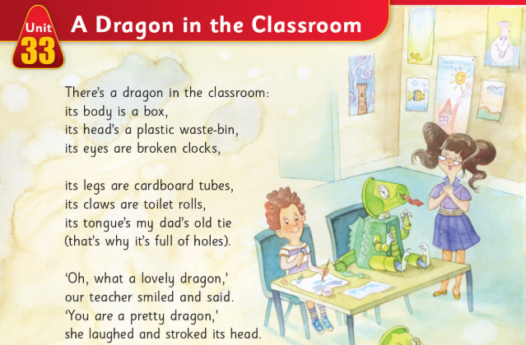
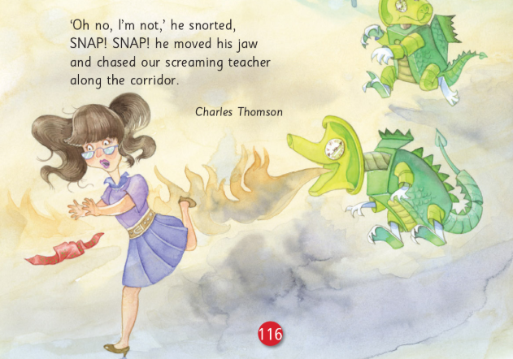

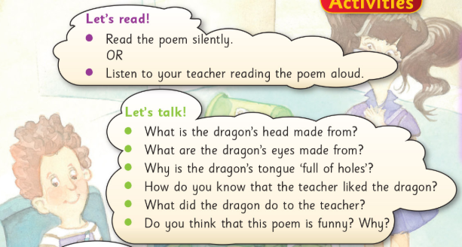
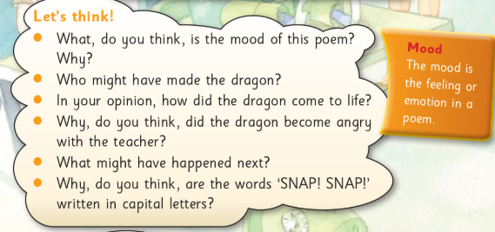

English Spellings:
List 1 and A & B
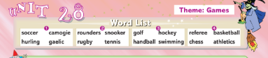
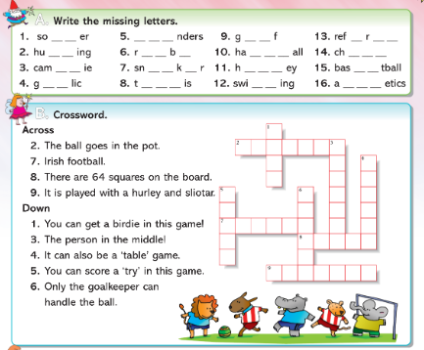

Maths:
Mental Maths:
Monday (1-15)
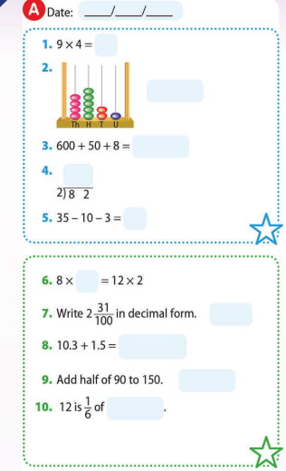
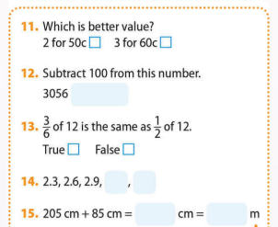

Tables: (x11 & ÷11)
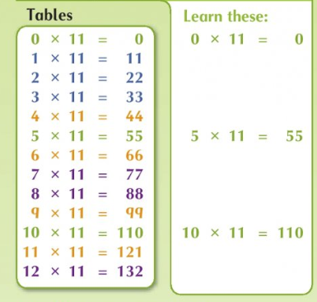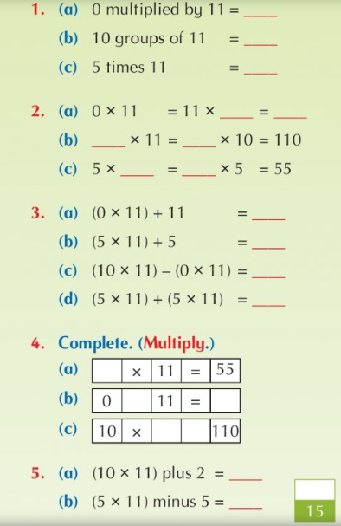

Maths Topic: Weight
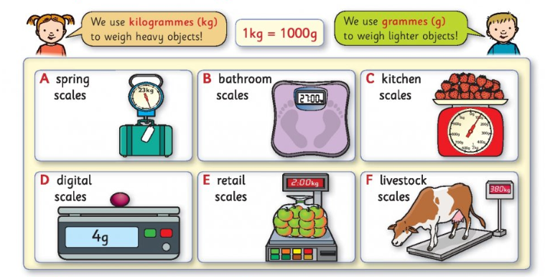
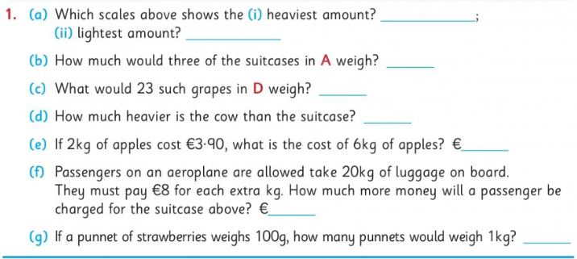
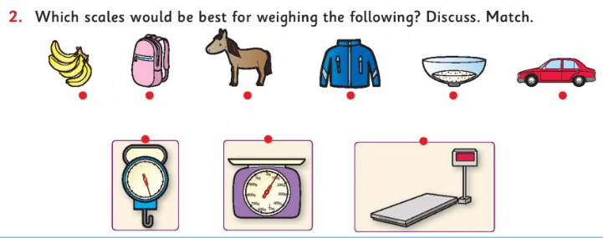

(You will need a scales for some of the activities below)
If you do not have the exact items listed below swap them for something similar
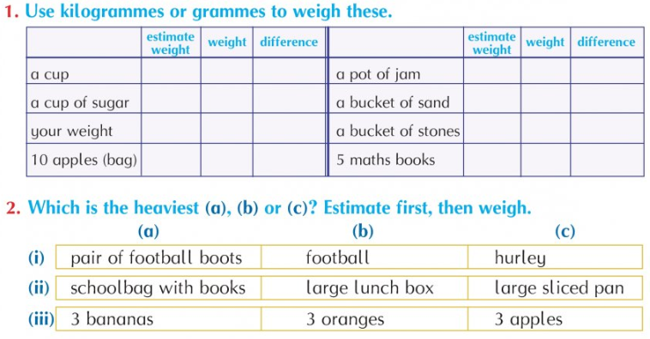

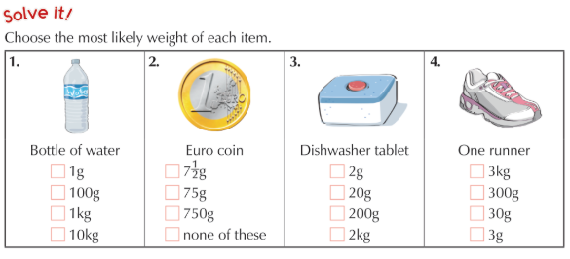

Gaeilge:
Gaeilge spellings: Ceartlitriú
Litir - Bosca Gorm agus A
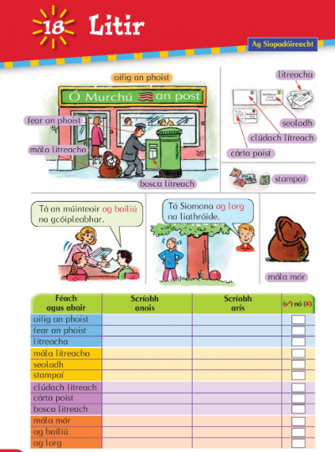

Scríobh na litreacha atá in easamh – write in the missing letters
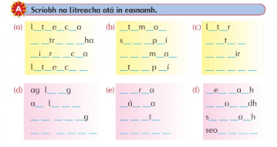

Gaeilge: Bun go Barr
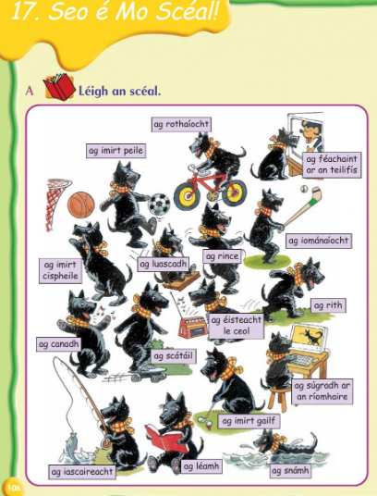

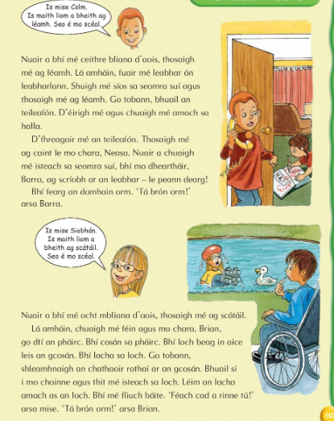

An Bhfaca? – Did you see
Chonaic – I saw
Ní fhaca – I didn’t see
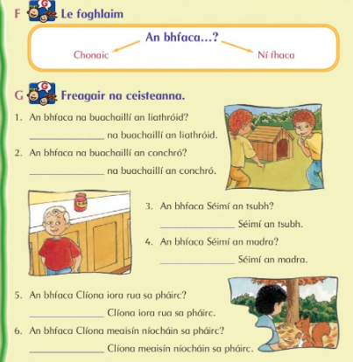

SESE:
Science: The Living Body
Read the information below on ‘The Skin’. Carefully draw and label a diagram of the skin. Do it nice and big, this will make labelling each part much easier.
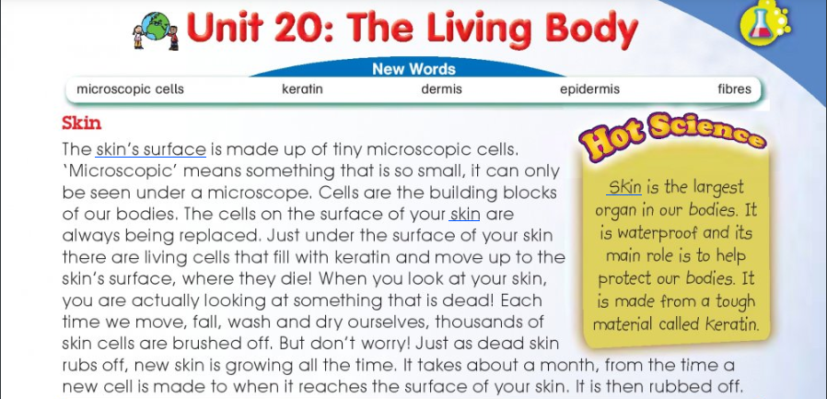
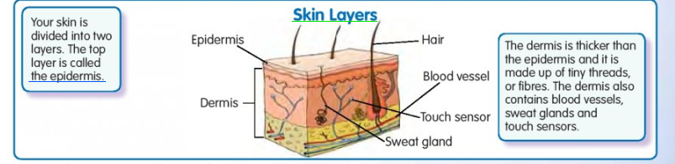
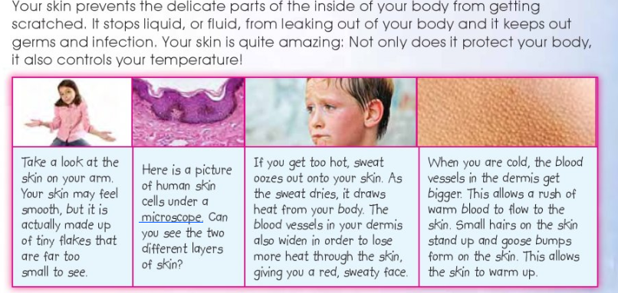
Tuesday 5th May 2020
English:
English Comprehension:
Crazy Carnivals: Read the poem ‘A Dragon in the Classroom’ and complete the following activities:
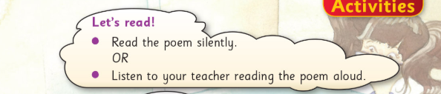
Your short account can be 8 sentences (8 full stops)
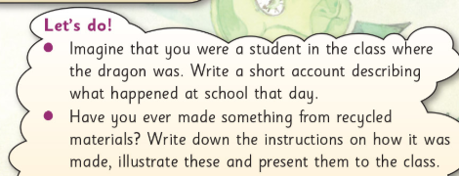

English Spellings:
List 1-2 and (C&D) Remember to write out the alphabet to help with part C
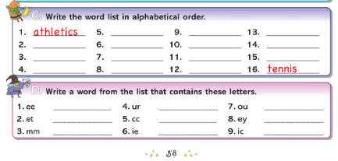

Maths:
Mental Maths:
Tuesday (1-15)
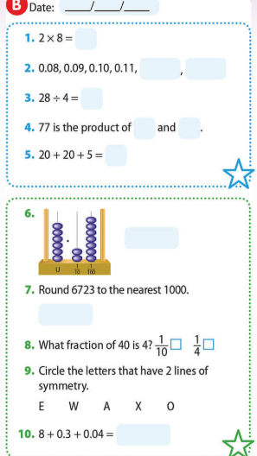
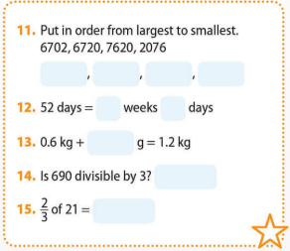

Tables: (x11 & ÷11)
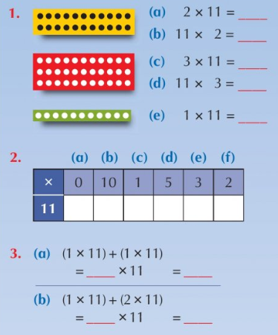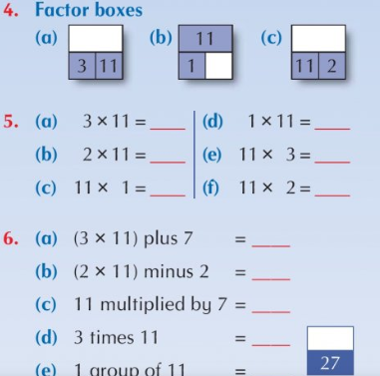

Maths Topic: Weight
Writing as Grams and Kilograms
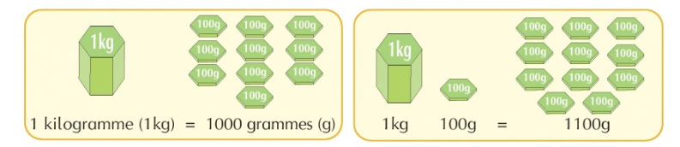
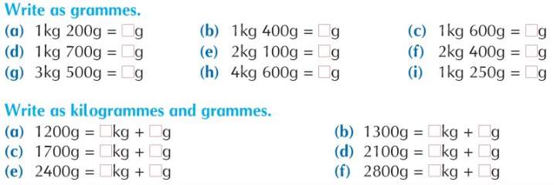
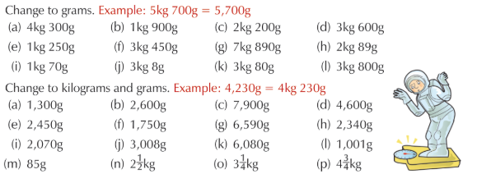
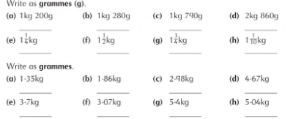
Gaeilge:
Gaeilge spellings: Ceartlitriú Bosca Gorm agus bosca Buí. B – Bris an cód

B – Bris an cód. Scríobh an abairt – crack the code and write the sentence.
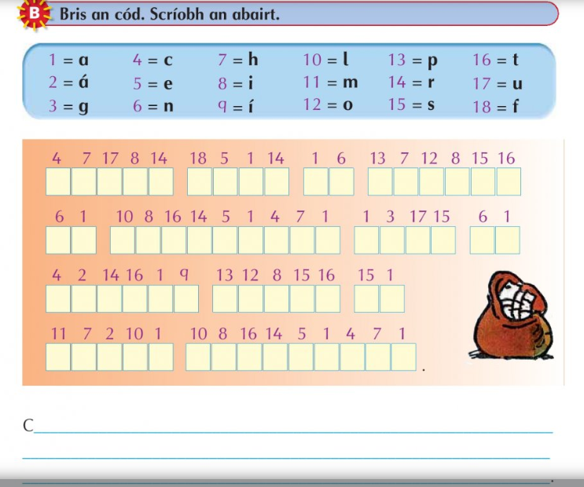

Gaeilge: Am don Léamh – An Sorcas – the circus
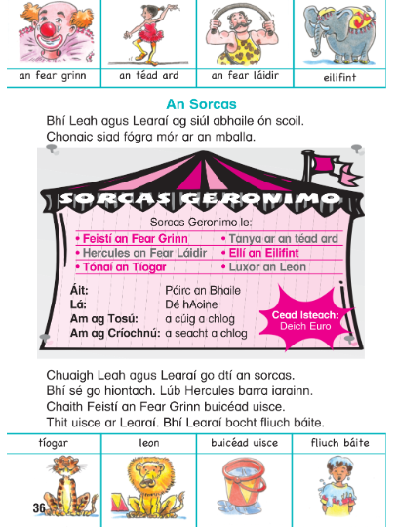

A – Fíor nó Bréagach (true or false)
C- Tarraing na pictiúir (draw the pictures)
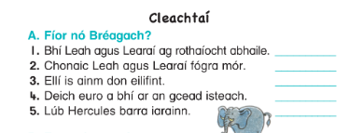

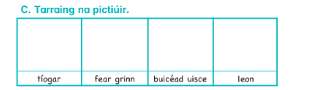

SESE:
Science: The Living Body
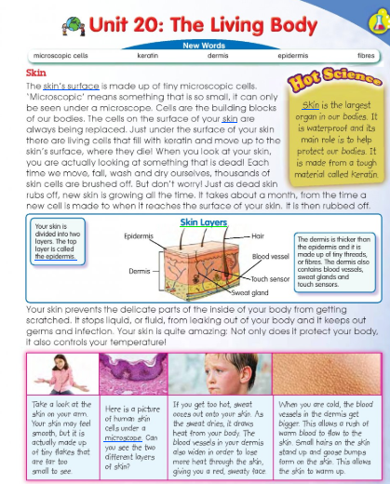
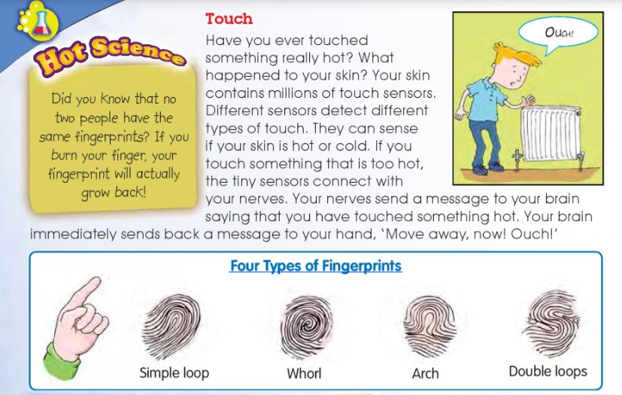
Complete the activities below in your copy. You might not be able to do all of part C unless you have a sibling or adult at home who can spare some time to do the pair work.
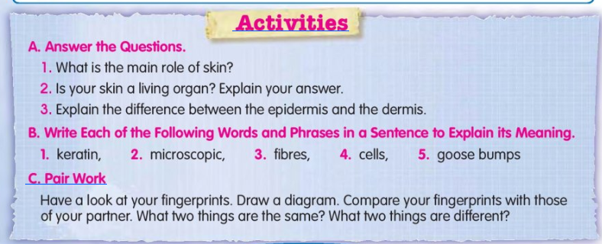
Wednesday 6th May 2020
English:
English Narrative writing: Complete the table below. Only plan your story today using the table.
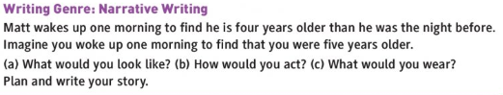
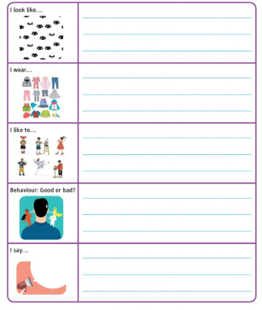

English Handwriting:
Carefully concentrate on your posture (your sitting position) and begin the following piece from your Write Here book. Remember to use your free hand as a guiding hand.
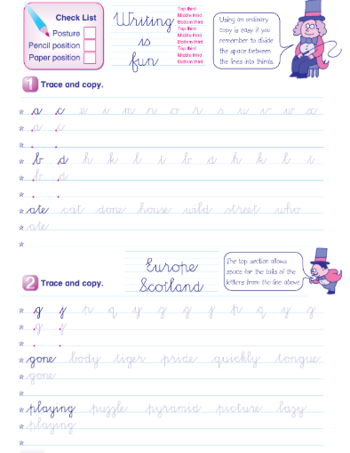

English Spellings:
List 1-3 and E&F
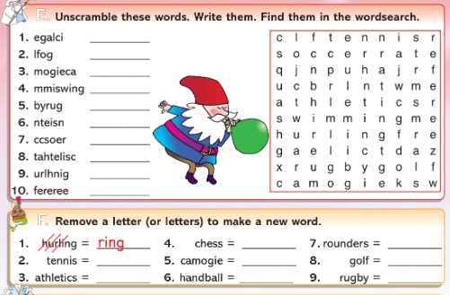

Maths:
Mental Maths:
Wednesday (1-15)
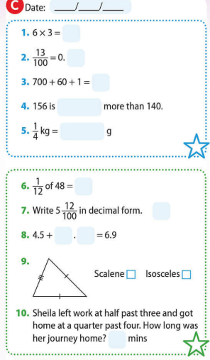
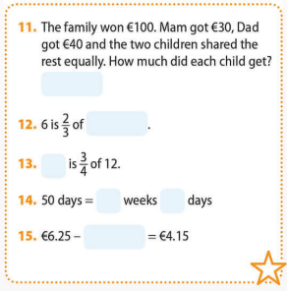
Tables: (x11 & ÷11)
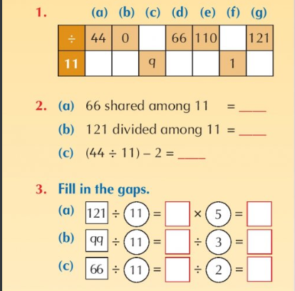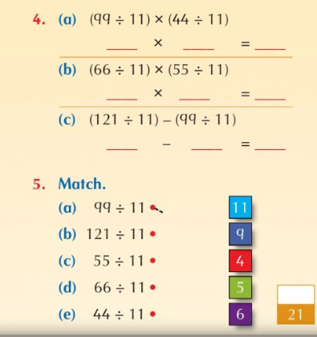

Maths Topic: Weight
Converting Grams and Kilograms
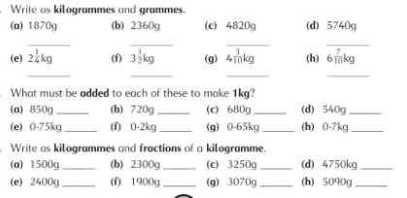
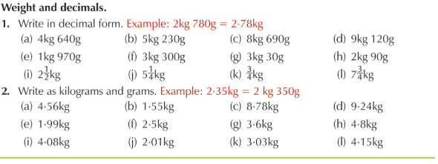

Converting using fractions
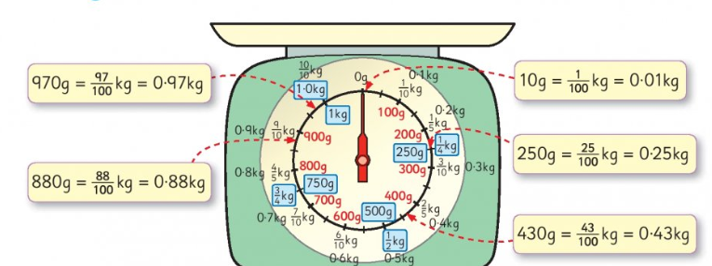
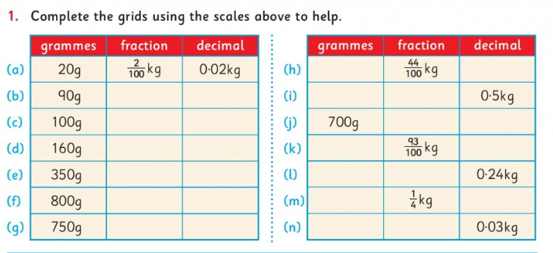

Gaeilge:
Gaeilge spellings: Ceartlitriú Bosca Gorm, bosca Buí agus bosca Corcra. C – ag bailiú agus ag lorg – collecting and searching for

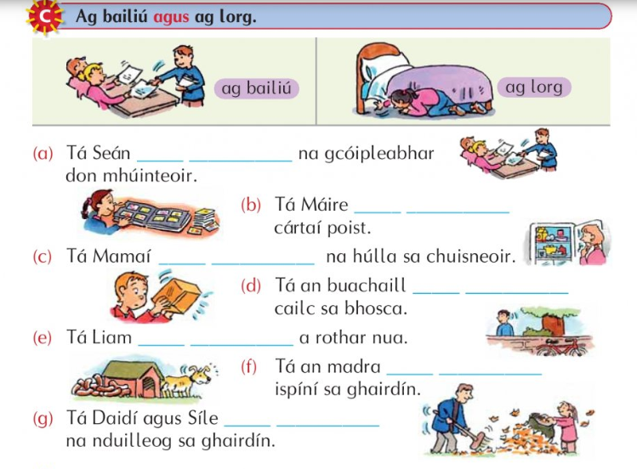

Gaeilge: Am don Léamh – An Sorcas – the circu

B – Freagair na Ceisteanna – answer the questions
D – Faigh 4 fhocal ón scéal ar an téad ard – find 4 words on the rope
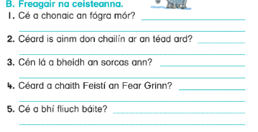

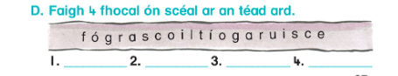

SESE:
Science: Muscle Power
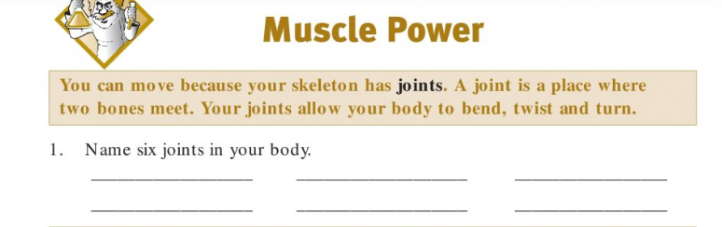
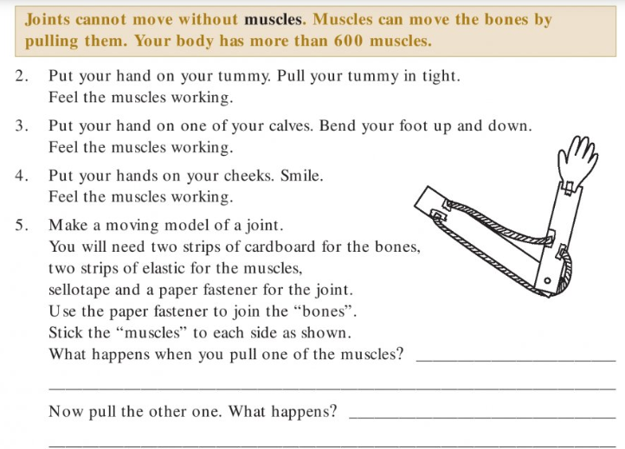
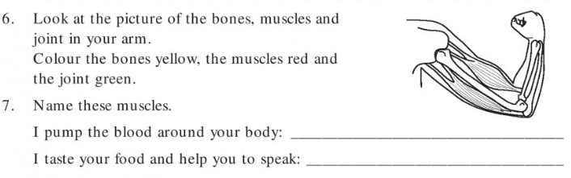

Thursday 7th May 2020
English:
English Narrative writing: Using your plan from yesterday; write your story. Think of a suitable title for your story. You can illustrate your story if you wish. Fill in the Self-Reflection when you complete your story.

English Spellings:
List 1-4 and A & B
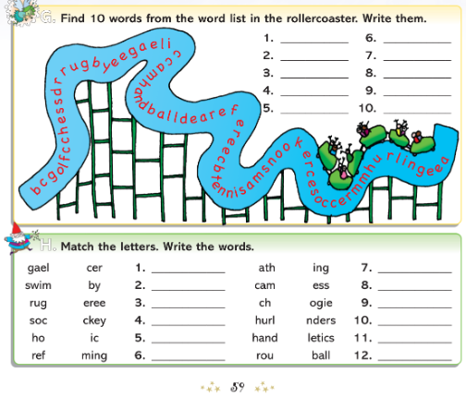

Maths:
Mental Maths:
Thursday (1-15)
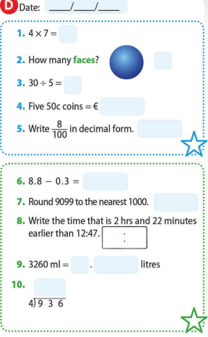
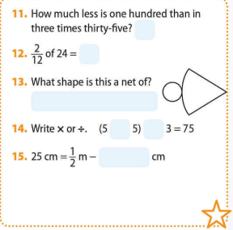

Tables: (x11 & ÷11)
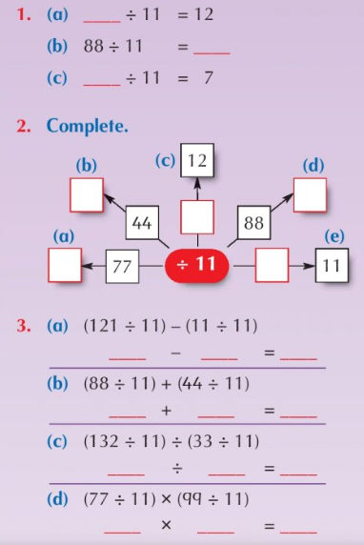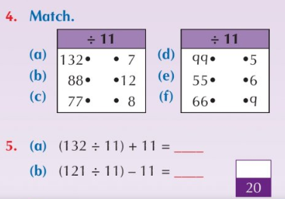

Maths Topic: Weight
Adding and Subtracting weights. Look at the signs carefully before working out each sum. Don’t forget the decimal point. (only complete as many of the sums below as you can)
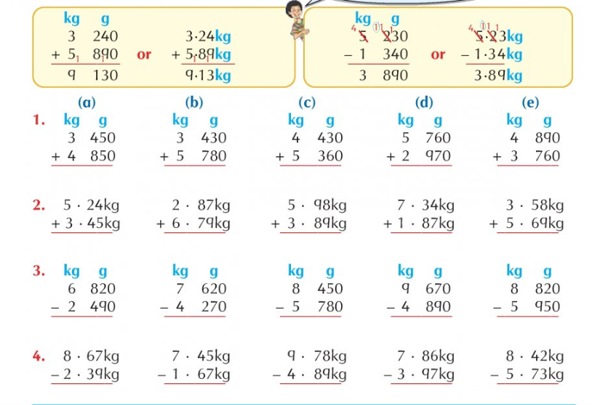
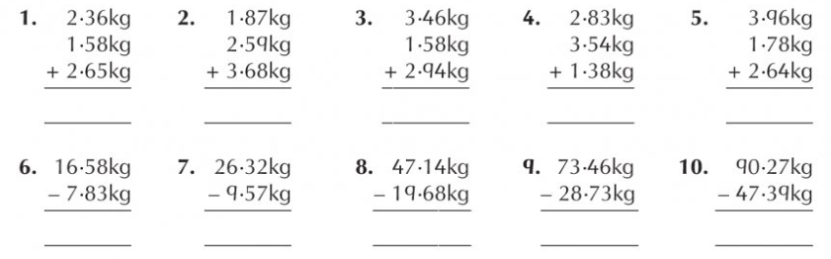

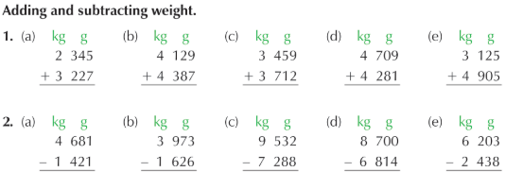
Gaeilge:
Gaeilge spellings: Ceartlitriú Bosca Gorm, bosca Buí, bosca Corcra agus bosca Oráiste. D – Scríobh an Scéal – write the story

Chuaigh mé – I went
Cheannaigh mé- I bought
Chuir mé – I put
Chuir sé – he put
Fuair mé – I got
Scríobh me – I write/I wrote
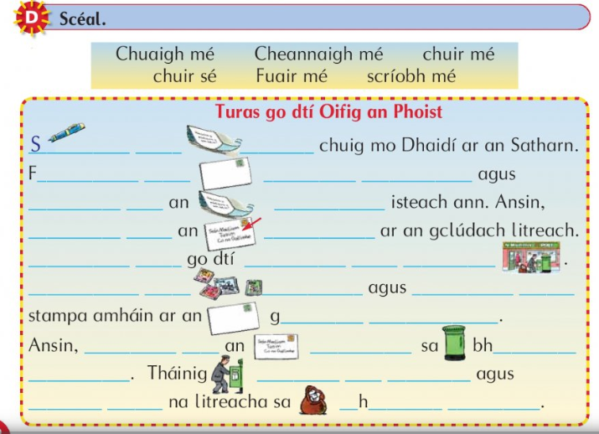

Gaeilge
Use your Bun go Barr story from Monday and Tuesday (Seo é mo Scéal) to complete this cuardach focal (word search) and put 5 of the words into sentences.
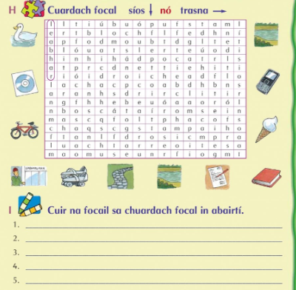

PE:
Go Noodle – a wide range of activities can be discovered in the categories section https://app.gonoodle.com/categories
Joe Wicks is doing daily PE classes on his YouTube channel https://www.youtube.com/channel/UCAxW1XT0iEJo0TYlRfn6rYQ
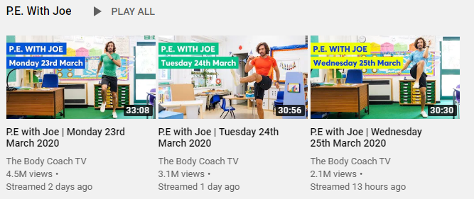
A guided workout to stay active at home https://www.youtube.com/watch?v=L-8wW40jTzc
For GAA enthusiasts why not attempt the 200 touches daily challenge
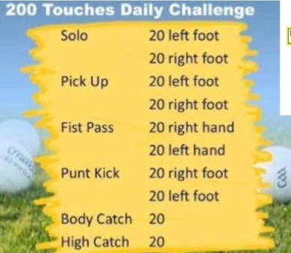

Religion: Wellbeing Activity
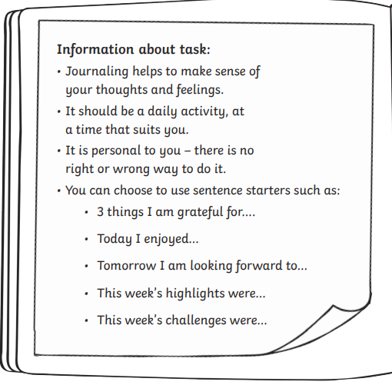
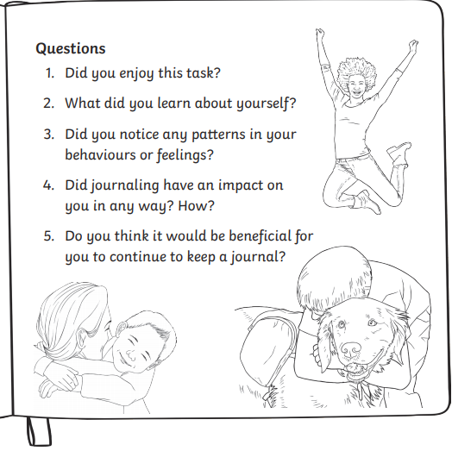

Complete your journal/diary on the template below
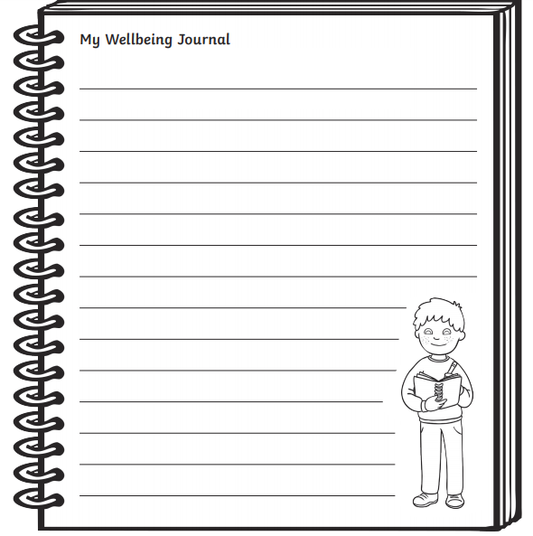
Friday 8th May 2020
English:
English Comprehension: Read the comprehension ‘The Duck-billed Platypus’ and complete the following activities: (For part A answer 7 Questions)
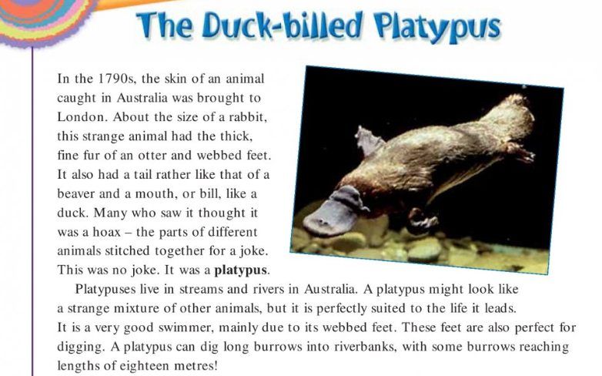
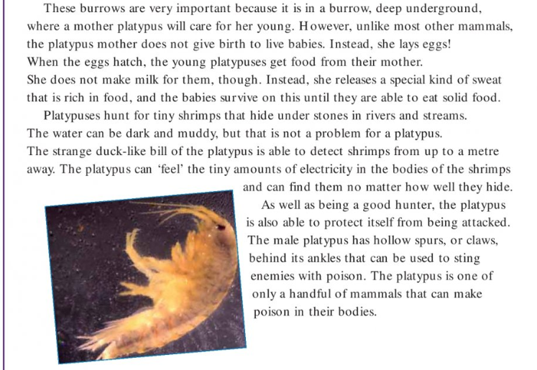
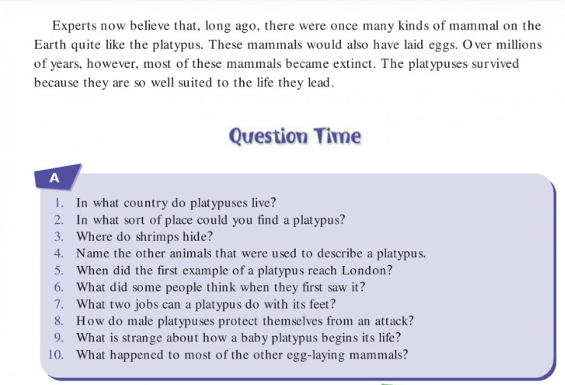
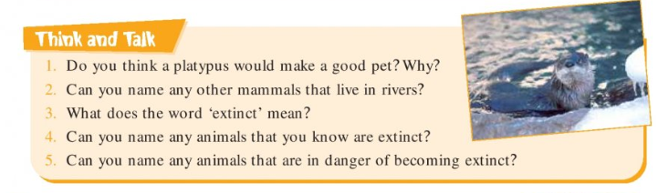
English Spellings:
Ask an adult or older sibling to quiz you on this week’s words from Spellbound. Write each word (16) into your copy.

Maths:
Mental Maths:
Friday (1-15)
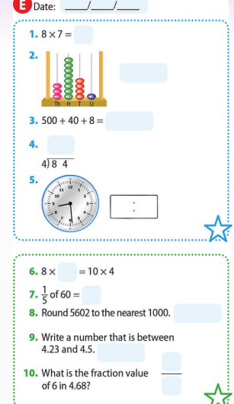
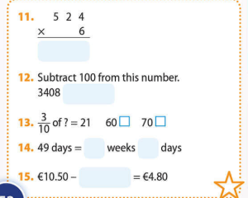

Tables: (x11 & ÷11)
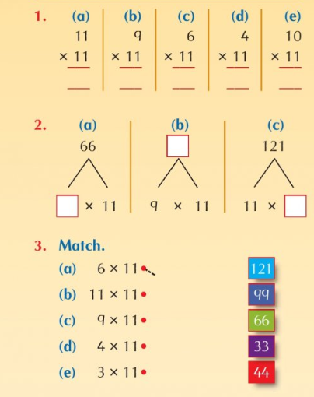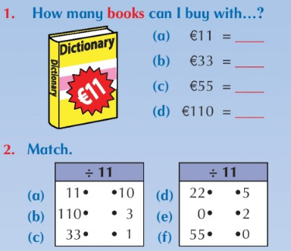
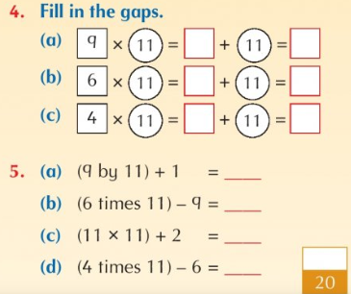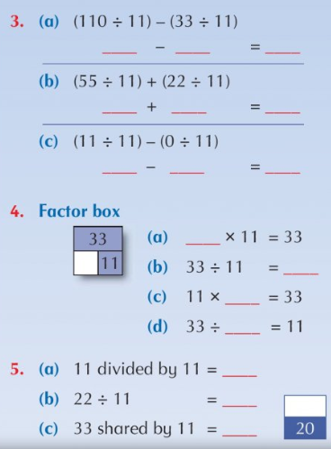

Maths Topic: Weight
Multiplying weights.
For some of the questions below you must write them out in the same format as the examples. Remember to include g and kg in your answers. Use your tables logs to ensure you don’t make any calculation mistakes.

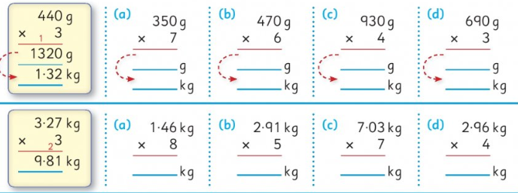

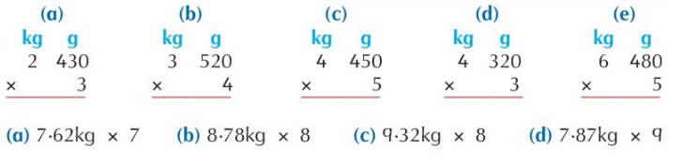

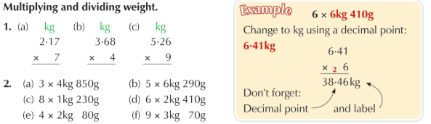

Gaeilge:
Gaeilge spellings: Ask an adult or older sibling to quiz you on your Gaeilge spellings from this week. The person testing you can choose 9 of the 12 spellings for you to write down.
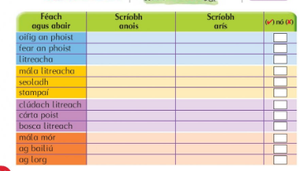

Gaeilge: Féach, foghlaim agus scríobh – look, learn and write
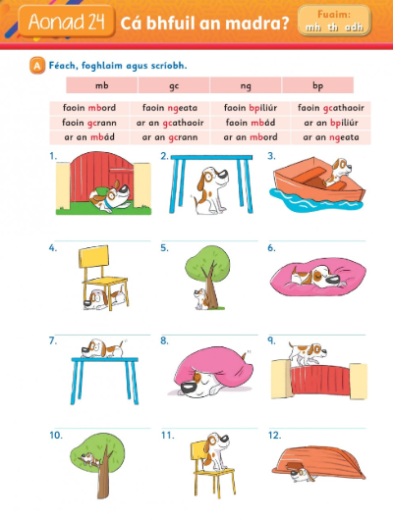

Art:
Using as many items as you can find to (cardboard boxes, washed out milk cartons, Pringles tubes, kitchen roll inserts, etc.) create your very own dragon from the poem ‘A Dragon in the Classroom’. Think of a suitable name for your dragon. Feel free to post pictures of your dragon on our Google Classroom page.
**Please ask an adult before taking boxes or any items you may need to create your dragon**

