Dear Parents / Guardians,
We hope you are all safe and well. We have decided to assign and suggest some class specific work / activities for your child in 2nd class. It would be a good idea to use the children’s ‘Free’ copy to complete your written work. These copies were sent home in their schoolbags. If you don’t have one, please just use a spare copy book. Please date and title the copy for each activity you complete.
Work through the suggested activities throughout the week completing as many as you can. Please do not feel pressured to complete all activities. We have included some worksheets to assist with some of the suggested ideas. These worksheets don’t necessarily have to be printed out (if access to a printer is unavailable). The children can read them from the computer and answer questions into their copies.
Remember to have fun while you’re learning at home.
Stay safe and we’ll hopefully see you soon.
Mrs Byrne and Ms Shiels

Gaeilge:
Topic: Caitheamh Aimsire (Sports and Hobbies)
- Scríobh agus tarraing ‘An Nuacht’ – write 3-4 sentences in your copy and draw a picture. E.g Inniú an _____(Today is _____), Tá an aimsir ______ (The weather is _______), Is maith liom ______ (I like______), Ní maith liom _____ (I don’t like______).
- Bua na Cainte (Irish workbook) p 48 + 49 and p110 (see pages below)
- Ceartlitriú Book – Spóirt p 24-26 (see pages below)
- Make a wordsearch on the Irish spellings you have learnt to date. Use Ceartlitriú to find the words
- Make a picture dictionary on all of the Irish spellings we have learnt to date (Irish word + a picture to match)
- TG4 – Watch a cartoon as Gaeilge
- Visit www.edcolearning.ie to access Gaeilge resources – (select teacher, fill in username (primaryedcobooks) and password (edco2020).
- Bí ag caint as Gaeilge chomh minic as is féidir (speak Irish as often as you can)
English:
Reading:
- Read the novel ‘Jasper Goes on Holiday’ and write a summary after each chapter. When finished the book write a short book review in your copy.
Design a cover poster for the story.
Draw comic pictures of the trouble Jasper gets into as you read through the story.

Comprehension:
- ‘The Young Detectives’ (see below) and answer questions ‘A, B and Talk Time’ in copy.
- ‘How Do Astronauts Survive in Space?’ (see below) and answer questions ‘A, B and Vocabulary’ in copy.
- A range of additional reading comprehensions with questions are available on www.twinkl.ie using the code IRLTWINKLHELPS
Creative Writing:
Write freely about any topic of your choice …………………… E.g.
- Plan your superhero story. (The villain, the superhero, superpowers, setting, what is the villan doing, how does the superhero save the day?) Write your story
(See worksheets below).
- Write a Diary entry – a personal account of your time away from school
- Write a letter, card or email to a friend or grandparent
- Write a Spring story

Maths:
Tables: Revise all addition and subtraction tables. Some fun online games are available on: www.topmarks.co.uk/maths-games/7-11-years/times-tables
Length: Calculate length /width of different items or objects in your house. Use a ruler, hand span, arm span and foot span to calculate these.
Time: Revise time using a clock – (o’clock, half past, quarter past, quarter to) Some online games to help with this : https://www.splashlearn.com/time-games-for-2nd-graders
Addition / Subtraction Sums: Practice some addition / subtraction sums with and without renaming. (see worksheets below).
Mental Maths: You could complete Mental Maths on a daily basis (Mon-Fri). Visit the CJFallon website on parent/student log in – Master your Maths 2. This is a Mental Maths book which covers a variety of topics and problem solving at 2nd class level. This book can be viewed online as an e-reader and Questions and Answers can be written into the copy. Complete on each day starting at Unit 1.
SESE (History, Geography and Science):
- Make a labelled poster of ‘The Solar System’. Please use the following websites for help and guidance. www.planetfacts.org, www.planetsforkids.org
- Design a planet (see worksheet below for ideas).
- Read the powerpoint on Neil Armstrong and design a timeline on his life
- Also added are posters / worksheets on Space and The Solar System. All activities can be completed in their copies.
- An excellent website full of activities and games that the children will enjoy navigating through www.nasa.gov/kidsclub/index.html
- Go on a nature walk in a safe environment – write about your day out – what did you see/find? Illustrate your findings
- Continue on your own choice of project.
Art:
- It’s almost Easter – you could design your own Easter Card for a family member and include a special message.
- Design your very own ‘Spaceship’ using as many 2D shapes as you can.
PE:
Make sure you keep active. Go Noodle is a fabulous online resource. The children are very familiar with this website. Even the adults might get their daily workout completed too!!! Guaranteed to get the heart rates up!
Religion:
Remember to continue saying all prayers in your ‘Sacred Space’. Learn the prayers ‘Prayer Before Communion’ and ‘Prayer After Communion’.

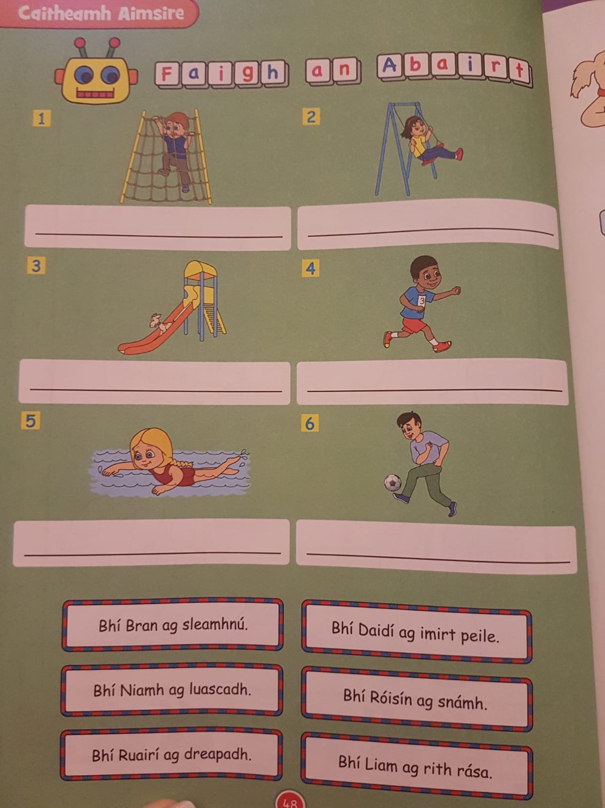

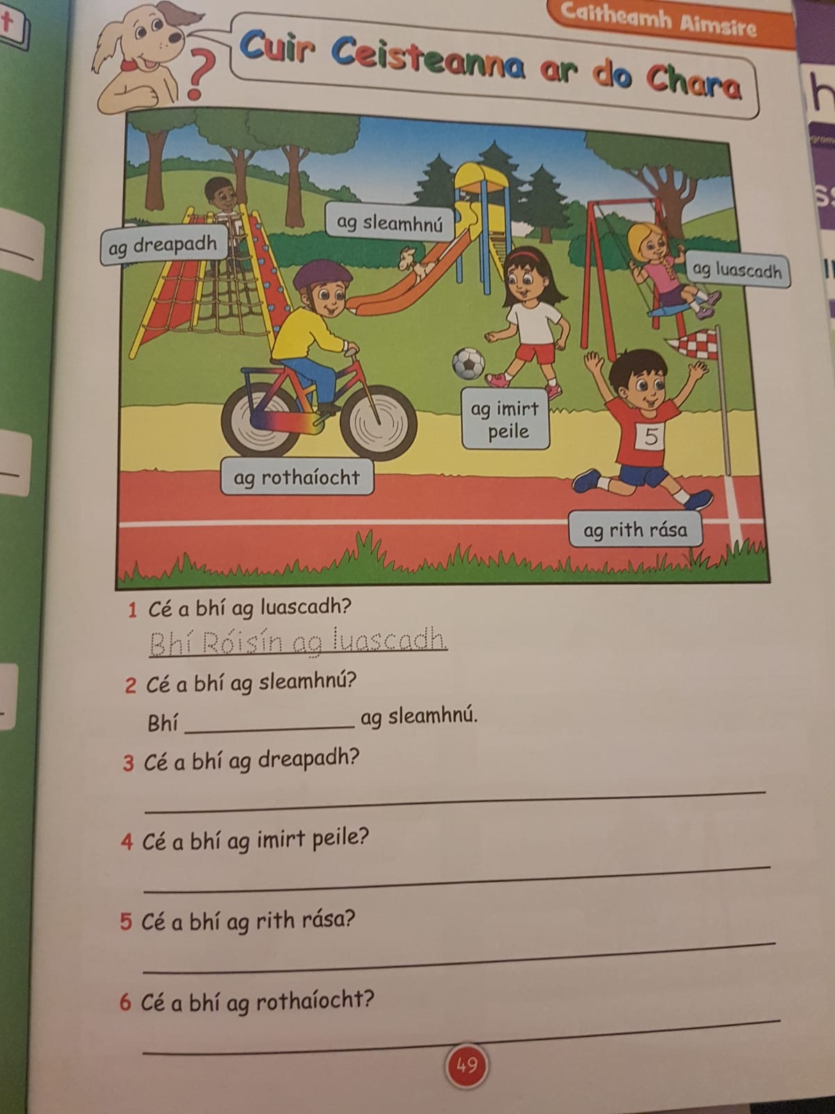

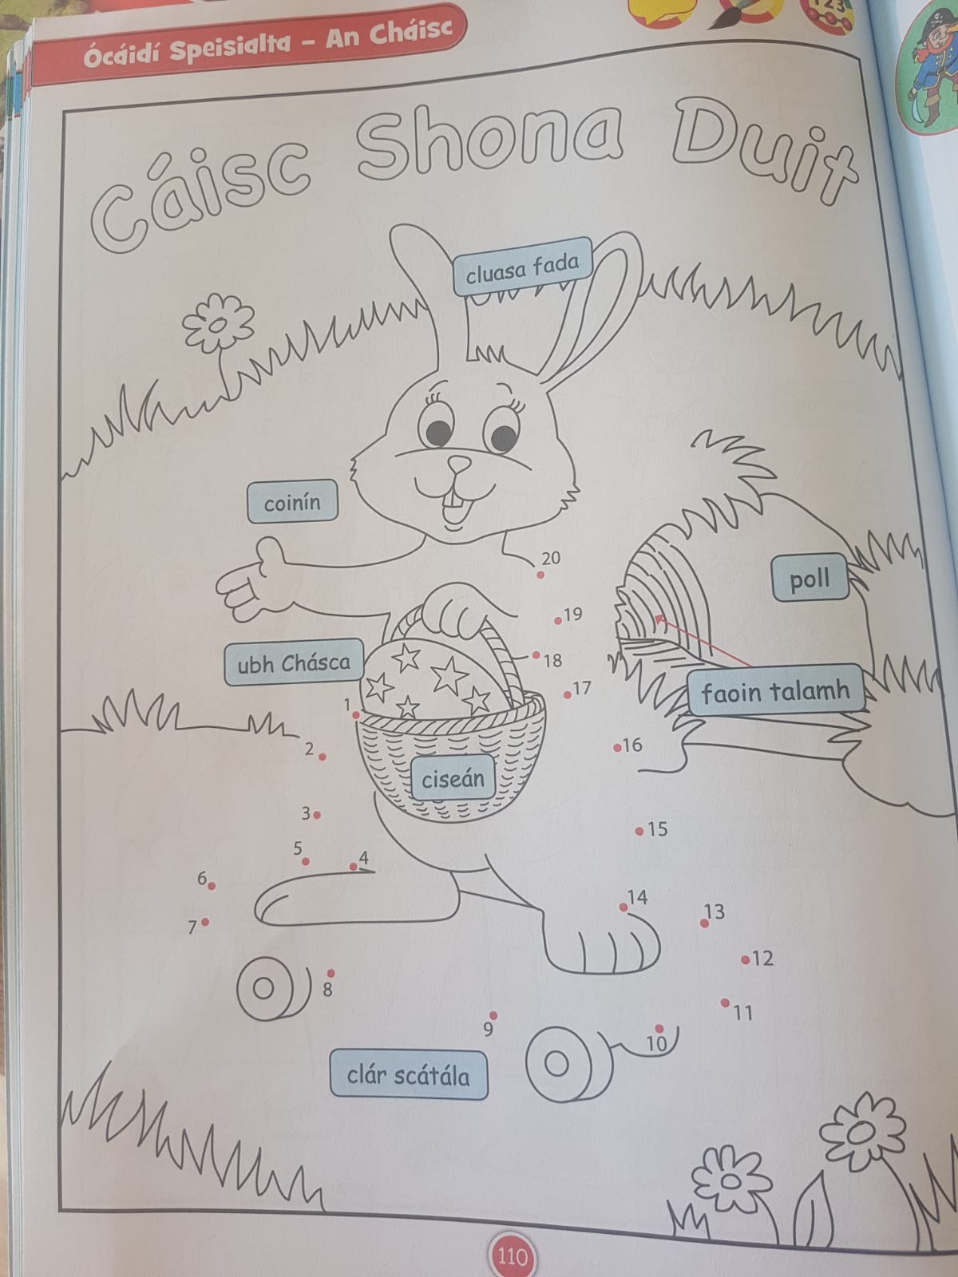

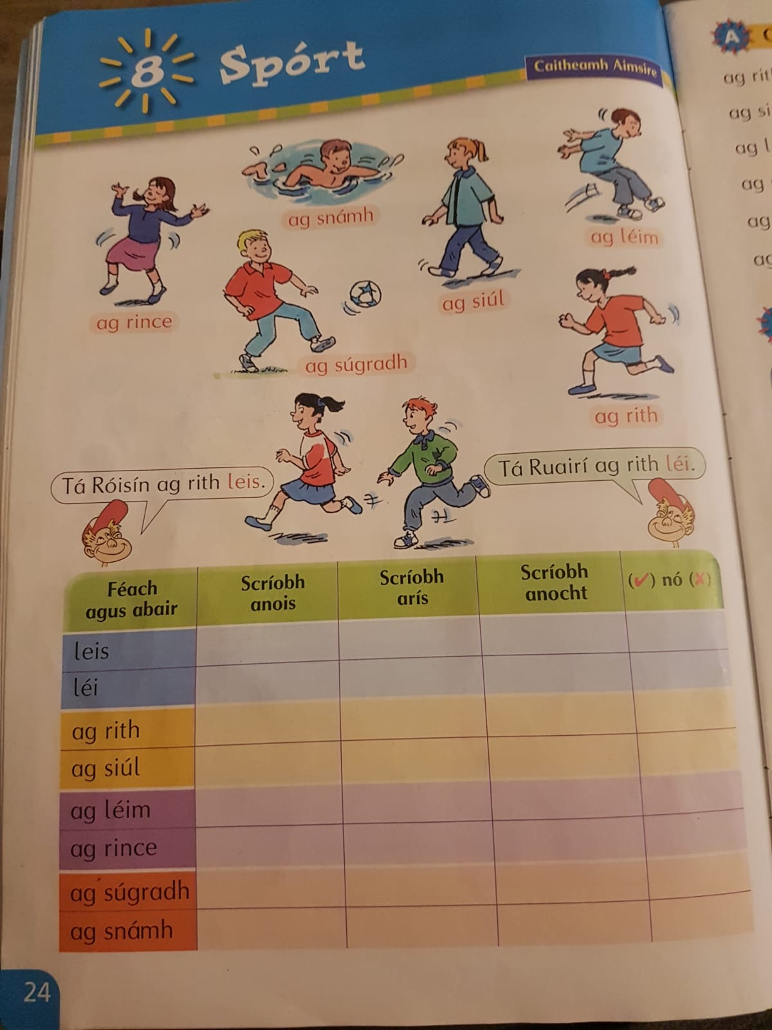

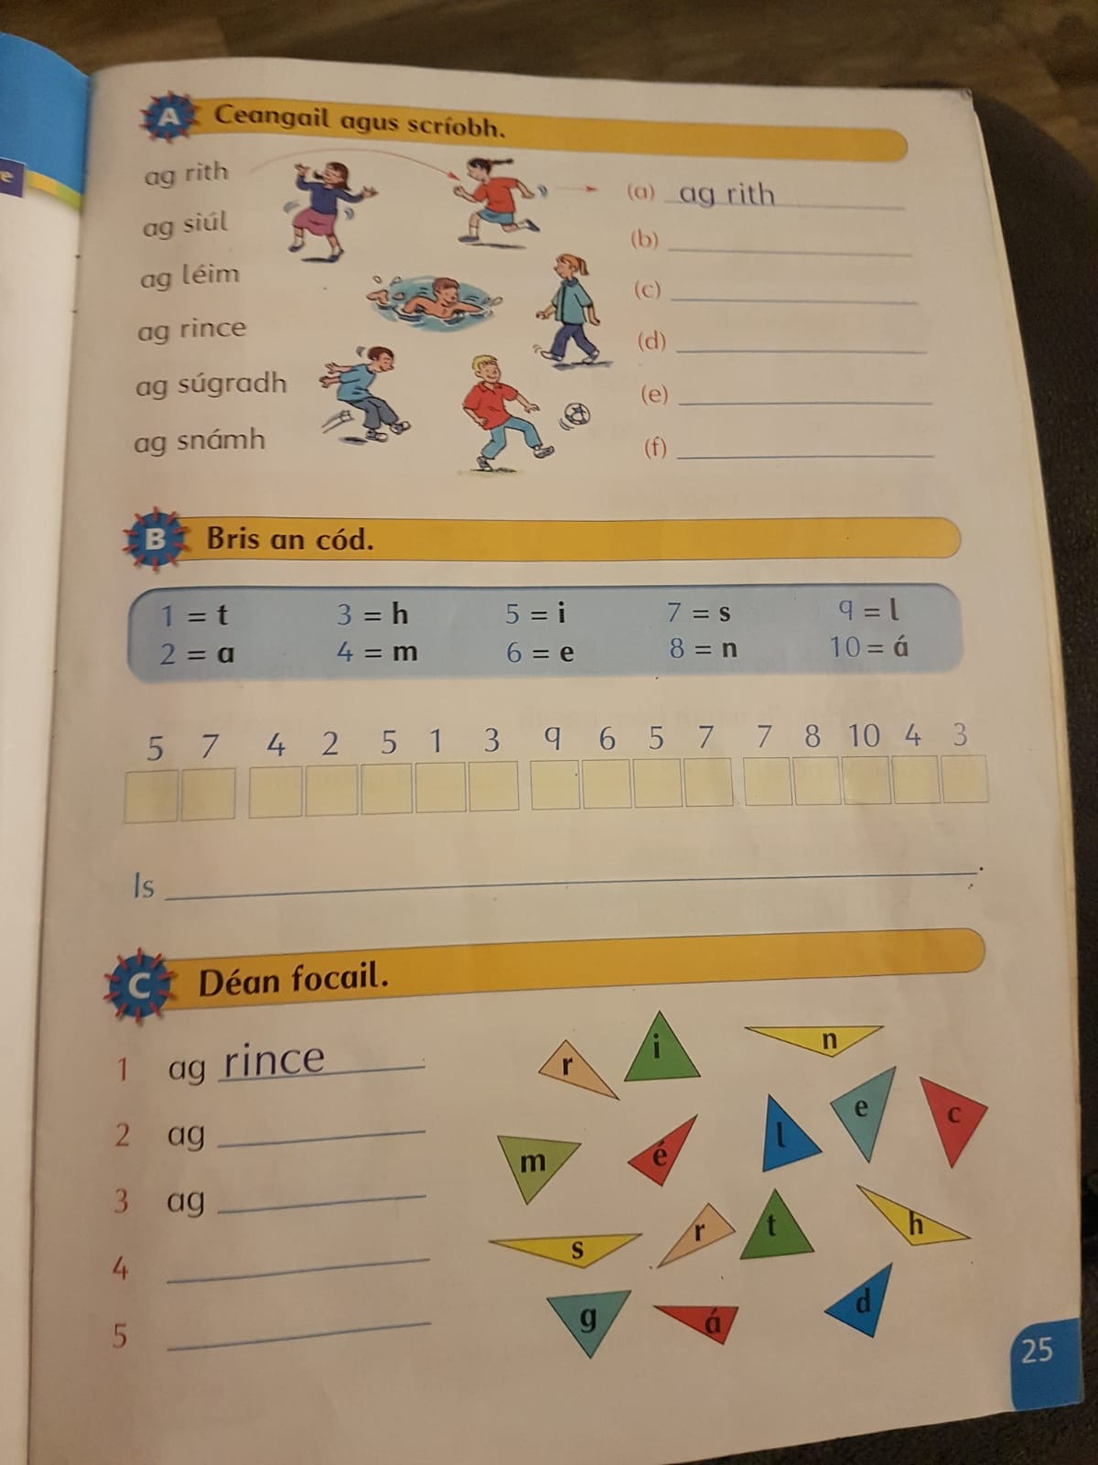

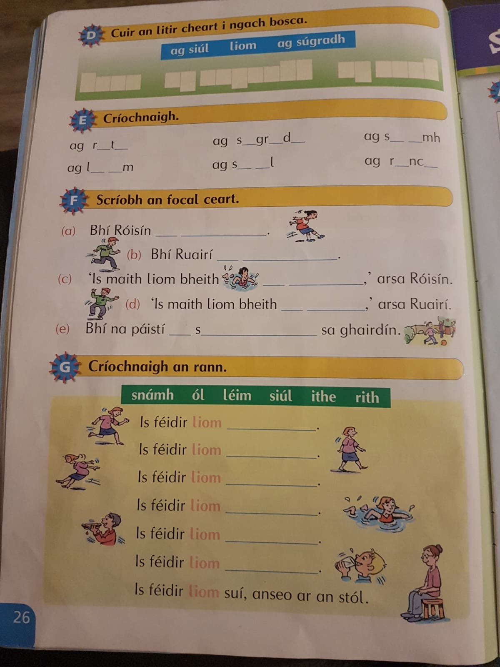

Comprehensions
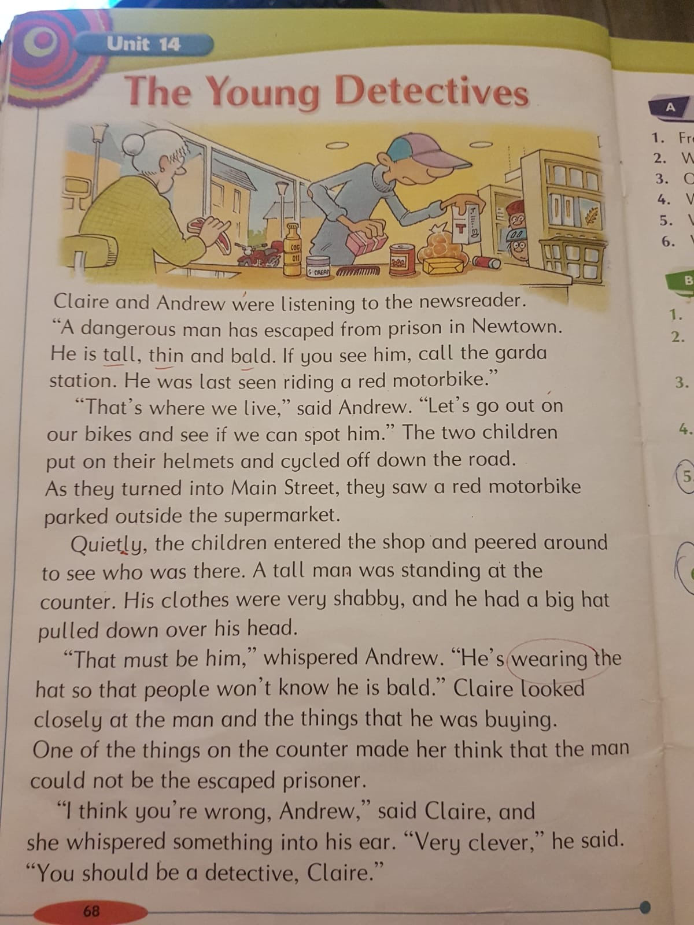

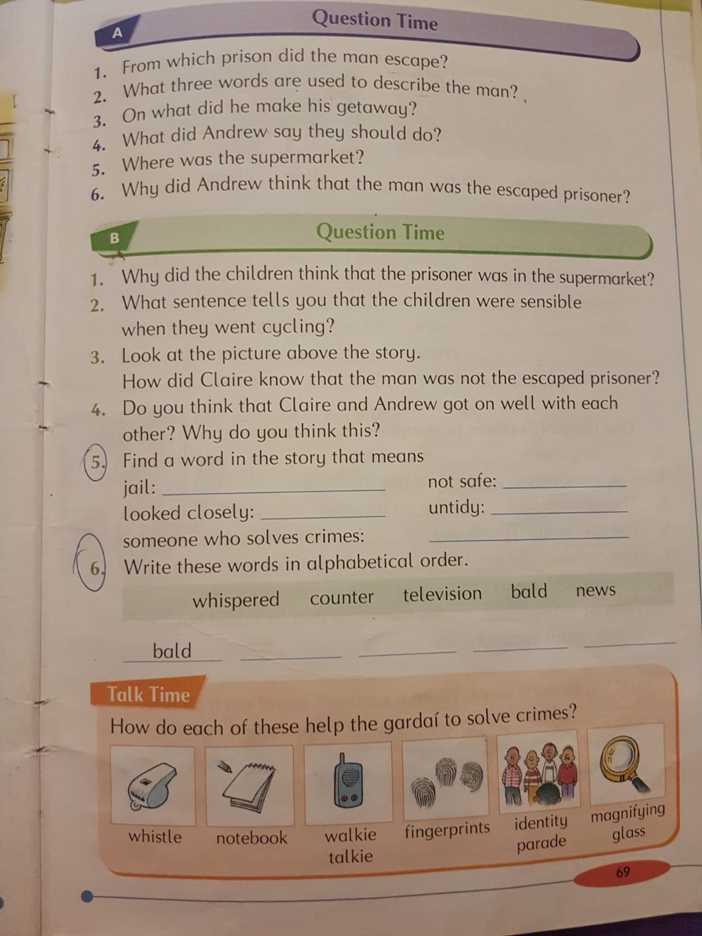

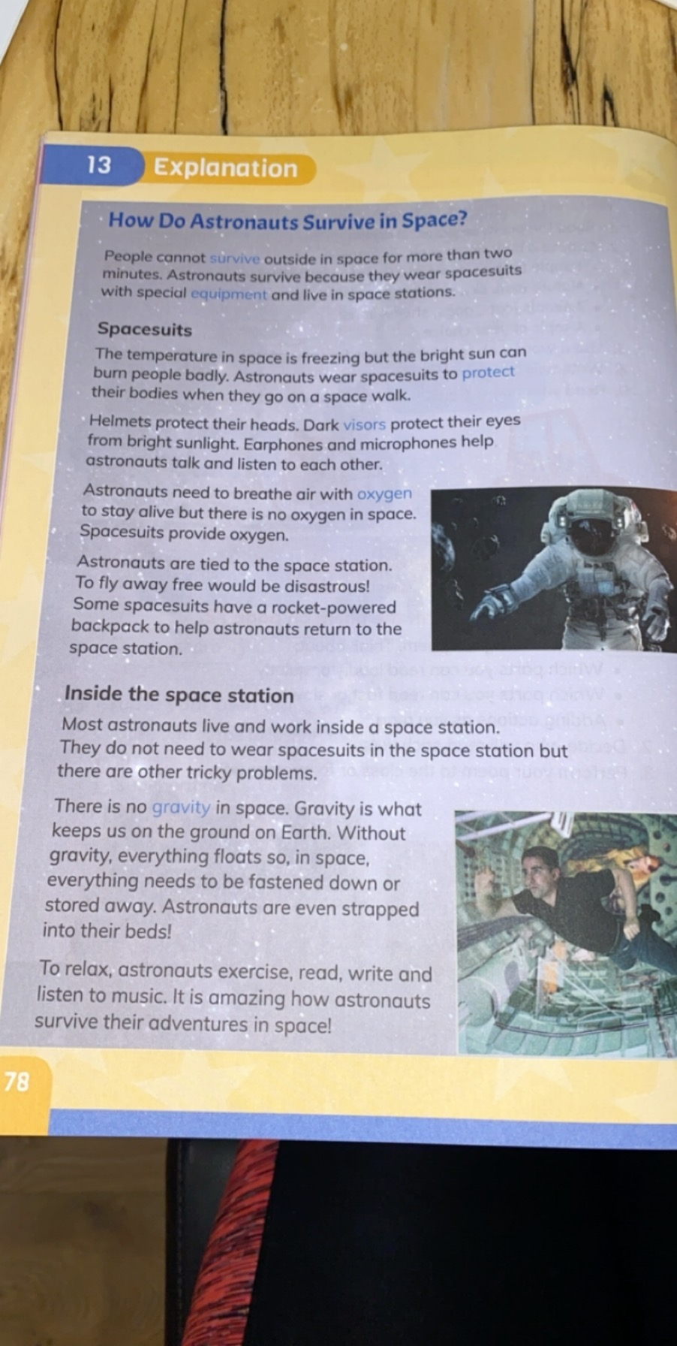
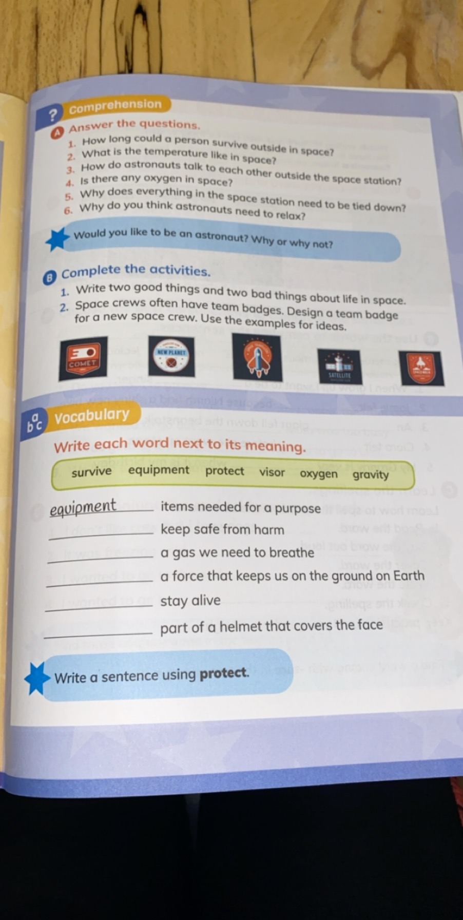
Creative Writing (Superhero)
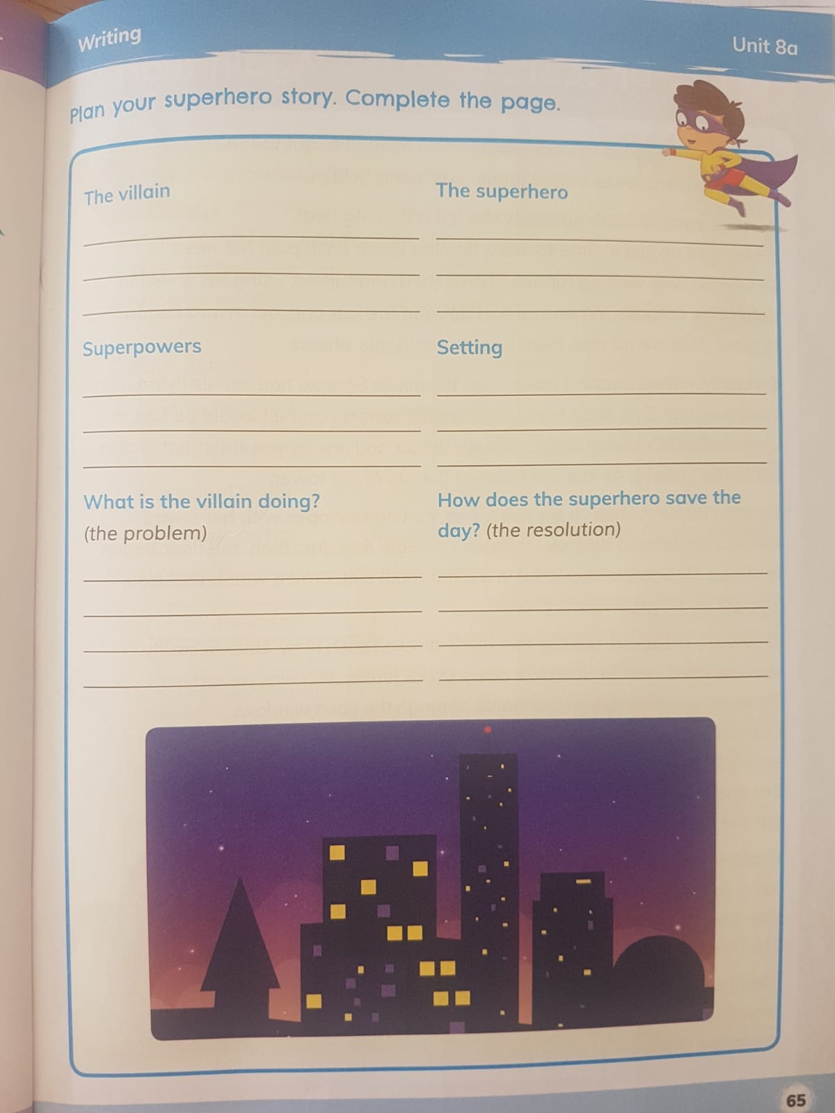

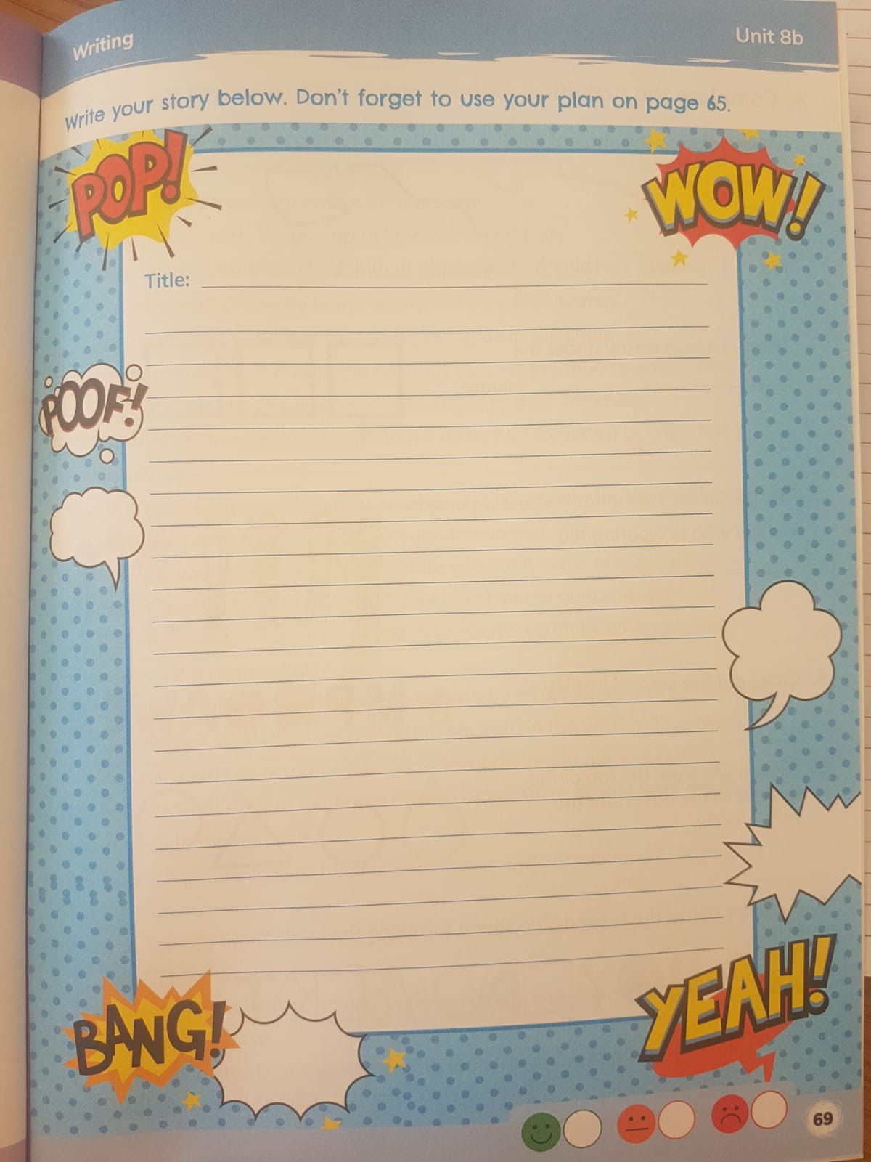

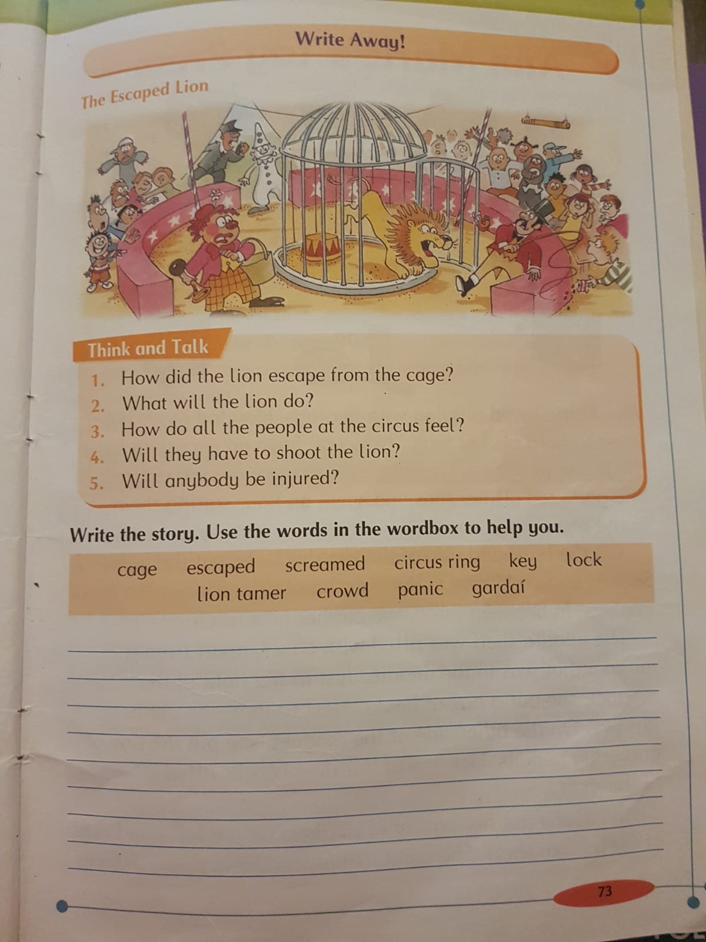

Maths Sheets (Addition and Subtraction)
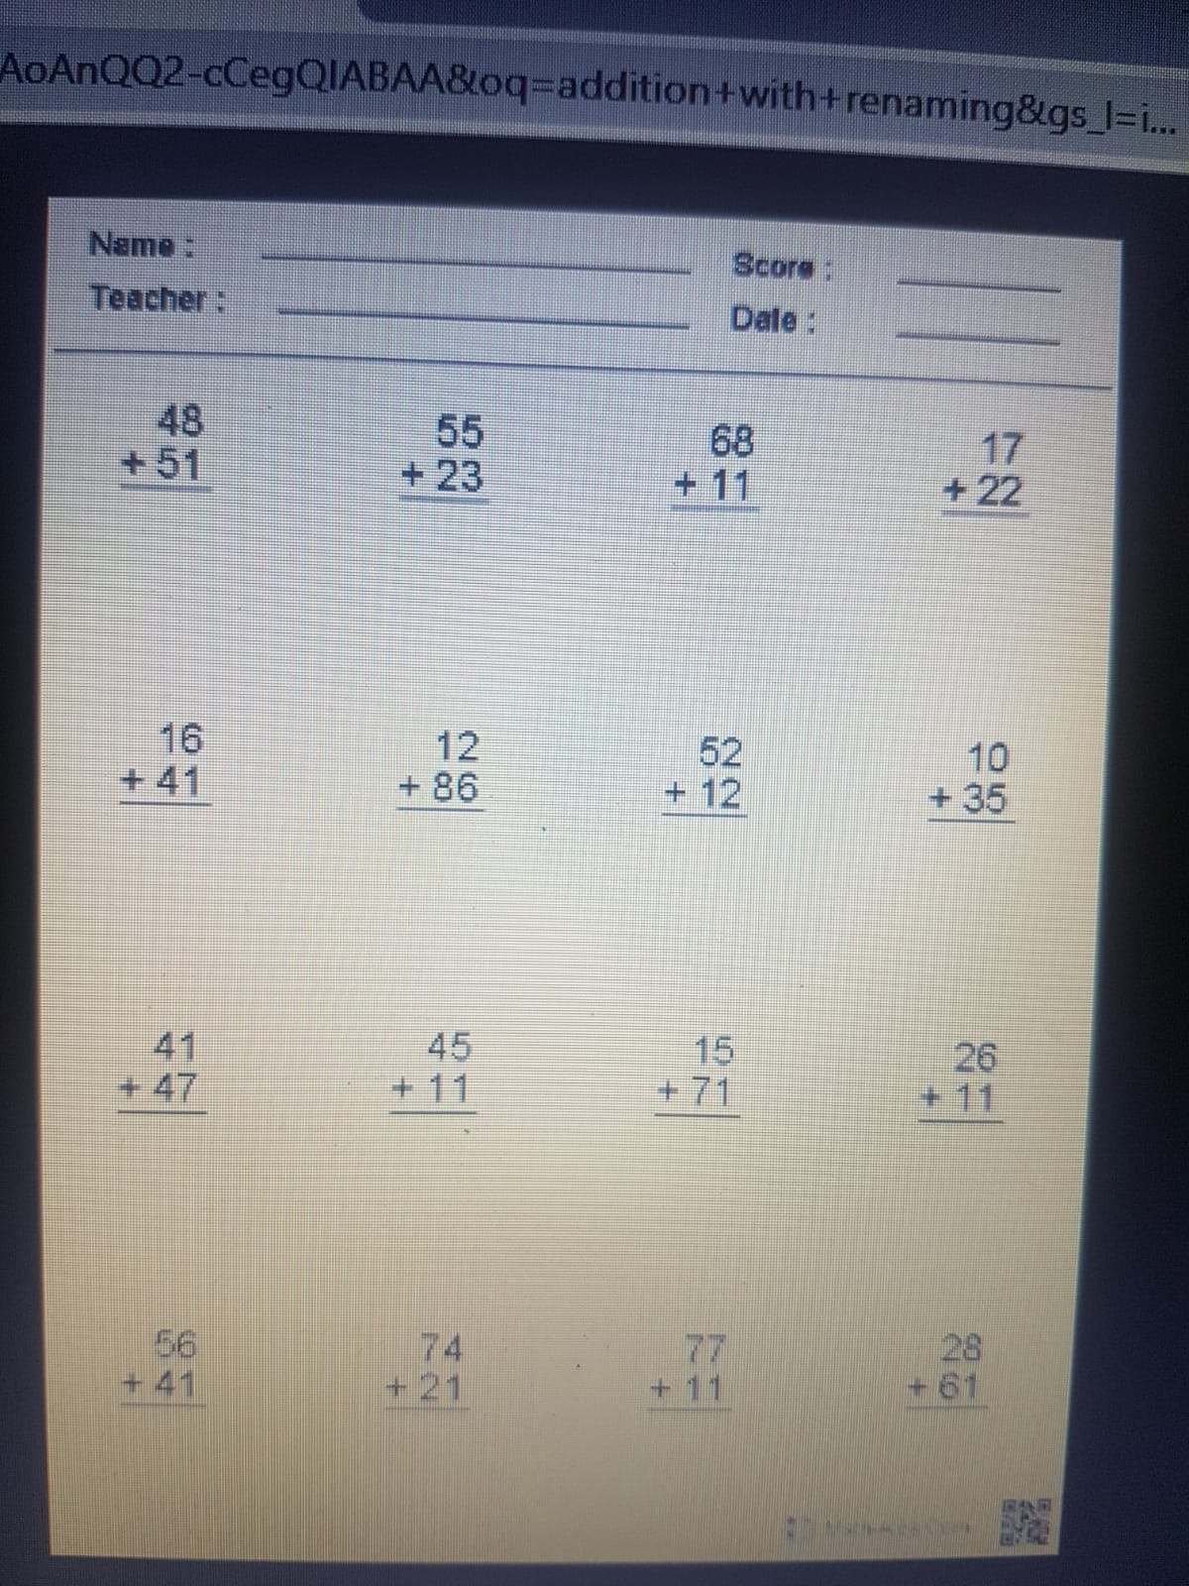

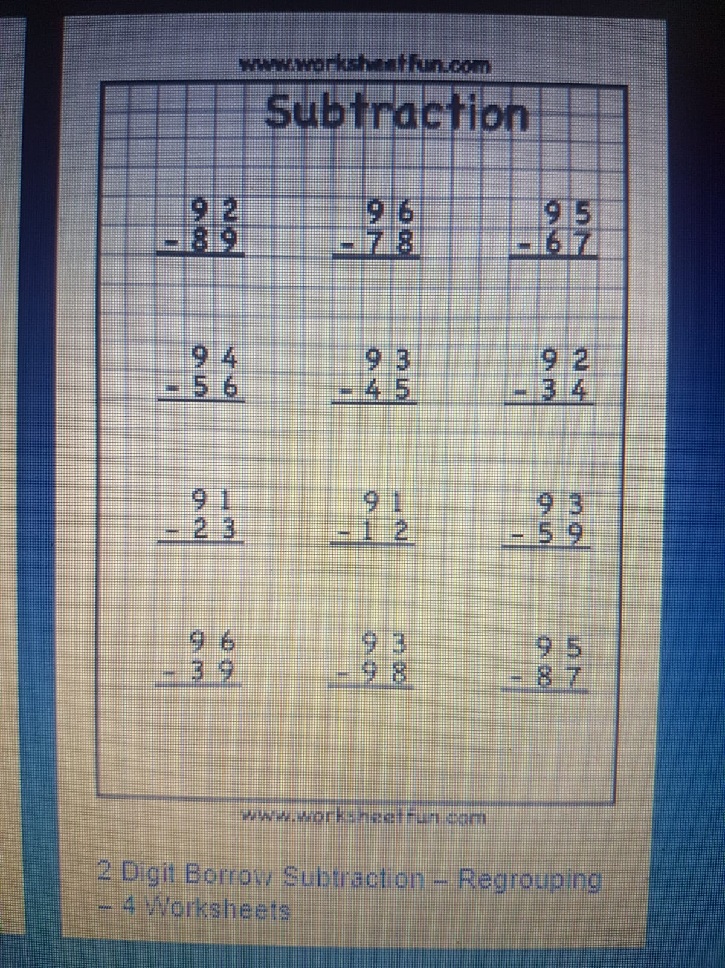

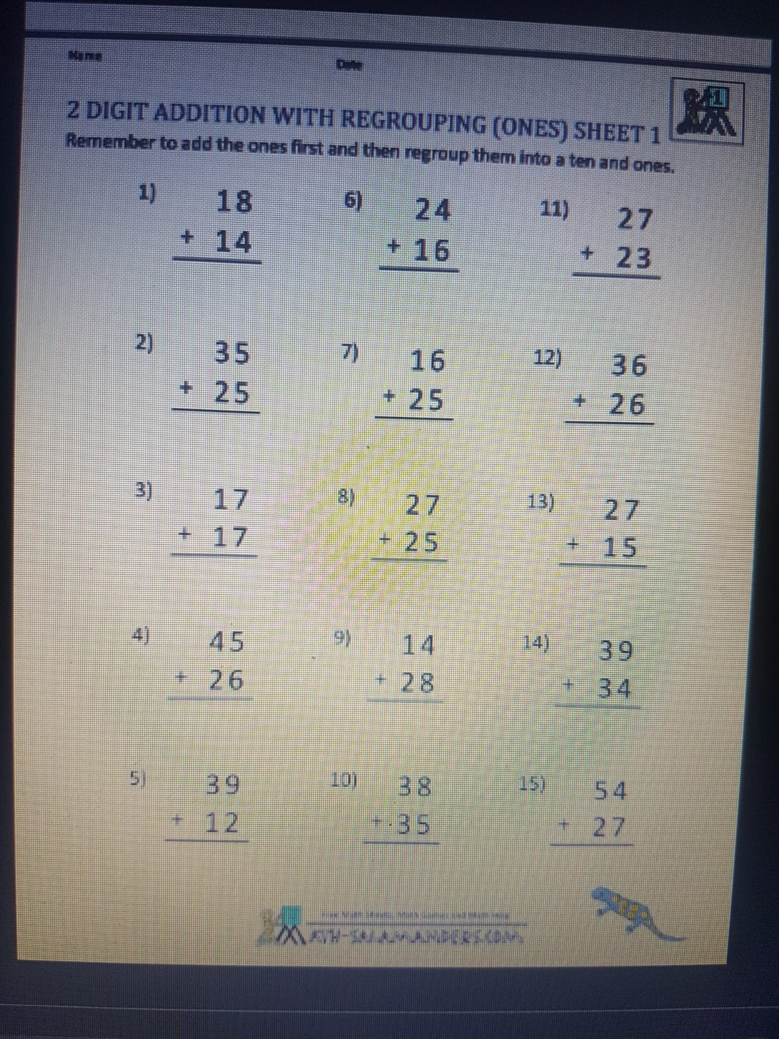

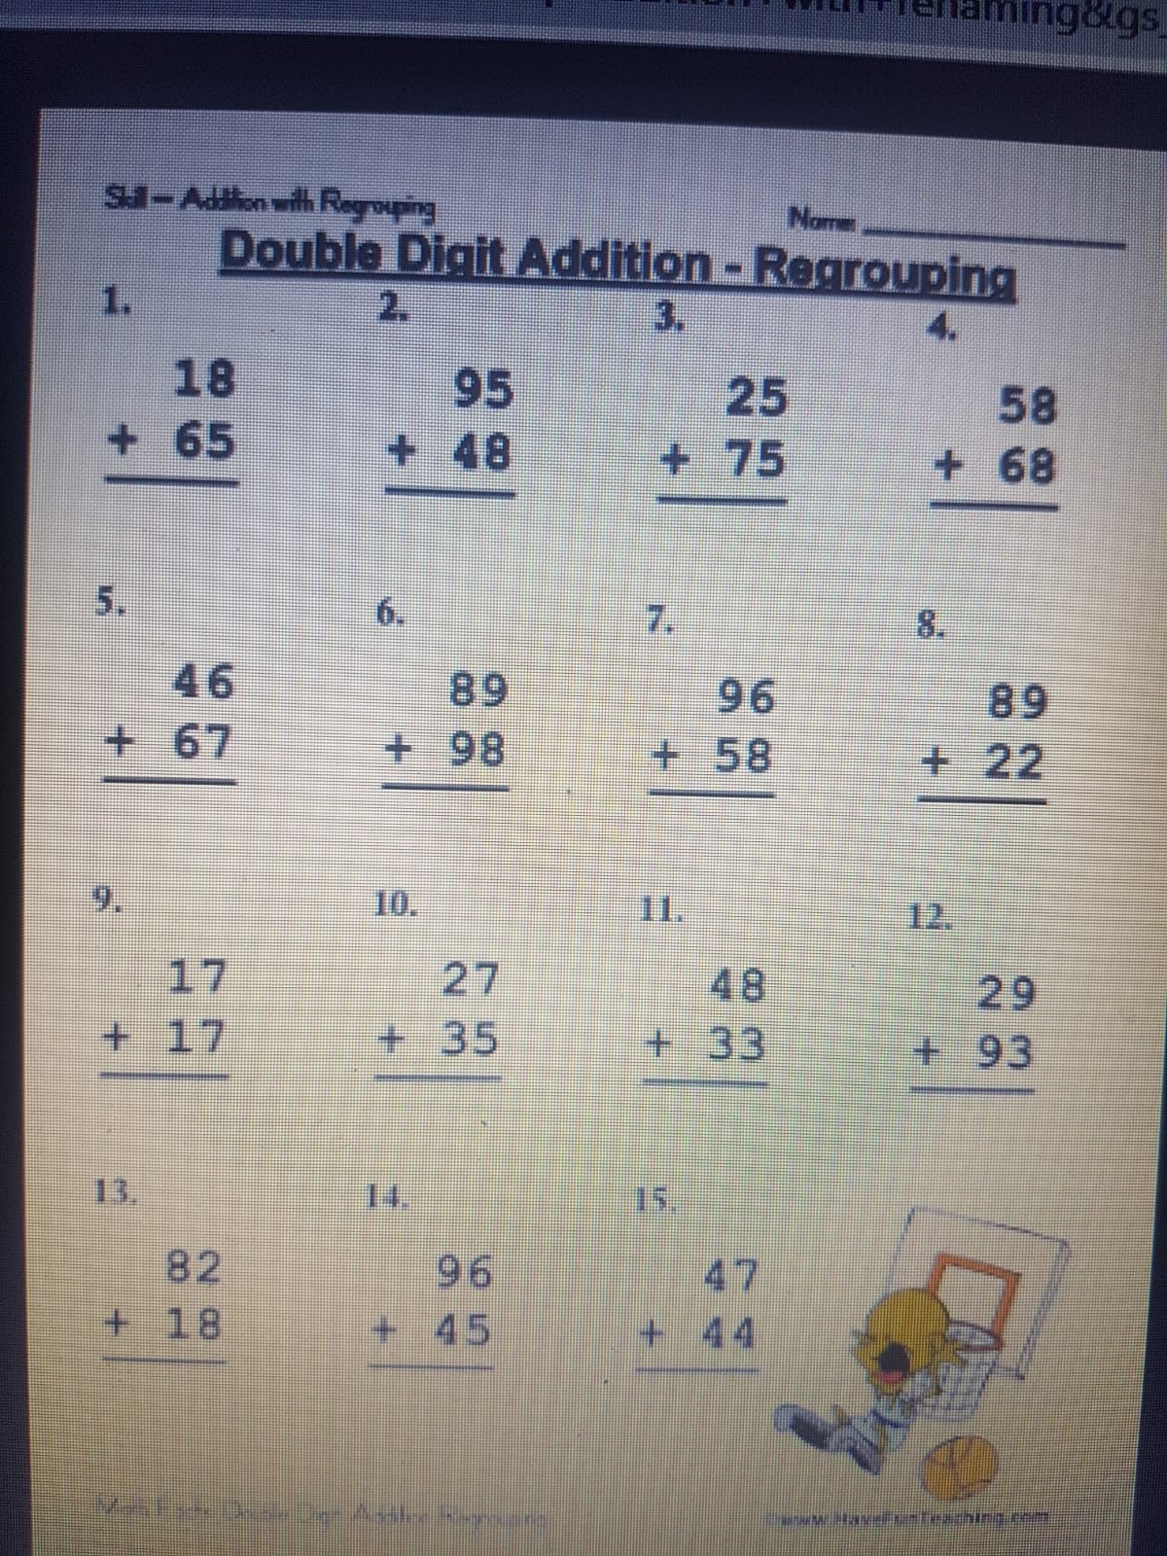

(SESE – Space)

