- Please note: Monday is a bank holiday. We have included some work for Tuesday but school was scheduled to be closed on Tuesday so this work is optional.
Subject | Monday  Bank Holiday | Tuesday | Wednesday | Thursday | Friday
Gaeilge  Revision materials and resource taken from a different Irish book – this allows the children to complete revision work at home. |  | Téama: Ócáidí Speisialta – Laethanta Saoire  Litriú (Spellings)  Bí ag Scríobh!  Críochnaigh na habairtí. Finish the sentences. Use the vocabulary provided. | Téama: Ócáidí Speisialta – Laethanta Saoire  Litriú (Spellings)  Bí ag Léamh!  Am don Léamh lth 56 & 57. Ag Surfáil. Léigh agus freagair na ceisteanna.  Online dictionaries  https://www.teanglann.ie/en/  https://www.focloir.ie/ | Téama: Ócáidí Speisialta – Laethanta Saoire  Litriú (Spellings)  Gramadach  Revise Briathra Neamhrialta (irregular verbs) Abair and Beir in the Aimsir Fháistineach (Future Tense)  Use the table to help you to fill in the blanks. Write and complete the sentences in your copy. | Téama: Ócáidí Speisialta – Laethanta Saoire  Litriú (Spellings)  Bí ag Scríobh!  Críochnaigh an scéal.  Write the story out and complete the sentences using the word bank provided.
English |  | Spellings (Unit 30)  Vocabulary: Complete the sentences from Activity G using words from the spelling list.  You can do all of Unit 30 if you wish in Spellbound.  Reading  Upside Down Worlds pgs.184, Books and Crooks pgs. 186-191  (https://edcolearning.ie/) | Learn Spellings  (Unit 30)  Poetry Activities:  Reading the poem, Kenny Had a Camera and completing the related activities pgs.184-185  Reading  Upside Down Worlds pgs.184, Books and Crooks pgs. 186-191  Continue reading novel | Learn Spellings  (Unit 30)  Grammar:  E.Y.E pg. 81  Phonics: Looking Closely at Words  Reading  Upside Down Worlds pgs.184, Books and Crooks pgs. 186-191  Continue reading novel | Spelling Test  (Unit 30)  Grammar: E.Y.E pg.81  Phonics: Vocabulary Development- Looking for smaller words.  Online dictionary  https://dictionary.cambridge.org/  Reading  Upside Down Worlds pgs.184, Books and Crooks pgs. 186-191  Continue reading novel
Subject | Monday | Tuesday | Wednesday | Thursday | Friday
Maths  Some revision resources not taken from Planet Maths |  | Learn Angles Chart  Angles  Planet Maths:  Activity A  Naming types of angles (acute, obtuse, right, straight, reflex)  Calculating the size of an angle in a triangle (add up known angles and take away from 180) | Learn Angles Chart  Angles  Planet Maths:  Activity B  Calculating the size of an angle in a quadrilateral (add up known angles and take away from 360)  Calculating the size of an obtuse angle along a straight line (add up known angles and take away from 180) | Learn Angles Chart  The Circle  Planet Maths:  Activity C  Naming the parts of a circle (diameter, radius, circumference, centre, arc)  Calculate the diameter of a circle, given the radius (Double the radius) | Learn Angles Chart  The Circle  Planet Maths:  Activity D  Calculate radius of a circle, given the diameter (Find half of the diameter)  Calculate the circumference of a circle given the diameter (multiply the diameter by 3.14)
 |  | Geography: Europe  Learn all about Europe (Countries, climate, famous landmarks)  Write about a time you visited a country in Europe or write about a country in Europe you would like to visit and explain why you would like to go there. | History / Geography:  The European Union  Read all about the European Union and learn:  What is the European Union?  Why was the European Union set up? | SPHE: Myself: Water Safety  Access the Primary Irish Water Safety Programme for Fifth and Sixth here: https://online.flowpaper.com/7efd0784/PAWS4ENGLISHWEB/#page=1  Focus on the topic of Water Safety on the Farm for this week.  We recommend that parents provide some support when children are engaging in the programme. | Art: Drawing / Painting / Collage  Draw / paint / collage: Create an imaginative piece based on a summer treat (ice pop, ice-cream, smoothie) Use any type of materials you have at home; crayons, paint, oil pastels, fabric, etc.

Gaeilge
Litriú (Spellings)
Day | Spelling | Translation
An Luan

An Mháirt | clár toinne  culaith fhliuch  an fharraige | surf board  wet suit  the sea
An Chéadaoin | ceamara digiteach  tonn mhór  ag surfáil | digital camera  a big wave  surfing
An Déardaoin | grianghraf  ag déanamh gaisce  bhuail | photograph  boasting/showing off  to hit

- Tuesday: Bí ag scríobh!
Thuirling (dismount) Scrúdaigh (examine) Shleamhnaigh (slip)

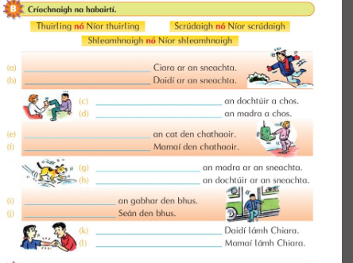

- Wednesday: Bí ag Léamh: Am don Léamh lth 56 & 57

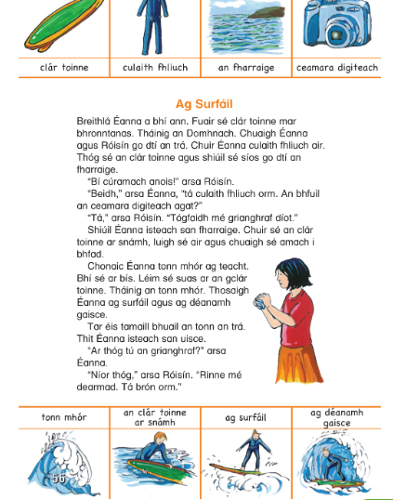

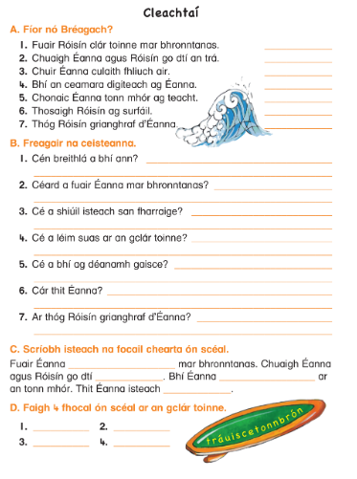

- Thursday: Gramadach: An Aimsir Fháistineach: Na Briathra Neamhrialta
The Future Tense: Irregular verbs. Use the table to fill in the blanks.
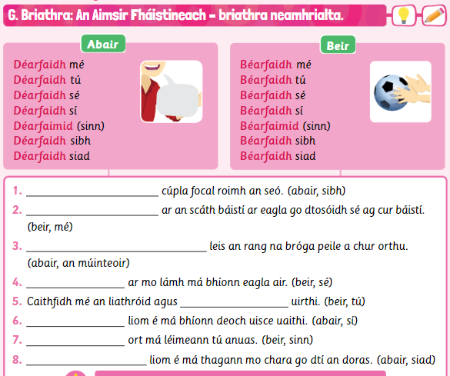
- Friday: Bí ag scríobh!
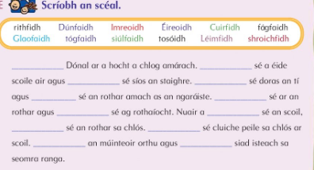

English
Spelling List: Spellbound pg 62-63 (Unit 30) Commonly Misspelled Words
Monday | Tuesday | Wednesday | Thursday
eighth  enemy  fiery  genius | heroes  clothing  muscle  shining | safety  twelfth  weather  young | which  advice  calendar  potatoes

Reading for the week: Upside Down Worlds: Kenny Had a Camera (Unit 42)
Books and Crooks (Unit 43)
- Tuesday: Vocabulary (You can complete the full unit in your workbook if you wish) Write these sentences into your copy and fill in the missing word using the spelling 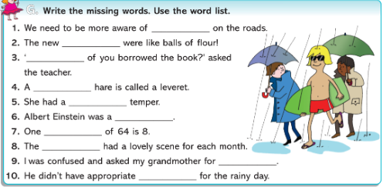
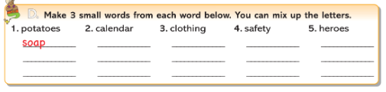

- Wednesday: Activities based on the poem Kenny Had a Camera pg.184

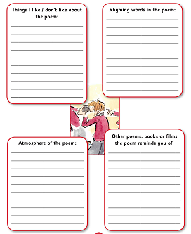

- Thursday: Phonics: Looking Closely at Words: Exercise Your English pg. 81
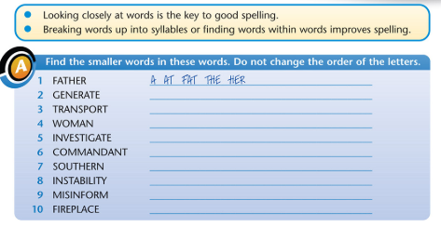
- Friday: Comprehension: Vocabulary Development; looking for smaller words within a larger word.

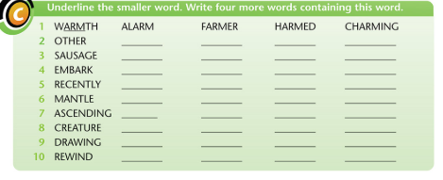

Maths:
Shape and Space: Angles / The Circle
To learn:
Diagram | Name | Angle
 | all triangles | 180°
 | all quadrilaterals | 360°
 | circle | 360°
 | pentagon | 540°
 | straight line | 180°
 | a full rotation | 360°

- Tuesday: Angles: Name the angles / Angles in triangles

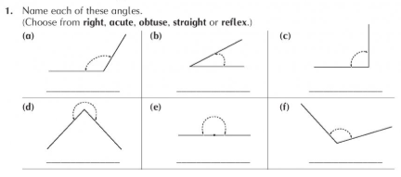

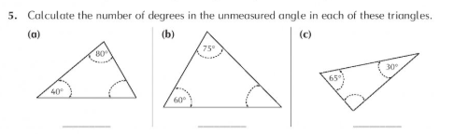

- Wednesday: Angles: Angles in quadrilaterals and straight lines

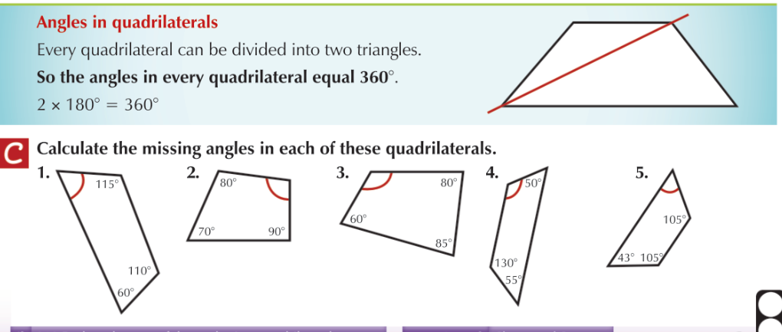

- Remember: There are 180° in a straight line.

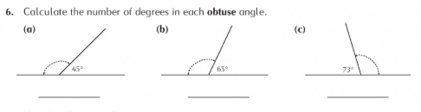

- Thursday: The Circle: Name the parts of a circle / Finding diameter

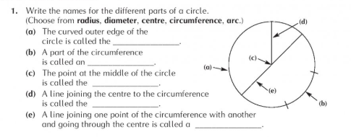

- Remember: The diameter of a circle is twice (double) the length of the radius

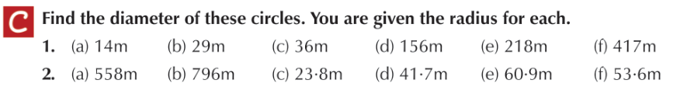

- Friday: The Circle: Find the radius / Find the circumference

- Remember: The radius is half the length of the diameter.

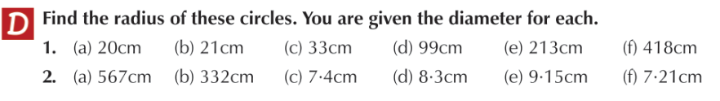

- Remember: Multiply the diameter by 3.14 to find the circumference of a circle.
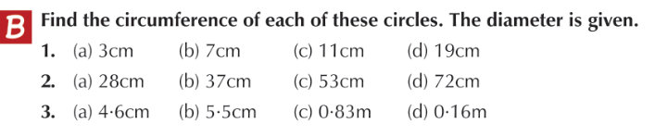
Tuesday: Geography
Read all about Europe
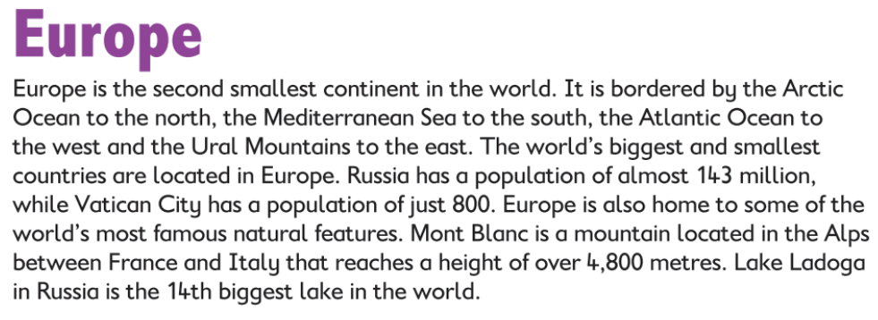
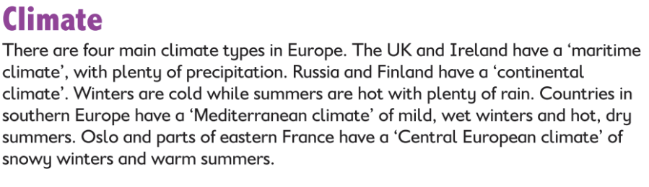
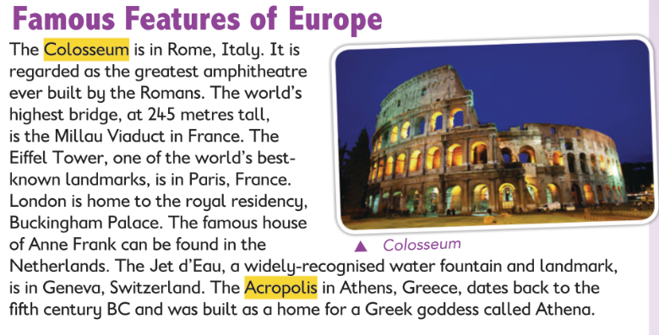
Questions
- Have you ever visited a European country? Describe your visit OR What European country would you like to visit? Explain why you would like to visit there.

Wednesday: Geography / History
Learn all about the European Union
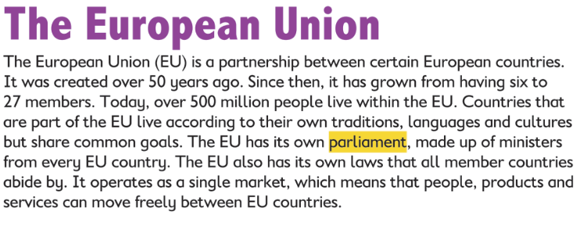
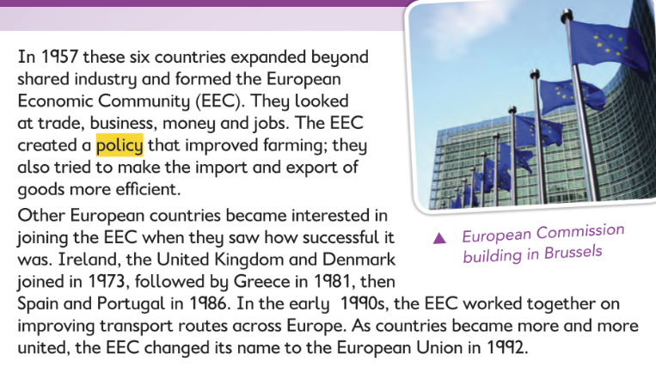
Thursday: SPHE
Water Safety
It’s very important to know how to take care of yourself and others around water. Access the Irish Water Safety programme for Fifth and Sixth Class here:
https://online.flowpaper.com/7efd0784/PAWS4ENGLISHWEB/#page=1
The pdf file is also available in Google Classroom. Please don’t print the document as it is quite long, the children should be able to read it online on a phone, tablet or laptop. Focus on the second section: Water Safety on the Farm.
Test your knowledge and take part in some of the online interactive activities here: http://paws.edco.ie/fifth-and-sixth-classes/

Friday: Art
Design your own summer treat: ice pops / ice-creams / smoothies. You can use any materials available to you. Here are some pictures to give you some ideas. Don’t forget to send us in pictures of your creations!
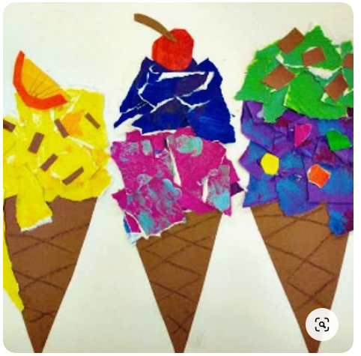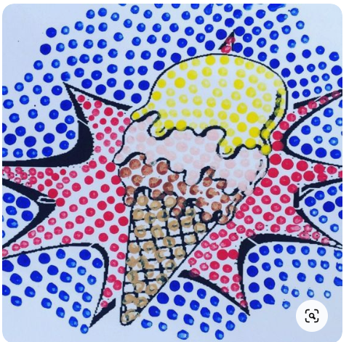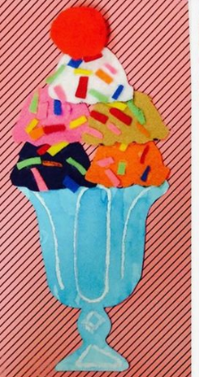
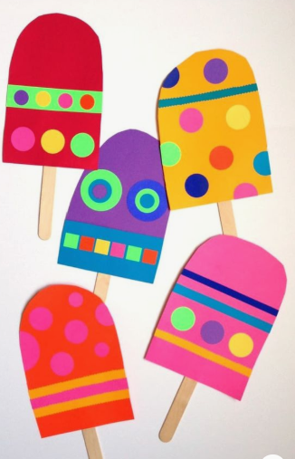
This doesn’t have to be an art activity. Look up some fun summer recipes online, if you would prefer, and learn to make a tasty new treat!

