Subject | Monday | Tuesday | Wednesday | Thursday | Friday
Gaeilge | Téama: Caitheamh Aimsire  Le foghlaim (Learn and spell):  Briathra Neamhrialta | Téama: Caitheamh Aimsire  Revise Briathra Neamhrialta list.  Bí ag caint!  Talk about your favourite hobbies. Explain your likes, dislikes and preferences. Write 8 sentences using the sentence structure. | Téama: Caitheamh Aimsire  Revise Briathra Neamhrialta list.  Bí ag scríobh!  Design a poster for a sports centre. Include available activities, price of tickets and opening hours. Don’t forget to name the sports centre. | Téama: Caitheamh Aimsire  Revise Briathra Neamhrialta list.  Bí ag Scríobh!  Write a short story about Sports Day. Start your story with the paragraph you learned in school. (Dhúisigh mé go moch ar maidin…)  Use the words and sentences and the Am don Léamh story to help. | Téama:  Caitheamh Aimsire  Revise Briathra Neamhrialta list.  Am don Léamh  Read and answer the questions.  (Also available online at folens.ie)  Online dictionaries  https://www.teanglann.ie/en/  https://www.focloir.ie/
English | Learn Spellings  Vocabulary: Write the sentences from Activity A and complete the sentences using words from the spelling list  Reading  By the North Star: Marshmallow Skye pg 154  (The class reader is available at https://edcolearning.ie/)  Choose a novel to read. | Learn Spellings  Grammar: Definite and indefinite article.  a, an or the?  Reading  By the North Star pg 155  Continue reading novel of choice. | Learn Spellings  Writing: Write a letter to your teacher telling her about your favourite hobbies. **Don’t forget that you can type it in a word document and attach it as a file in Google Classroom if you wish.  Reading  By the North Star pg 156  Continue reading novel of choice. | Learn Spellings  Vocabulary Development  Match the words to the correct meaning. Use your dictionary to help.  Online dictionary  https://dictionary.cambridge.org/  Reading  By the North Star pg 157  Continue reading novel of choice. | Learn Spellings / Spelling Test  Comprehension  Complete the comprehension questions based on the reading Marshmallow Skye pg 154-157  Online dictionary  https://dictionary.cambridge.org/  Reading  By the North Star pg 154 – 157 Revise all  Continue reading novel of choice.
Subject | Monday | Tuesday | Wednesday | Thursday | Friday
Maths | Tables: x12  Learn Fractions, Decimals and Percentages chart.  **See power points in Google Classroom for help if needed  You Tube  https://www.youtube.com/watch?v=gLWphGTjGHI  https://www.youtube.com/watch?v=gLWphGTjGHI&feature=emb_logo | Tables: x12  Learn Fractions, Decimals and Percentages chart.  Activity C  Fractions: Mixed numbers and improper fractions  Power point available | Tables: x12  Learn Fractions, Decimals and Percentages chart.  Activity D Fractions:  Addition and subtraction  Power point available | Tables: x12  Learn Fractions, Decimals and Percentages chart.  Activity E Fractions:  Addition and subtraction | Tables: x12  Learn Fractions, Decimals and Percentages chart.  Activity F  Fractions:  Finding a fraction of a whole number.
Other Lessons | History: The Famine  See ‘The Great Famine’ power point in Google Classroom for information.  Complete cloze exercise. | Religion: The Eucharist: The Mass  The Mass: Read the piece about the Mass and write a reflection piece.  Reflection: Draw or write about one way that you will use a gift that God has given you to bring joy or comfort to someone you know. | Geography: Famine Today  See the ‘Famine Today’ power point in Google Classroom.  Answer the questions about famine in today’s world. | SPHE: Taking care of myself  Complete exercise about changing negative thoughts to positive thoughts. | Art: Drawing / Colouring  Draw a clown with Don Conroy on You Tube.  https://www.youtube.com/watch?v=7CRFX5zUdbk  Spring colouring

Gaeilge: Téama: Caitheamh Aimsire: Spóirt
- Monday: Le foghlaim (To learn): Briathra Neamhrialta
 | Inné | Amárach | Gach lá
to be | Bhí | Beidh | Bíonn
to see | Chonaic | Feicfidh | Feiceann
to go | Chuaigh | Rachaidh | Téann
to say | Dúirt | Déarfaidh | Deireann / Deir
to get | Fuair | Gheobhaidh | Faigheann
to make/do | Rinne | Déanfaidh | Déanann
to hear | Chuala | Cloisfidh | Cloiseann
to eat | D’ith | Íosfaidh | Itheann
to grab/catch | Rug | Béarfaidh | Beireann
to come | Tháinig | Tiocfaidh | Tagann
to give | Thug | Tabharfaidh | Tugann

- Tuesday: Bí ag caint!
(Talk about your favourite hobbies. Explain your likes, dislikes and preferences. Write 8 sentences using this vocabulary.)

Ceist: Cén caitheamh aimsire atá agat?

Is maith liom a bheith ag… I like to…
Ní maith liom a bheith ag… I don’t like to…
Is fearr liom a bheith ag… I prefer to…

Foclóir
ag péinteáil | ag imirt iománaíochta | ag léamh | ag éisteacht le ceoil | ag féachaint ar an teilifís | ag dreapadóireacht
ag snámh | ag imirt peile | ag imirt leadóige | ag imirt cluichí ríomhaire | ag surfáil ar an idirlíon | ag féachaint ar you tube / Tik Tok / Instagram

- Wednesday: Bí ag scríobh!

Design a poster for a sports centre.

- Ainm an t-ionad gníomhaíochta (name of the activity centre)
- Céard iad na gníomhaíochtaí atá ar siúl (what activities are on?)
- Cén praghas atá ar na ticéidí? (what price are the tickets?)
- Céard iad na huaireanta oscailte? (what are the opening hours?)

- Thursday: Bí ag scríobh!
Lá Spóirt a bhí ann. Scríobh scéal beag. (It was Sports Day. Write a short story. Use the Am don Léamh Story to help.)

Tosaigh an scéal mar seo. (Start the story like this) - Dhúisigh mé go moch ar maidin. Léim mé amach as an leaba...

Foclóir

Bhí sceitimíní áthais orm mar lá spóirt a bhí ann.
Rás céad méadar – 100m race
Sa chéad áit – in first place
ar nós na gaoithe – as fast as the wind
Bhuaigh – won
Bonn óir – gold medal
Bonn airgid – silver medal
Sa dara háit – in second place
Sa triú háit – in third place
Bonn cré-umha – bronze medal
An léim árd – the high jump
Rás barra rotha – the wheelbarrow race
Bhí mé tuirseach traochta. – I was exhausted.
Bhí an-spóirt againn. – We had great fun.
Ní dhéanfaidh mé dearmad ar an lá sin go deo. – I will never forget that day.

- Friday: Am don Léamh
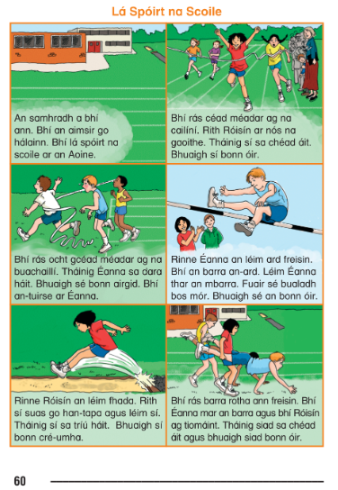

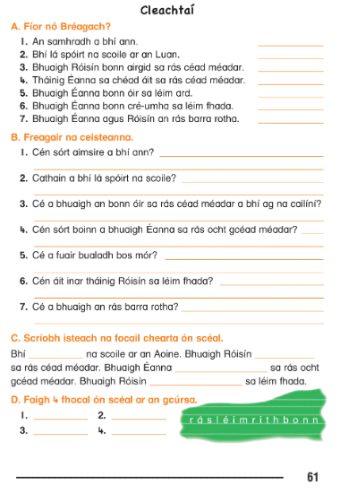
English
Spelling List
Monday | Tuesday | Wednesday | Thursday
history  memory  factory  victory | category  territory  directory  compulsory | secretary  necessary  ordinary  voluntary | library  military  temporary  dictionary

Reading for the week: By the North Star pg 154 – 157: Marshmallow Sky (Unit 34)

- Monday: Vocabulary
Write these sentences into your copy and fill in the missing word using the spelling list.
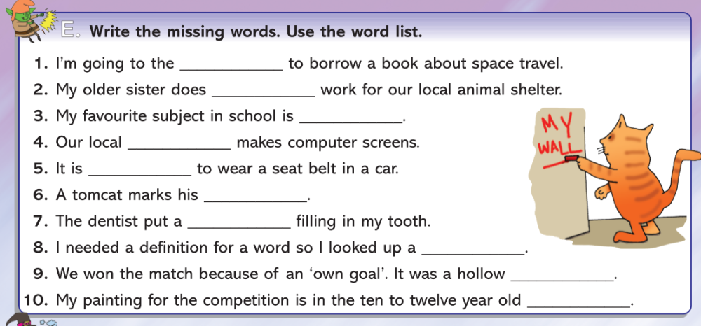

- Tuesday: Grammar: definite / indefinite article
Definite article: When writing about a specific noun, use the word the in front of the noun.
e.g. I lost the pen that my teacher gave me.
Indefinite article: Use a or an when writing about a non-specific noun.
e.g. I lost a pen in school.
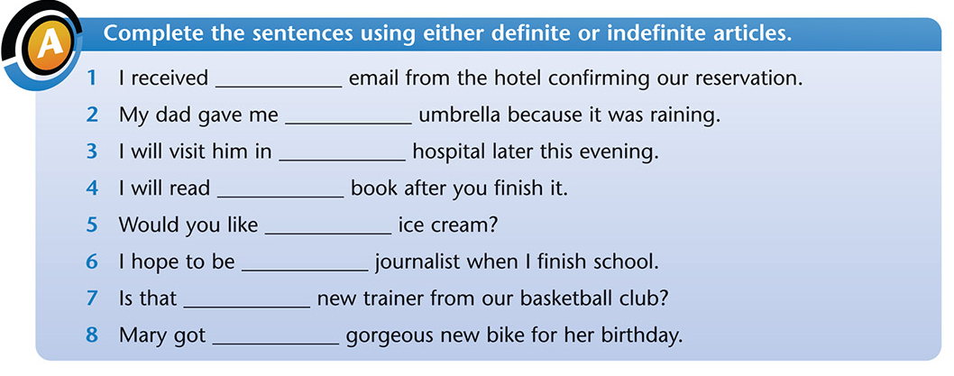
- Wednesday: Writing
Write a letter to your teacher telling her all about your favourite hobbies. Aim to write 12 sentences. Don’t forget to structure your writing in the correct letter format.

Structure of a letter

Address
Date
Dear Teacher,

(Main body of the letter – 2 paragraphs)

Yours sincerely,

Your name.

- Thursday: Vocabulary Development
Match the words to the correct meaning. Use your dictionary to help.
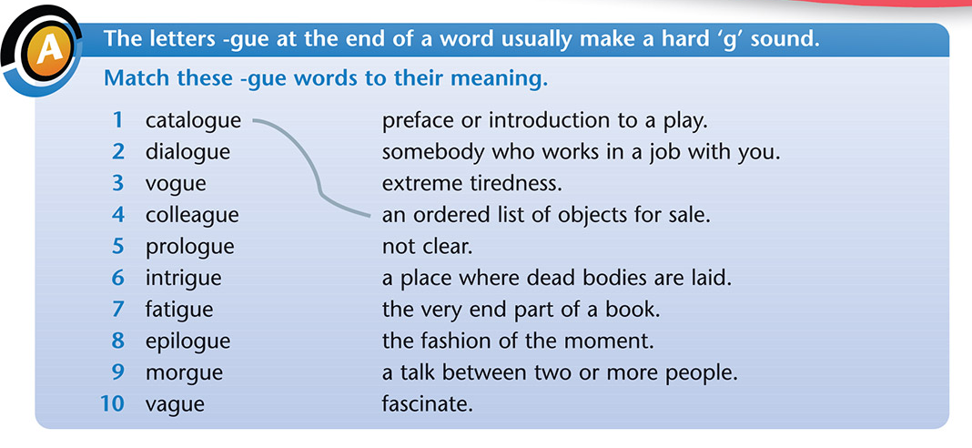
- Friday: Comprehension
Answer the comprehension questions based on the reading Marshmallow Skye found in class reader By the North Star pgs 154-157.
The reader is available online at https://edcolearning.ie/ if you don’t have your reader at home with you.

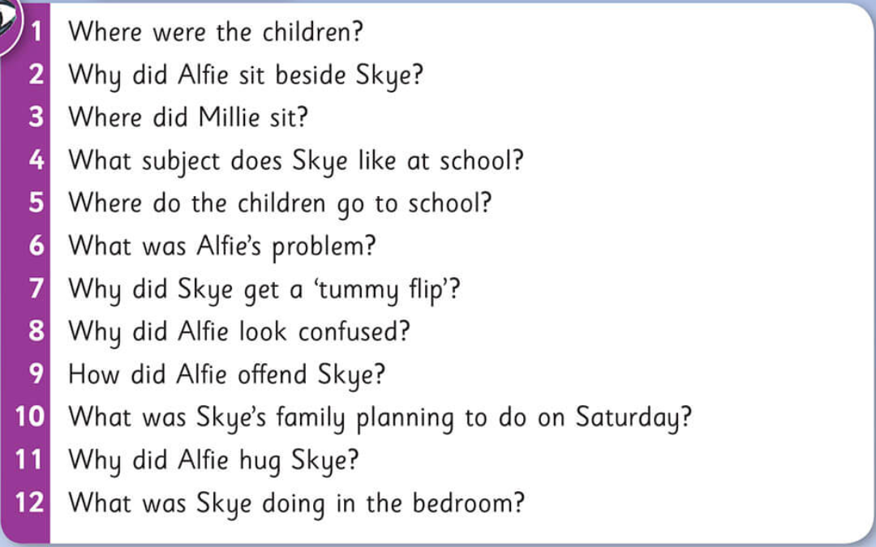
Maths
- Tables: x 12

- Monday: To learn: Fraction, Decimal and Percentage Chart

Fraction | Decimal | Percentage
1/6 | 0.166 | 16 2/3%
1/7 | 0.142 | 14 2/7%
1/8 | 0.125 | 12 ½ %
3/8 | 0.375 | 37 ½ %
5/8 | 0.625 | 62 ½ %
7/8 | 0.875 | 87 ½ %
1/9 | 0.111 | 11 1/9%
1/10 | 0.10 | 10%
1/20 | 0.05 | 5%

- Tuesday: Fractions
Instructions

- Change a mixed number to an improper fraction: “Go around in a circle” Multiply denominator by the whole number and add on the numerator.
- Change an improper fraction to a mixed number: “Divide the bottom into the top” Divide the denominator into the numerator. Any remainders should be put over the denominator as a fraction.
- Simplifying a fraction: Choose a number that will divide into both the top and bottom numbers.
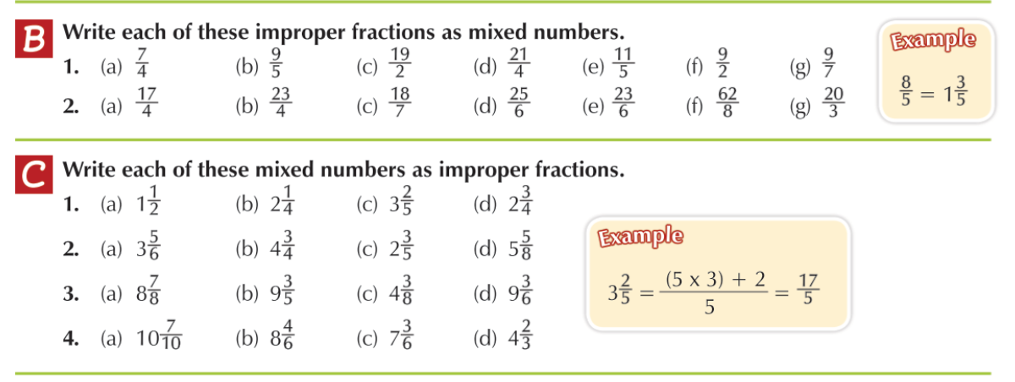
- Wednesday: Fractions: Addition and Subtraction
Find the lowest common denominator

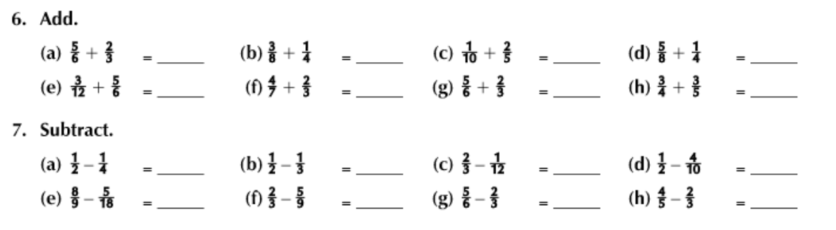
- Thursday: Fractions: Addition and Subtraction
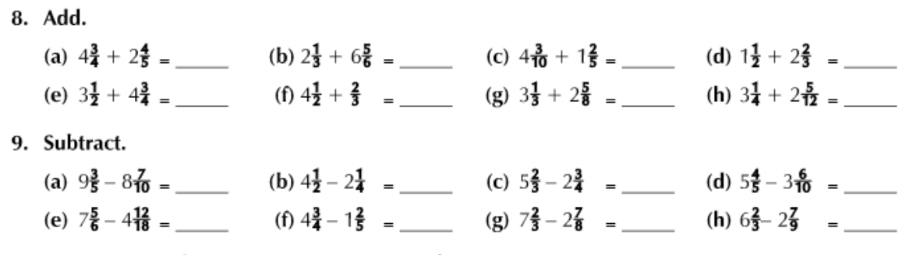

- Friday: Fractions: Find a Fraction of a whole number

Instructions
- To find a fraction of a whole number: “Divide by the bottom, multiply by the top” Divide the number by the denominator and multiply the answer by the numerator
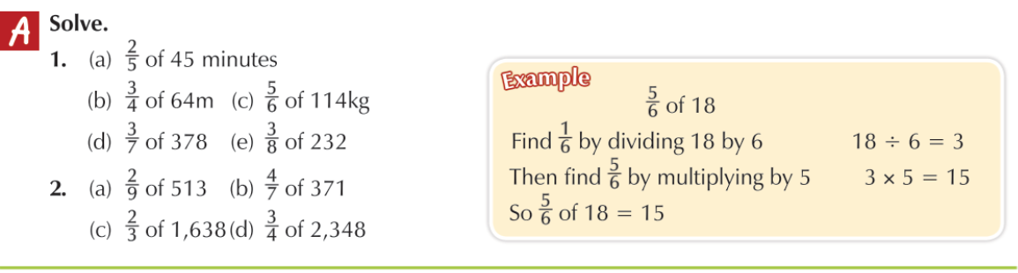

Monday: History: The Famine
Write out the cloze exercise. See power point ‘The Great Famine’ in Google Classroom for more information about the Irish Famine.
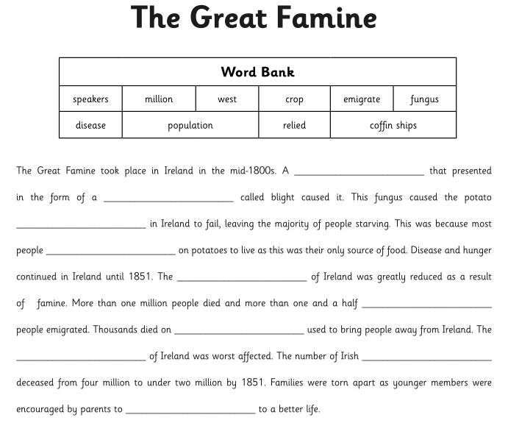
Tuesday: Religion: The Eucharist: The Mass
Read this piece about the Mass.
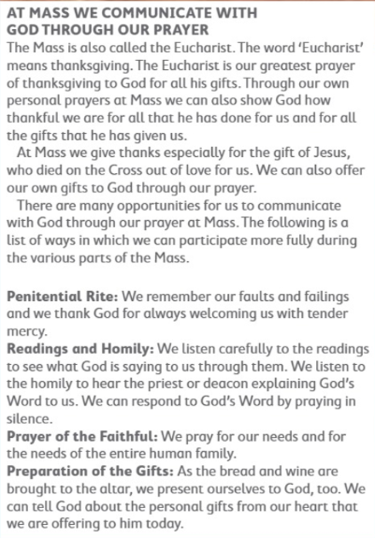

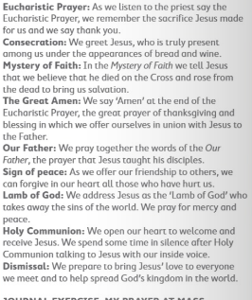
Reflection: Draw or write about one way that you will use a gift that God has given you to bring joy or comfort to someone you know.

Wednesday: Geography: Famine Today
Look at the power point ‘Famine Today’ in Google Classroom and answer the following questions in your copy.

- What is famine?
- What are the causes of famine in the world today?
- Name three effects of famine in the world today?
- What do charities and other organisations do to help people suffering from famine?
- ‘Climate change is a cause of famine’. Explain why you agree or disagree with this statement.

Thursday: SPHE
Taking care of myself: Changing negative thoughts to positive thoughts.
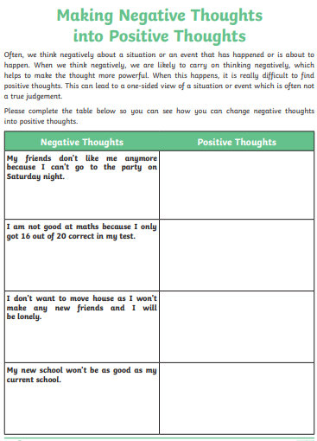
Friday: Art
Draw a clown with Don Conroy on You Tube: https://www.youtube.com/watch?v=7CRFX5zUdbk
Spring colouring
