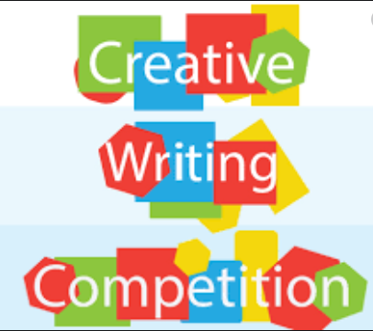

It’s competition time!!

I am inviting you to take part in a writing competition. Choose one of the following titles and write a story. Your story can be typed or handwritten and you can include illustrations if you wish. There is no word count limit but please watch spellings, punctuation and remember to include paragraphs.
BEST OF LUCK!
Please submit your entries by Thursday at 12pm either on Google Classroom or directly to my email.

Title 1: My greatest accomplishment

Title 2: If I was the President, I would…

Title 3: The homework machine

Title 4: What I like about my neighbourhood

