Monday 25th May 2020

English/Language:
English Poetry: My Adventure – read the poem written by a 10-year old girl called Mairéad and complete the 4 activities below. In Part 4 you are asked to write your own ‘My Adventure’ poem.
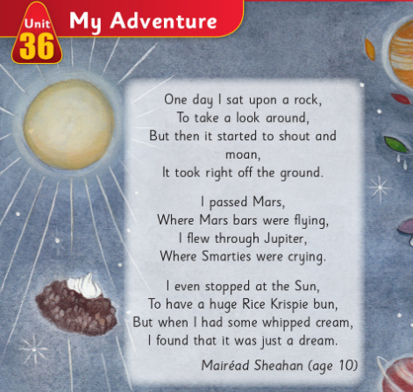

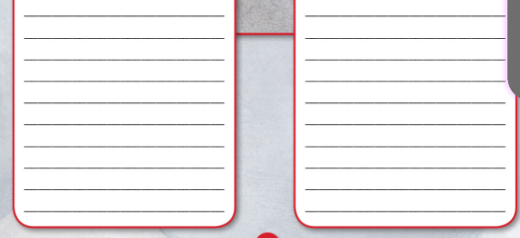
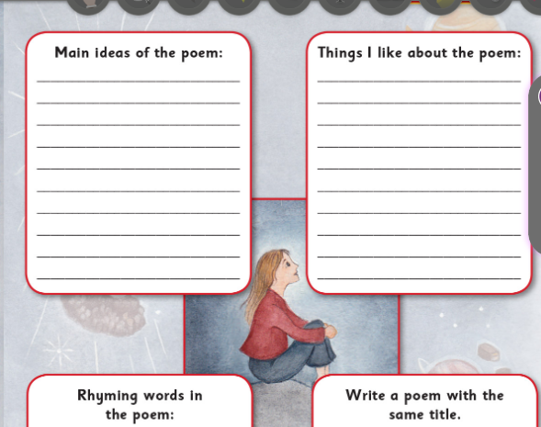

Spellbound: List 1. (A + B)
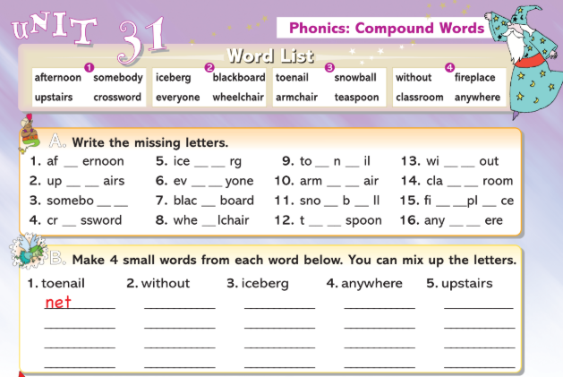

Maths/Numeracy:
Mental Maths:
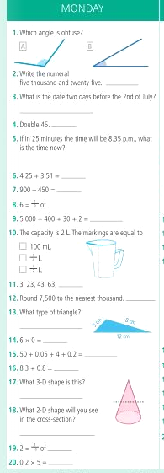

Tables:
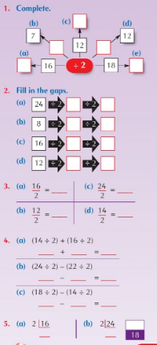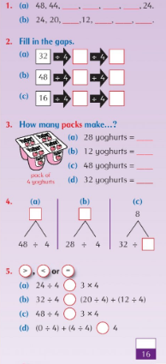

Maths Topic: 3D Shapes – face, vertex and edge of 3D Shapes
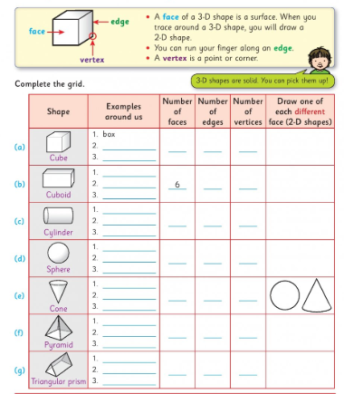
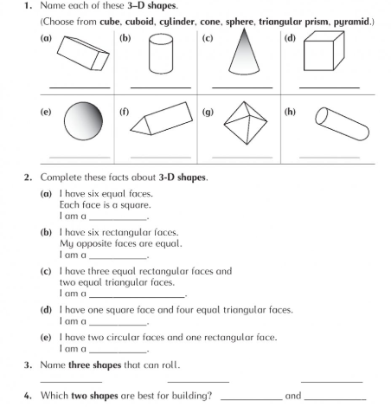
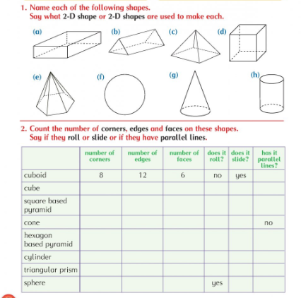
Gaeilge:
Ceartlitriú: Aonad 29 Rás na Lachán (the duck race) Bosca Gorm
Uimhir= number Déan deifir= hurry up Bhuaigh mé= I won
Droichead= bridge sruthán= stream Shéid me= I blew Stallaí= stalls
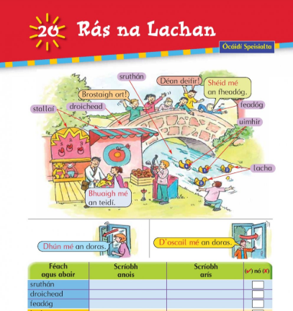

Bun go Barr: Cén Saghas Lae Atá Ann? (what sort of day is it?) B – Scríobh an Scéal
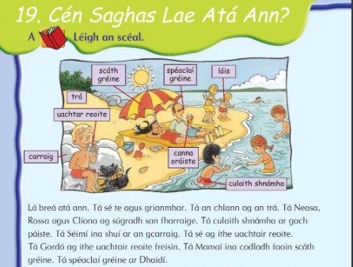
Carraig= rock trá= beach lóis= lotion/sun cream culaith shnámha= swimming togs
B – Scríobh an scéal – write the story using the words from the word bank
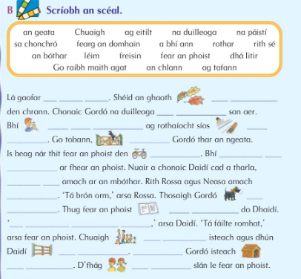

SESE: History
A video from the Small World multimedia files has been added to your work this week. You may find it helpful to watch the video before beginning this task.
Read the following pages on Tuatha Dé Dannan and answer Q1-6 from part A below. 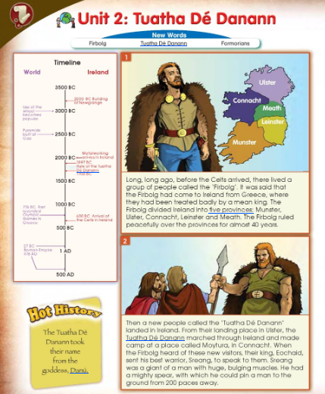
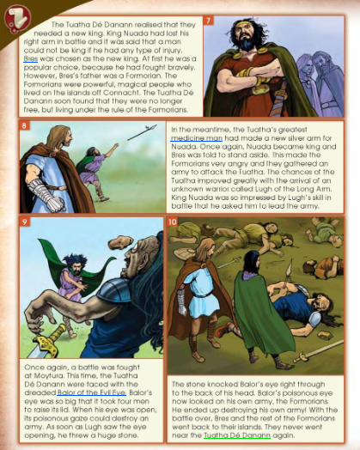
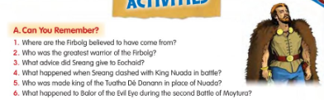

Tuesday 26th May 2020

English/Language:
English Comprehension: Read through the services guide and answer 7 of the 10 questions below in Part A
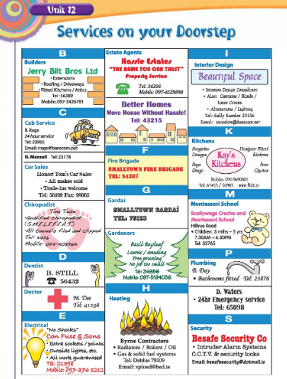
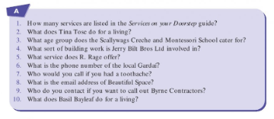

Spellbound: List 1-2. (C + D)
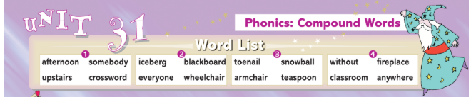
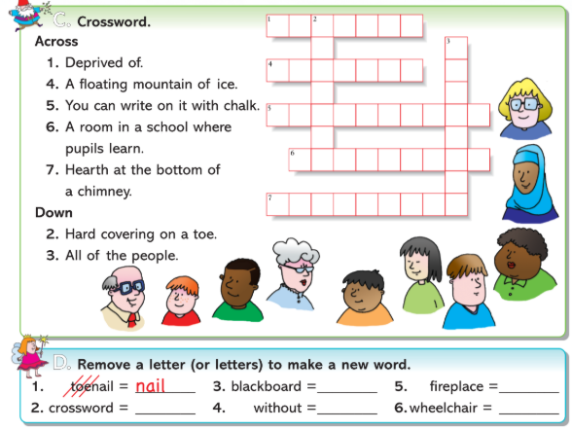

Maths/Numeracy:
Mental Maths:
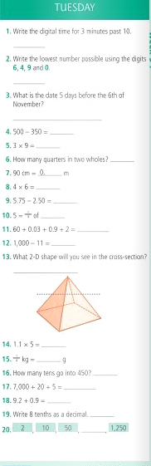

Tables:
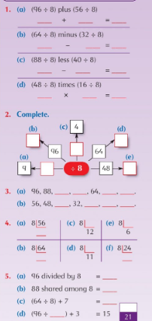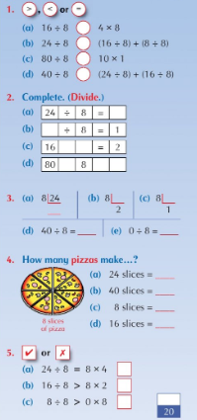

Maths Topic: 3D Shapes - Pyramids
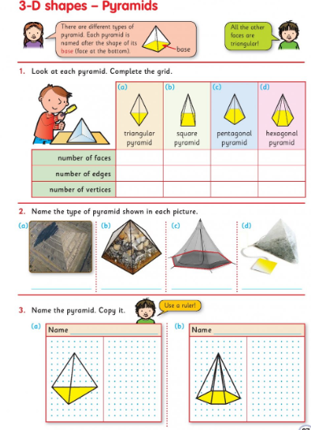
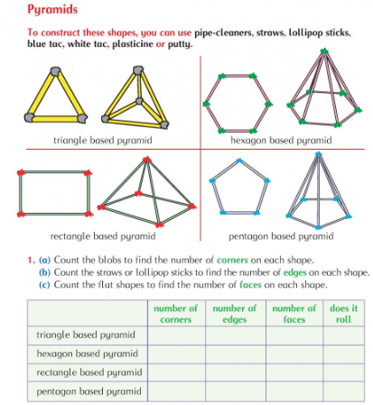

Gaeilge:
Ceartlitriú: Bosca gorm arís agus A- Scríobh na focail (write the words)
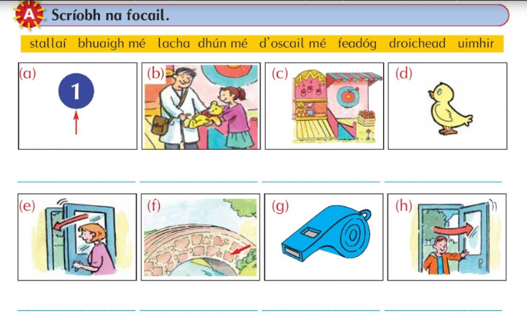
Bun go Barr: léigh an scéal agus D – Cén saghas lae atá inniu?
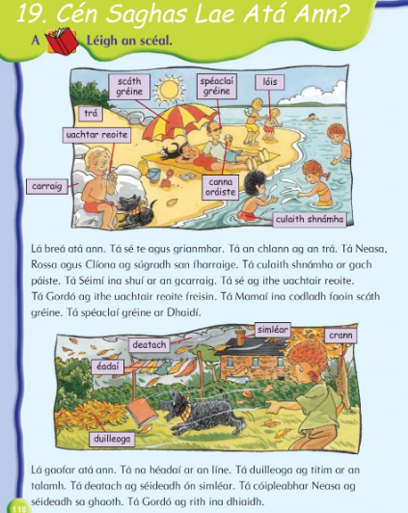

Duilleoga= leaves éadaí= clothes deatach= smoke ag titim= falling
ag séideadh= blowing sa ghaoth= in the wind

Cén saghas lae atá inniu? (what sort of day is it today? Read the sentences and fill in the missing word from the word box. Draw a picture to match each story)
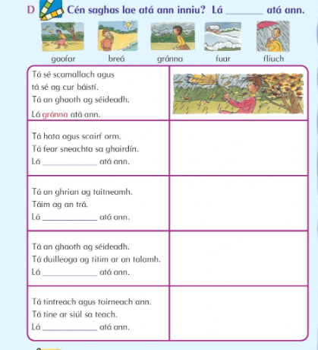

SESE: History
Read the following three pages on Tuatha Dé Dannan and answer Q1-4 from part B below (choose the correct answer)

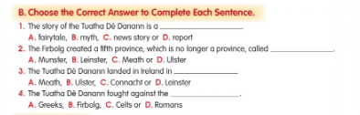

Wednesday 27th May 2020

English/Language:
English Comprehension: Read through the Services guide and answer 7 of the 10 questions below in Part B.
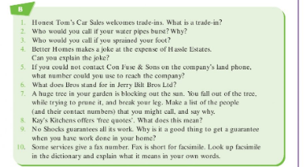
Spellbound: List 1-3. (E + H)
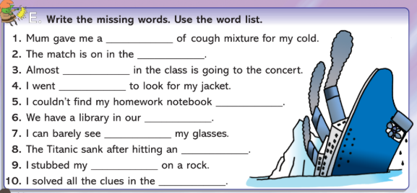
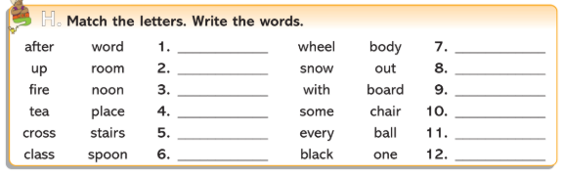

Handwriting/Write Here:
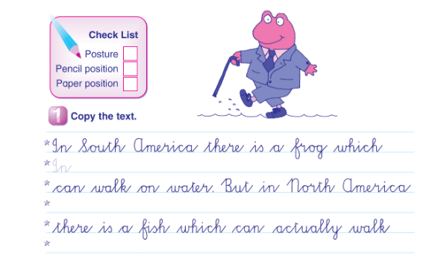
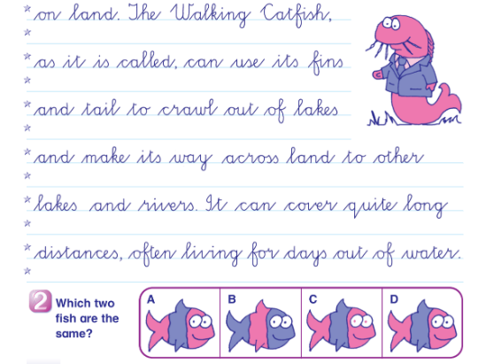

Maths/Numeracy:
Mental Maths:
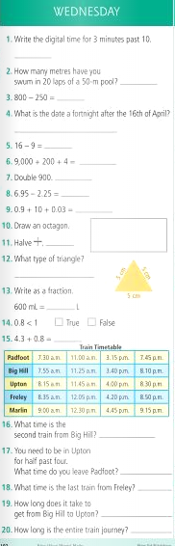

Tables:
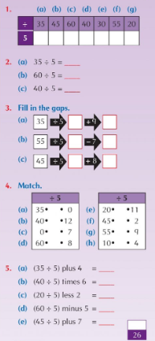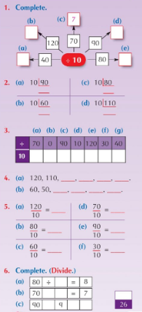

Maths Topic: 3D Shapes - Prisms
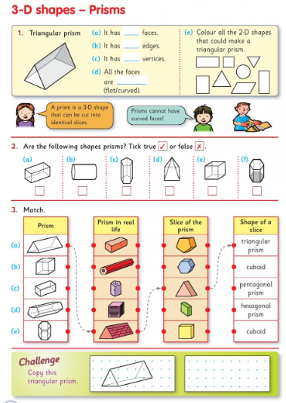
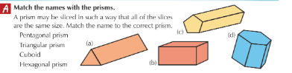

Gaeilge:
Ceartlitriú: Bosca Gorm agus Bosca Buí. B – Brís an cód (crack the code) Scríobh (write)
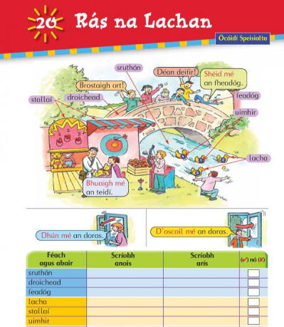
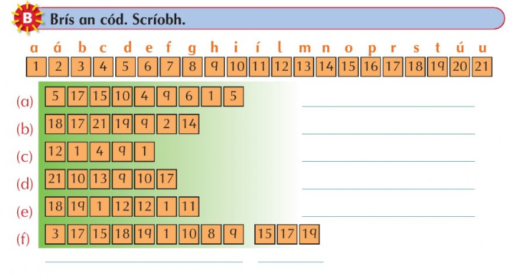

Bun go Barr: léigh an scéal agus G
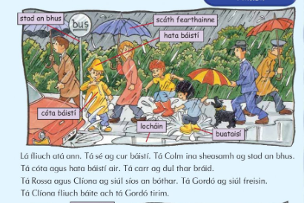
Lacháin= puddle ag cur báistí= raining ina sheasamh= standing
Ag dul that braid= going passed fliuch báite= saturated/very wet
Ceangail (match) agus scríobh na habairtí i do chóioleabhar (write the sentences into your copy)
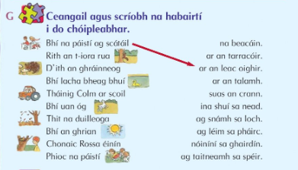

SESE: History:
Re-read the following three pages on Tuatha Dé Dannan and answer 1-5 part C – think about.

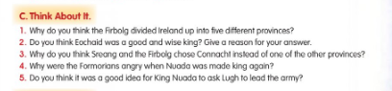

Thursday 28th May 2020

English/Language:
English Poetry: The Morag. Read the poem carefully and visualise the descriptions. Answer Q1-6 below – you do not have to answer the 7th question.
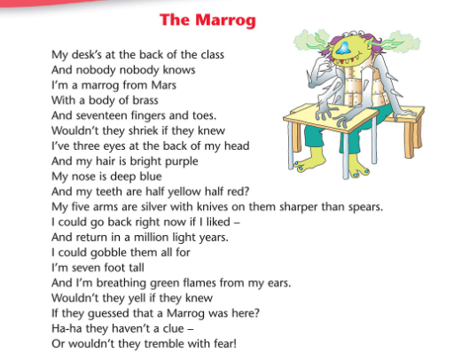
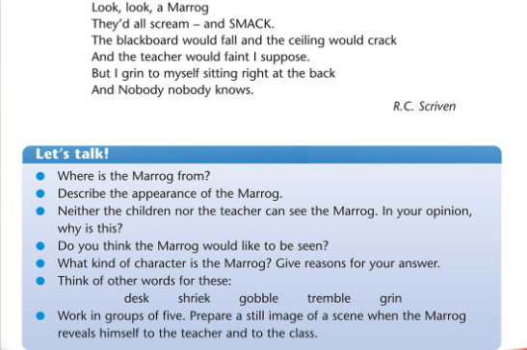
Spellbound: List 1-4. (F + G)
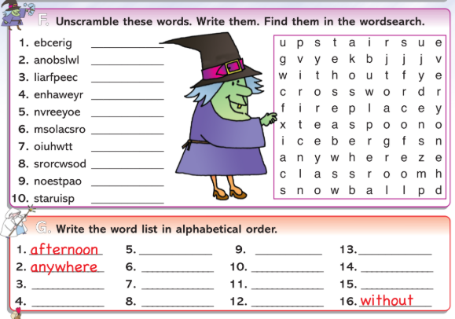

Maths/Numeracy:
Mental Maths:
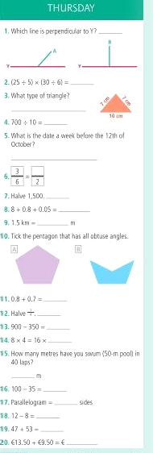

Tables:
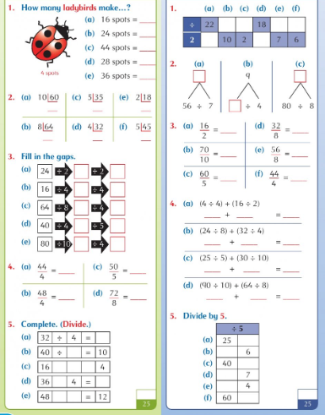

Maths Topic: 3D Shapes – Nets of various 3D shapes
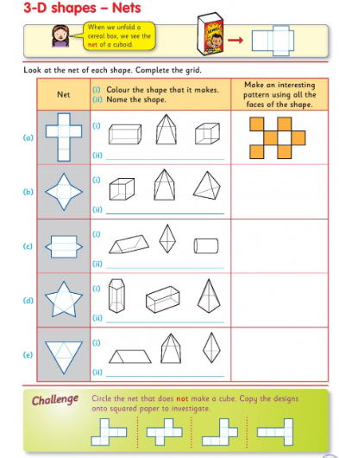
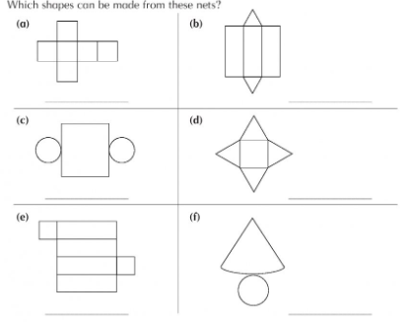
Pick 3 of the nets below to copy and cut out
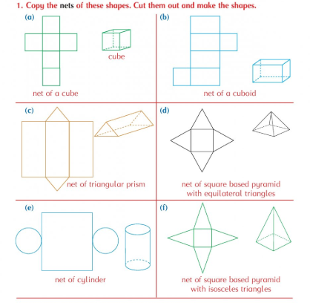

Gaeilge:
Ceartlitriú: Bosca Gorm agus Bosca Buí. C- Cuir an litir cheart i ngach bosca (put the correct letter into each box)
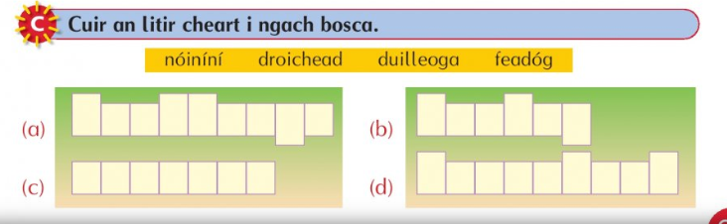

Bun go Barr: léigh an scéal agus B
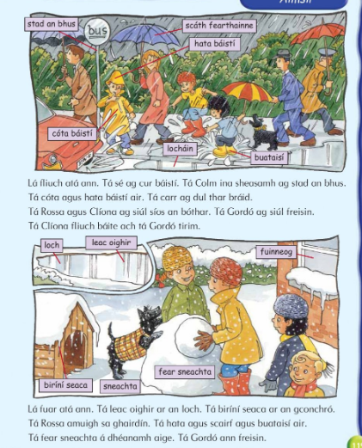
Loch= lake leac oighir= ice biríní seacha= icicles
amuigh sa ghairdín= out in the garden
H – tá biríní seaca ar an gcronchró - there are icicles on the kennel. Read the sentences and fill in the missing words.
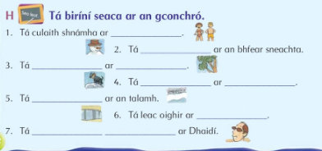

P.E:
Go Noodle – a wide range of activities can be discovered in the categories section https://app.gonoodle.com/categories
Joe Wicks is doing daily PE classes on his YouTube channel https://www.youtube.com/channel/UCAxW1XT0iEJo0TYlRfn6rYQ
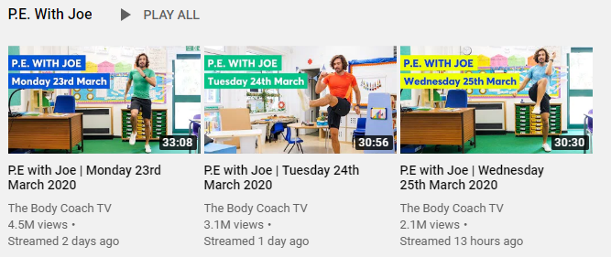
A guided workout to stay active at home https://www.youtube.com/watch?v=L-8wW40jTzc
For GAA enthusiasts why not attempt the 200 touches daily challenge
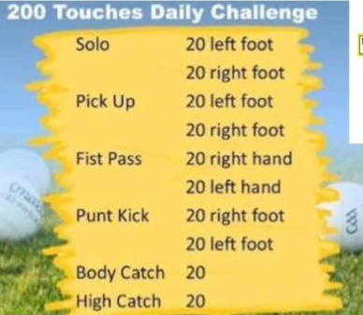

Religion:
read the Parable of the Unforgiving Servant and complete the discussion and the activity below.
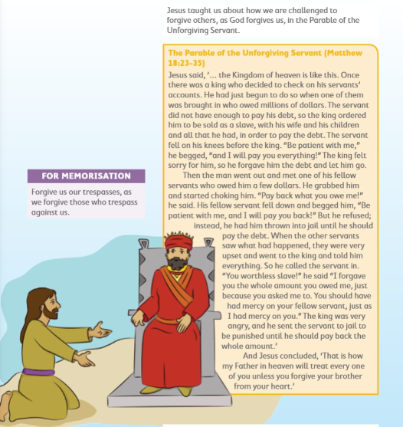
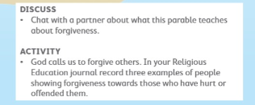

Friday 29th May 2020

English/Language:
English: Phonics – Syllables (you may find the Syllables PowerPoint from last week helpful)
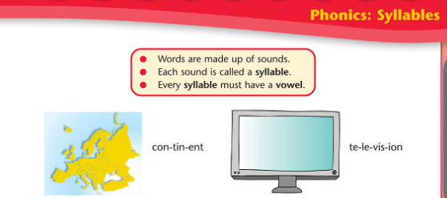
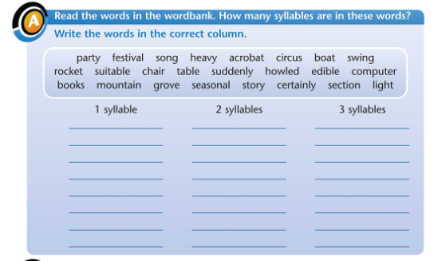
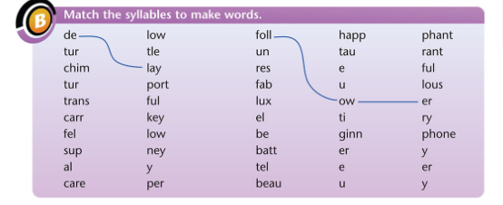
English Spellings/Spellbound: Ask an older sibling or an adult to quiz you on your spellings from this week. Write out all 16 spellings today. Keep a record of your score.

Maths/Numeracy:
Mental Maths:
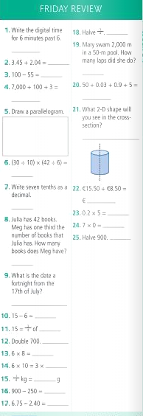
Tables:
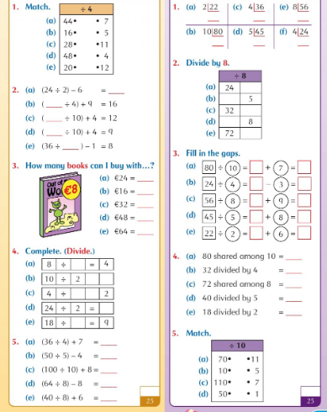

Maths Topic: 3D Shapes – Check-up
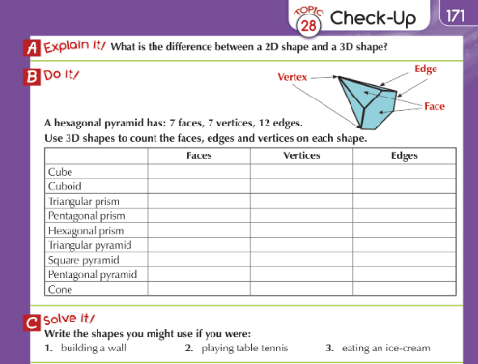
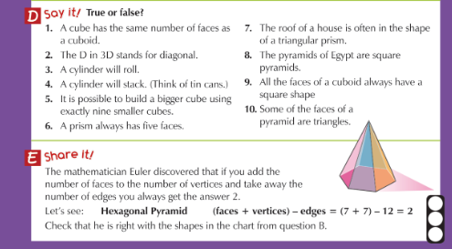

Gaeilge:
Gaeilge Spellings/Ceartlitriú: Ask an older sibling or an adult to quiz you on your spellings from this week. Write out all 6 words. Keep a record of your score.
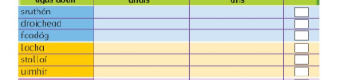
Bun go Barr: léigh an scéal agus J

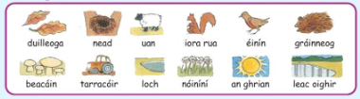

Cuir na focail seo sna boscaí thíos – fill in the mssing words from the word bank below
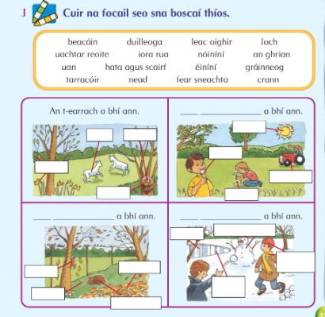

Art: From the Religious theme of ‘Forgiveness’; design a poster to demonstrate the Parable of Unforgiving Servant.

