Tuesday 2nd
Please remember that these activities are not mandatory. You can pick and choose different activities you wish to do each day. You don’t have to do every activity every day! We just want to give you lots of different activities and ideas. You choose what will suit you best. Feel free to send back any pictures or work that your child has done if you would like to but again, you don’t have to! If you have any questions about anything just send us an email!

Ms Denieffe and Ms O’Neill
Subject | Activity
English | - We are looking at the long oo sound in spellings this week  - Watch these videos to revise the sounds - https://www.youtube.com/watch?v=Dbvp5ZNxabI https://www.youtube.com/watch?v=TdM2LUkBQzk https://www.youtube.com/watch?v=kL074H5XdNI  - Make a list of long and short oo words (Ms O’Neills class can use page 72 Sounds Like Phonics book for this activity, Ms Denieffe’s class can record these on a sheet or alternatively complete page 79 of Sounds in Action (located on page 3 of this document)  - Words (Week 1st June)  - Spellings Week 30 - You can look at exercises 1&2 (located on page 4 of this document)  - Reading – All our class readers for the year are available on the Edco website. https://www.edcolearning.ie/User/Login  - You can choose other books from Collins Big Cat e- readers at: https://connect.collins.co.uk/School/Portal.aspx?ReturnUrl=%2fschool%2fporal.aspx
Maths | Time  - If you follow this link it will bring you to an online clock where you can change the time -https://www.roomrecess.com/Tools/InteractiveClock/play.html  - If you click “lock” on the minute hand it will prevent it from moving while you change the hours  - Ask your child to show you a number of different hours  - Sample questions – Time to get up, its 7 o’clock – can you show me 7 o’clock? School has ended, its 2 o’clock – can you show me 2 o’clock? Time for dinner, it’s 6 o’clock – can you show me 6 o’clock? Bed time, it’s 8 o’clock – can you show me 8 o’clock?  - You can swap and ask your child to choose a time and an activity you do at that time while you set the time on the clock. They can check to make sure there’s no mistakes made!
Gaeilge | An Scoil  - Listen to comhrá 1.1 and comhrá 1.2 in ceacht 1  - You could practice some of the phrases e.g. you knock on the door and child says “tá cnag ar an doras”, you wait to enter the room and child says “tar isteach”, once you are in the room child says “fáilte romhat isteach”  - Look at ceacht 2 and listen to the comhrá – your child should know “dia duit” and “dia’s Muire duit”  - Pretend you are going to do the rolla and see who is ‘anseo”  - Practice what to say if someone is/isn’t in school “tá Niamh ar scoil. Níl Niamh ar scoil”  - Listen to the amhrán with ceacht 1 “Is maith liom dul ar scoil” – try to sing along to some parts
SESE | Materials  - We are learning all about different materials this week  - Have a look around the room and spot different materials and point them out e.g. wood, glass, plastic, cardboard  - You can use the Materials PowerPoint in the resources folder to help you  - Go on a materials hunt in your house or outside – how many different materials can you find  - You could feel some of the different materials and compare their texture – do they feel different  - Place a selection of different materials on the table and ask your child to sort them e.g, put the plastic together
PE  Art | You can choose do to PE/Art any day of the week!  - Joe Wicks - https://www.youtube.com/channel/UCAxW1XT0iEJo0TYlRfn6rYQ  - KidsYoga - https://www.youtube.com/user/CosmicKidsYoga  - RTE do 10 minutes of activity at 10am everyday – you could try this https://rtejr.rte.ie/10at10/  - As we’re learning all about time this week you could try playing the “What Time is it Mr Wolf?” game – instructions are located on page 6 of this document  - You could try making foil stars for Art this week – you don’t need a lot of supplies for this! Follow the steps below to try  - Trace a number of different star shapes out onto cardboard (e.g. old cereal box)  - Cover the star shape in glue and cover it with tinfoil  - You can use different markers to decorate the stars  - Pictures of the different steps are located on page 7 of this document  - You could do the colouring page on stars located on page 7 either if you’d prefer!

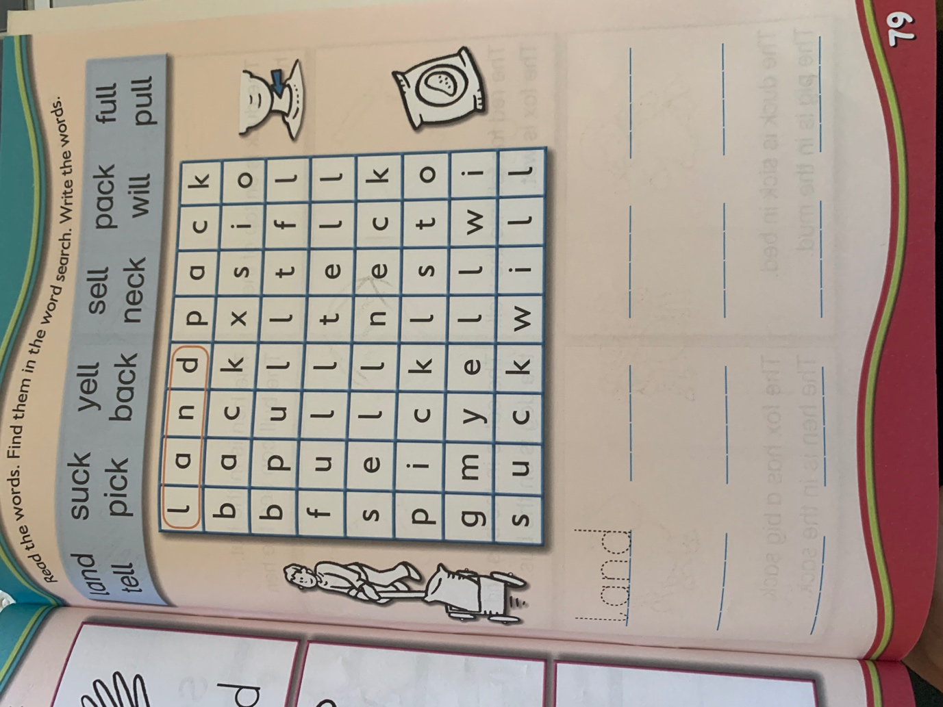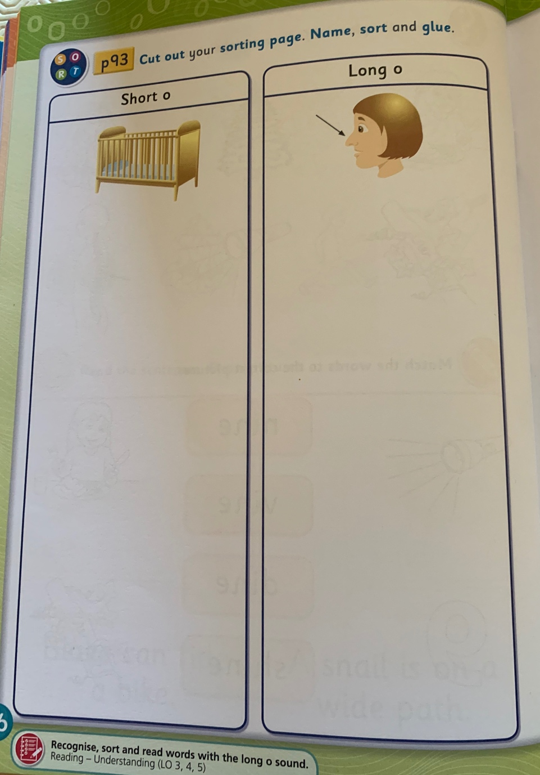
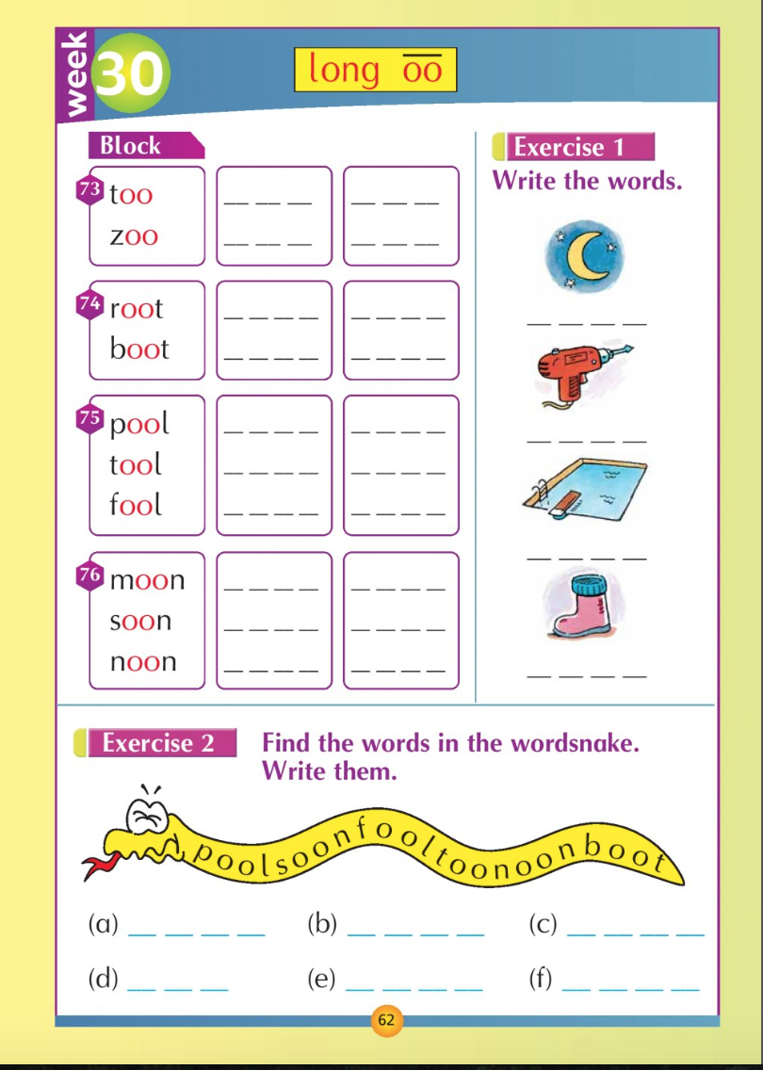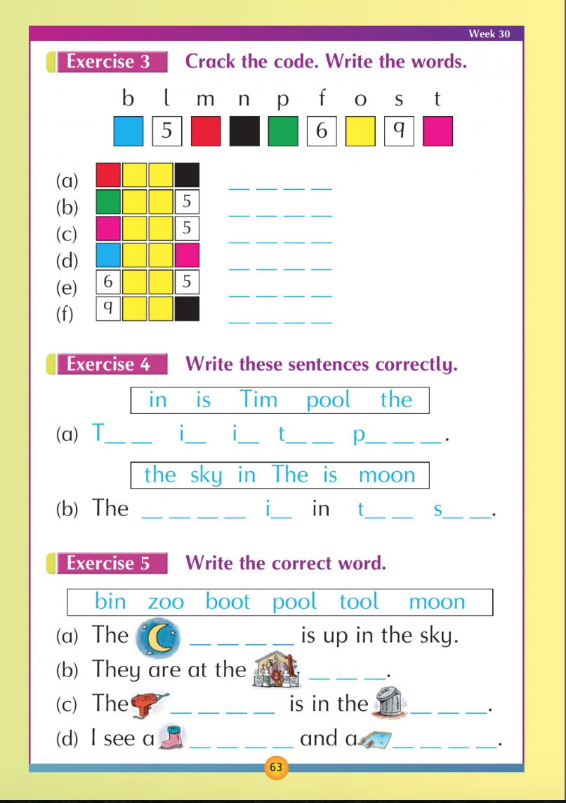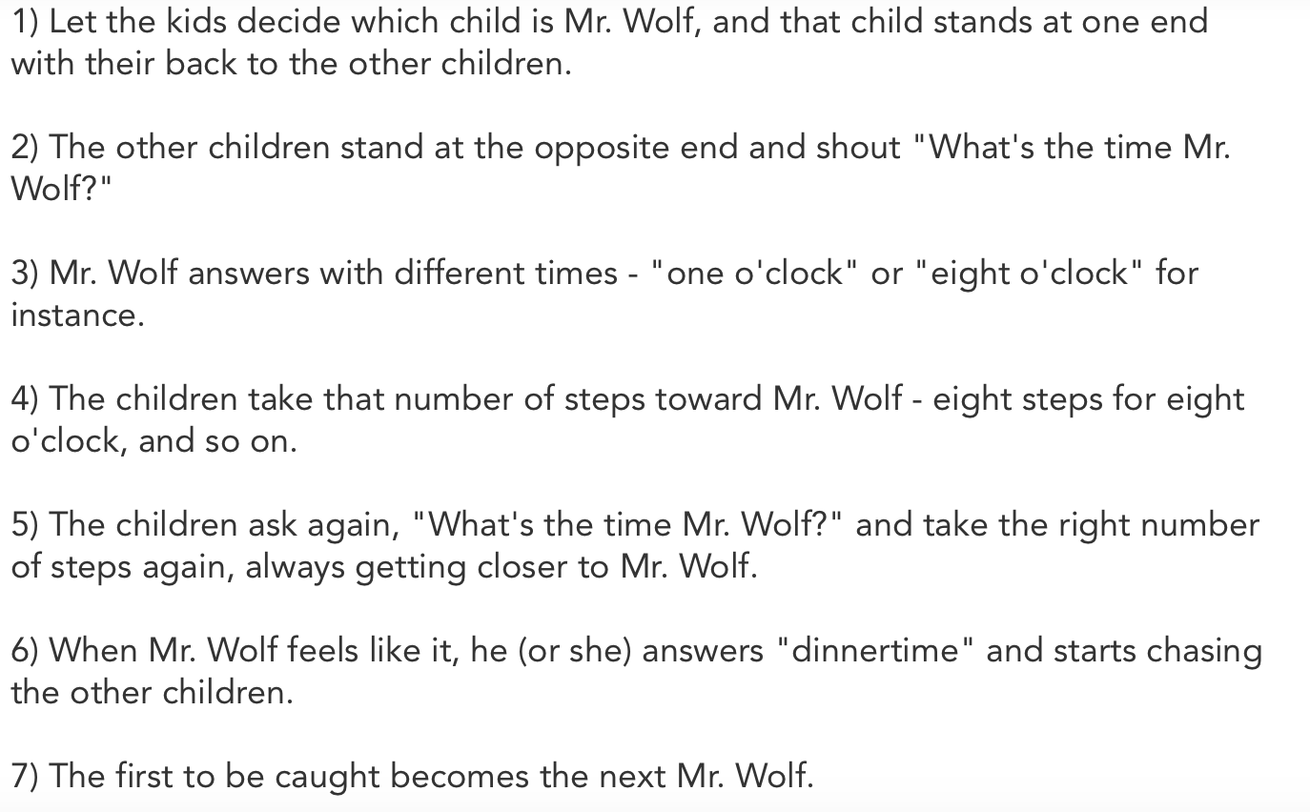

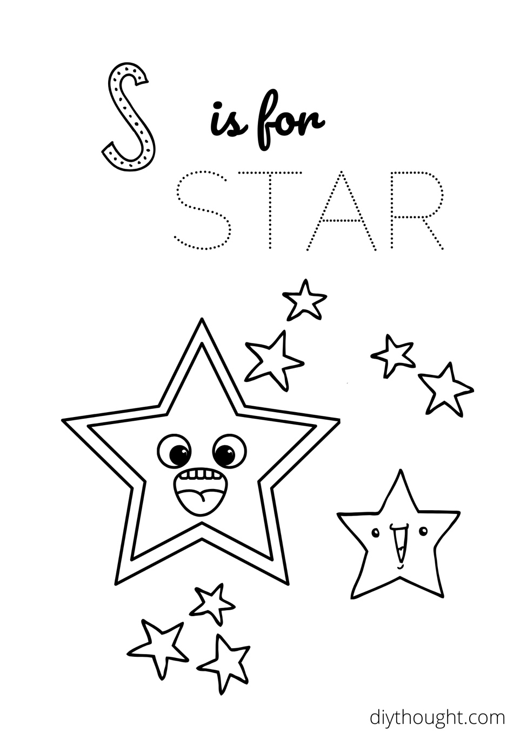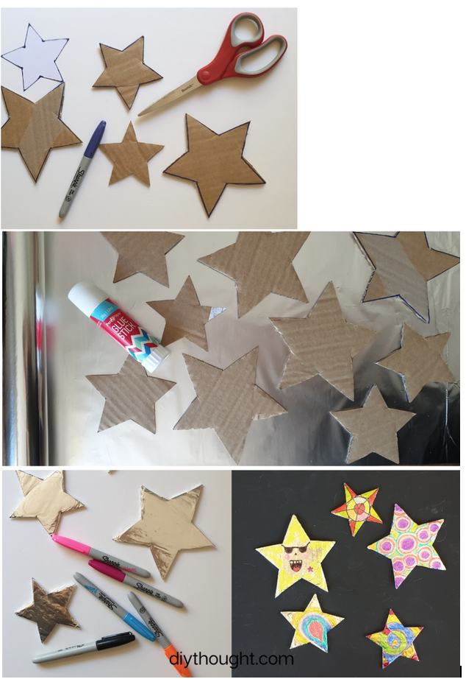
Wednesday 3rd
Please remember that these activities are not mandatory. You can pick and choose different activities you wish to do each day. You don’t have to do every activity every day! We just want to give you lots of different activities and ideas. You choose what will suit you best. Feel free to send back any pictures or work that your child has done if you would like to but again, you don’t have to! If you have any questions about anything just send us an email!

Ms Denieffe and Ms O’Neill
Subject | Activity
English | Dictation  - Ask your child to listen carefully as you will only say the sentence twice.  - Call out the sentence and give your child a chance to write it down  - As spellings this week include long “oo” words we are practising these in our dictation  Sentences  - Fish is a good food for you.  - The man will be there soon.  - Can you see me up on the roof?  - Look at the sentence together - What words were tricky? How did you figure out how to spell this word? Where did you go wrong?  Challenge – Ask your child to write their own sentence!  - Words (Week 1st June)  - Spellings Week 30 (located in Monday’s documents)  - Reading class reader or choose a new book to read
Maths | Time  - Draw some clocks on a blank piece of paper and fill in some of the missing hours  - Leave 3 hours black  - Ask your child to figure out what the missing hours are and fill them in  - Once they have filled in the missing hours you can ask them to show a particular time on the clock e.g. 2 O’clock  - Page 3 of this document is a template/sample of this activity from the extra worksheets for your child’s Planet Maths programme, you don’t need to print off the page to do the activity  - You could try playing this game for some more practice - http://www.learningplanet.com/act/tw/index.asp?contentid=410
Gaeilge | An Scoil  - Look at ceacht 3 and listen to the comhrá about “cuir isteach”  - Move on to the comhrá for ceacht 4 which is ‘tóg amach”  - You could play this game at home “cuir … isteach sa mhála scoile” and “tóg amach an ….”  - Listen to the poem “Mo Mhála Scoile” which accompanies ceacht 4
SESE | Materials  - Can you remember some of the materials you looked at yesterday?  - Look at the selection of materials on page 34 in your child’s Small World book (located on page 3 of this document)  - Discuss the different materials on the page  - Same questions to help you – can you name other things made from this materials, which of the materials is strong, which material would break easily, which material can bend, which material tears, which material rusts?  - Can you find something on the page which is made from more than one material? What other things can you think of that are made from more than one material?

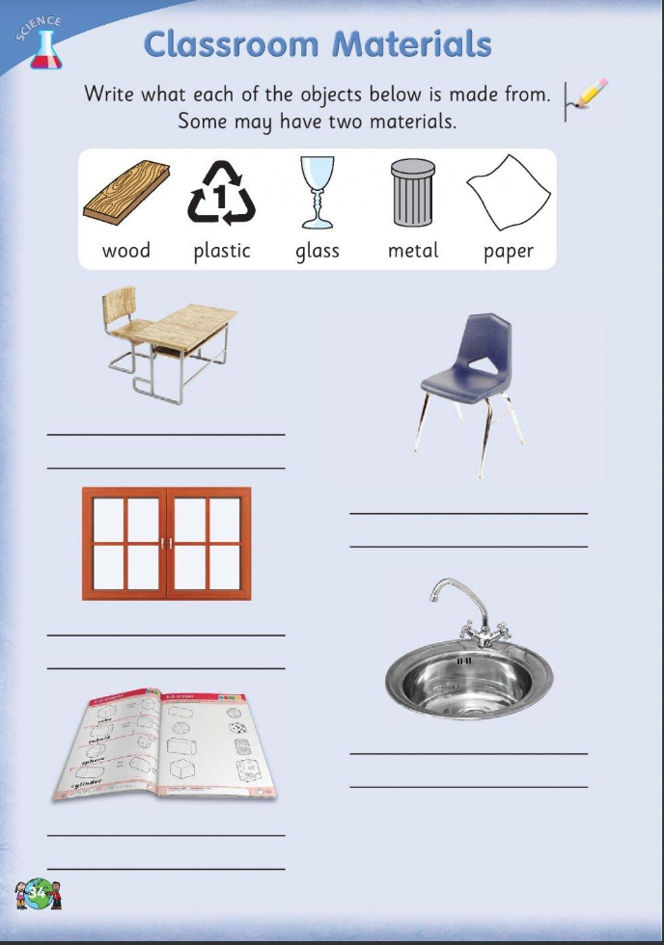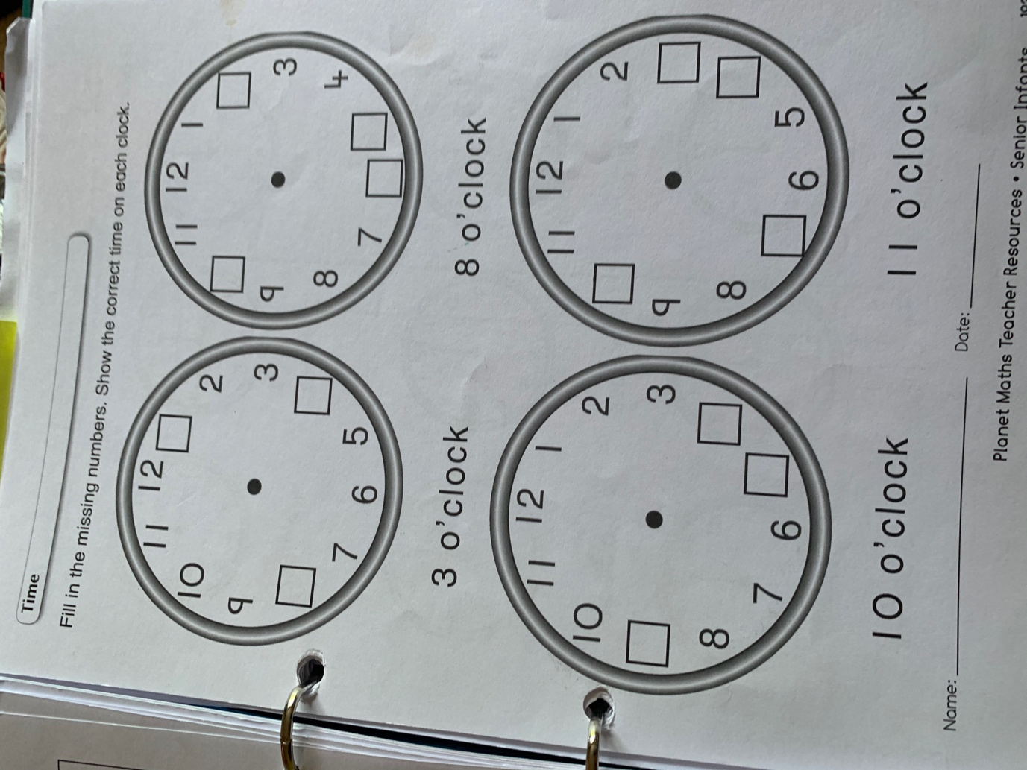

Thursday 4th
Please remember that these activities are not mandatory. You can pick and choose different activities you wish to do each day. You don’t have to do every activity every day! We just want to give you lots of different activities and ideas. You choose what will suit you best. Feel free to send back any pictures or work that your child has done if you would like to but again, you don’t have to! If you have any questions about anything just send us an email!

Ms Denieffe and Ms O’Neill

Subject | Activity
English | - We are looking at forming of the capital letter M + N this week.  - Can you write a lowercase N/M?  - You could look through a book and try to find some capital N/m or other capital letters in it  - This video will help you with forming the letter - https://www.youtube.com/watch?v=wJYCLfzSOQE, https://www.youtube.com/watch?v=DtB4hdDWUec  - Try forming the capital N/ m in the air using your magic finger, try writing it on someone’s book or make it with pasta  - You can complete page 45 and 46 in the handwriting book to practice  - Words (Week 1st June)  Spellings Week 30 (located in Monday’s document  Reading class reader or new book
Maths | - Do you remember discussing morning, afternoon, evening and night last week?  - Brainstorm the different things you do in the morning, afternoon, evening and night  - Use the template on page 3 of this document to help you with the next activity (you don’t need to print it off)  - Divide a page in 4 and draw a clock in each section  - Think of something you do in the morning and draw it in here – what time would we draw onto the clock for morning  - Repeat for afternoon, evening and night
Gaeilge | An Scoil  - Listen to the comhrá for ceacht 6 which is about things in the classroom  - You could look around the room you’re in and find the fuinneog, bord, cathaoir, doras, peann, scriosán (rubber), mála scoile.  - There’s a number of games to accompany this lesson and you can revise the song from yesterday
Religion | The Golden Rule  - What do you think the “Golden Rule” might be?  - The Golden Rule is in lots of different religions – it is about treating others as you wish to be treated  - Why do you think it’s important to treat other people the way you want to be treated?  - Watch the video on Respect from Seaseme Street - https://www.youtube.com/watch?v=GOzrAK4gOSo  - Look at the different scenarios on page 5 of this document. In each situation the person had to decide what they were going to do – do these children follow the Golden Rule?  - Read through them and decide whether it was a good/bad choice – do you give it a thumbs up or a thumbs down?  - Ask your child for a reason for their answer  - If you had a Golden Rule, what would it be and why?

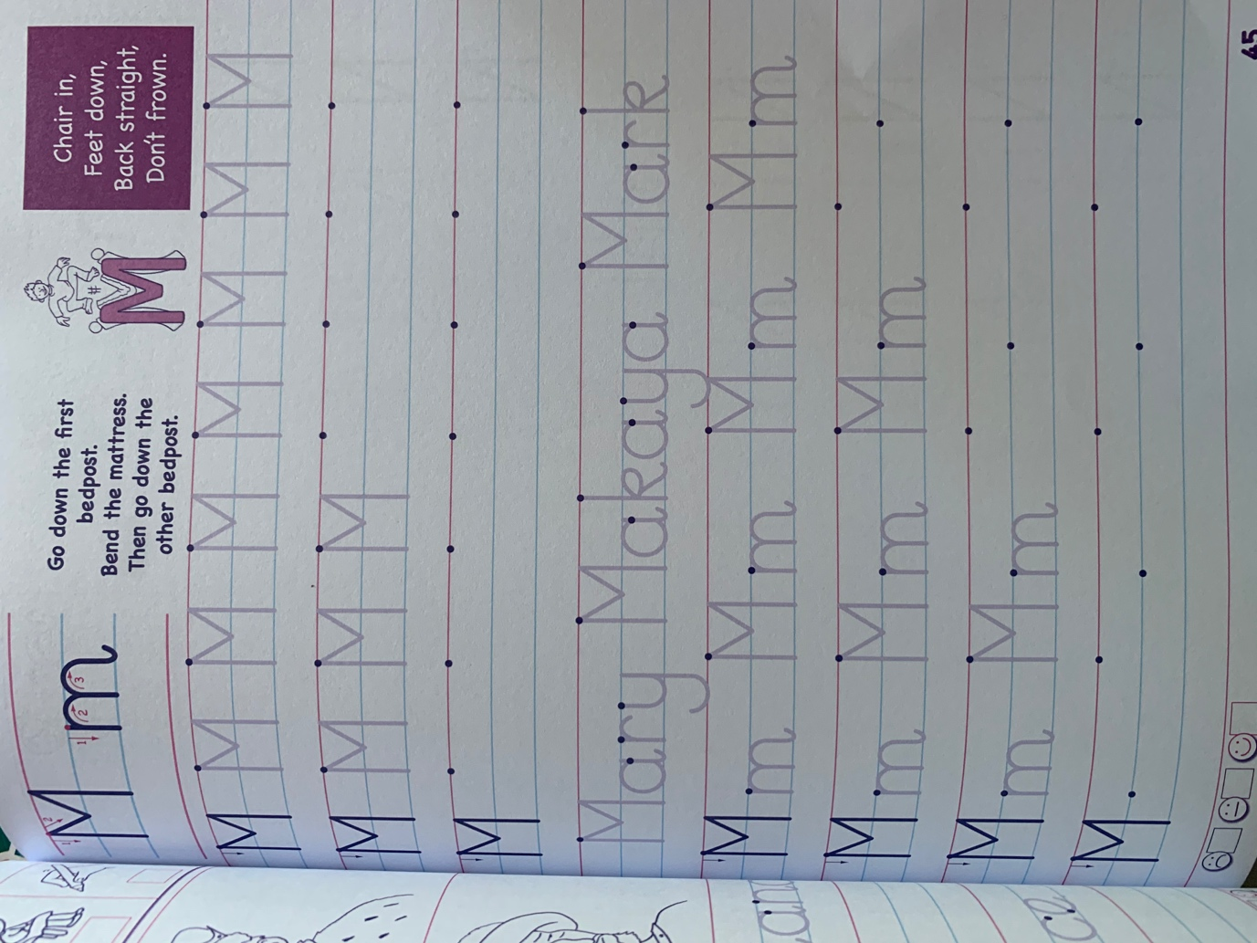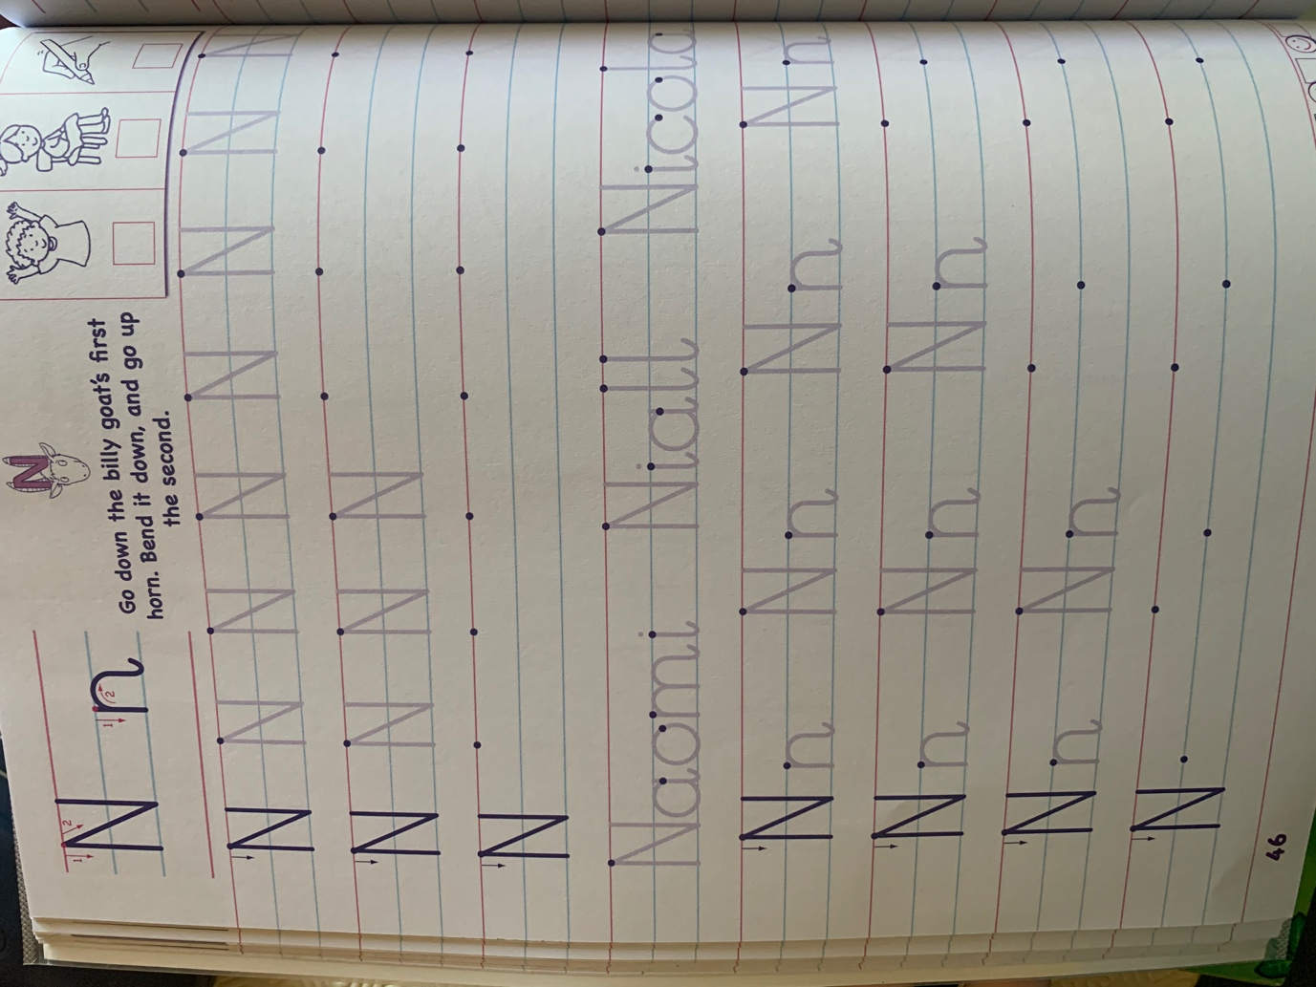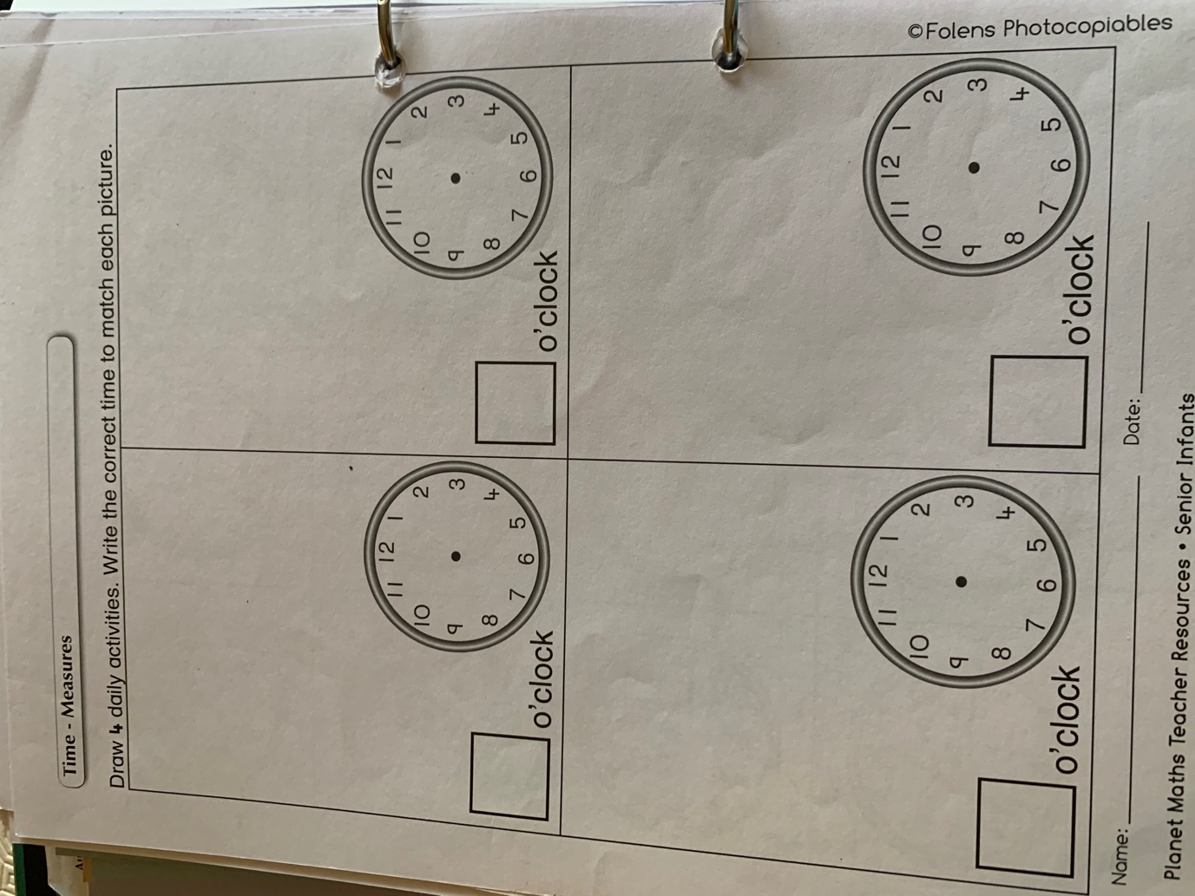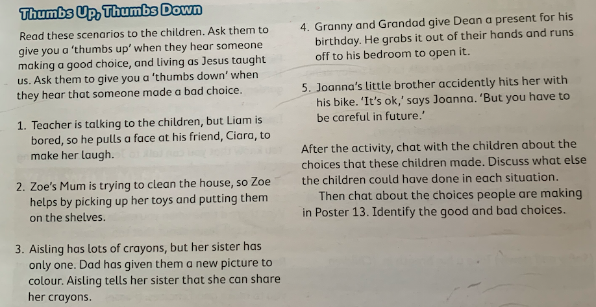

Friday 5th
Please remember that these activities are not mandatory. You can pick and choose different activities you wish to do each day. You don’t have to do every activity every day! We just want to give you lots of different activities and ideas. You choose what will suit you best. Feel free to send back any pictures or work that your child has done if you would like to but again, you don’t have to! If you have any questions about anything just send us an email!

Ms Denieffe and Ms O’Neill

Subject | Activity
English | - You can do a spelling and word test to assess words/spellings if you’d like  - Creating your own story  - Use the story cards on page 2 of this document to create your own story  - Plan it with a beginning, middle and end  - Tell your story orally to someone  - You could write down a few sentences from your story, illustrate it or create a comic strip about it if you’d like
Maths | - Listen to and learn the rhyme “Hickory Dickory Dock” - https://www.youtube.com/watch?v=HGgsklW-mtg  - Set a timer/stopwatch for 1 minute  - You can try to do a selection of different activities for 1 minute and see how long it is and how much you can do. Below are some sample activities you can try  - How many cubes can you put together?  - How many words can you write?  - How many times can you jump up and down?  - How much of your picture can you colour?  - How many letters of the alphabet can you write?
Gaeilge | An Scoil  - Look at ceacht 9 which is about “glan”  - There are a few games to accompany this ceacht  - Listen to the song “caithfidh mé an seomra a glanadh”
SESE | Three Little Pigs  - Read/Revise the story The Three Little Pigs - https://www.youtube.com/watch?v=CtP83CWOMwc  - You can use the “Three Little Pigs” PowerPoint in the resources folder to help you  - Discuss what the different houses were made from  - Why do you think the first two houses fell down? Why did the third house stay standing? What material could have been used instead for the first two houses?  - Design another house for the Three Little Pigs – what materials are you going to use in your house and why are you choosing these materials?

