Subject | Monday | Tuesday | Wednesday | Thursday | Friday
Gaeilge | Litriú (Spellings)  Bí ag léamh!  Am don Léamh  Léamhthuiscint  Am don Léamh – Freagair na ceisteanna atá bunaithe ar Am don Léamh Turas go Plútón  Online dictionaries  https://www.teanglann.ie/en/  https://www.focloir.ie/ | Litriú (Spellings)  Bí ag léamh!  Am don Léamh  Gramadach  Aidiachtaí (Adjectives)  Learn the adjectives vocabulary.  Use the vocabulary to complete the sentences. | Litriú (Spellings)  Bí ag léamh!  Am don Léamh  Bí ag scríobh!  Líon na bearnaí agus scríobh scéal beag. | Litriú (Spellings)  Bí ag léamh!  Am don Léamh  Gramadach  Forainm réamhfhoclach (prepositional pronoun)  Revise and learn ar  orm, ort, air, uirthi, orainn, oraibh, orthu | Litriú (Spellings)  Bí ag léamh!  Am don Léamh  Gramadach  Forainm réamhfhoclach (prepositional pronoun)  Revise and learn ag  agam, agat, aige, aici, again, agaibh, acu
English | Learn Spellings  (Unit 28)  Vocabulary:  Write out the sentences from Activity A and  complete the sentences using words from the spelling list. Complete the word search.  Reading  Upside Down Worlds: The Fountain of Fair Fortune pg 174  (Reader available at edcolearning.ie)  Choose a novel to read. | Learn Spellings  Word Study:  Learning about metaphors and similes.  *Metaphors describe something as something else.  *Similes compare things using ‘as’ or ‘like’.  Reading  Upside Down Worlds pg 175  Continue reading novel | Learn Spellings  Grammar / Word Study:  Pronouns: Pronouns replace nouns in a sentence  She looked at him.  Complete the sentences  Reading  Upside Down Worlds pg 176  Continue reading novel | Learn Spellings  Comprehension  Complete the questions (pg 178) based on the reading The Fountain of Fair Fortune pg 174-177  Online dictionary  https://dictionary.cambridge.org/  Reading  Upside Down Worlds pg 177  Continue reading novel | Spelling Test  Writing  Report Writing  A report is a piece of factual writing. Write a report about an endangered animal.  Reading  Upside Down Worlds pg 174-177: Revise  Continue reading novel
Subject | Monday | Tuesday | Wednesday | Thursday | Friday
Maths | Tables: x6  Data  Activity A  Data: Averages  Revising averages- remember to add up the numbers and divide by the number of numbers. | Tables: ÷6  Data  Activity B  Data: Pie charts: Interpreting information on pie charts. | Tables: x7  Data  Activity C  Data: Pie charts: Interpreting information on pie charts. | Tables: ÷7  Data  Activity D  Data: Constructing pie charts  Express the number as a fraction.  Find a fraction of 360 degrees.  See this link for a good tutorial on how to make a pie chart.  https://www.mathsisfun.com/data/pie-charts.html | Tables: Revise all  Data  Activity E  Data: Revision  Interpreting data on a pie chart.
Other Lessons | Geography/ Science: Space: The Sun  Look at the power point about the Sun under the Other Lesson Resources in Google Classroom or here:  https://www.twinkl.ie/resource/au-t2-s-034-australia-sun-facts-powerpoint-and-worksheets  Read the piece about the Sun and answer the questions. | Geography/ Science: Space: The Sun  Test out your general knowledge about the Sun by completing the cloze procedure. | Art: Drawing  Try to draw a colourful scene based on the sun and the moon. Use the pictures as inspiration. | S.P.H.E: Taking Care of Myself  It’s important that we take care of ourselves. This week we have included a link to the Weaving Wellbeing site. Here you will find a free wellbeing journal.  https://www.otb.ie/wp-content/uploads/2020/04/At-Home-with-Weaving-Well-being-A-Mental-Health-Journal-for-Kids.pdf | Religion: The Church: Our Parish  Learn about the Sacrament of the Holy Orders.  Read the piece, learn the vocabulary and write about a special occasion that your family celebrated in church. Draw a picture or paste a photograph of the event.

Gaeilge
Litriú (Spellings)
Lá | Litríocht | Aistriúchán
An Luan | nuachtán  raicéad | newspaper  racket
An Mháirt | stáisiún spáis  pictiúrlann | space station  cinema
An Chéadaoin | culaith spáis  linn snámha | space suit  swimming pool
An Déardaoin | clocha  liathróid ghailf | rocks/meteorites  golf ball

- Monday: Am Don Léamh: Léigh agus freagair na ceisteanna.
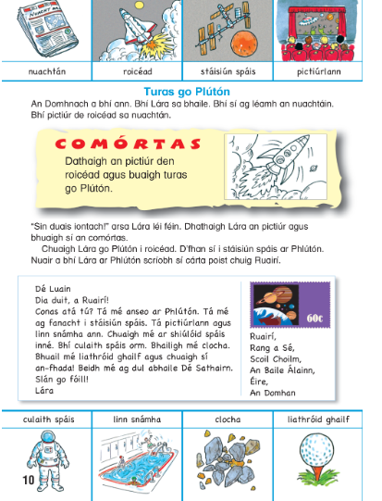
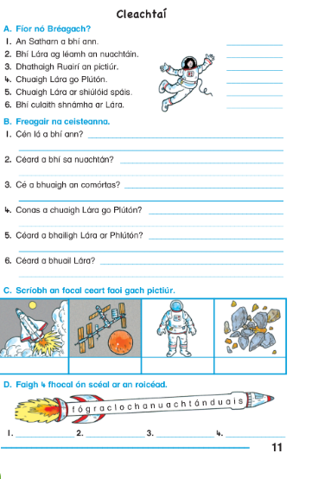
- Tuesday: Gramadach: Aidiachtaí (Adjectives): Learn the table below
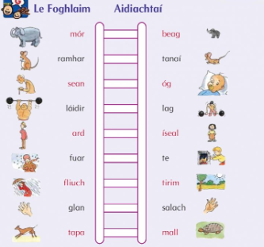
Líon na bearnaí
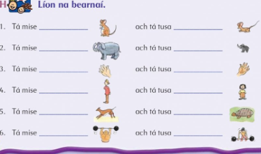
- Wednesday: Críochnaigh an scéal

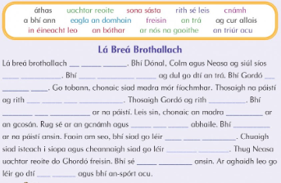
- Thursday: Le foghlaim- An Réamhfhocail - Ar
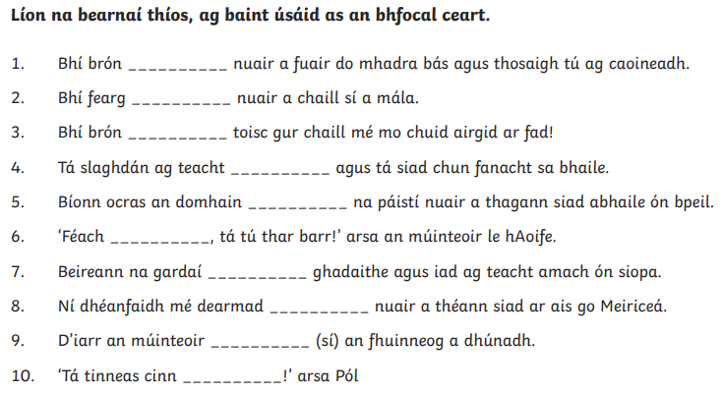
- Friday: Le Foghlaim: An Réamhfhocail- Ag
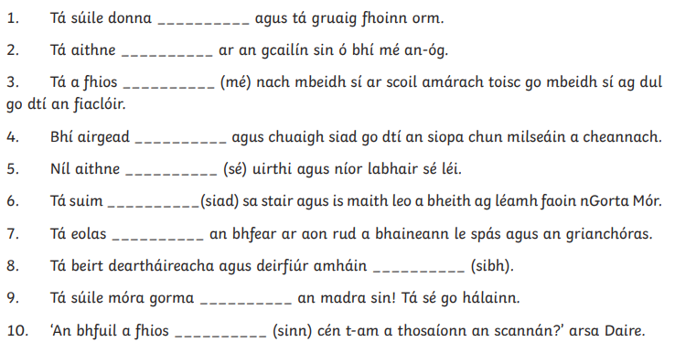

English
Spelling List: Spellbound Unit 28
Monday | Tuesday | Wednesday | Thursday
either  opinion  grammar  climbed | likely  lightening  pleasant  stopped | though  usually  bargain  woman | fourth  ninth  magazine  Wednesday

Reading for the Week: Upside Down Worlds (Unit 40): The Fountain of Fair Fortune pgs.174-177
- Monday: Write out these sentences and fill in the missing words.
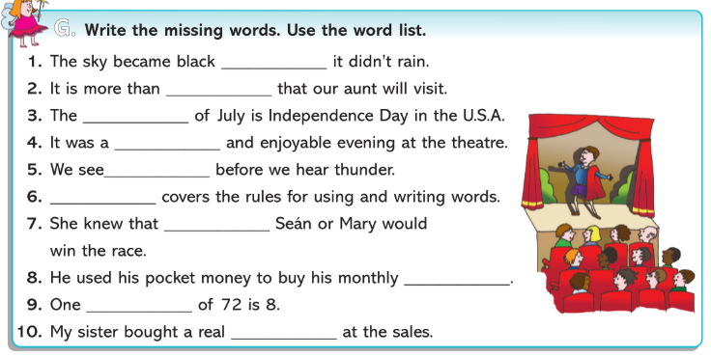
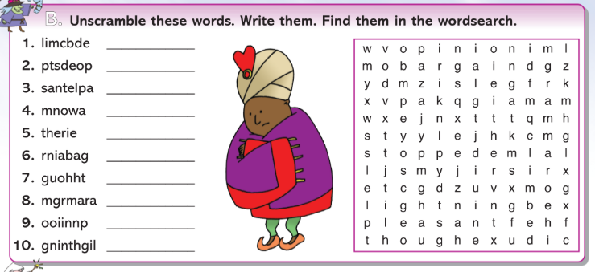
- Tuesday: Word Study- Metaphors and Similes
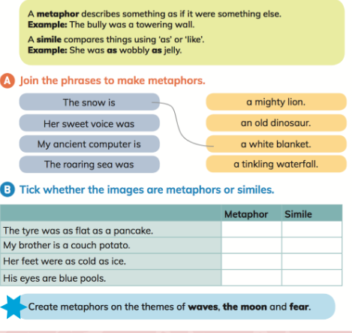
- Wednesday: Grammar- Pronouns
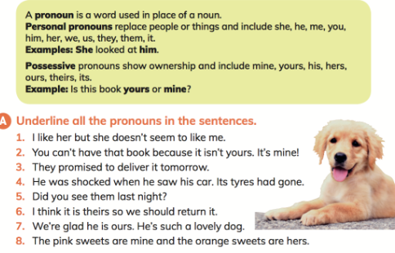
- Thursday: Comprehension
Answer the comprehension questions based on the story The Fountain of Fair Fortunes from your reader Upside Down Worlds pgs.174-177. Answer the accompanying questions on pg.178.
The story is available online at https://www.edcolearning.ie/Book/Page?bookId=book281&chapterId=chapter43&pageId=page178
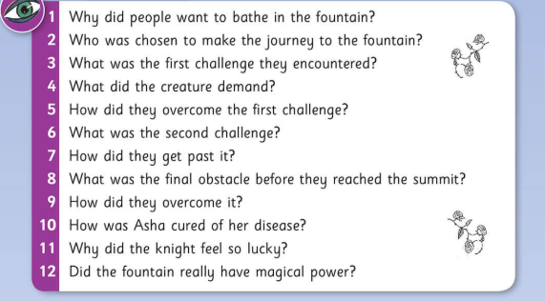
- Friday: Writing a Report- Write about an endangered animal
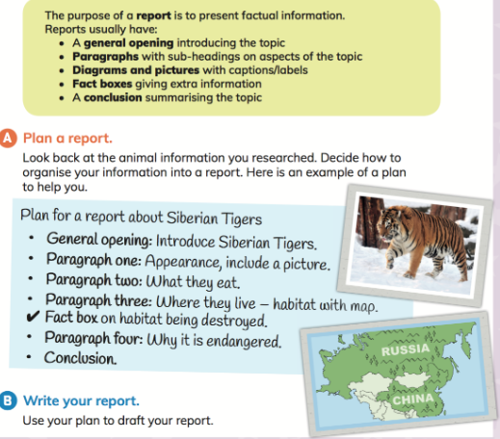
Maths
Tables: Revising x/÷ 6, x/÷ 7
- Monday: Data
Revising averages- remember to add up the numbers and divide by the number of numbers. For example, to find the average of 4, 5, 6 you add 4+5+6=15 and divide by 3 to give you an answer of 5.

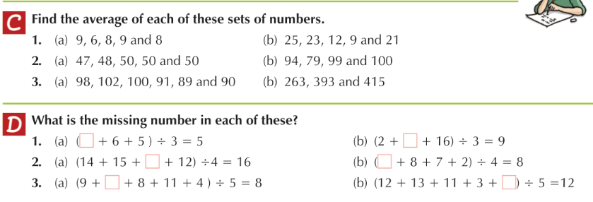
- Tuesday: Using Pie Charts to display information.

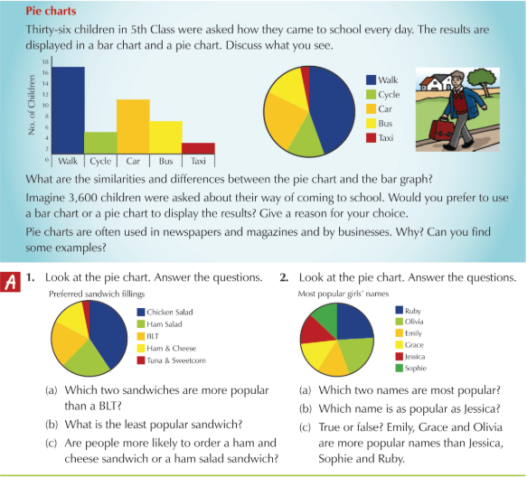
- Wednesday: Reading Pie Charts
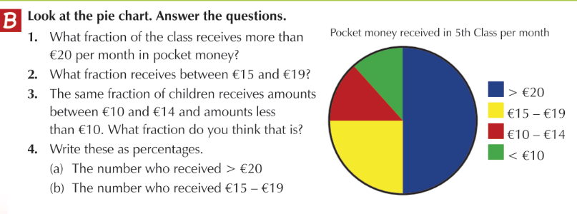
- Thursday: Constructing Pie Charts

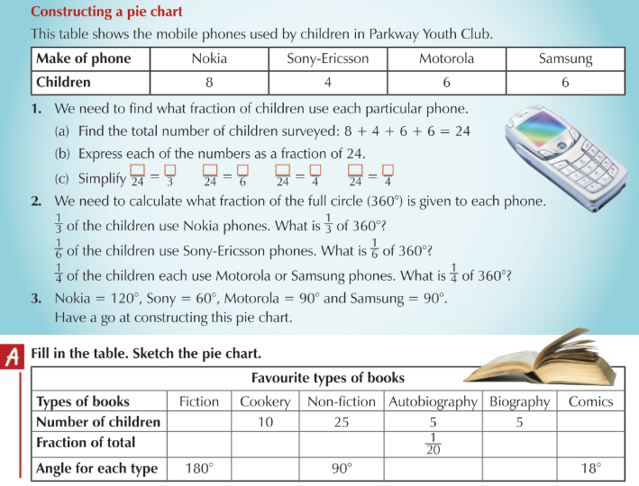

- Friday: Revision of the Week

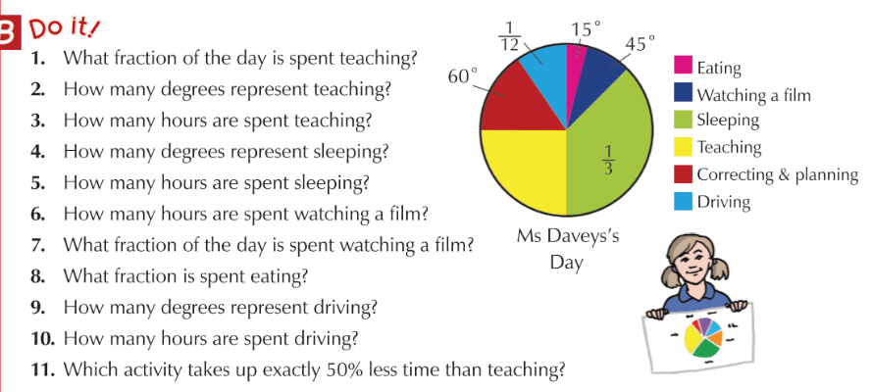

Other Lessons

- Monday: Science / Geography
The Sun: Check out this power point on the Sun-https://www.twinkl.ie/resource/au-t2-s-034-australia-sun-facts-powerpoint-and-worksheets
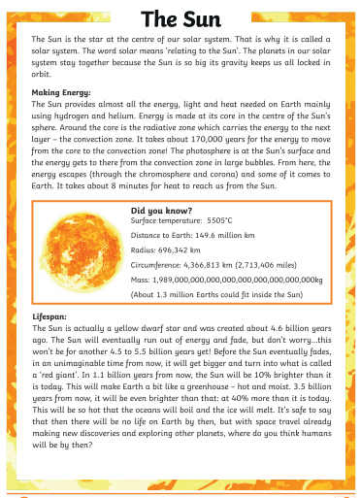
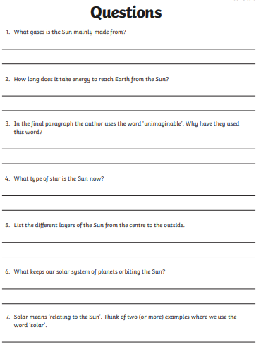
- Tuesday: The Sun, complete the cloze exercise
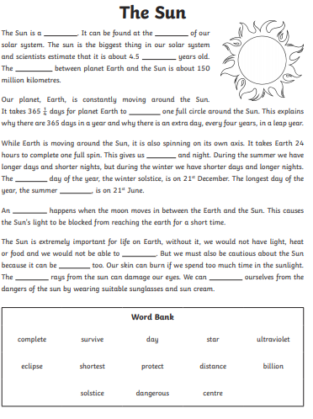
- Wednesday: Art: Try to draw a colourful scene based on the sun and the moon. The following picture could be used as a guideline to give you all some inspiration.
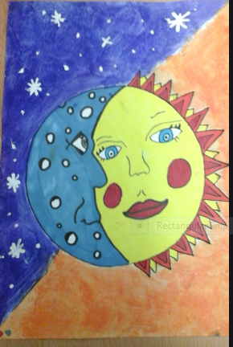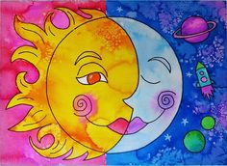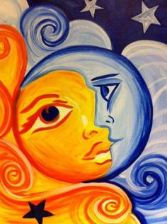

There are over 28 posters to choose from on Twinkl to say Thank You to our key workers for all their hard work during these difficult times. You might like to pick one to colour to place in the window of your house or to give to a family member. You can pick one or more by clicking on the link below.
https://content.twinkl.co.uk/resource/5e/a8/t-tp-2549562--new-thank-you-key-workers-colouring-posters-_ver_14.pdf?__token__=exp=1588707242~acl=%2Fresource%2F5e%2Fa8%2Ft-tp-2549562--new-thank-you-key-workers-colouring-posters-_ver_14.pdf%2A~hmac=73a94886b84d2b9181a244fc292e1f29adf23e864f200ae51967f8ef3507e0d8

- Thursday: SPHE: Remember to continue to work on your Weaving Well-Being Booklet, the link is included below. It is so important to take time out and to look after our minds and our well-being.
https://www.otb.ie/wp-content/uploads/2020/04/At-Home-with-Weaving-Well-being-A-Mental-Health-Journal-for-Kids.pdf

- Friday: Religion

The Sacrament of Holy Orders
Key words to learn:
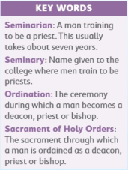
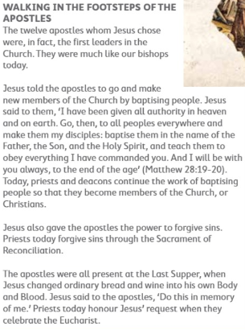
Write about a special occasion that your family celebrated in church. Draw a picture or paste a photograph of the event.

