Subject | Monday | Tuesday | Wednesday | Thursday | Friday
Gaeilge  Revision materials and resource taken from a different Irish book – this allows the children to complete revision work at home. | Téama: Ócáidí Speisialta – Turas Scoile  Litriú (Spellings)  Bí ag Léamh!  Am don Léamh: Turas Scoile. Léigh agus freagair na ceisteanna.  Online dictionaries  https://www.teanglann.ie/en/  https://www.focloir.ie/ | Téama: Ócáidí Speisialta – Turas Scoile  Litriú (Spellings)  Bí ag Scríobh!  Use the vocabulary provided to write your own six sentences. | Téama: Ócáidí Speisialta – Turas Scoile  Litriú (Spellings)  Bí ag Scríobh!  Mothúcháin (emotions)  Use the emojis to help you to complete the sentences.  Online dictionaries  https://www.teanglann.ie/en/  https://www.focloir.ie/ | Téama: Ócáidí Speisialta – Turas Scoile  Litriú (Spellings)  Gramadach  Revise Briathra Neamhrialta (irregular verbs) Feic and Ith in the Aimsir Fháistineach (Future Tense)  Use the table to help you to fill in the blanks. Write and complete the sentences in your copy. | School Tour Day
English | Spellings (Unit 31)  Vocabulary: Write the sentences and complete them using words from the spelling list.  Complete the word search.  You can do all of Unit 31 if you wish in Spellbound.  Reading  Class novel / Novel of your choice | Spellings (Unit 31)  Comprehension  Read the piece and answer the comprehension questions based on the text Summer in Ireland.  Reading  Class novel / Novel of your choice | Learn Spellings  (Unit 31)  Vocabulary Development / Dictionary Work  E.Y.E. pg 92  Use your dictionary to complete the vocabulary exercises.  Reading  Class novel / Novel of your choice | Learn Spellings  (Unit 31)  Cloze Procedure  E.Y.E pg 93  Write out the cloze procedure and complete the text using the bank of words. Remember to check spellings and only use each word once.  Reading  Class novel / Novel of your choice | School Tour Day
Subject | Monday | Tuesday | Wednesday | Thursday | Friday
Maths  Some revision resources not taken from Planet Maths  See Google Classroom for Answer Sheets. | Chance  Activity A  Explore the topic of chance using coins (heads or tails). Answer the questions. | Chance  Activity B  Explore the topic of chance using dice and coloured paper. Answer the questions. | Chance  Activity C  Explore the topic of chance using a spinner. Answer the questions. | Chance  Activity D  Explore the topic of chance using a survey based on preferences. Answer the questions. | School Tour Day
 | Science / Geography:  Caring for the environment  Learn about plastic pollution from the power point and answer the questions. | Art:  Create a piece based on the theme of sunflowers. You can use the information provided to help or create your own piece. Use any materials you have at home. | SPHE:  Myself: Safety in the Sun  Learn all about the importance of staying safe in the sun. Look at the power point and design a summer safety poster. | Religion  Learn all about God’s love for us. Complete the reflection question in your journal. | School Tour Day  Today should have been your school tour so take the day off work  See links in plan to virtual tours.

Gaeilge
Litriú (Spellings)
Day | Spelling | Translation
An Luan | an turas scoile  ar bís | the school tour  excited
An Mháirt | ag marcaíocht  ag sodar | horse riding  trotting
An Chéadaoin | praghas  ag dreapadh | price  climbing
An Deardaoin | shleamhnaigh sé  tharraing sí | he slipped  she pulled

- Monday: Bí ag Léamh! Am Don Léamh Ich.58-59 Léigh agus freagair na ceisteanna.
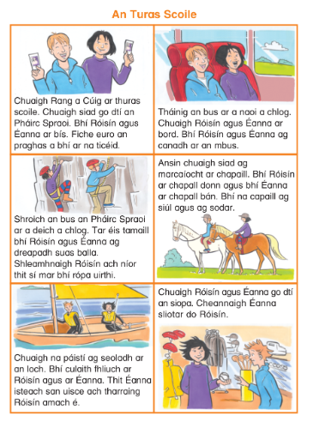
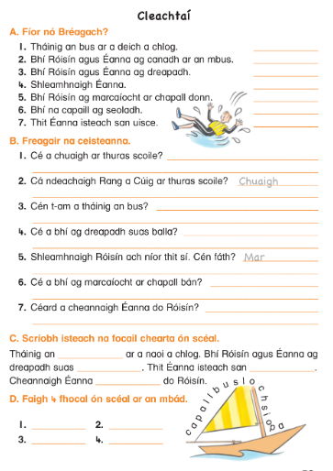
- Tuesday: Bí ag scríobh. Use the words to help you write 5 sentences.
Start the sentence with Bíonn/ Téim or Imrím
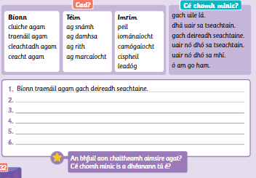

- Wednesday: Mothúcháin. Let the emoji explain new emotions. Use the words to complete the sentences.

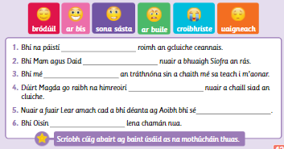

- Thursday: Gramadach: An Aimsir Fháistineach: Na Briathra Neamhrialta
The Future Tense: Irregular verbs. Use the table to fill in the blanks.

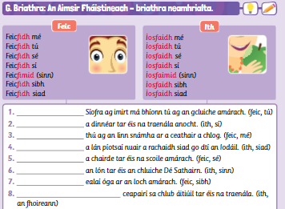

English
Spelling List: Spellbound pg 64-65 (Unit 31) Phonics: ious
Monday | Tuesday | Wednesday | Thursday
serious  curious  furious  vicious | cautious  precious  various  glorious | hilarious  delicious  mysterious  victorious | obvious  anxious  suspicious  contagious

Reading for the week: Continue to read your class novel if you have it at home with you. Read the comprehensions based in this week’s plan and most importantly continue with your own personal reading.
- Monday: Vocabulary based on the Spelling Unit. (You can complete the full unit in your workbook if you wish)

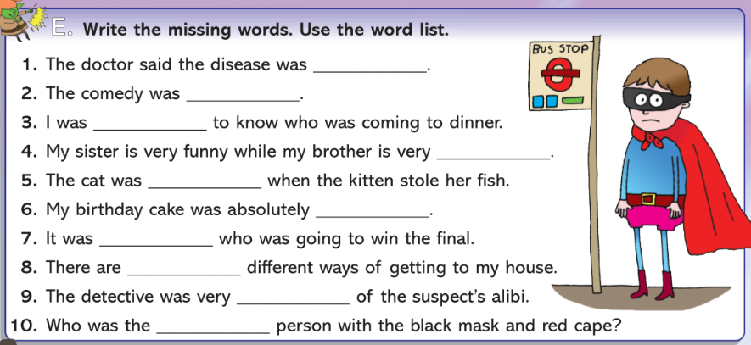
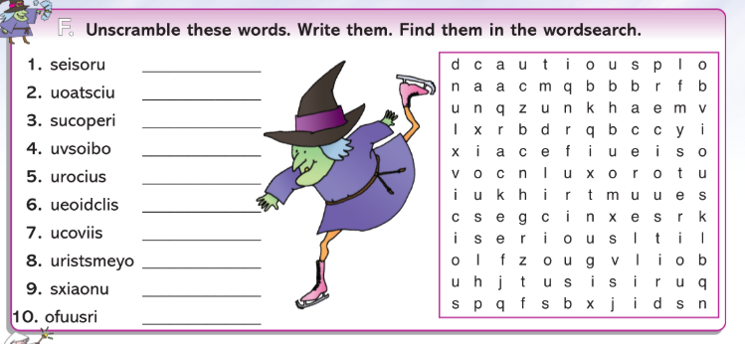

- Tuesday: Comprehension Activities. Read the story and answer the accompanying questions.
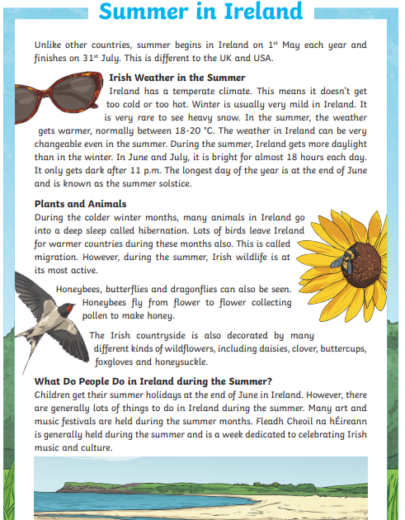

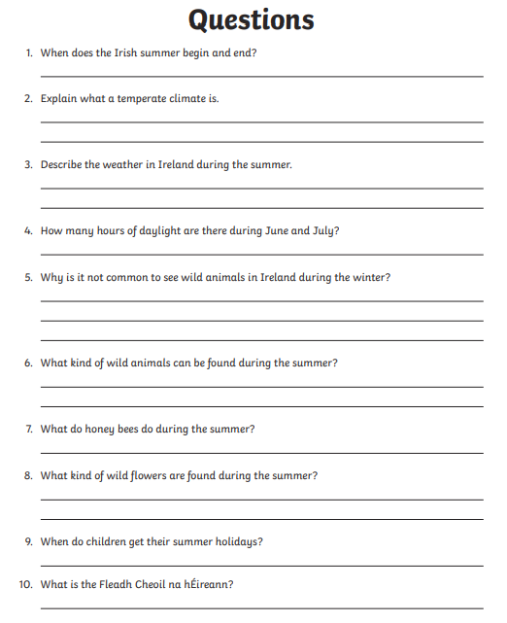

- Wednesday- Dictionary Skills pg. 92, Exercise Your English.
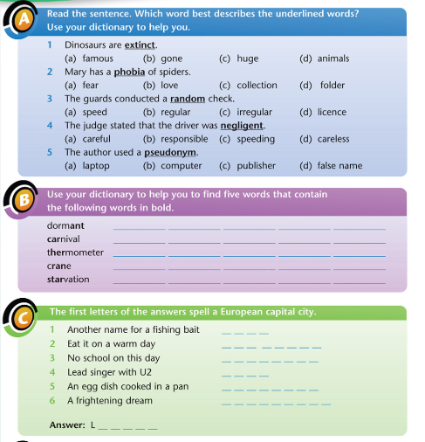
D. Thursday- Cloze Activity: The Sloth, Exercise Your English pg. 95
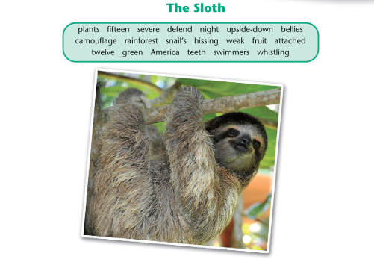
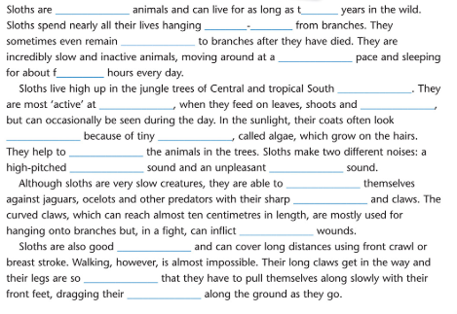
Maths- Chance
- Monday- It is useful to get yourself two coins and a dice to help out with the chapter this week.

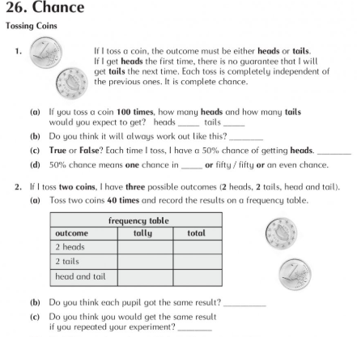

- Tuesday- For the activities today you will need a dice and some coloured counters. If you do not have counters you could simply use pieces of coloured paper or pieces of lego in the various colours.

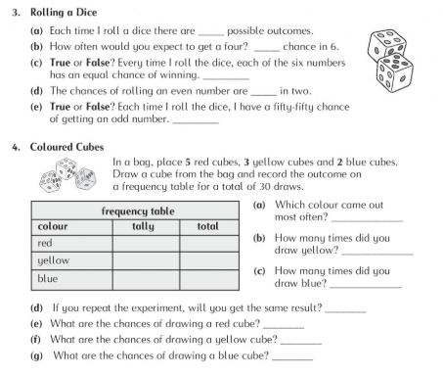
- Wednesday- Working with a spinner to demonstrate Chance.

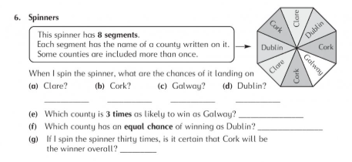

- Thursday- using a survey to look at the chances of different types of fruit being picked in a class.

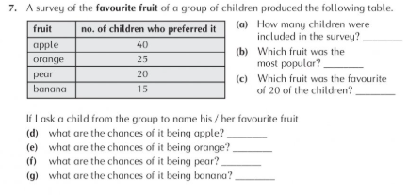

Other Lessons
- Monday- Science/Geography. Have a look at the following power points as a starting point.
https://www.twinkl.ie/resource/t2-t-72379-the-problem-with-plastics-information-powerpoint
https://www.twinkl.ie/resource/lks2-bbc-teach-live-lesson-blue-planet-powerpoint-t2-t-1532

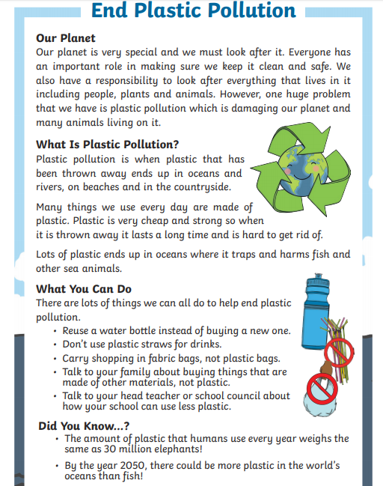

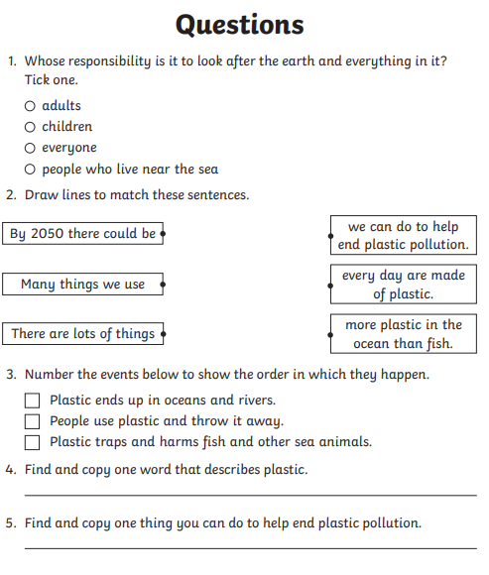
- Tuesday- Art Keeping with the summer theme, drawing some sunflowers
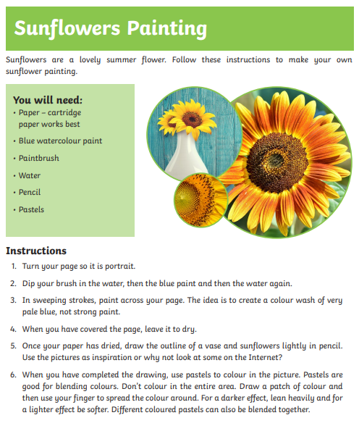

- Wednesday- SPHE: Keeping safe in the Sun
Have a look at the following power point based on Safety in the Sun. With the good weather we are having this is particularly important at the moment. Design a poster to inform people about the importance of being safe in the sun.
https://www.twinkl.ie/resource/t-t-2546973-sun-awareness-information-powerpoint
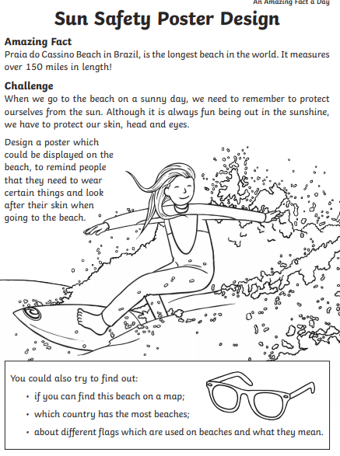

- Thursday- Religion

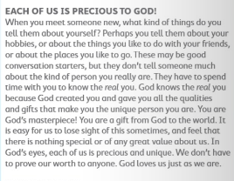

Write in your copy:
How does it make you feel to know that you are precious to God and that God loves you just the way you are?

- Friday- School Tour Day
As today should have been your school, we want you to take a day off and enjoy a virtual tour of a place that interests you. It could be Dublin Zoo or the world famous San Diego Zoo if animals are your passion. If you are interested in History you might chose a museum or a historical site such as Anne Frank’s home or Pompeii and experience the sights that Mount Vesuvius covered. If Art is your calling visit the Louvre and see the famous Mona Lisa or after all the Space activities at the weekend you might want to check in on NASA! Have fun whatever you decide and if you want drop us a line about your experience.
You can visit the Scoilnet website where you have lots of great options or click on one of the links below;
https://www.scoilnet.ie/go-to-post-primary/collections/tours/

Zoos
- Dublin
  - Elephants – bit.ly/DublinZooElephants
  - Penguins – bit.ly/DublinZooPenguins
  - African Savanna – bit.ly/DublinZooAfricanSavanna
- San Diego Zoo – bit.ly/SanDiegoZooCams

Irish Museums
- Trinity College Dublin
  - The Long Room – bit.ly/TCDTheLongRoom
- National Library of Ireland – bit.ly/NationalLibraryIRL
- National Gallery of Ireland – bit.ly/NationalGalleryIRL
- National Museum of Ireland
  - Natural History – bit.ly/NaturalHistoryIRL
  - Country Life – bit.ly/CountryLifeMuseum
  - Archaeology – bit.ly/ArchaeologyMuseumIRL
  - Decorative Arts and History – bit.ly/DecorativeArtsHistoryIRL
- Medieval Museum Treasures of Medieval Waterford – bit.ly/MedievalWaterford
- Titanic Experience Cobh – bit.ly/TitanicExperienceCobh

International Museums
- The Louvre, Paris – bit.ly/LouvreOnlineTour
- Anne Frank House, Amsterdam – bit.ly/AFHouseTour
- The Vatican Museums, Vatican City – bit.ly/TheVaticanMuseum
- The Guggenheim, New York – bit.ly/GuggenheimFromHome
- Pompeii, Naples – bit.ly/VirtualPompeii
- The British Museum, London – bit.ly/BritishMuseumVirtual
- NASA
  - Glen Research Centre – go.nasa.gov/39fbJCk
  - Langley Research Centre – go.nasa.gov/39faljf

