Moving On:
Preparing for Secondary School

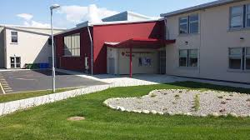

25th May 2020
To our pupils,
Usually at this time of year we would be thinking about end of year tests, getting excited about our upcoming school tour, talking about how to cope in secondary school and preparing for the big milestone of graduation.
We are conscious that your final days as pupils of Killeshin National School have been unusual and maybe, for some of you, worrying. It must feel very strange to be apart from your friends and teachers during your final days in primary school. We want you to know that we are thinking of you and your families at this time.
This booklet is a resource to help you reflect on your time as pupils of our school and to begin to look ahead to what life might be like as a secondary school student. You will find pages in which you can record your memories of Killeshin N.S. along with some advice for moving forward into your secondary schools.
Do contact us via Google Classroom with any queries or concerns.
We hope you are all keeping well.
Mrs. McGuill & Mrs. Mannion

Reflecting on My Time at School

My Friends  ________________________________  ________________________________  ________________________________  ________________________________  ________________________________  ________________________________  ________________________________  ________________________________  ________________________________  ________________________________ | My Teachers  ________________________________  ________________________________  ________________________________  ________________________________  ________________________________  ________________________________  ________________________________  ________________________________  ________________________________  ________________________________
Activities I enjoyed  ________________________________  ________________________________  ________________________________  ________________________________  ________________________________  ________________________________  ________________________________  ________________________________  ________________________________  ________________________________ | My favourite Memory of 6th Class  ________________________________  ________________________________  ________________________________  ________________________________  ________________________________  ________________________________  ________________________________  ________________________________  ________________________________  ________________________________

Reflecting on My Time at School
My Funniest Memory of School  ________________________________  ________________________________  ________________________________  ________________________________  ________________________________  ________________________________  ________________________________  ________________________________  ________________________________  ________________________________ | My Favourite School Trip  ________________________________  ________________________________  ________________________________  ________________________________  ________________________________  ________________________________  ________________________________  ________________________________  ________________________________  ________________________________
My Interests and Hobbies  ________________________________  ________________________________  ________________________________  ________________________________  ________________________________  ________________________________  ________________________________  ________________________________  ________________________________  ________________________________ | A Photograph of Me

My Achievements

The Achievements I am Proud of
__________________________________________________________________
__________________________________________________________________
__________________________________________________________________
__________________________________________________________________
__________________________________________________________________
__________________________________________________________________
__________________________________________________________________
__________________________________________________________________
__________________________________________________________________
__________________________________________________________________
__________________________________________________________________

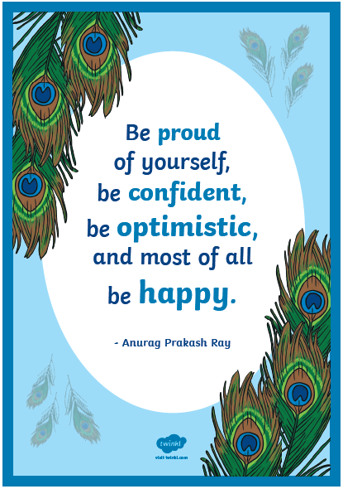
Finding out about my new school

Name of my school: _____________________________

Address: ________________________________________

Phone Number: _________________________________

School Website: _________________________________

Principal’s Name: _______________________________

School starts at ________ and finishes at _________

My New Subjects: _______________________________
__________________________________________________

I am looking forward to: ________________________
__________________________________________________
__________________________________________________
My Life in Secondary School
Finding my Way Around
Most 6th Class pupils feel nervous about secondary school because they are worried they might not be able to find their way around the new bigger building. They might feel worried about getting lost or being late for a class.
Secondary schools understand this and in most schools Meitheal leaders or prefects are assigned to new pupils to help them find their way around in the first days at their new school.

Timetable
One of the first pieces of information you will be given when you arrive at your new school will be your timetable. It is very important as it will tell you which lessons you will have each day. This will help you to get organised for your lessons and help you plan what books and copies you will need to have for each day.

Organisation
In secondary school you will have different teachers and different classrooms. This will be an exciting change but will mean you need to be organised for each lesson. Your French teacher won’t want to correct your homework in your English copy.
Use your timetable to help you plan what books and copies you will need to collect from your locker. It is a good idea to pack your bag the night before to make sure you have all of your homework prepared for the next day.

Homework and Study
In secondary school, more than one teacher will be responsible for setting homework. Homework will be set by your teachers during lessons. It is a good idea to make note of it in your homework diary straight away so you don’t forget it. You may not see all of your teachers every day but it is still a good idea to complete your homework on the day it is given to you so that you don’t forget it. Remember to check your timetable and homework diary each evening to make sure you have all the required homework complete for the next day.

You will find that tests are a more frequent part of school life now that you are in secondary school. No one enjoys tests but they are a part of every day school life and it’s important to learn how to cope with them.
Try to revise back over class work when completing your homework in the evening times. Your teachers will point out important things to learn. Revise over these important points. Regular study (a few minutes every evening) will help you to stay on top of your learning so that you don’t feel overwhelmed when it comes to test time.
Make a study timetable and stick to it. Take regular breaks / exercise and eat healthily. Make sure to get plenty of sleep.

It’s really important to ask for help from a trusted adult if you are ever feeling under pressure or upset about anything.
Talk to your teacher if you don’t understand the work.

Making Friends
Most pupils in primary school are very happy in their classes because they know everyone very well and feel like they belong. You might be nervous about making friends in your new school, particularly if your close friends are moving on to a different secondary school.
It’s important to know that lots of pupils will feel like this. It will take some time to get to know your new class mates but it is a great opportunity to make new friends.

Tips for making friends:
- Smile
- Introduce yourself and ask them their name
- Find out if they have any hobbies
- Talk about similar interests – you might both be interested in GAA or music
- Ask them if they would like to do something at lunchtime

It can be sad saying goodbye to friends you have been in school with for years but with modern technology it has never been easier to stay in touch. Keep in contact with old school friends and be open to making some new friends too.

We are proud to say you were pupils of Killeshin National School and look forward to hearing about all of your wonderful accomplishments in the future. We wish you the very best of luck on this new and exciting adventure and we are thinking of you always.

