Tuesday 2nd June

English
- Spelling block 1 & 2 pg. 66
- Word List
- Sound of ir,er,ur https://youtu.be/vhTdmBPL5hU

- Spellbound pg. 66
- Sounds like Phonics pg 73 & 75
- 1-2 pages in small Handwriting book
- Read Treasures in the Garden - See attachment for ebook on Google classroom.
- 5 pages each day
- Question your child about what they have read.
- Sequence the events of the pages.
- Discuss the actions/feelings of the characters.
- Predict what may happen next.
Maths
- Table Toppers pg. 54 Day 1
- Learn -10 tables
- Revise other tables by asking your child a variety of sums they have already completed. Please use the link below to assist with revising tables.
- Table Challenge
- Maths Time pg. 52 A, B &C

Subtraction
- Planet maths pg 120

Gaeilge
Ceacht 1: An Teilifís
● An Nuacht- Orally ask your child to tell you the news each day
Inniu an Luan. ( Today is Monday)
Inné an Déardaoin. ( Yesterday was Thursday)
Tá an lá……. grianmhar, fliuch, tirím, gaofar. ( Today is sunny, wet, dry, windy)
Chonaic mé…. ar maidin. ( I saw…. this morning)

● Rann - Haigh Didil, Didl

Haigh Didil Didil, An cat is an fhidil.
Léim an bhó thar an ré.
An madra beag donn,
Rinne sé gáire le fonn.
Is d’imigh an spúnóg ar strae. Revise this poem from last week.
Revise Irish songs and poems that your child knows- An Luascán, A Bhóin Dé, An Teach Bábóige, Tá Capall ag Seáinín, An Madra

New vocabulary
seomra suí- sitting room tolg- couch teilifís- telivision, lampa sa chúinne- lamp in the corner, bláthanna- flowers, raidió-radio ag éisteacht, listening, ar an talamh- on the ground, ag imirt cluiche-playing games, ar an ríomhaire- on the computer

Cómhra: (Listen to the speech bubble conversation) 1.1

Bhí na páistí sa seomra suí.
Bhí Mamaí agus Daidí ina suí ar an tolg.
Bhí siad ag féachaint ar an teilifís.
Bhí lampa sa chúinne.
Bhí bláthanna ar an mbord.
Bhí Niamh ina suí ar an tolg freisin.
Bhí raidió ag Niamh. Bhí sí ag éisteacht leis an raidió.
Bhí Oisín agus Liam ina suí ar an talamh.
Bhí siad ag imirt cluiche ar an ríomhaire.

Cluichí teanga

Use the attached picture to help teach vocabulary.
Play taispeáin dom…. show me
Feicim le mo shuilín….. I spy

Tasc éisteachta 1.1
Ag éisteacht- listening, ag féachaint- watching

SESE
- People in our school
- Discuss all the people that work in our school
- Match the name to the person
- Discuss ways we can make the school better when we return
- Small world pg 86 & 87

Word List
high | school
every | father
near | keep
add | tree
food | never
between | start
own | city
below | earth
country | eyes
plant | light

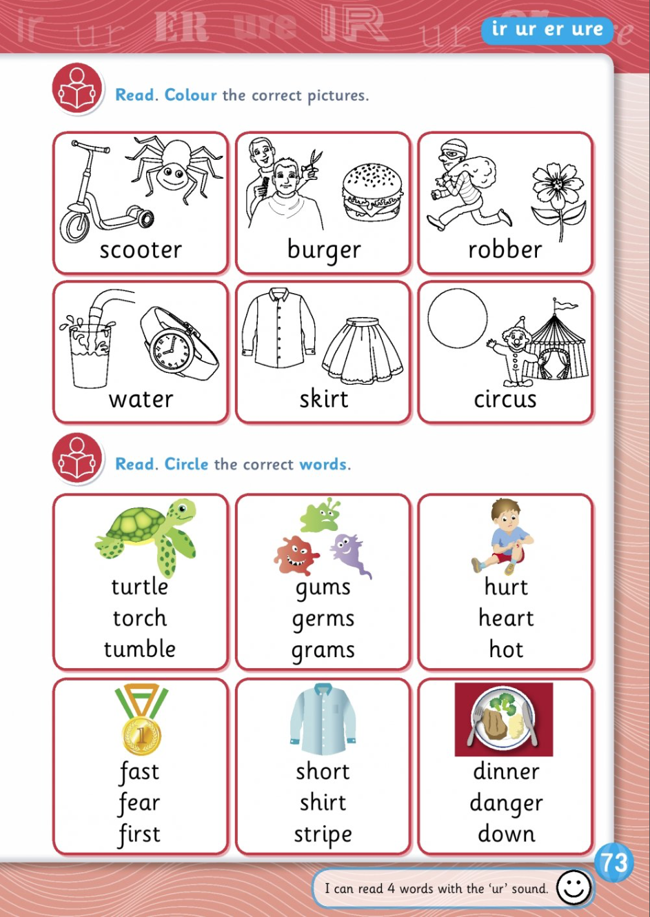

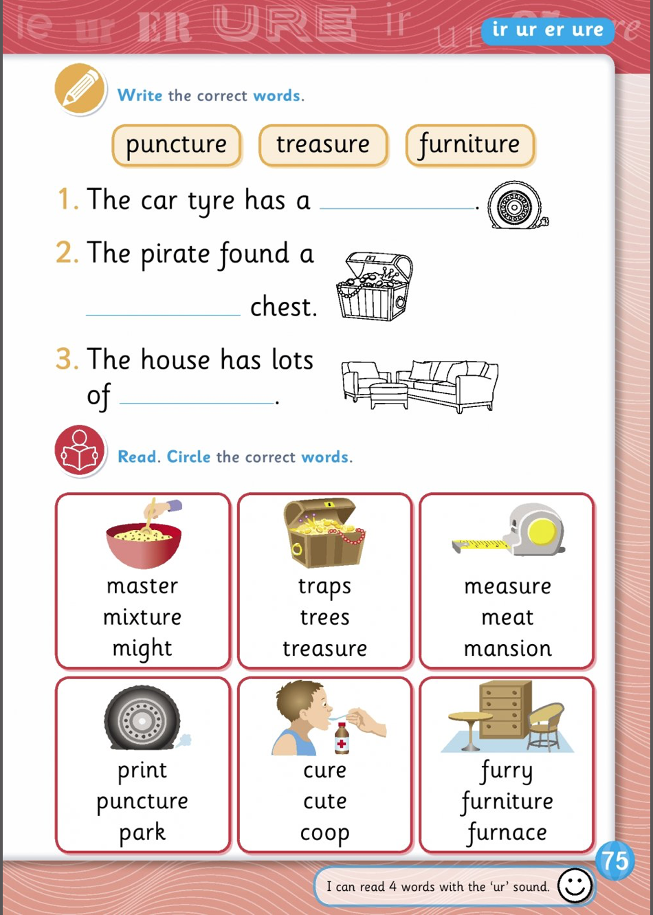

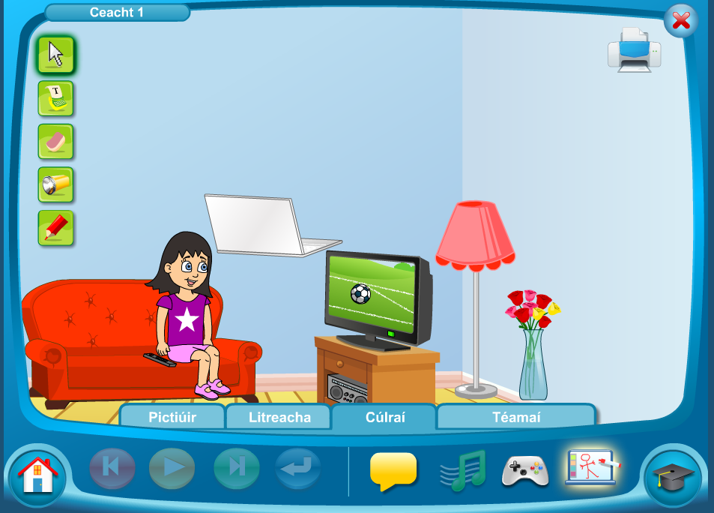

Wednesday 3rd June 2020
English
- Spelling block 3 pg. 66
- Word List
- 1-2 pages in small Handwriting book
- Spellbound pg 67
- Exercise your English pg 77
Read Treasures in the Garden? 5 pages
- Discuss the story with your child.
- Talk about the actions of the characters and why they acted that way.
- Predict what may happen next.
- Sequence the events of the story.
- Summarise the events of the pages
Maths
- Learn -10 tables
- Revise other tables by asking your child a variety of sums they have already completed. Please use the link below to assist with revising tables.
- Table Challenge link for game
- Table Toppers pg 54 Day 2
- Maths Time pg 53 D &E

Subtraction
- Planet Maths pg 132

Ceacht 1: An Teilifís
● An Nuacht- Orally ask your child to tell you the news each day
Inniu an Luan. ( Today is Monday)
Inné an Déardaoin. ( Yesterday was Thursday)
Tá an lá……. grianmhar, fliuch, tirím, gaofar. ( Today is sunny, wet, dry, windy)
Chonaic mé…. ar maidin. ( I saw…. this morning)

● Rann - Haigh Didil, Didl

Haigh Didil Didil, An cat is an fhidil.
Léim an bhó thar an ré.
An madra beag donn,
Rinne sé gáire le fonn.
Is d’imigh an spúnóg ar strae.
Revise Irish songs and poems that your child knows- An Luascán, A Bhóin Dé, An Teach Bábóige, Tá Capall ag Seáinín, An Madra

New vocabulary
seomra suí- sitting room tolg- couch teilifís- telivision, lampa sa chúinne- lamp in the corner, bláthanna- flowers, raidió-radio ag éisteacht, listening, ar an talamh- on the ground, ag imirt cluiche-playing games, ar an ríomhaire- on the computer
ag canadh- singing

- Cómhra: (Listen to the speech bubble conversation) 1.2

An raibh tú ___? Bhí mé/Ní raibh mé ___. (ag léim, ag damhsa, ag féachaint ar an teilifís, ag canadh, ag éisteacht leis an raidió)

Cluiche
Tasc Éisteachta 1.2: Cuir ___ sa seomra suí. (tolg, cófra, cathaoir) Cuir ___ (ríomhaire, bláthanna, raidió) ___ sa seomra suí. (ar an mbord, ar an mbord freisin, ar an gcófra, sa chúinne) Cluiche Kim: seomra suí, tolg, teilifís, cúinne, lampa, raidió, ríomhaire, bláthanna.

Bua na cainte pg 67

SESE
Natural materials
Discuss what your clothes are made from- check labels of your clothes
Watch the video about where materials come from?
https://www.bbc.co.uk/scotland/education/wwww/tech/flash/flash_index.shtml
Explain the words- natural, manufactured, silk, silkworm and cocoon.
Information on the silkworm;
https://www.enchantedlearning.com/subjects/butterfly/activities/printouts/silkworm.shtml
How silk is made-
https://www.youtube.com/watch?v=eqFm_7KyfHI
Small world pg 88
Use materials around the house to make artwork- houses, stone faces etc.
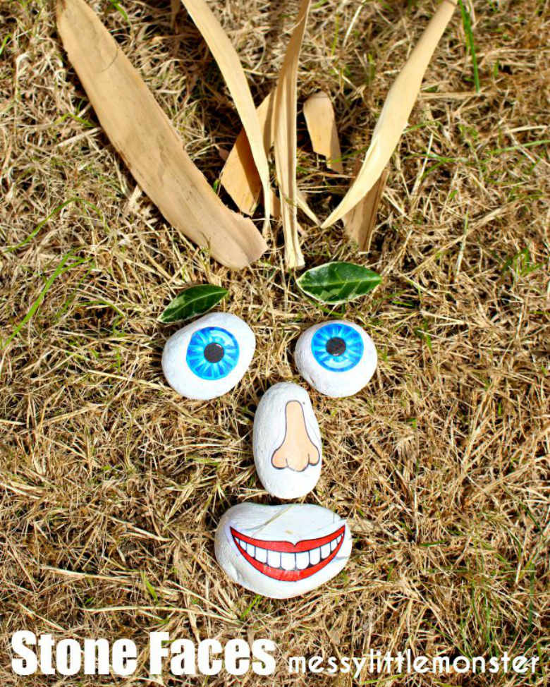

Thursday 5th June 2020
- Spelling block 4 pg. 66
- Word List
- Dictation-Parents please revise the sound “oi” with your child.
- Please say these words and sentences and ask children to write the following sentences without any help;
girl
herb
curb
water
circus
hurt
- The little boy went to the circus.
- The pirate had a ship.
- The turtle swam in the sea.
- Treasure in the Garden : Write what you imagine the fairy land in the story looks like using the template provided.
- 1-2 pages in small Handwriting book

Read Treasures in the Garden? 5 pages
- Discuss the story with your child.
- Talk about the actions of the characters and why they acted that way.
- Predict what may happen next.
- Sequence the events of the story.
- Summarise the events of the pages
Maths
- Learn -10 tables
- Revise other tables by asking your child a variety of sums they have already completed. Please use the link below to assist with revising tables.
- Table Challenge link for game
- Table Toppers pg 55 Day 3
- Maths Time pg 54 A,B &C

Subtraction

- Planet Maths 148

Gaeilge
Ceacht 2: An Teilifís
● An Nuacht- Orally ask your child to tell you the news each day
Inniu an Luan. ( Today is Monday)
Inné an Déardaoin. ( Yesterday was Thursday)
Tá an lá……. grianmhar, fliuch, tirím, gaofar. ( Today is sunny, wet, dry, windy)
Chonaic mé…. ar maidin. ( I saw…. this morning)

● Rann - Haigh Didil, Didl

Haigh Didil Didil, An cat is an fhidil.
Léim an bhó thar an ré.
An madra beag donn,
Rinne sé gáire le fonn.
Is d’imigh an spúnóg ar strae.

Revise Irish songs and poems that your child knows- An Luascán, A Bhóin Dé, An Teach Bábóige, Tá Capall ag Seáinín, An Madra

New vocabulary
- seomra suí- sitting room tolg- couch teilifís- telivision, lampa sa chúinne- lamp in the corner, bláthanna- flowers, raidió-radio ag éisteacht, listening, ar an talamh- on the ground, ag imirt cluiche-playing games, ar an ríomhaire- on the computer
- ag canadh- singing

Cómhra: (Listen to the speech bubble conversation) 2.1

- ‘Las ___.’ (an choinneal, an lampa, an solas)- light the lamp, light
- ‘Cuir/Ná cuir ___ ar siúl.’ (an teilifís, an raidió, an ríomhaire)- Put on/off the radio, ‘Ceart go leor.’

Cluiche
- Comhrá 2.1 Cuir/Ná cuir ___ ar siúl. (an ríomhaire, an teilifís, an raidió) Las ___, más é do thoil é. (an choinneal, an lampa, an solas) Ceart go leor.

Religion
Prayer:
Song: Listen to Baruch Atah https://vimeo.com/178440989 English translation- Blessed are you, lord our god, king of the universe.
Learn actions to the song.

Inter- religious education
Name the hijab as the clothing worn by some Muslim women and the kippah is the cap worn by some Jewish men
Identify a mezuzah.
Learn the word Bismilliah in arabic means- In the name of god

Grow in love pg 62 & 63

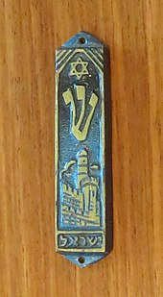

Mezuzah Kippah Hijab

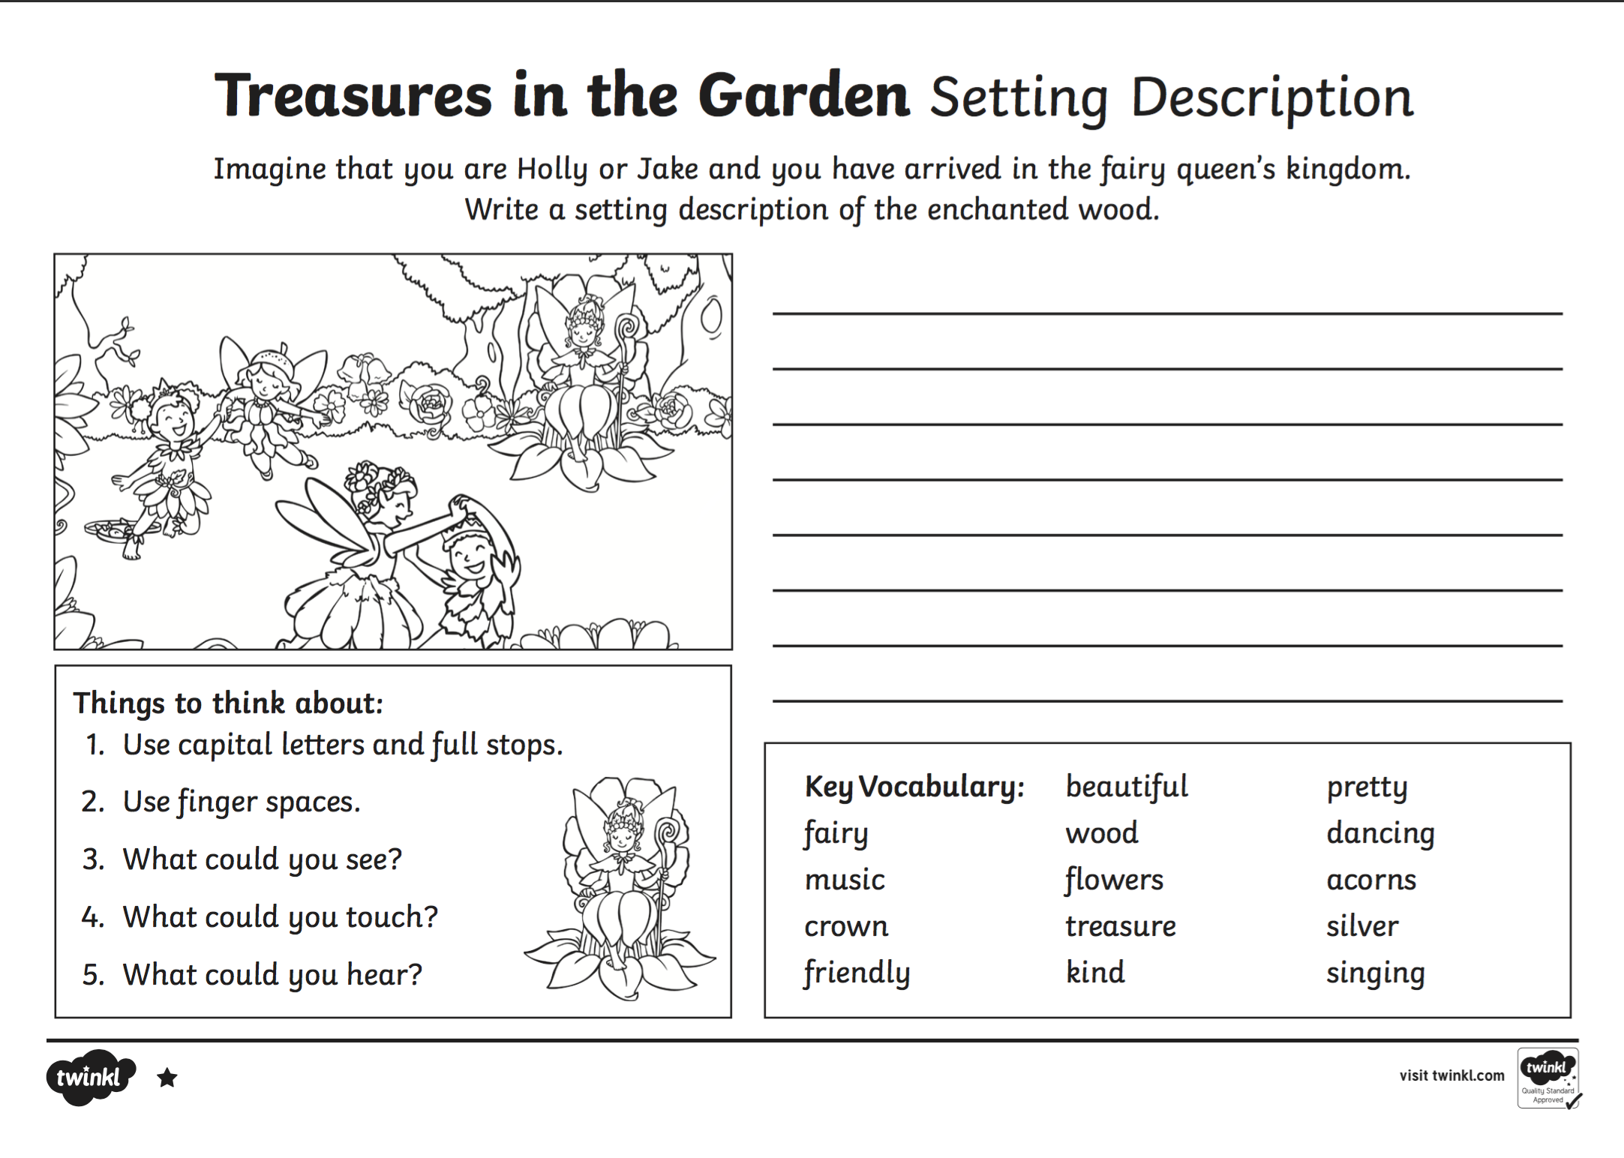

Friday 5th June 2020
English
- Spelling Test
- Word List
- 1-2 pages in small Handwriting book
Read Treasures in the Garden? ( 2 pages each day)
- Discuss the story with your child.
- Talk about the actions of the characters and why they acted that way.
- Predict what may happen next.
- Sequence the events of the story.
- Summarise the events of the pages

Maths
- Tables test
- Table Toppers pg 55 Day 4
- Maths Time pg 55 D & E

Subtraction

- Planet Maths page 149 & 150

Gaeilge
Gaeilge
Ceacht 2: An Teilifís
● An Nuacht- Orally ask your child to tell you the news each day
Inniu an Luan. ( Today is Monday)
Inné an Déardaoin. ( Yesterday was Thursday)
Tá an lá……. grianmhar, fliuch, tirím, gaofar. ( Today is sunny, wet, dry, windy)
Chonaic mé…. ar maidin. ( I saw…. this morning)

● Rann - Haigh Didil, Didl

Haigh Didil Didil, An cat is an fhidil.
Léim an bhó thar an ré.
An madra beag donn,
Rinne sé gáire le fonn.
Is d’imigh an spúnóg ar strae.

Revise Irish songs and poems that your child knows- An Luascán, A Bhóin Dé, An Teach Bábóige, Tá Capall ag Seáinín, An Madra

New vocabulary
- seomra suí- sitting room tolg- couch teilifís- telivision, lampa sa chúinne- lamp in the corner, bláthanna- flowers, raidió-radio ag éisteacht, listening, ar an talamh- on the ground, ag imirt cluiche-playing games, ar an ríomhaire- on the computer
- ag canadh- singing

Cómhra: (Listen to the speech bubble conversation) 2.2

- ‘Cuir an teilifís ar siúl, más é do thoil é.’ ‘Ardaigh an fhuaim.’ ‘Tá sé ró-íseal.’ - Turn on the television please. Turn up the volume, it is too low.
- ‘Beidh sé ag cur báistí inniu.’ ‘Ísligh an fhuaim.’ ‘Tá sé ró-ard.’ ‘Tá sé díreach ceart.’ Lower the volume, it is too high. That is just right.
- ‘Cad atá ar siúl ar an teilifís?’ ‘Tá ___ ar siúl.’ (an aimsir, an nuacht, clár spóirt, cartún, sorcas) What is on the television?
- ‘Athraigh an cainéal.’ Change the channel
- ‘Go hiontach.’ Wonderful.
Cluiche
- Tasc Éisteachta 2.2: Cuir an teilifís ar siúl. Ardaigh/Ísligh an fhuaim. Tá sé ___. (ró-íseal/ró-ard) Athraigh an cainéal. Múch an teilifís.
Art
Clowns
Use template attached to cut out a face.
Stick the face onto coloured paper or leave on the white paper if coloured paper is not available.
Create a clown face, hair, hat and a bow tie.
Use the images as a guide.
Give your clown a name and send pictures where possible.

