Subject | Monday | Tuesday | Wednesday | Thursday | Friday
Gaeilge | Téama: Bia  Le foghlaim (Learn and spell):  Briathra Neamhrialta | Téama: Bia  Revise Briathra Neamhrialta list.  Bí ag caint!  Talk about your favourite foods. Explain your likes, dislikes and preferences. Write 8 sentences using the sentence structure. | Téama: Bia  Revise Briathra Neamhrialta list.  Bí ag scríobh!  Design a menu for a restaurant. Include starters, main courses and desserts. | Téama: Bia  Revise Briathra Neamhrialta list.  Bí ag léamh!  Read the restaurant menu and answer the comprehension questions. | Téama: Bia  Revise Briathra Neamhrialta list.  Am don Léamh 6  Read pg 44 and answer the questions on page 45.  (Also available online at folens.ie)  Online dictionaries  https://www.teanglann.ie/en/  https://www.focloir.ie/
English | Learn Spellings  Vocabulary: Write the sentences from Activity A and complete the sentences using words from the spelling list  Choose a novel to read. | Learn Spellings  Grammar: Making words plural. Add s, es or ies to change the words in Activity B from singular to plural.  - See power point on Google Classroom for lessons on plurals  Continue reading novel of choice. | Learn Spellings  Grammar: A homophone is a word that sounds the same but has different spellings and meanings. Write a homophone for each word in Activity C  Continue reading novel of choice. | Learn Spellings  Comprehension: Read the piece on Activity D and answer the comprehension questions.  Continue reading novel of choice. | Learn Spellings / Spelling Test  Writing Biographies:  Choose a famous person and write a biography. Aim to write a minimum of 15 sentences.  **Don’t forget that you can type it in a word document and attach it as a file in Google Classroom if you wish.  Continue reading novel of choice.
Subject | Monday | Tuesday | Wednesday | Thursday | Friday
Maths | Tables: x10  Learn Fractions, Decimals and Percentages chart. | Tables: ÷10  Learn Fractions, Decimals and Percentages chart.  Activity C in Resource Document: Mental Maths | Tables: x11  Learn Fractions, Decimals and Percentages chart.  Activity D in Resource Document: Mental Maths | Tables: ÷11  Learn Fractions, Decimals and Percentages chart.  Activity E in Resource Document: Mental Maths | Tables: Revise all  Learn Fractions, Decimals and Percentages chart.  Activity F in Resource Document: Mental Maths
Other Lessons | History: Local History  Choose a local site of historical significance and write a short piece about it. Draw a picture.  Some ideas:  - The Romanesque Doorway  - The Dolmen  - Carlow Castle  - Duckett’s Grove | Geography: Maps  Draw an aerial view map of your local area. Identify areas of interest on your map (school, church, shops, sports facilities, river, historical sites, etc.) | Science / SPHE: Healthy Eating  Research the food pyramid and design a healthy, balanced daily menu.  - See power point on Google Classroom for lesson on the Food Pyramid. | Religion: Reflecting on Easter  Read the piece and write or draw a picture showing how your faith gives you hope. | Art: Still-life drawing  Still life: Choose a fruit or vegetable at home and draw and colour.

Gaeilge: Téama: Bia
- Monday: Le foghlaim (To learn): Briathra Neamhrialta
Dearfach () | Diúltach ()
Bhí mé | Ní raibh mé
Chonaic mé | Ní fhaca mé
Chuaigh mé | Ní dheachaigh mé
Dúirt mé | Ní dúirt mé
Fuair mé | Ní bhfuair mé
Rinne mé | Ní dhearna mé
Chuala mé | Níor chuala mé
D’ith mé | Níor ith mé
Rug mé | Níor rug mé
Tháinig mé | Níor tháinig mé
Thug mé | Níor thug mé

- Tuesday: Bí ag caint!
(Talk about your favourite foods. Explain your likes, dislikes and preferences. Write 8 sentences using this vocabulary.)

Is maith liom … I like…
Ní maith liom… I don’t like…
Is fearr liom… I prefer…
Ba mhaith liom…le do thoil. I would like…please.

- Wednesday: Bí ag scríobh!

(Design a menu for a restaurant)

Réamhchúrsaí (Starters)

Príomhchúrsaí (Main courses)

Milseoga (Desserts)

Deochanna (Drinks)

- Thursday: Bí ag léamh!

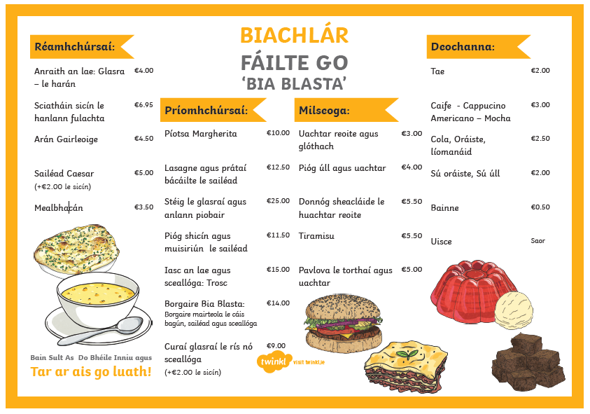

Ceisteanna
- Cad is ainm don bhialann seo?
- Cén sort anraith atá ar fail inniu?
- Cad atá ar fáil leis an stéig don phríomhchúrsa?
- Cad atá sa ‘Bhorgaire Bia Blasta’?
- Ba mhaith liom sicín. Cad atá ar fail dom don phríomhchúrsa?
- Céard í an mhilseog is saoire (cheapest) ar an mbiachlár?
- Cén praghas atá ar an arán gairleoige agus curaí sicín?
- Cén praghas atá ar anraith agus stéig?

- Friday: Am do Léamh pg 44-45
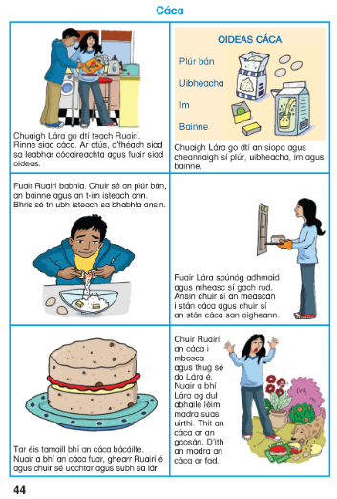
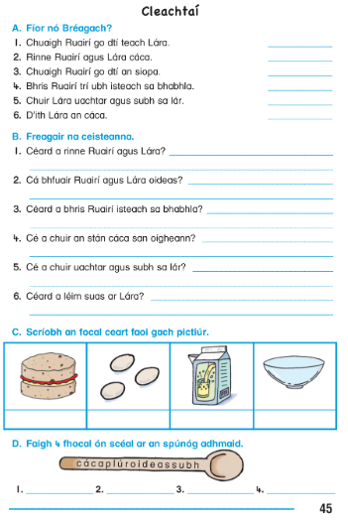
English
Spelling List
Monday | Tuesday | Wednesday | Thursday
completely  equipped  difference  business | absence  guarantee  temperature  recommend | especially  occurred  spontaneous  fascinating | category  privilege  accidentally  advertisement

- Monday: Vocabulary
Write the missing word using the spelling list
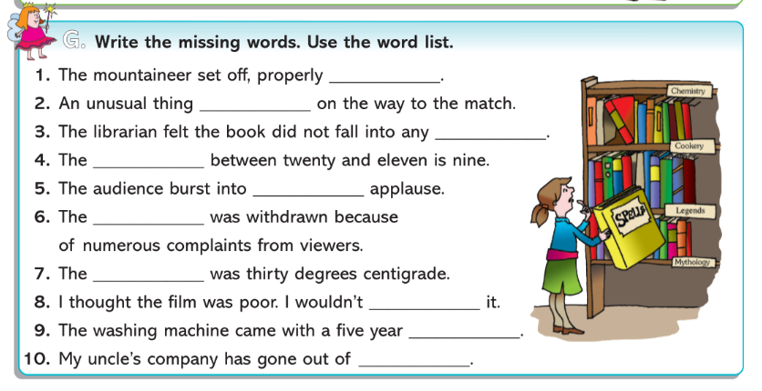

- Tuesday: Grammar: Plurals (More than one)
Add es, s or ies to make these words plural.
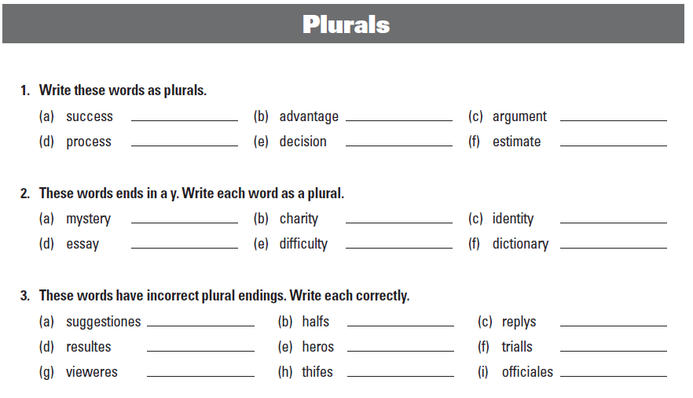
- Wednesday: Grammar: Homophones
Homophones are words that sound the same but have different spellings and meanings. E.g. fair and fare
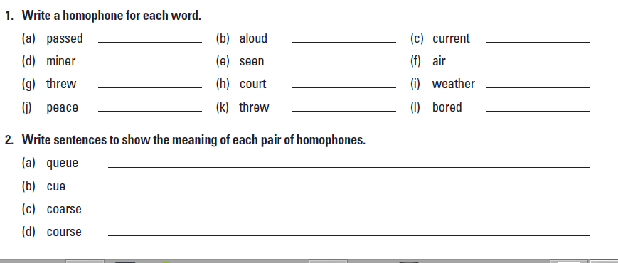
- Thursday: Reading: Comprehension
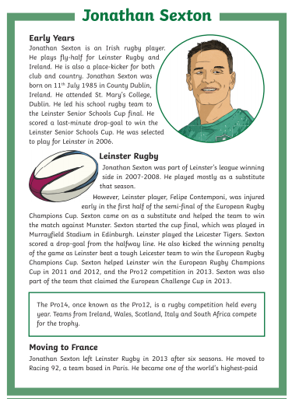
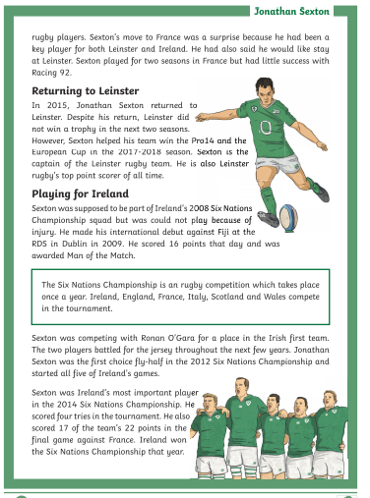
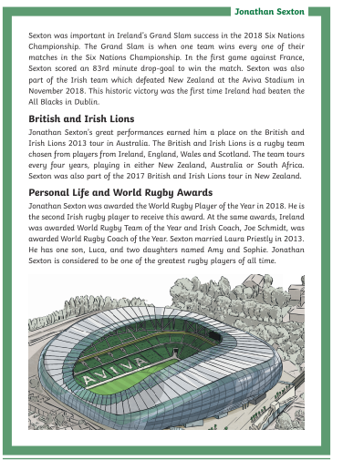
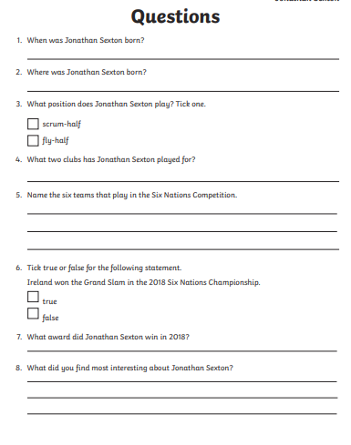

- Friday: Writing: Biographies
Choose a famous person and write a biography. Use the following prompts to structure your writing:
- Early life and family
- Interesting facts
- Difficulties they have overcome
- Personal achievements

Maths
- Tables: x/÷ 10,11

- To learn: Fraction, Decimal and Percentage Chart

Fraction | Decimal | Percentage
1/4 | 0.25 | 25%
1/2 | 0.50 | 50%
3/4 | 0.75 | 75%
1/3 | 0.333 | 33 1/3%
2/3 | 0.666 | 66 2/3%
1/5 | 0.20 | 20%
2/5 | 0.40 | 40%
3/5 | 0.60 | 60%
4/5 | 0.80 | 80%

- Tuesday
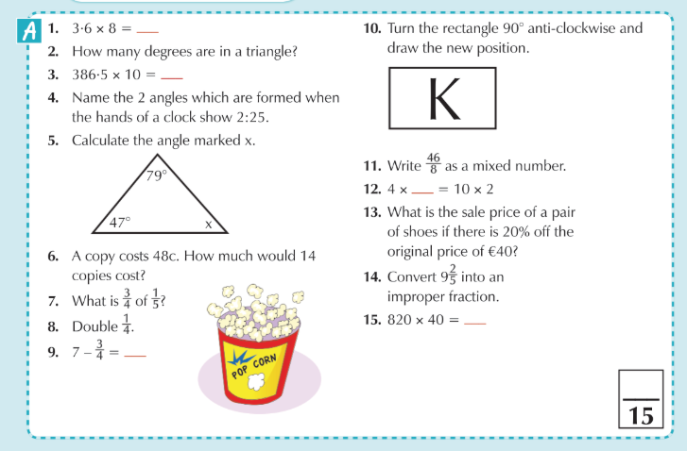

- Wednesday
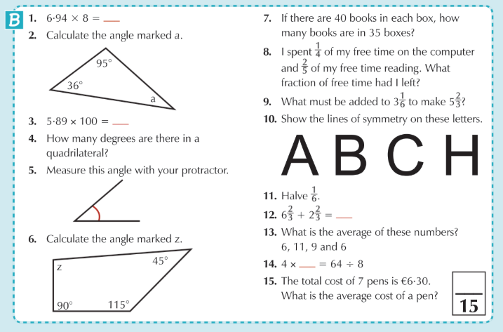

- Thursday
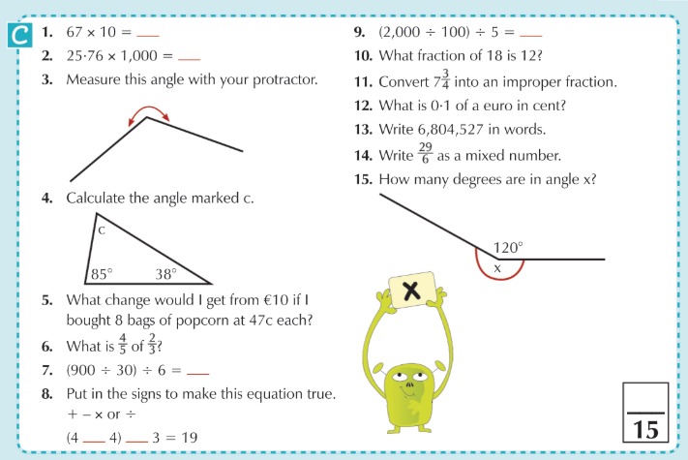

- Friday
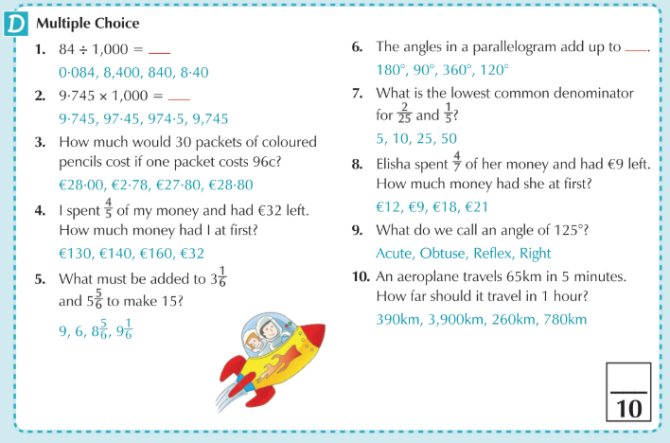

Monday: History

Choose a local site of historical significance and write a short piece about it. Draw a picture.

Some ideas:
- The Romanesque Doorway
- The Dolmen
- Carlow Castle
- Duckett’s Grove
Tuesday: Geography
Draw an aerial view map of your local area. Identify areas of interest on your map (school, church, shops, sports facilities, river, historical sites, etc.)
Wednesday: Science / SPHE
Healthy eating: Research the food pyramid and design a healthy, balanced daily menu.
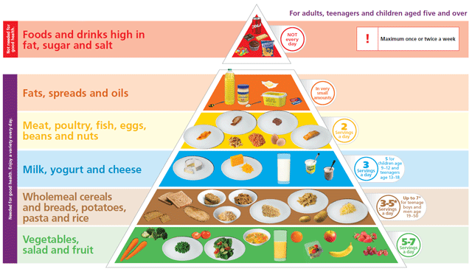

Thursday: Religion
Read the following piece. Write or draw a picture showing how your faith gives you hope.
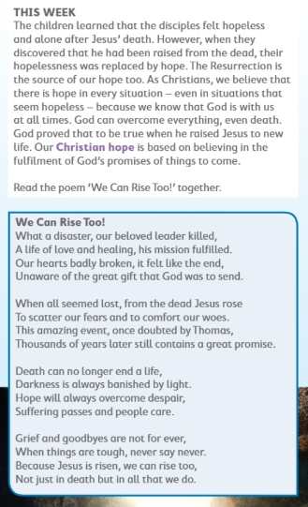

Friday:
Still life drawing: Choose a fruit or vegetable and draw and colour using materials of your choice (pencils, crayon, chalk, paint)
Examples:
