Monday 25th May

English
- Spelling block 1 pg. 64
- Word List
- Sounds of the Week is orhttps://www.youtube.com/watch?v=-48G217E0fQ

- Sounds like phonics pg 70&71 (worksheet below)
- Spellbound pg. 64
- Complete the or sound worksheet
- Read Who’s at the Zoo- See attachment for ebook on Google classroom.
- Question your child about what they have read.
- Sequence the events of the pages.
- Discuss the actions/feelings of the characters.
- Predict what may happen next.
Maths
- Table Toppers pg. 52 Day 1
- Learn -9 tables
- Revise other tables by asking your child a variety of sums they have already completed. Please use the link below to assist with revising tables.
- Table Challenge
- Maths Time pg. 47 D & E

Addition
- Please watch the video on Google classroom before starting your work.
- Planet maths pg 137

Gaeilge
Bua na cainte- download resources
Bua na Cainte
Username: trial
Password: trial
Ceacht 9- Sa Bhaile
● An Nuacht- Orally ask your child to tell you the news each day
Inniu an Luan. ( Today is Monday)
Inné an Déardaoin. ( Yesterday was Thursday)
Tá an lá……. grianmhar, fliuch, tirím, gaofar. ( Today is sunny, wet, dry, windy)
Chonaic mé…. ar maidin. ( I saw…. this morning)

● Rann –
Mo Mhadra
Sin é mo mhadra Ina shuí ar an stól.
Bíonn sé ag ithe.
Bíonn sé ag ól.
Ólann sé bainne.
Itheann sé cnámh.
Bíonn sé ag tafann
Nuair a bhíonn sé lán.

- Revise this poem from last week.
Revise Irish songs and poems that your child knows- An Luascán, A Bhóin Dé, An Teach Bábóige, Tá Capall ag Seáinín

New vocabulary
féar- grass, cnámh- bone, leitís- lettuce, stól-stool- ar an stól-on the stool, faoin stól- under the stool, sa bhosca- in the box

Cómhra: (Listen to the speech bubble conversation)

- Cad a itheann ___? (an capall, an madra, an cat, an coinín) Itheann an capall féar. Itheann an madra cnámh. Itheann an cat iasc. Itheann an coinín leitís.

Games- Bua na cainte
Tasc Éisteachta 9.1: Itheann an coinín leitís. Itheann an bhó féar. Itheann an cat iasc. Itheann an madra cnámh.
Tasc Éisteachta 9.2: Bíonn an madra ___. (ag ithe, ag ól, ag tafann, ag caoineadh, ag dul a chodladh)
SESE
Irish wild flowers
- Small world page 84
- In your Small world project copy, pick your favourite flower from your garden or from a walk and stick it onto your copy and then describe it .
- Name it
- Describe the colour
- How many petals does it have.

Word List
use | sit
fast | which
say | carry
light | fall
pick | small
hurt | under
pull | read
cut | why
kind | own
both | found

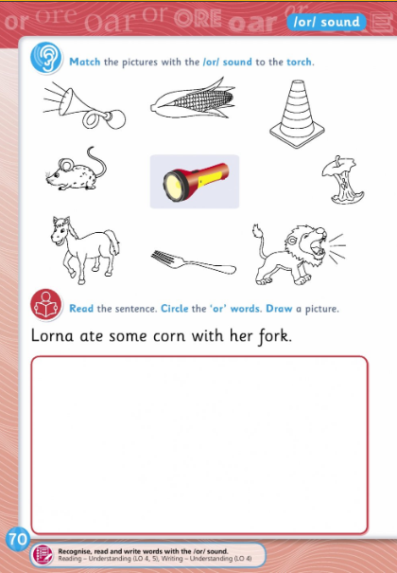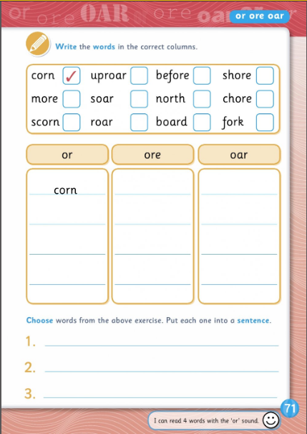

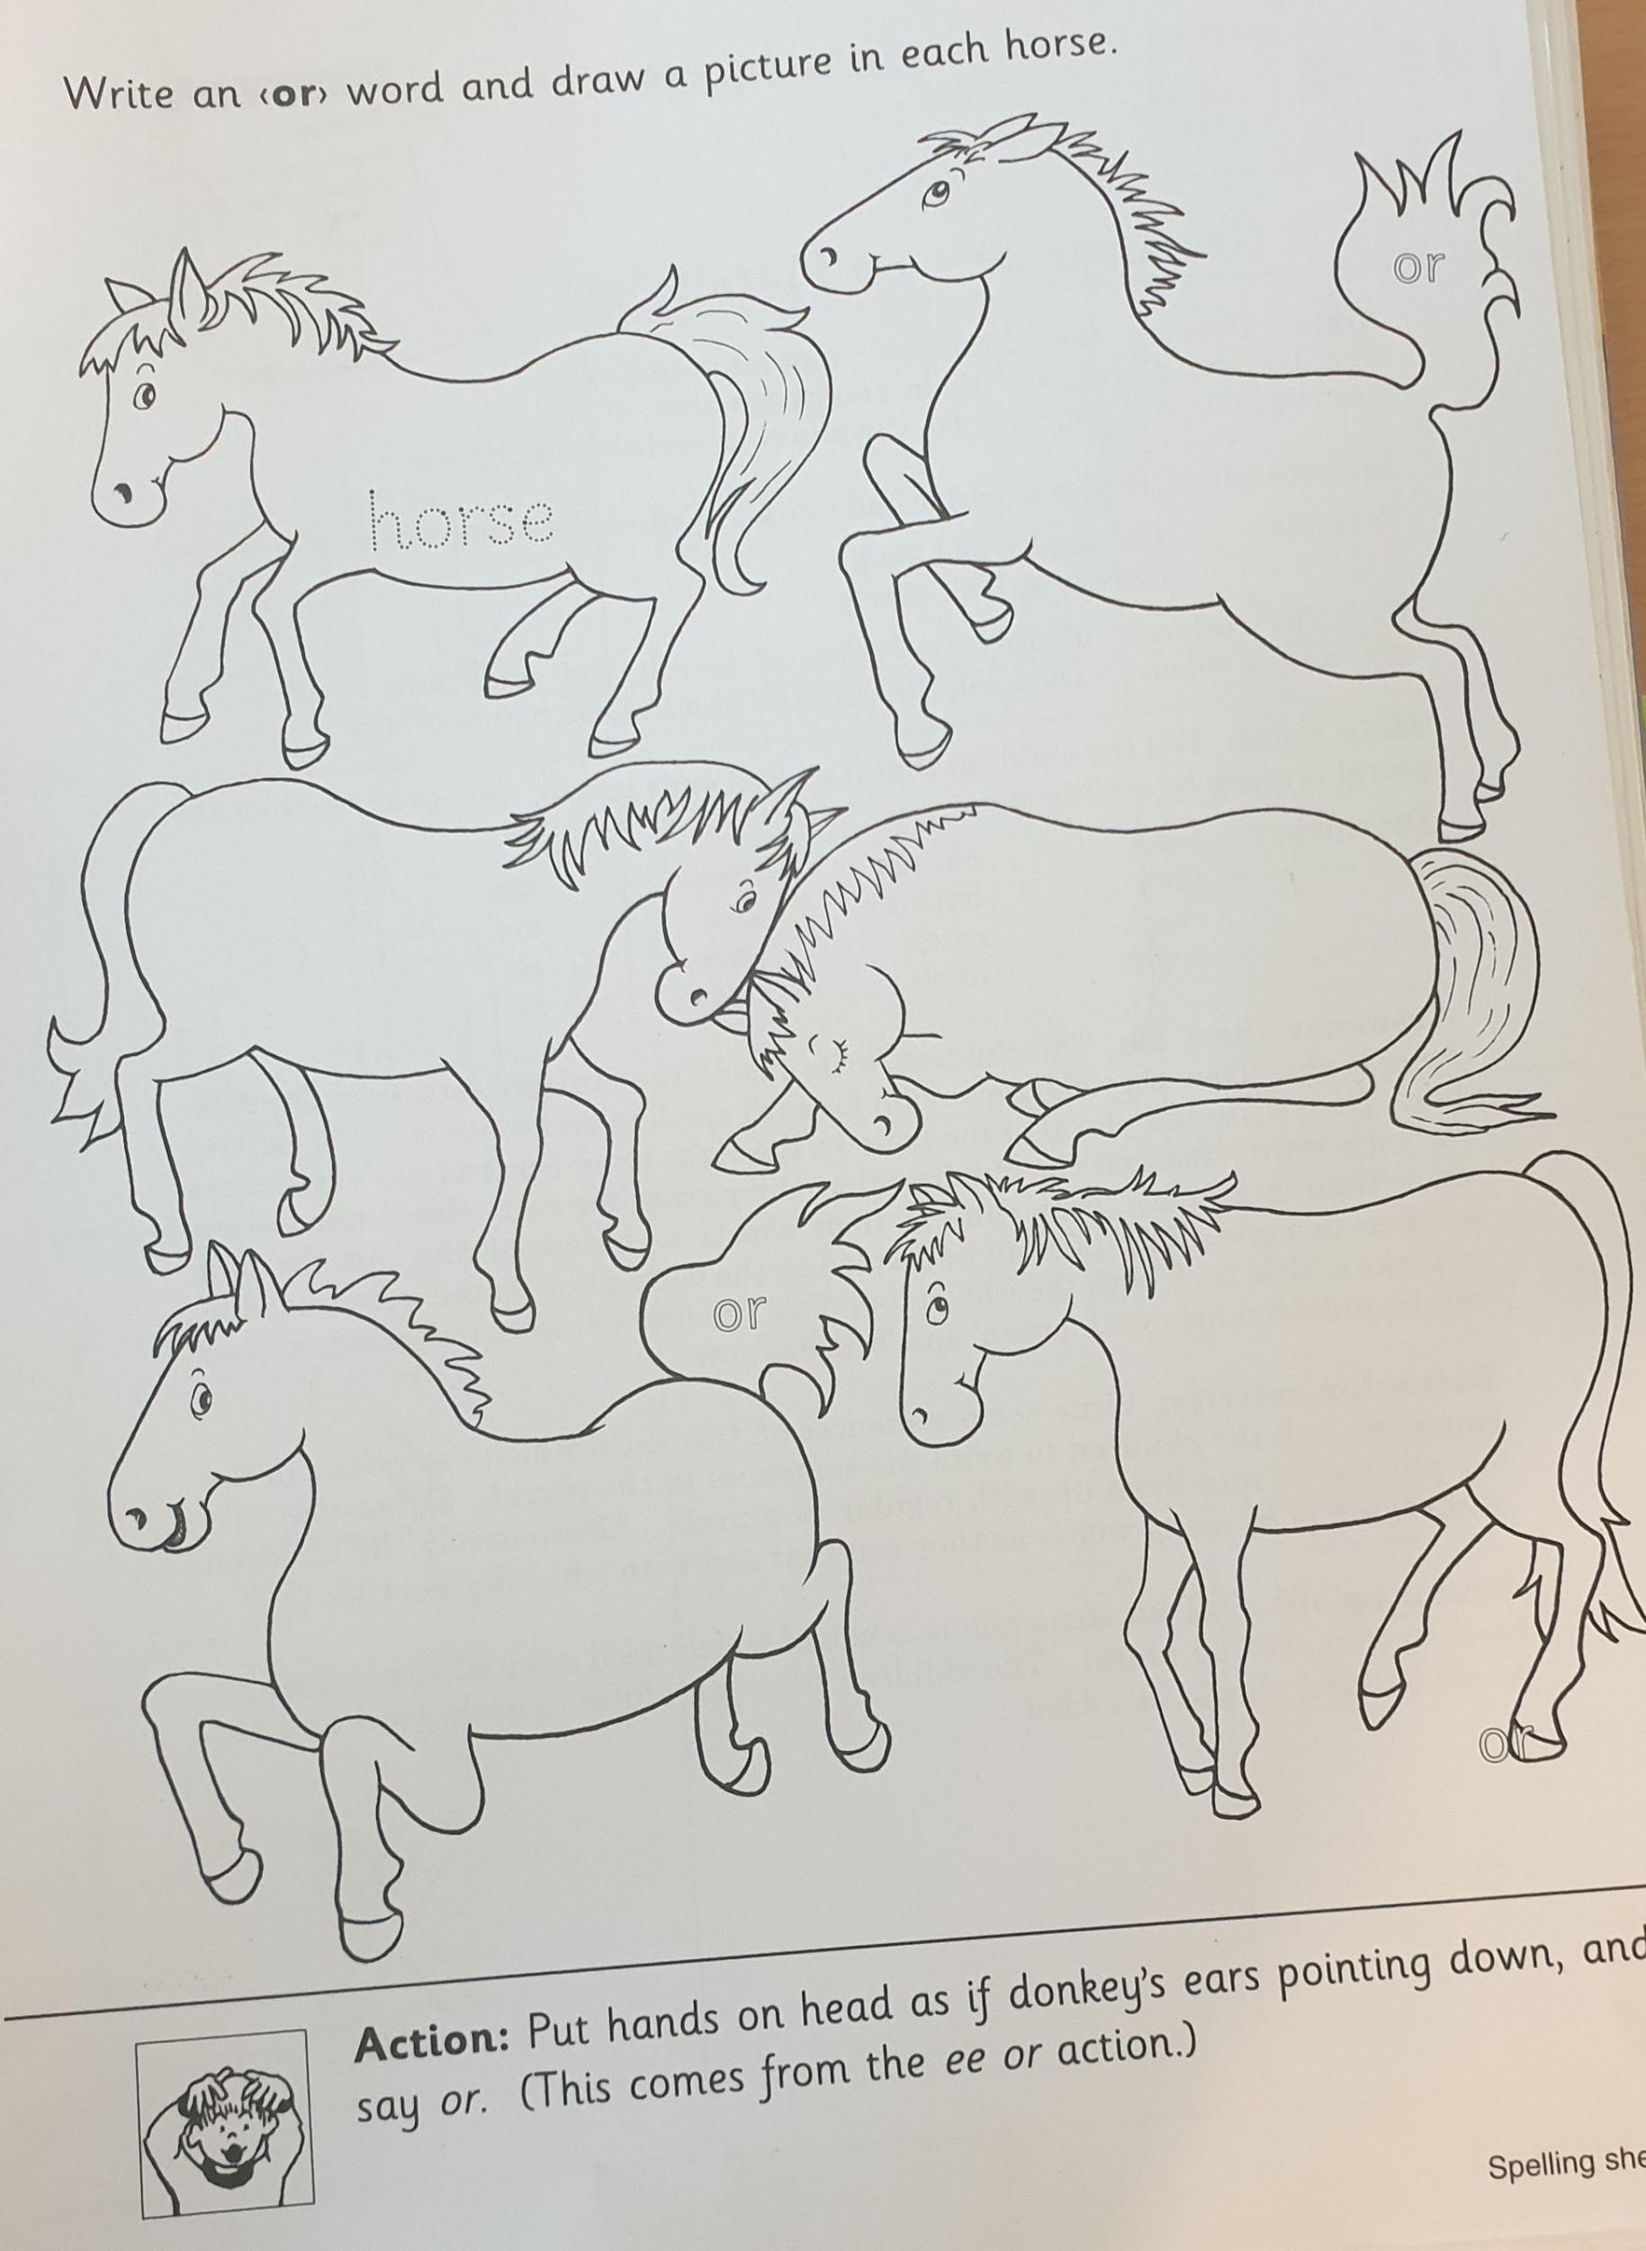

Tuesday 26th May 2020
English
- Spelling block 2 pg. 64
- Word List
- Plurals- see slideshow on Google classroom
- Make these singular words into plurals;

bunch  catch  ditch  class  pass  six  fix | wish  church  dress  box  crash  brush  fox

- Spellbound pg 65
Read Who’s at the Zoo?
- Discuss the story with your child.
- Talk about the actions of the characters and why they acted that way.
- Predict what may happen next.
- Sequence the events of the story.
- Summarise the events of the pages
Maths
- Learn -9 tables
- Revise other tables by asking your child a variety of sums they have already completed. Please use the link below to assist with revising tables.
- Table Challenge link for game
- Table Toppers pg 52 Day 2
- Maths Time pg 48 A,B & C

Addition
- Planet Maths pg 138

Gaeilge
Ceacht 9- Sa Bhaile
● An Nuacht- Orally ask your child to tell you the news each day
Inniu an Luan. ( Today is Monday)
Inné an Déardaoin. ( Yesterday was Thursday)
Tá an lá……. grianmhar, fliuch, tirím, gaofar. ( Today is sunny, wet, dry, windy)
Chonaic mé…. ar maidin. ( I saw…. this morning)

● Rann –
Mo Mhadra
Sin é mo mhadra Ina shuí ar an stól.
Bíonn sé ag ithe.
Bíonn sé ag ól.
Ólann sé bainne.
Itheann sé cnámh.
Bíonn sé ag tafann
Nuair a bhíonn sé lán.

- Revise this poem from last week.
Revise Irish songs and poems that your child knows- An Luascán, A Bhóin Dé, An Teach Bábóige, Tá Capall ag Seáinín

New vocabulary

féar- grass, cnámh- bone, leitís- lettuce, stól-stool- ar an stól-on the stool, faoin stól- under the stool, sa bhosca- in the box
Cómhra: (Listen to the speech bubble conversation)

- Cad a itheann ___? (an capall, an madra, an cat, an coinín) Itheann an capall féar. Itheann an madra cnámh. Itheann an cat iasc. Itheann an coinín leitís.

Games- Bua na cainte
Tasc Éisteachta 9.3: Cá bhfuil an madra? Tá an madra ___. (ag an doras, ar an stól, faoin stól, sa bhosca)

Draw pictures of all the animals they know on paper or a whiteboard. Play headbands in irish. Place the picture on your head and guess the animal.

An…… é? Sea is…. é. Ní hea, ní…. é. Is it ….. Yes it is… or No it isn’t……

SESE
Summer
- Small world pg 85
- Summer senses poem, you can use the attached worksheet or write the poem in your Small world Project copy.

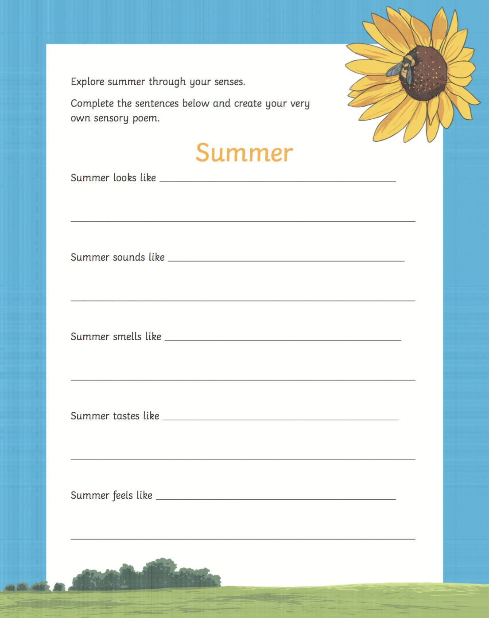

Wednesday 27th May 2020
- Spelling block 3 pg. 62
- Word List
- Dictation-Parents please revise the sound “oi” with your child.
- Please say these words and sentences and ask children to write the following sentences without any help;
corn
sort
worn
torch
for
sport
- The old farmer cut the corn on Saturday.
- I will sort those forks out in the morning.
- There is going to be a horrid storm, called Thor.
- Exercise your English pg 76

Read Who’s at the zoo?
- Discuss the story with your child.
- Talk about the actions of the characters and why they acted that way.
- Predict what may happen next.
- Sequence the events of the story.
- Summarise the events of the pages
Maths
- Learn -9 tables
- Revise other tables by asking your child a variety of sums they have already completed. Please use the link below to assist with revising tables.
- Table Challenge link for game
- Table Toppers pg 53 Day 3
- Maths Time pg 49 D & E

Addition
- Please watch video on Google classroom before starting your Planet Maths work
- Planet Maths 139

Gaeilge
Ceacht 10- Sa Bhaile
● An Nuacht- Orally ask your child to tell you the news each day
Inniu an Luan. ( Today is Monday)
Inné an Déardaoin. ( Yesterday was Thursday)
Tá an lá……. grianmhar, fliuch, tirím, gaofar. ( Today is sunny, wet, dry, windy)
Chonaic mé…. ar maidin. ( I saw…. this morning)

● Rann –
Mo Mhadra
Sin é mo mhadra Ina shuí ar an stól.
Bíonn sé ag ithe.
Bíonn sé ag ól.
Ólann sé bainne.
Itheann sé cnámh.
Bíonn sé ag tafann
Nuair a bhíonn sé lán.

- Revise this poem from last week.
Revise Irish songs and poems that your child knows- An Luascán, A Bhóin Dé, An Teach Bábóige, Tá Capall ag Seáinín

New vocabulary

féar- grass, cnámh- bone, leitís- lettuce, stól-stool- ar an stól-on the stool, faoin stól- under the stool, sa bhosca- in the box
Cómhra: (Listen to the speech bubble conversation)

- An Nuacht- ‘Cén lá atá ann inniu?’ ‘Inniu ___.’ ‘Inné ___.’ ‘Amárach ___.’

Games- Bua na cainte
An...é?- Bua na cainte

Lch 65 An Nuacht

Religion
Prayer:
Song: Listen to “Love one another” Lullaby https://vimeo.com/173033105

- Watch the video to hear the message Jesus gave his apostles
- https://vimeo.com/202407629
- Discuss with your child how they can live Jesus’ message of “Love one another as I have loved you”
- Help them make a list of how they can show love to their friends and family.
- Draw a picture of you showing love to your family and friends.

Thursday 28th May 2020
English
- Spelling block 4 pg. 64
- Word List
- Comprehension - The Lion and the Mouse
Read Who’s at the Zoo? ( 2 pages each day)
- Discuss the story with your child.
- Talk about the actions of the characters and why they acted that way.
- Predict what may happen next.
- Sequence the events of the story.
- Summarise the events of the pages

Maths
- Learn -9 tables
- Revise other tables by asking your child a variety of sums they have already completed. Please use the link below to assist with revising tables.
- Table Challenge link for game
- Table Toppers pg 53 Day 4
- Maths Time pg 50 A,B &C

Addition

- Planet Maths page 140 & 141

Gaeilge
Gaeilge
Ceacht 10- Sa Bhaile
● An Nuacht- Orally ask your child to tell you the news each day
Inniu an Luan. ( Today is Monday)
Inné an Déardaoin. ( Yesterday was Thursday)
Tá an lá……. grianmhar, fliuch, tirím, gaofar. ( Today is sunny, wet, dry, windy)
Chonaic mé…. ar maidin. ( I saw…. this morning)

● Rann –
Mo Mhadra
Sin é mo mhadra Ina shuí ar an stól.
Bíonn sé ag ithe.
Bíonn sé ag ól.
Ólann sé bainne.
Itheann sé cnámh.
Bíonn sé ag tafann
Nuair a bhíonn sé lán.

- Revise this poem from last week.
Revise Irish songs and poems that your child knows- An Luascán, A Bhóin Dé, An Teach Bábóige, Tá Capall ag Seáinín

New vocabulary

féar- grass, cnámh- bone, leitís- lettuce, stól-stool- ar an stól-on the stool, faoin stól- under the stool, sa bhosca- in the box
Cómhra:
Cad é sin? Sin…. teach gairdín, srl

Games- Bua na cainte
An scéal- Na Trí Muc
Revision for children
Listen to the story and ask questions about the picture on pg 66.
Cad é sin? Sin….
Try to name all the objects in the picture.

PE
Take part in this dance lesson https://youtu.be/JWTyO8npkOQ
OR
Pick your favouite song and make up your own dance to it.

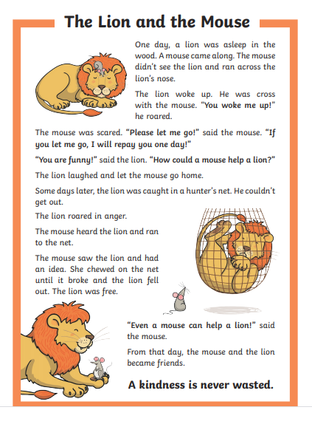

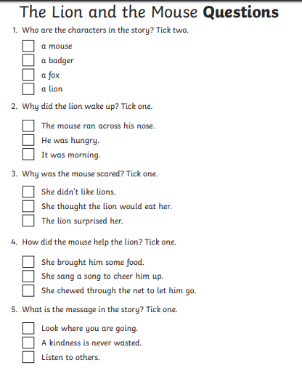

Friday 29th May 2020
English
Spelling Test
Word List Test
- Novel Activity for Jasper Saves the Day
- Book review for Jasper Saves the Day. (Template below or write in copy)
Maths
Tables Test
Maths Time pg 51 D & E
Planet Maths pg 142 (please complete part C in your Maths copies)
Gaeilge
Ceacht 10- Sa Bhaile
● An Nuacht- Orally ask your child to tell you the news each day.
Inniu an Luan. ( Today is Monday)
Inné an Déardaoin. ( Yesterday was Sunday)
Tá an lá……. grianmhar, fliuch, tirím, gaofar. ( Today is sunny, wet, dry, windy)
Chonaic mé…. ar maidin. ( I saw…. this morning)

· Revise Irish songs and poems that your child knows- An Luascán, A Bhóin Dé, An Teach Bábóige, An Chircín Rua, Tá capall ag Seáinín.

Act out the story- Na Trí Mhuc using finger puppets, accompany the story on Bua na Cainte.
Lig isteach mé- let me in
Ní ligfidh mé, ní ligfidh mé, ni ligfidh mé isteach thú- I won’t let you in.
Shéid sé- he blew
Leag sé an teach….adhmaid, tuí

Music
- Sing along with the song “I love Summertime”
- https://youtu.be/Xg5i9rxxuJM
- Can you list all of things that singer loves in the song?

