Subject  ** Special Note: Some work has been included for Monday for those who wish to avail of it but do note that Monday 4th of May is a bank holiday. | Monday  Bank Holiday | Tuesday | Wednesday | Thursday | Friday
Gaeilge | Téama: Éadaí: An Gorta  Litriú (Spellings)  Am do Léamh  Bí ag scríobh  Scríobh amach na habairtí agus líon na bearnaí | Téama: Éadaí: An Gorta  Litriú (Spellings)  Am do Léamh  Bí ag Léamh!  Am don Léamh  Read and answer the questions.  Online dictionaries  https://www.teanglann.ie/en/  https://www.focloir.ie/ | Téama: Éadaí: An Gorta  Litriú (Spellings)  Am do Léamh  Gramadach  Revise Briathra Neamhrialta (irregular verbs) and choose the correct verb to fill in the blanks.  (Aimsir Chaite – Past Tense) | Téama: Éadaí: An Gorta  Litriú (Spellings)  Am don Léamh  Gramadach  Revise Briathra Neamhrialta (irregular verbs) and choose the correct verb to fill in the blanks.  (Aimsir Fháistineach – Future Tense) | Téama: Éadaí: An Gorta  Litriú (Spellings)  Am don Léamh  Gramadach  Revise Briathra Neamhrialta (irregular verbs) and choose the correct verb to fill in the blanks.  (Aimsir Láithreach – PresentTense)
English | Learn Spellings  Vocabulary: Write the sentences from Activity A and complete the sentences using words from the spelling list  Reading  By the North Star: Toys Aren’t Us pg 160  (The class reader is available at https://edcolearning.ie/)  Choose a novel to read. | Learn Spellings  Vocabulary Devlopment / Phonics (tion, cian)  Write the sentences from Activity B and fill in the blanks using words from the box  Reading  By the North Star pg 161  Continue reading novel | Learn Spellings  Grammar  Adjectives are describing words. They give us more information and make our writing more interesting. Write out the sentences and underline the adjectives.  Reading  By the North Star pg 162  Continue reading novel | Learn Spellings  Comprehension  Complete the comprehension questions based on the reading Toys Aren’t Us pg 160-163  Online dictionary  https://dictionary.cambridge.org/  Reading  By the North Star pg 163  Continue reading novel | Spelling Test  Writing  Book review: Write a book review for a novel you have read recently.  Reading  By the North Star pg 160-163: Revise  Continue reading novel
Subject | Monday | Tuesday | Wednesday | Thursday | Friday
Maths | Tables: x2  Activity A  Fractions: Finding the whole number if given a fraction | Tables: ÷2  Activity B  Fractions: Multiplying fractions  https://www.youtube.com/watch?v=V3sW3wtUuYc | Tables: x3  Activity C Fractions:  Dividing fractions | Tables: ÷3  Activity D  Fractions:  Problem solving with fractions | Tables: Revise  Activity E  Fractions:  Fractions and the unitary method
 | History: The Famine  Read the ‘Famine Slides’ under the Other Lesson Resources in Google Classroom to learn more about the Great Famine.  Complete the cause and effect exercise. | Religion: The Mass: The Eucharist  Read the piece about the Body of Christ.  Read the parable of the Real Vine. | Science: Living Things – Biodiversity  Read the power point on ‘Biodiversity’ in ‘Other Lessons’ in Google Classroom to learn about biodiversity in the world around us.  Exercise: Match the animal to its habitat. | Science: Living Things – Biodiversity  Do an audit of the challenges to biodiversity in your home.  Complete the audit worksheet. | Art/SPHE: Drawing / Mindfulness Colouring  Draw a barn owl with Don Conroy on You Tube.  https://www.youtube.com/watch?v=RIr-LtOFkMM  Mindfulness colouring

Gaeilge
- Monday: Litriú (Spellings)

Day | Spelling | Translation
An Luan | gorta  bia  éide scoile | famine  food  school uniform
An Mháirt | cúig euro  éadaí ildaite  peileadóir | five euro  colourful clothes  football player
An Chéadaoin | iománaí  carbhat  spéaclaí gréine | hurler  tie  sun glasses
An Déardaoin | buicéad  bocht  saibhir | bucket  poor  rich

- Monday: Bí ag scríobh!
Scríobh amach na habairtí agus líon na bearnaí.

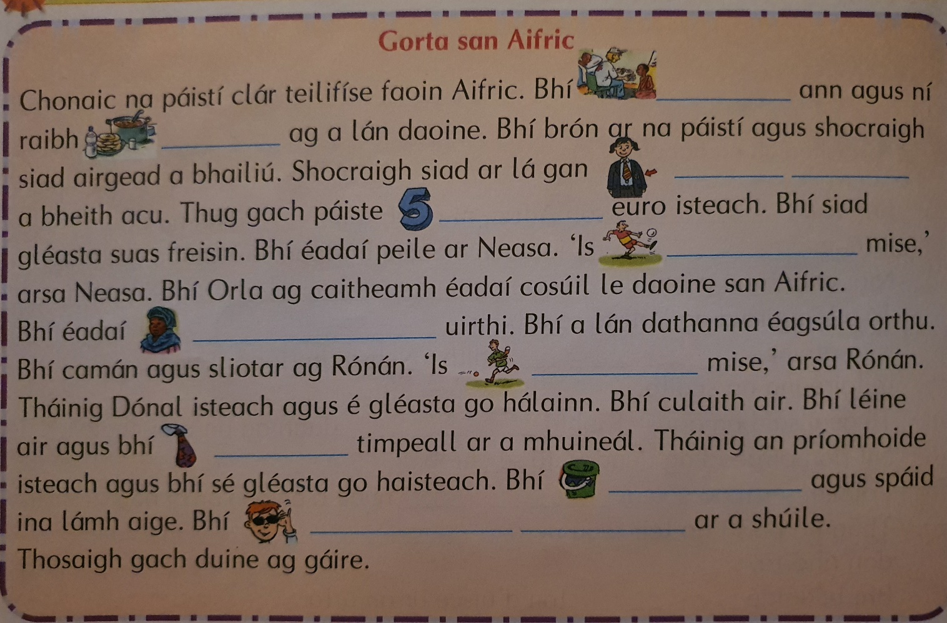
- Tuesday: Am don Léamh: Léigh agus Scríobh
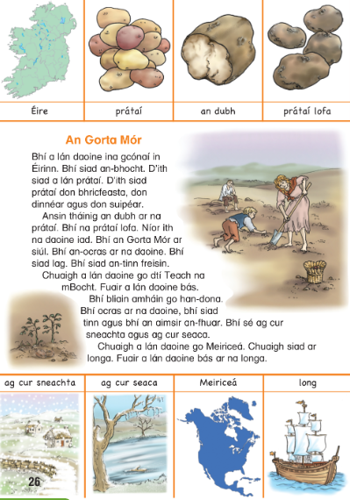

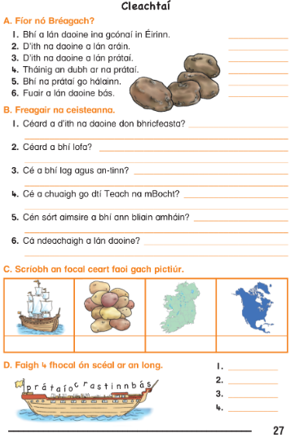
- Wednesday: Gramadach: Na Briathra Neamhrialta
Ná dean dearmad! Aimsir Láithreach + mé = add im /aim
e.g. Bíonn mé = Bím Feiceann mé = Feicim Déanann mé = Déanaim
 | Inné | Amárach | Gach lá
Bí - to be | Bhí | Beidh | Bíonn
Feic - to see | Chonaic | Feicfidh | Feiceann
Téigh - to go | Chuaigh | Rachaidh | Téann
Abair - to say | Dúirt | Déarfaidh | Deireann / Deir
Faigh - to get | Fuair | Gheobhaidh | Faigheann
Déan - to make/do | Rinne | Déanfaidh | Déanann
Clois - to hear | Chuala | Cloisfidh | Cloiseann
Ith - to eat | D’ith | Íosfaidh | Itheann
Beir - to grab/catch | Rug | Béarfaidh | Beireann
Tar - to come | Tháinig | Tiocfaidh | Tagann
Tabhair - to give | Thug | Tabharfaidh | Tugann

Líon na bearnaí: Aimsir Chaite (Inné) – Use the table above for help
1.(Bí) ______________ mé sa siopa inné.
2. (Beir) ____________ Seán an liathróid sa chluiche peile.
3. (Ith) ______________ siad an bricfeasta le chéile inné.
4. (Tar) ________________ na seanthuismitheoirí ar cuairt linn inné.
5. (Clois) _________________ tú torann sa ghairdín.
6. (Tabhair) ___________________ Siobhán brontannas dom.
7. (Abair) __________________ mé mo phaidreacha aréir.
8. (Faigh) ___________________ Lisa obair bhaile ón múinteoir inné.
9. (Déan) ___________________ Niamh cáca mór sa chistin.
10. (Téigh) ________________ sé go dtí an linn snámha.
11. (Feic) __________________sibh na páistí ag imirt sa chlós.

- Thursday: Gramadach: Briathra Neamhrialta
Líon na bearnaí: Aimsir Fháistineach (Amárach)
1.(Bí) ______________ liathróid nua agam amárach.
2. (Abair) ____________ Seán an dán amárach.
3. (Faigh) ______________ Aoife a dinnéar ón siopa anocht.
4. (Feic) ________________ sibh an múinteoir nua an tseachtain seo chugainn.
5. (Téigh) _________________ siad go dtí an linn snámha amárach.
6. “(Beir mé) ___________________ ar an ngadaí amárach!” arsa an garda.
7. (Clois) __________________ sí na héin ag canadh maidin amárach.
8. (Ith) ___________________ siad ispíní don dinnéar anocht.
9. (Déan) ___________________ mé m’obair bhaile tar éis an dinnéir.
10. (Tar) ________________ m’aintín ar cuairt Dé hAoine seo chugainn.
11. (Feic) __________________sibh na páistí ag imirt sa chlós.
- Friday: Gramadach: Briathra Neamhrialta
Líon na bearnaí: Aimsir Láithreach (Gach Lá)
1.(Bí) ______________ Aoife ag súgradh sa ghairdín.
2. (Abair) ____________ Seán an dán ar scoil gach lá.
3. (Faigh) ______________ Pól banana agus úll sa siopa gach lá.
4. (Feic) ________________ mé mo chairde ar scoil gach lá.
5. (Téigh) _________________ siad go dtí an siopa gach lá.
6. (Beir) _____________ sí ar an liathróid sa cluichí peile.
7. (Clois) __________________ mé an cloigín ag bualadh gach maidin.
8. (Ith) ___________________ siad a ndinnéar gach lá.
9. (Déan) _________________ mé m’obair bhaile tar éis an dinnéir gach lá.
10. (Tar) ________________ m’aintín ar cuairt gach Aoine.
11. (Tabhair) __________________ Aoife úll don mhúinteoir gach Luan.
English
Spelling List
Monday | Tuesday | Wednesday | Thursday
strength  apartment  extremely  jewellery | suspicious  ridiculous  official  benefit | schedule  eliminate  conscience  discipline | definitely  primitive  orchestra  unnecessary

Reading for the week: By the North Star pg 160 – 163: Toys Aren’t Us (Unit 35)
- Monday: Vocabulary
Write these sentences into your copy and fill in the missing word using the spelling list.
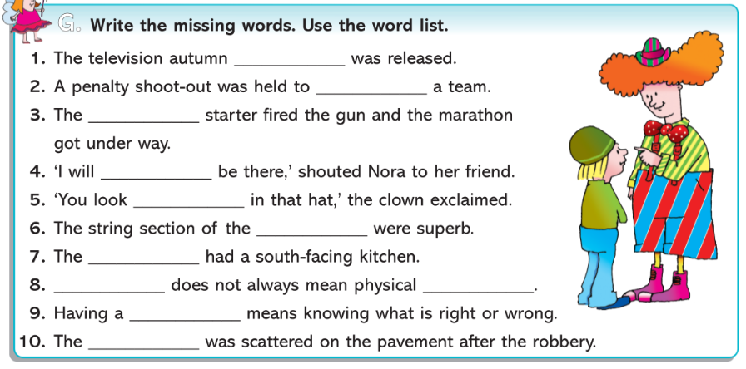

- Tuesday: Vocabulary Development
Replace the underlined words with a word from the word box.
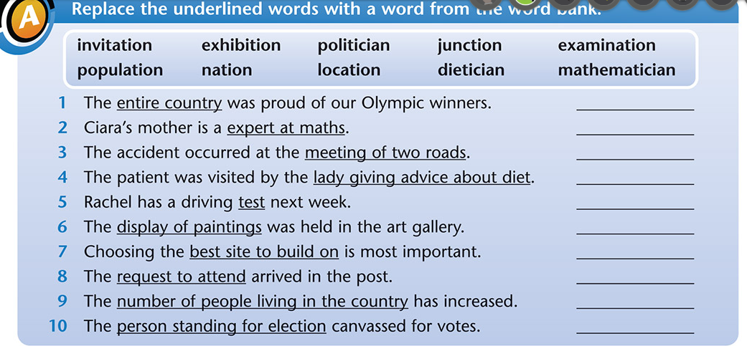

- Wednesday: Grammar
Adjectives are describing words. They give us more information and make our writing more interesting. Write out the sentences and underline the adjectives.

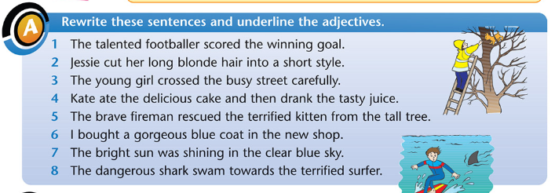

- Thursday: Comprehension
Answer the comprehension questions based on the reading Toys Aren’t Us found in class reader By the North Star pgs 160-163.

Don’t forget that these are yellow box questions. Give some extra detail and use quotations from the text to support your answer.

The reader is available online at https://edcolearning.ie/ if you don’t have your reader at home with you.

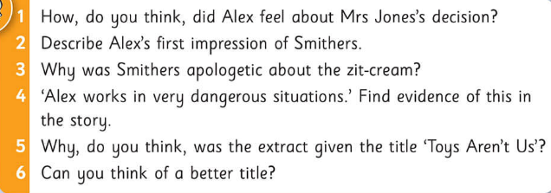

- Friday: Writing: Book Review
Choose a book you have read recently and write a report about it. You can use the template or design your own.
- Don’t forget that you can type your work into a Word document and attach it as a file in Google Classroom if you would like your teacher to see your work.
- You could write your work into a copy and take a photograph of it and attach that in Google Classroom either.
- You could also print the sheet and fill out the template, take a picture of it and attach it in Google Classroom.

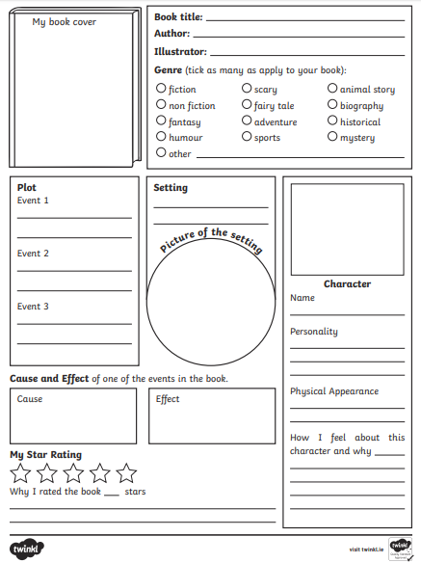
Maths
Tables: x/÷ 2, x/÷ 3

- Monday: Fractions: Finding a whole number if given a fraction

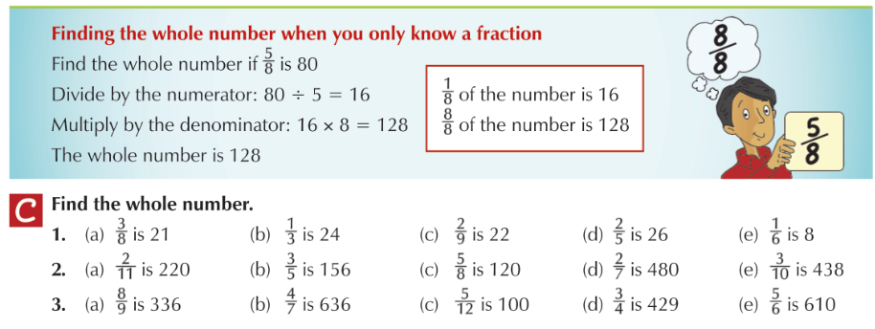
- Tuesday: Multiplying Fractions

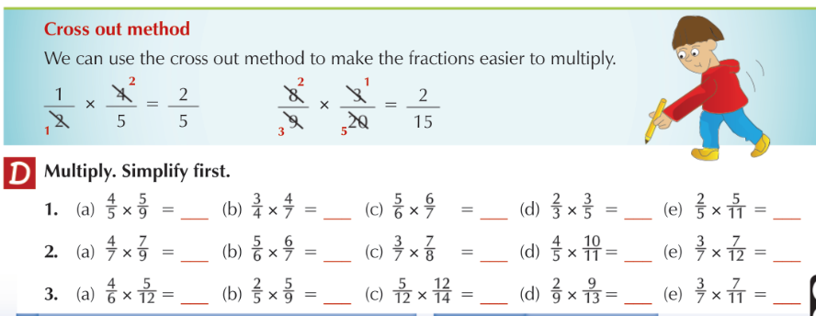

- Wednesday: Dividing Fractions

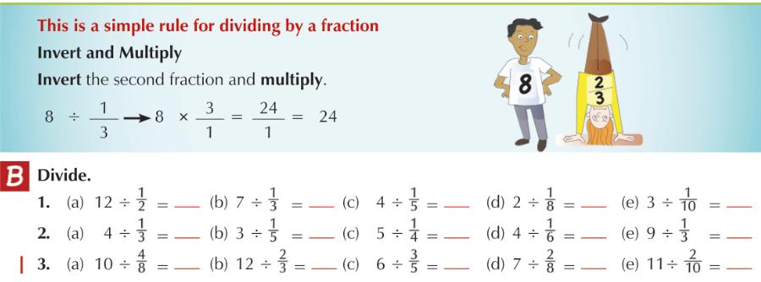

- Thursday: Fractions: Problem Solving

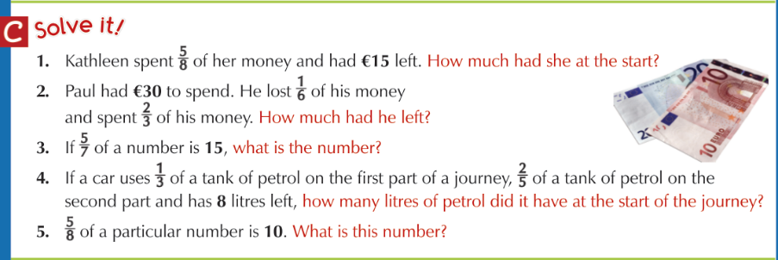

- Friday: Fractions and the Unitary Method

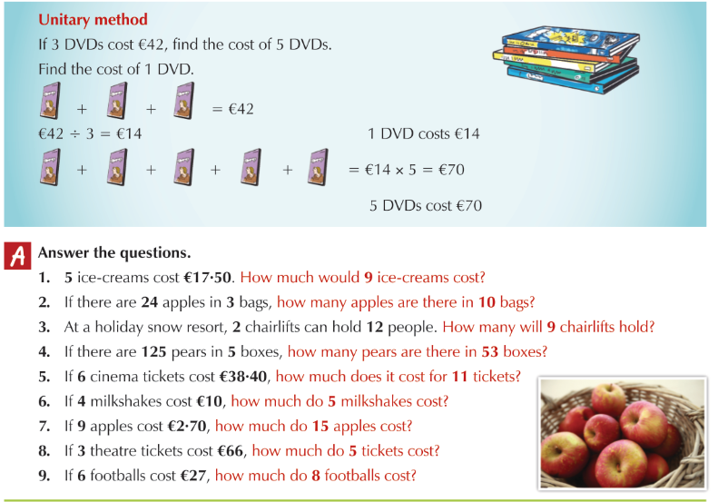

Monday: History: The Famine
Read the ‘Famine Slides’ document under resources.

Complete this exercise about the Great Famine.
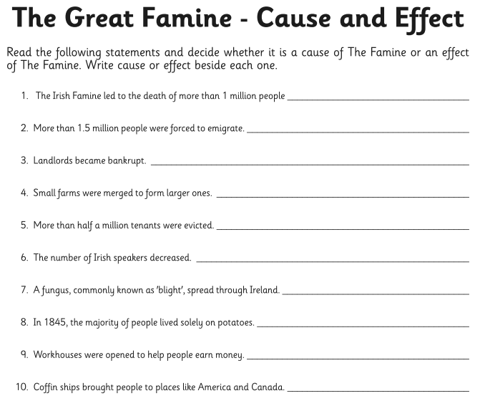

Tuesday: Religion: The Mass: The Eucharist
Read the piece below.
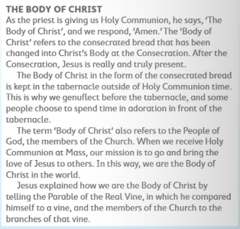

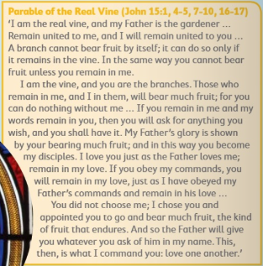

Wednesday: Science: Living Things: Biodiversity
Read the power point on ‘Biodiversity’ in ‘Other Lessons’ to learn about biodiversity in the world around us.
Complete the activity below. Match the animals to their habitats (homes).
You don’t have to print the page, just write house spider = _________ etc.
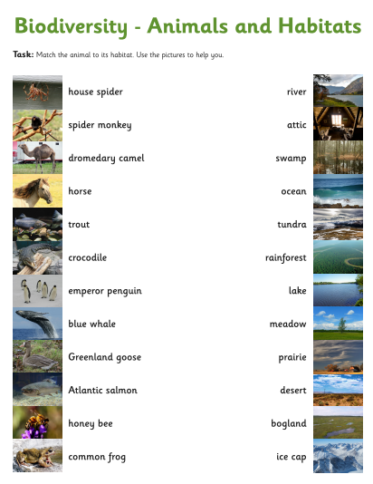

Thursday: Science: Living Things: Biodiversity
Do an audit of the challenges to biodiversity in your home.
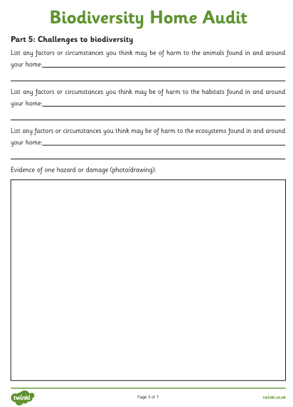
Friday: SPHE/Art: Mindfulness Colouring / Drawing
Draw a barn owl with Don Conroy on You Tube.
https://www.youtube.com/watch?v=RIr-LtOFkMM

Optional Extra Religion Activities for May
