Monday 8th June 2020 – Friday 12th June 2020
Monday 8th June 2020

English/Language:
Crazy Carnivals: Unit 38 The Fabulous Deeds of the Sons of Tuireann – read the following extract and answer the questions listed below – remember to give full answers
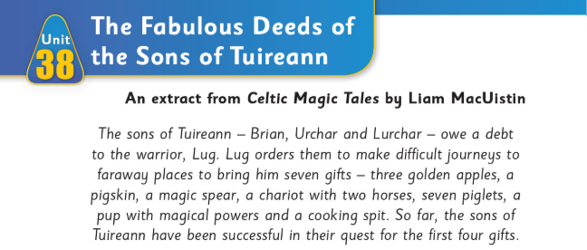
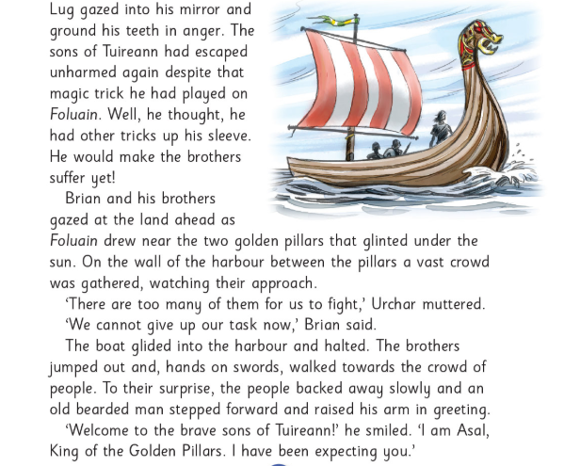
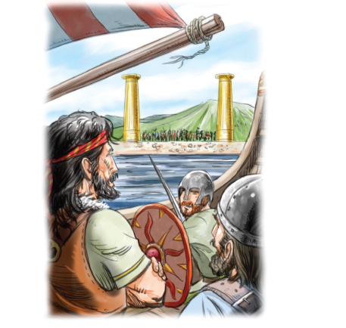
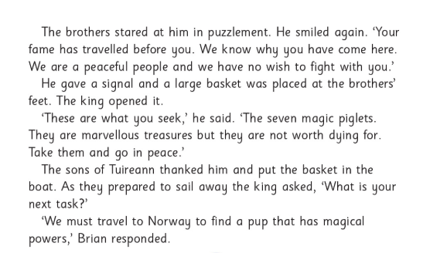
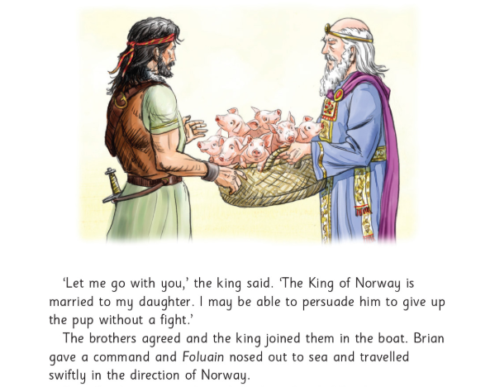
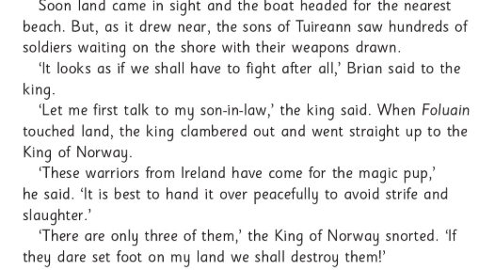
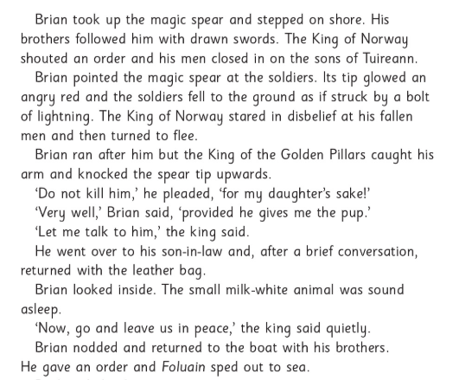
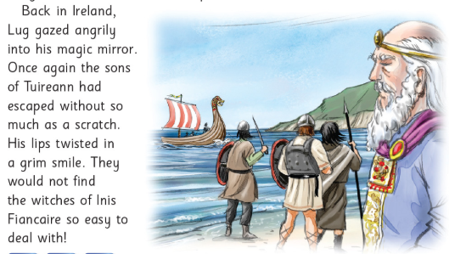
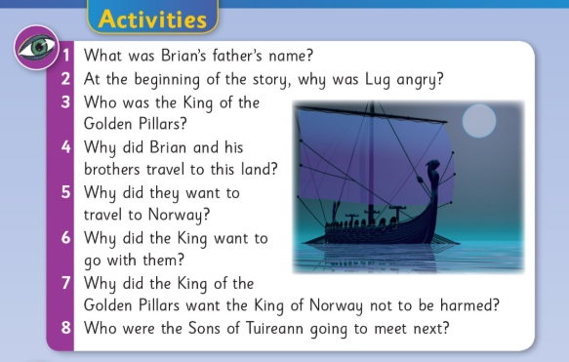
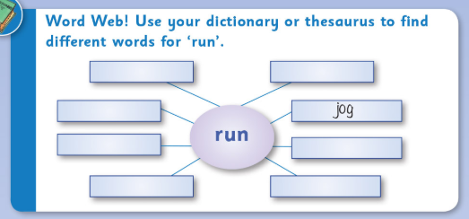

Spellbound: list 29 and exercise one below. If you do not have access to a printer, you may wish to fill in some blank units in our regular Spellbound. These activities are from a different version of Spellbound as our book is finished.
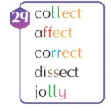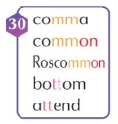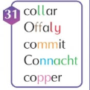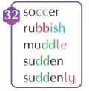
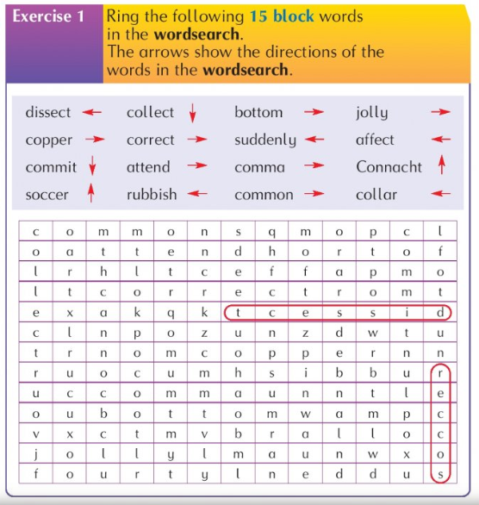

Maths/Numeracy:
New Wave Mental Maths: Monday week 36
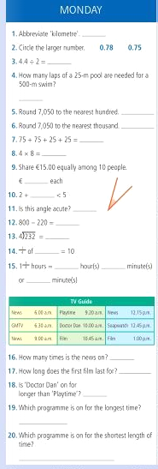
Tables: (revision)

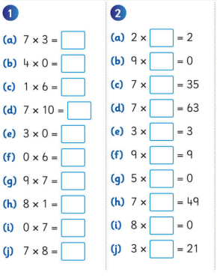

Maths Topic: Mental Maths 6 (revision)
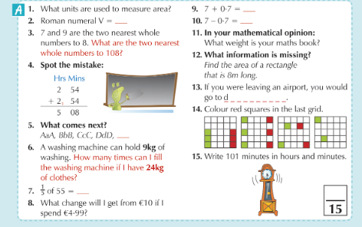
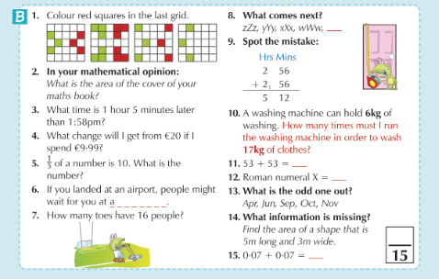

Gaeilge:
Ceartlitriú: Súil Siar E – look back on the previous 4 units to help
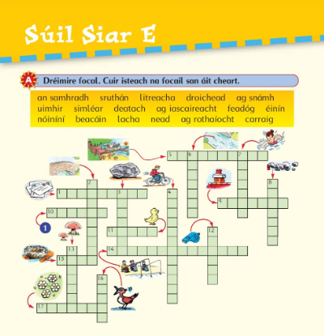
Am don Léamh: Tir na nóg (A + D)
Léigh an scéal agus freagair na cleachtaí

Ag fiach – hunting trasna na farraige – across the beach
I ngrá – in love álainn – beautiful
Marbh – dead ar an talamh – on the ground sean – old
Fuair Oisín bás – Oisín died

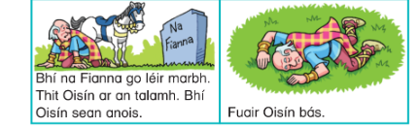
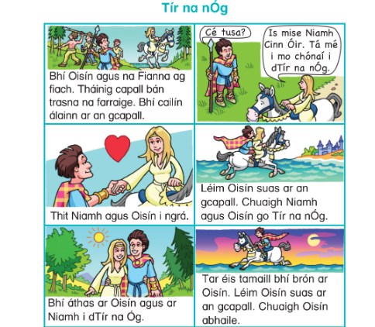

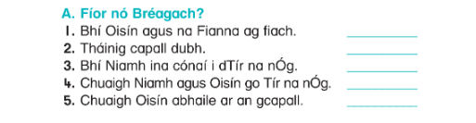
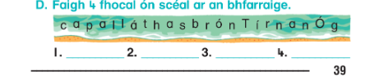

SESE:
Small World Geography and Science: Unit 13 – Japan (continued)
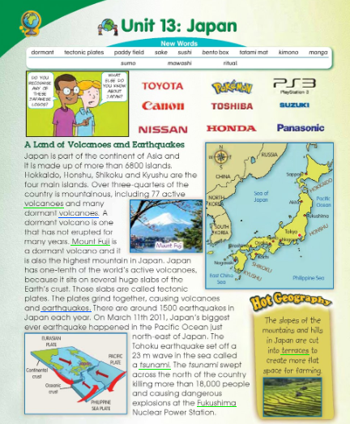
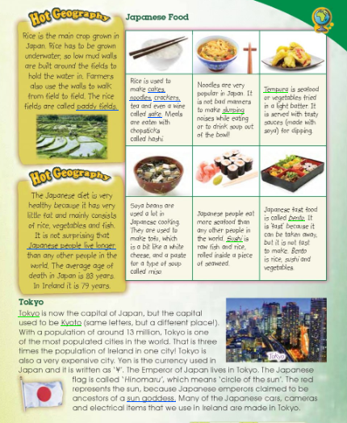
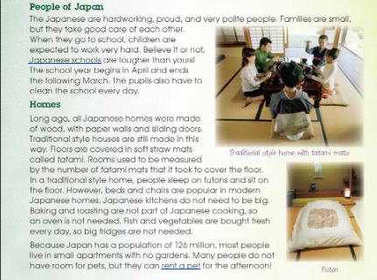
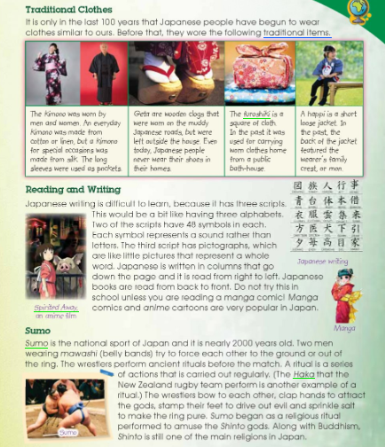
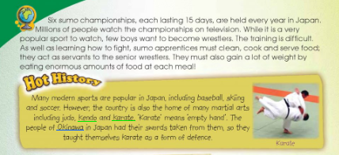
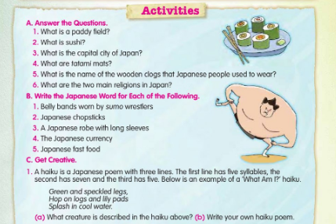

Tuesday 9th June 2020

English/Language:
Crazy Carnivals: Unit 38 The Fabulous Deeds of the Sons of Tuireann – read the following extract and answer the questions listed below – remember to give full answers
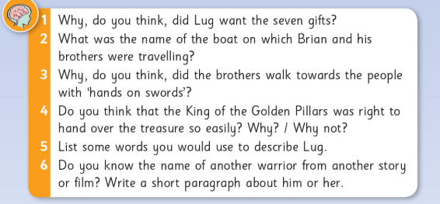
Spellbound: list 29-30 and exercise two & three below. If you do not have access to a printer, you may wish to fill in some blank units in our regular Spellbound. These activities are from a different version of Spellbound as our book is finished.

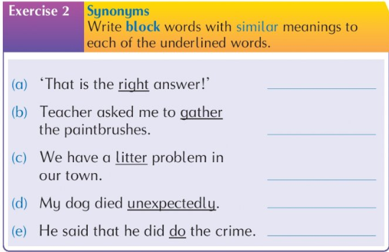
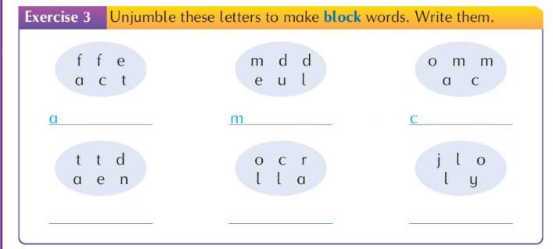
Maths/Numeracy:
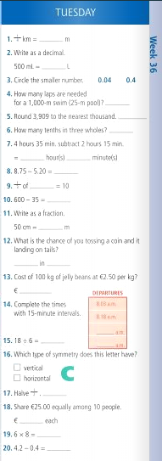
Tables: (revision) New Wave Mental Maths: Tuesday week 36
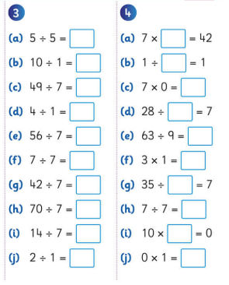

Maths Topic: Mental Maths 6 / revision
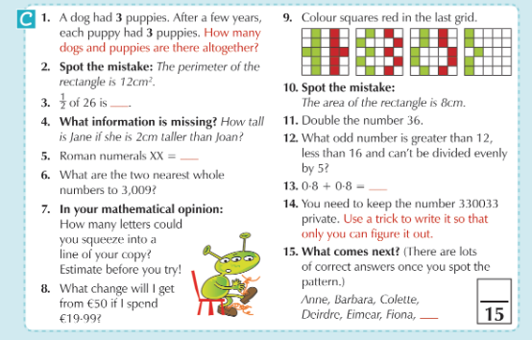
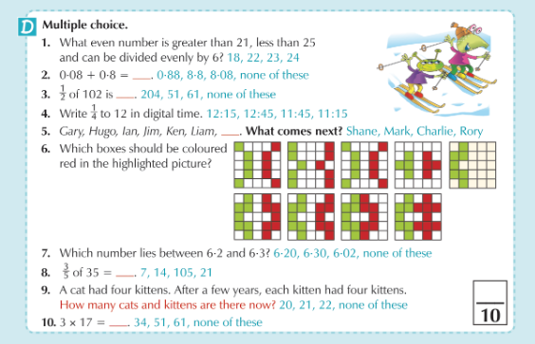

Gaeilge:
Ceartlitriú: Súil Siar E – look back on the previous 4 units to help
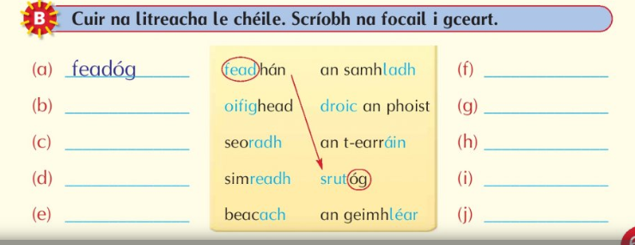
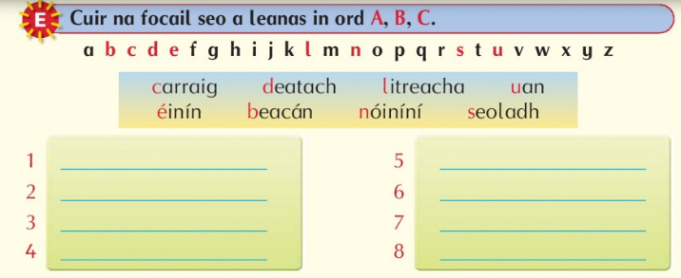
Am don Léamh: Tir na nóg (B + C)
Léigh an scéal agus freagair na cleachtaí

Ag fiach – hunting trasna na farraige – across the beach
I ngrá – in love álainn – beautiful
Marbh – dead ar an talamh – on the ground sean – old
Fuair Oisín bás – Oisín died

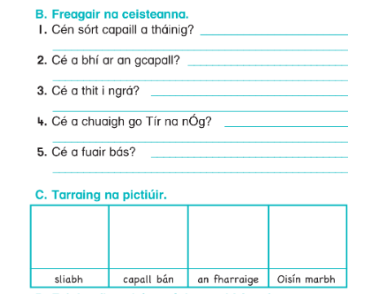
SESE:
Small World Geography and Science: Unit 13 Japan (continued) – read back over the unit on Japan and complete the following in your Geography copy. Read the question carefully and give many reasons for your choice of country.
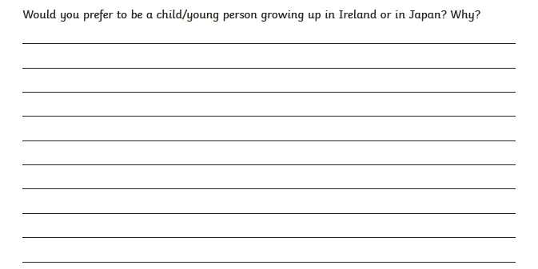

Wednesday 10th June 2020

English/Language:
Crazy Carnivals: Unit 38 The Fabulous Deeds of the Sons of Tuireann – read the following extract and answer the questions listed below – remember to give full answers
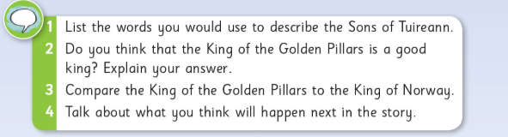
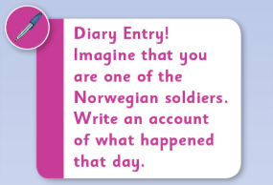

Spellbound: list 29-31 and exercise four below. If you do not have access to a printer, you may wish to fill in some blank units in our regular Spellbound. These activities are from a different version of Spellbound as our book is finished.
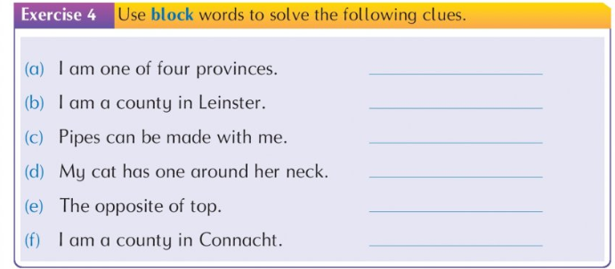

Write Here: pg 62. Rewrite the words and passage in cursive style
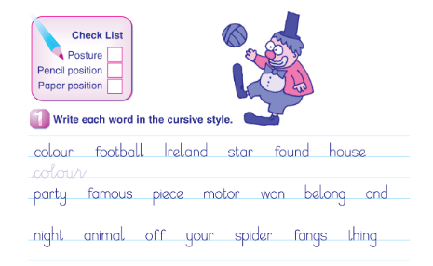
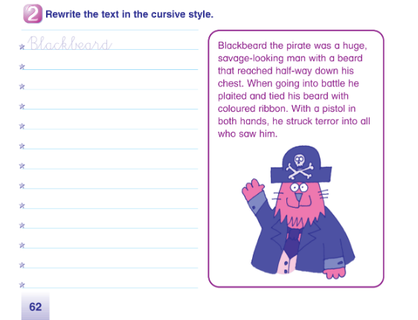

Maths/Numeracy:
Tables: (revision) New Wave Mental Maths: Wednesday week 36

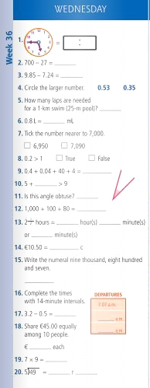
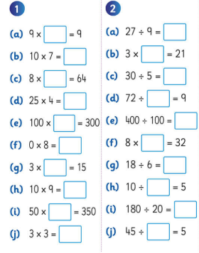

Maths Topic: Operations
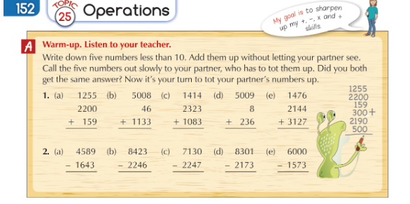
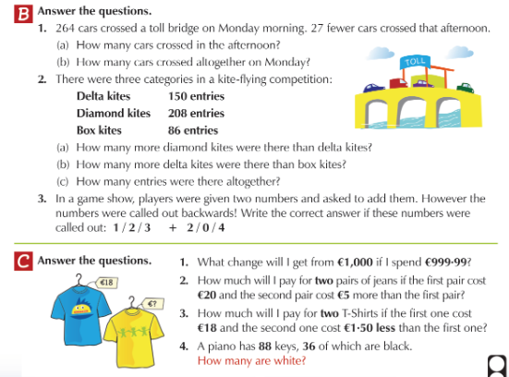
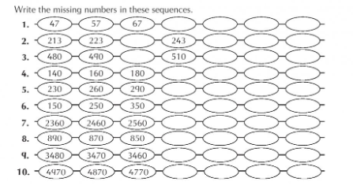

Gaeilge:
Ceartlitriú: Súil Siar E – look back on the previous 4 units to help
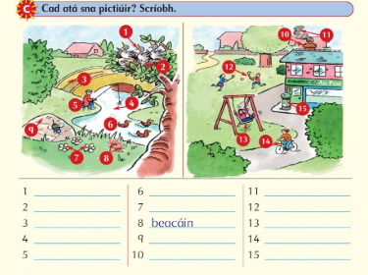

Bun go Barr:
Aonad 20 – Rás na Lachan
basár – fair planda – plants shroich – reached ag roth an áidh – wheel of fortune praghas – price Uimhir – number sruthán – stream feadóg – whistle ar aghaidh leat – on you go/go on a phleidhce – messer droichead – bridge caoga – fifty bhuaigh – won díomá – disappointed
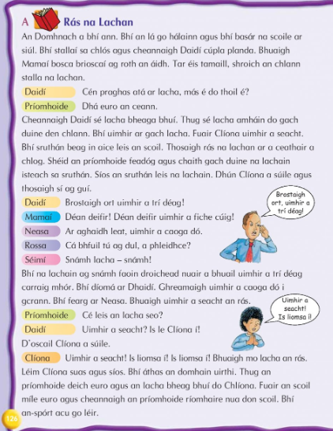
C – Síos an sruthán leis
Use the words in the box below to complete the first part of the sentences. You will have to look back through your Bun go Barr or use your fócloir to find the other missing words. We have come across the missing words before. The only new word is; rúidbhealach (runway)
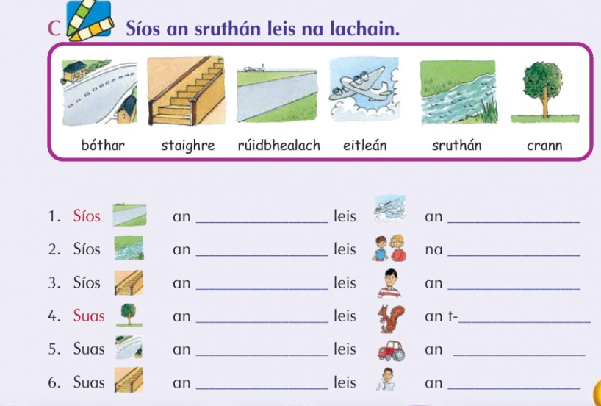

SESE:
Small World Geography and Science: Unit 13 Japan (continued)
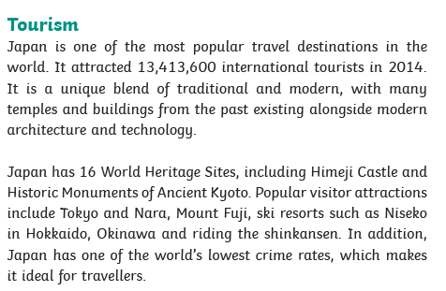
Design a brochure article about one of the 16 World Heritage Sites in Japan – why would you encourage people to visit the site you’ve chosen? Tell the reader some points of information about your chosen site. Use the template below to help you lay out your information. Include an illustration of your chosen site and write a suitable heading.
Thursday 11th June 2020

English:
Exercise your English: Unit 10 The Climb. Read the following extract and complete the questions below. Remember to give full answers and back up your answer with evidence from the extract.
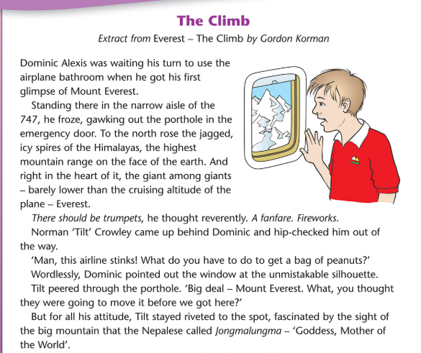
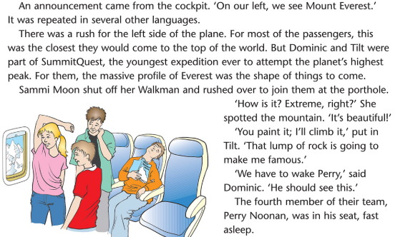
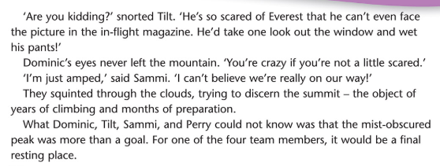
Answer 6 of the 8 questions below in part A. For the alphabetical order exercise (from Crazy Carnivals) pick 5 sets to order
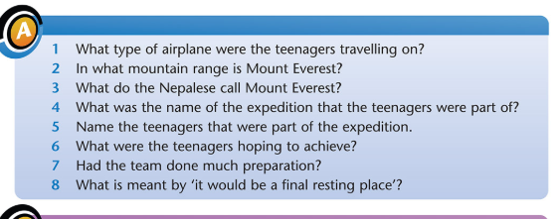
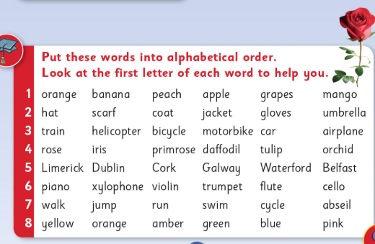

Spellbound: list 29-32 and exercise five below. If you do not have access to a printer, you may wish to fill in some blank units in our regular Spellbound. These activities are from a different version of Spellbound as our book is finished.
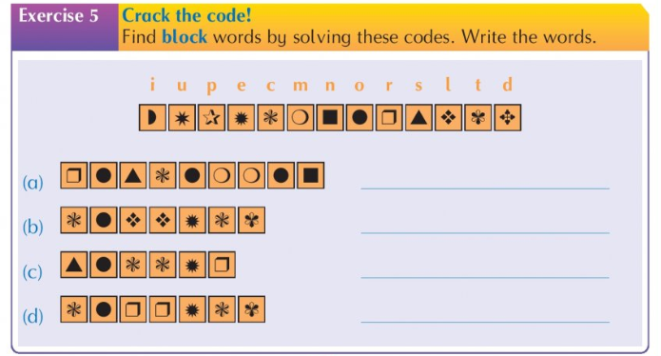

Maths:
Tables: (revision) Mental Maths: Thursday week 36
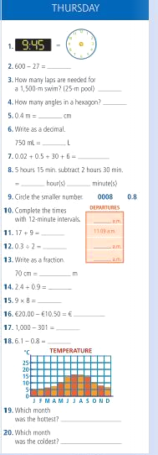
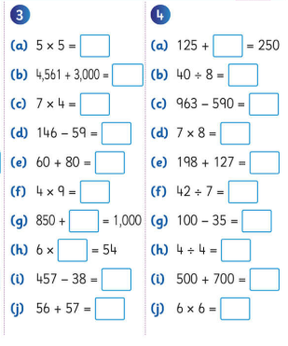

Maths Topic: Operations (work out the brackets first)
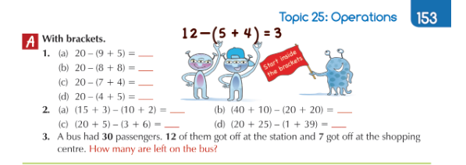
Read the clues to fill in the nets (follow the arrows)
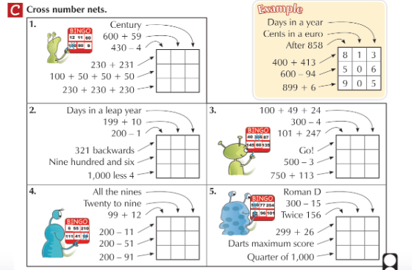
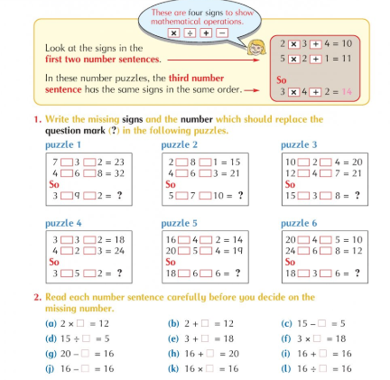

Gaeilge:
Ceartlitriú: Súil Siar E – look back on the previous 4 units to help. You must insert the words below and also look back to find the workd to match the pictures.
Brostaigh – hurry bhuaigh mé- I won shéid- blow chuir – put chonaic mé – I saw
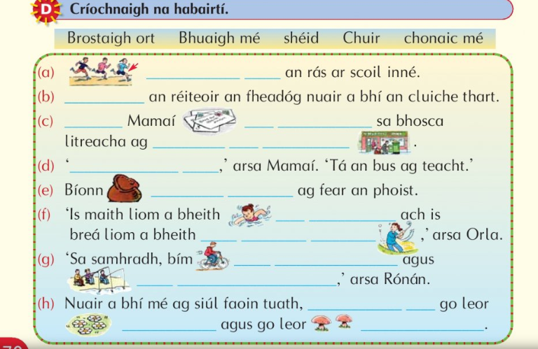
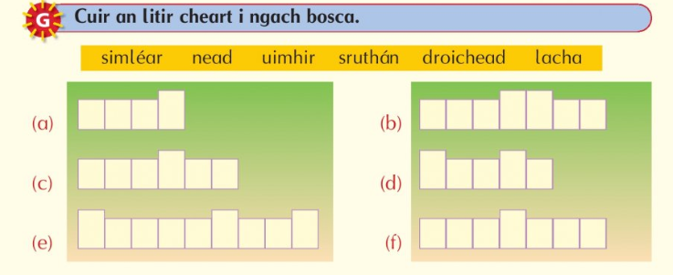

Bun go Barr: Rás na Lachan
basár – fair planda – plants shroich – reached ag roth an áidh – wheel of fortune praghas – price Uimhir – number sruthán – stream feadóg – whistle ar aghaidh leat – on you go/go on a phleidhce – messer droichead – bridge caoga – fifty bhuaigh – won díomá – disappointed
D - Cé leis é seo? Who owns this?
Remember to put in ‘an’ before you list the itens next to each picture. You will answer your cé leis é seo with is liomsa é (it’s mine) ní liomsa é (it’s not mine) is le Clíona (it’s Cliona’s) or níl a fhpis agam (I don’t know)
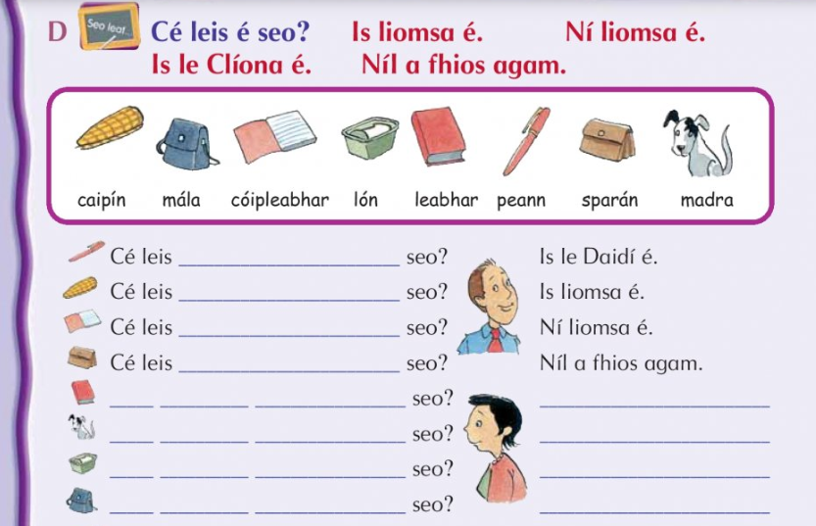

PE:
Go Noodle – a wide range of activities can be discovered in the categories section https://app.gonoodle.com/categories
Joe Wicks is doing daily PE classes on his YouTube channel https://www.youtube.com/channel/UCAxW1XT0iEJo0TYlRfn6rYQ
A guided workout to stay active at home https://www.youtube.com/watch?v=L-8wW40jTzc
For GAA enthusiasts why not attempt the 200 touches daily challenge
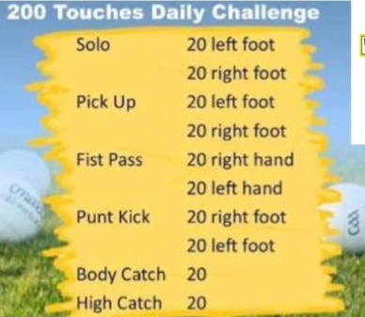

Religion: Grow in Love Theme 11 The Mass (giving and receiving)
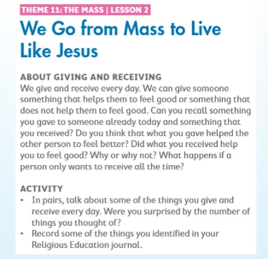
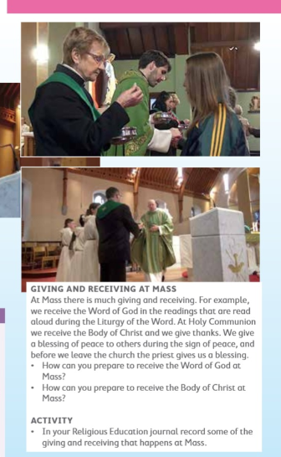

Friday 12th June 2020

English:
Exercise your English: Unit 10 The Climb. Read the following extract and complete the questions below. Remember to give full answers and back up your answer with evidence from the extract.
Answer B 1-6. For part C pick 6 words and find their meanings
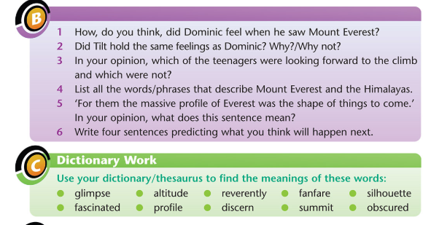
Spellbound: Ask an adult or older sibling to Quiz you on this week’s spellings. You are only required to pick 16 words for your test. Good Luck! Record your test in your test copy.

Maths:
Mental Maths: Friday week 36
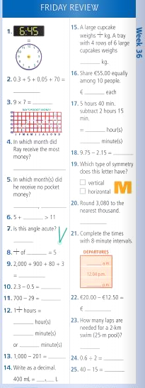

Tables: revision – how many can you complete in 10 minutes? Set a timer
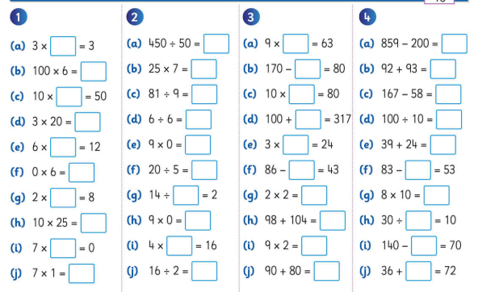
Maths Topic: Operations (remember the rule for x10 – add a zero)
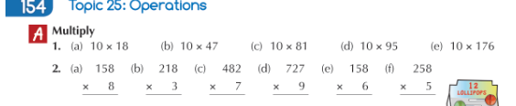
Dividing by ten is opposite to multiplying by ten (drop a zero)
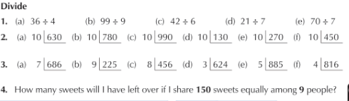
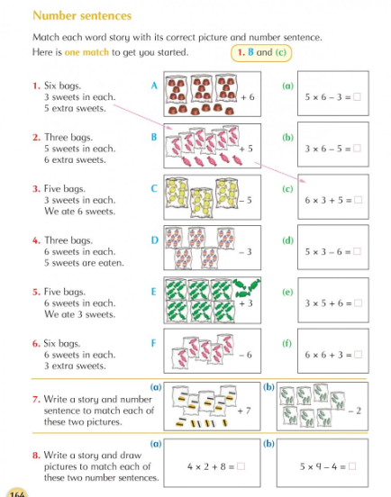

Gaeilge:
Ceartlitriú: Súil Siar E – look back on the previous 4 units to help
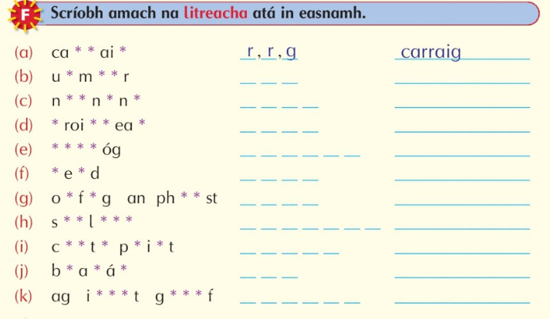
Bun go Barr: Rás na Lachan
basár – fair planda – plants shroich – reached ag roth an áidh – wheel of fortune praghas – price Uimhir – number sruthán – stream feadóg – whistle ar aghaidh leat – on you go/go on a phleidhce – messer droichead – bridge caoga – fifty bhuaigh – won díomá – disappointed
B - Cúpla Ceist
Cén saghas lae – what sort of day Cathain – when cad a rinne …what did someone do
cad a tharla – what happened cé a bhuaigh – who won cad a cheannaigh… - what did someone buy
Freagair na ceisteanna 1-6
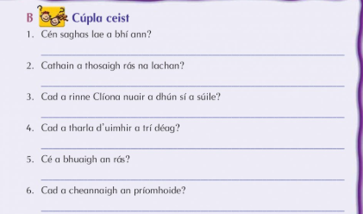
Art: follow the steps; 1-5 to create your own cherry blossom tree. If you do not have all of the supplies listed below you can swap them for what you do have. E.G; crayons/markers can be used instead of paint etc.
