Subject | Monday | Tuesday | Wednesday | Thursday | Friday
Gaeilge  Revision materials and resource taken from a different Irish book – this allows the children to complete revision work at home. | Téama: Ócáidí Speisialta – Ar Saoire  Bí ag Léamh!  Am don Léamh pg 62: Pás Róisín. Léigh agus freagair na ceisteanna.  Online dictionaries  https://www.teanglann.ie/en/  https://www.focloir.ie/ |  | Téama: Ócáidí Speisialta – Ar Saoire  Gramadach  Revise Briathra Neamhrialta (irregular verbs) Déan and Faigh in the Aimsir Fháistineach (Future Tense)  Use the table to help you to fill in the blanks. Write and complete the sentences in your copy. |  | Téama: Ócáidí Speisialta – Ar Saoire  Gramadach  Uatha & iolra (singular and plural)  Learn how to change singular nouns to plural nouns.
English | Spellings (Unit 32)  Vocabulary: Write the sentences and complete them using words from the spelling list.  Put the spelling list into alphabetical order  You can do all of Unit 32 if you wish in Spellbound.  Reading  Novel of your choice | Spellings (Unit 32)  Comprehension  Comprehension questions based on the text All the Gold in the World: Exercise Your English pg 88 & 89  Reading  Exercise Your English pg 88 & 89 | Learn Spellings  (Unit 32)  Reading  Novel of your choice | Learn Spellings  (Unit 32)  Spellings / Phonics  E.Y.E pg 93  Revise the meaning of common homophones. Choose the correct words to complete the sentences.  Reading  Novel of your choice | Spelling Test  (Unit 32)  Poetry Writing  Look at the examples of the three different types of poetry.  Who? What? Where? When? Why? Poem  Shape Poem  Cinquain Poem  Choose one type (or more if you’d like) and try write your own. Share your poems via Google Classroom.  Reading  Novel of your choice
Subject | Monday | Tuesday | Wednesday | Thursday | Friday
Maths  Some revision resources not taken from Planet Maths  See Google Classroom for Answer Sheets. |  | Directed Numbers  Activity A  Use the signs < & > to show greater than and less than with positive and negative numbers. | Directed Numbers  Activity B  Number line work: Use your number line to solve the problems involving positive and negative numbers. | Directed Numbers  Activity D  Calculate the difference between a positive and negative numbers using the number line.
 | Religion:  The Beatitudes  Learn all about the Beatitudes. Use the worksheet to rewrite them in your own words or write them into your copy. | STEM Challenge 1:  My Dream Playground:  Plan and sketch a diagram of your dream playground. | STEM Challenge 1:  Continue My Dream Playground challenge:  Make a simple model of your playground using materials you have available at home.  Share your designs via Google Classroom. | STEM Challenge 2:  Choose from three construction challenges: Tallest Tower, Design a Boat or Marble Rollercoaster.  You can try more of the challenges if you wish.  Share your designs via Google Classroom. | STEM Challenge 3:  Choose from one of two challenges (or both if you wish): Design an egg protector or Design an Intruder Detection Device.  Make your device and share via Google Classroom.

Gaeilge

- Monday: Bí ag Léamh! Am don Léamh lth. 62. Freagair na Ceisteanna
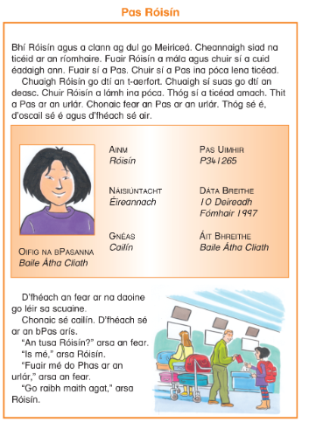

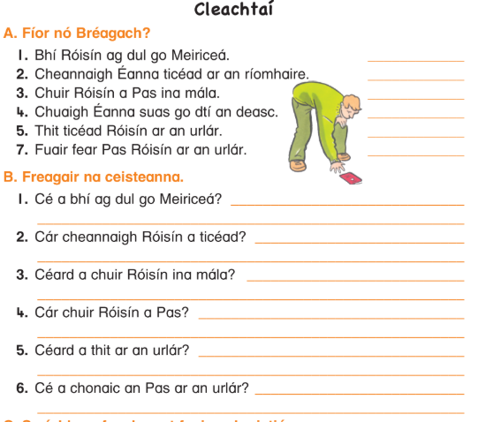
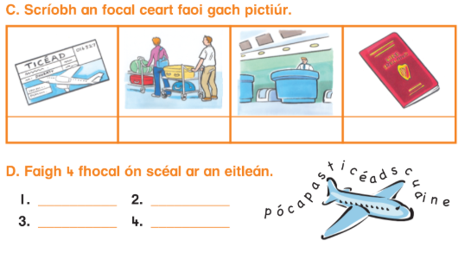

- Wednesday: Gramadach: An Aimsir Fháistineach (Future Tense)
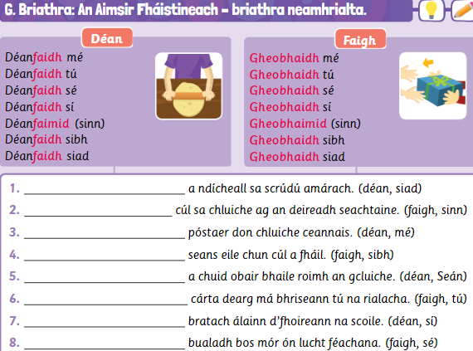

- Friday: Gramadach: Uatha & Iolra (singular and plural)
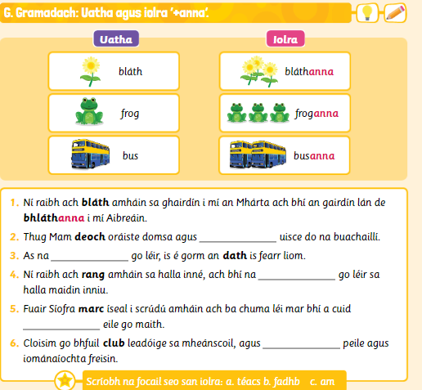
English
Spelling List: Spellbound pg 66-67 (Unit 32)
Monday | Tuesday | Wednesday | Thursday
vision  television  revision  division | invasion  occasion  confusion  explosion | collision  mission  procession  expression | possession  permission  impression  admission

Reading for the week: Exercise Your English pg 88: Skeleton in the Cupboard
Novel of your choice
- Monday: Vocabulary (You can complete the full unit in your workbook if you wish) Write these sentences into your copy and fill in the missing word using the spelling list.
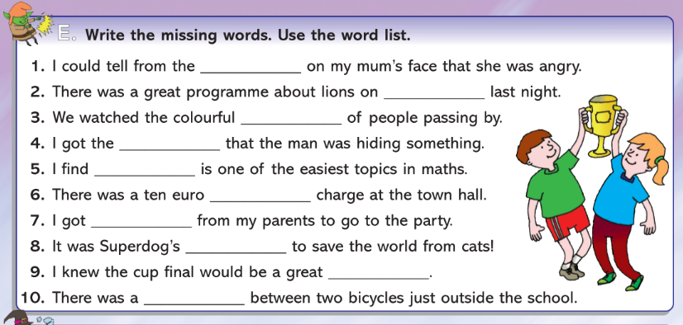
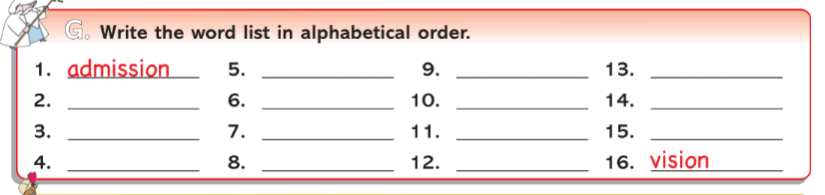

- Tuesday: Comprehension Activity based on the story All the Gold in the World: Exercise Your English pg.88 & 89: Read and answer the questions.
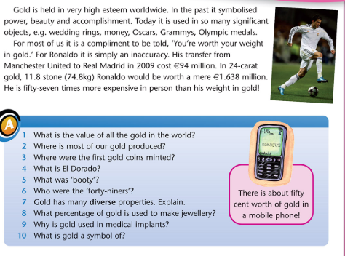

- Thursday: Homophones Revision – Exercise Your English pg. 93
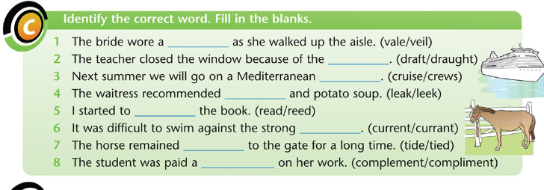

- Friday: Poetry Writing Challenge
Look at the following examples and write your own poem or poems!
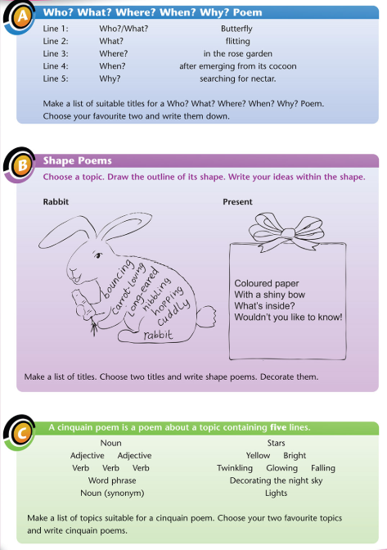
Maths- Directed Numbers
- Tuesday- Use the correct simple to identify greater than and less than.

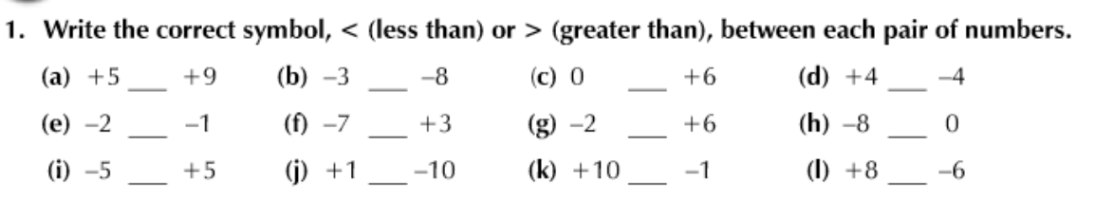

- Wednesday- Number line work

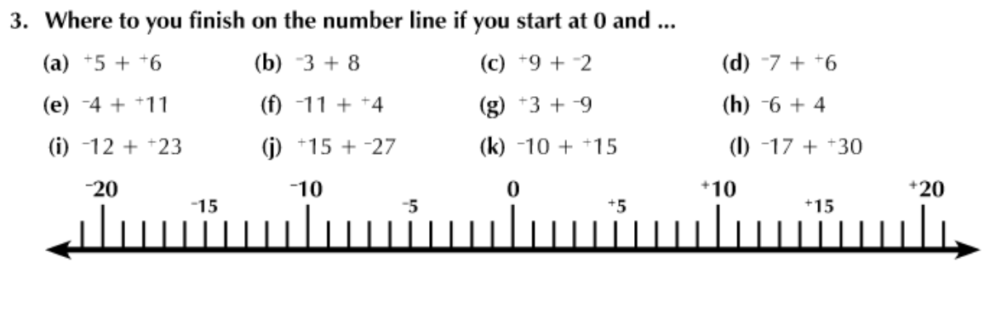
- Thursday- Find the difference. Use the number line to help.
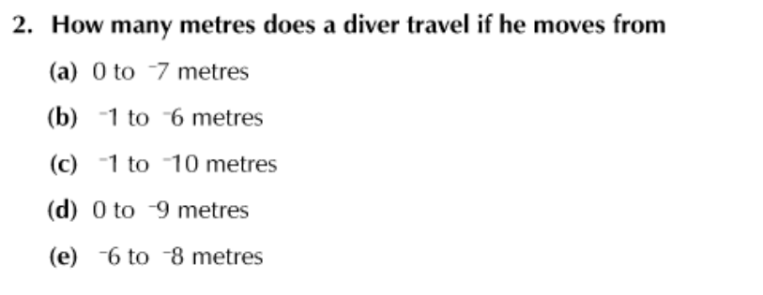
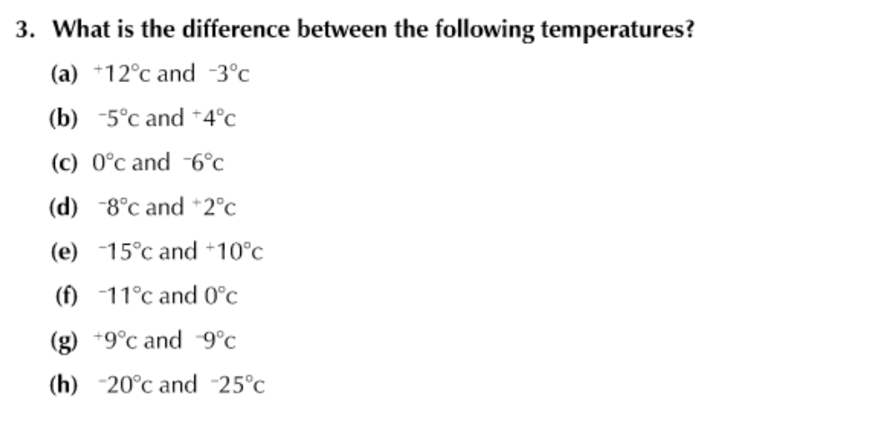

Other Lessons
- Monday- Religion: The Beatitudes

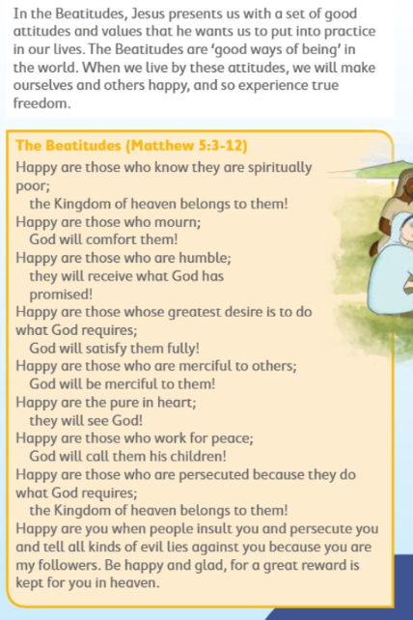

Use the next page to write the Beatitudes in your own words.

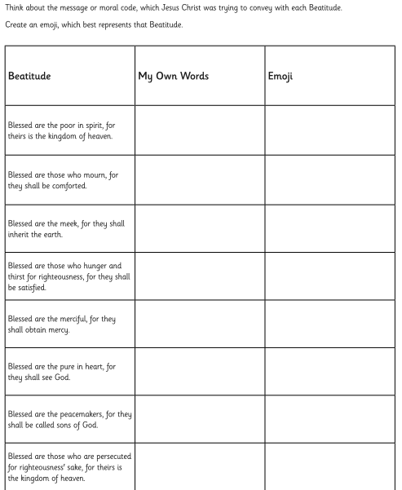

- Tuesday & Wednesday: STEM Challenge 1
Article 31 of the UN Convention on the Rights of the child states that all children have the right to play.
Did you know, not all children in the world have safe places to play? If you could design the perfect playground, what would it look like?

- Plan your playground and draw a sketch of it. Use the questions to help guide you.
- Build a model of your perfect playground

Suggested list of materials (but you can use anything you have available to you):

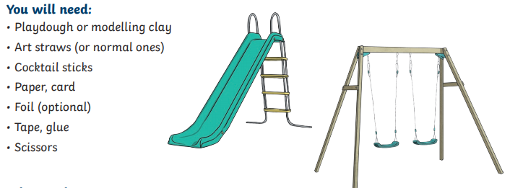
Questions to guide your planning:
- What do children enjoy playing at a playground?
- What age groups will your designs be for?
- What are the best materials to use?
- Will you include quiet spaces in your playground?
- Do you need a lot of small items or fewer, larger pieces of equipment?
- Have you considered all abilities?

Sketch your playground.

- Thursday: STEM Challenge 2
Choose one of the construction challenges below. Don’t forget to share your creations with us via Google Classroom.
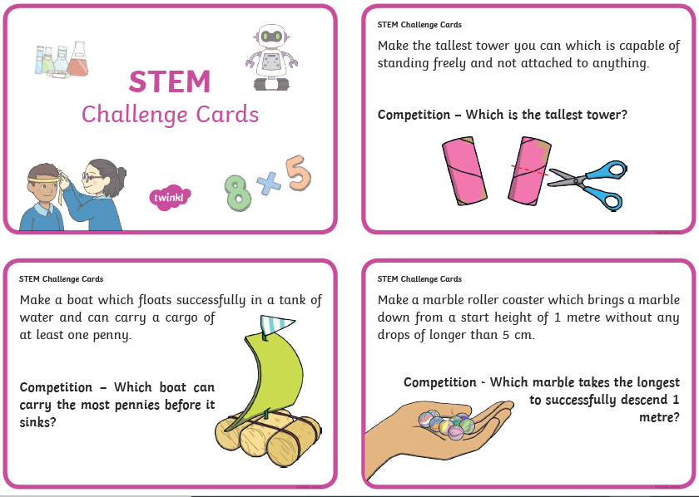

- Friday: STEM Challenge 3
Choose from one of the challenges below (or both if you’d like!) We’d love to see photographs or videos of your creations in action. Share them via Google Classroom.
