Monday 20th
Please remember that these activities are not mandatory. You can pick and choose different activities you wish to do each day. You don’t have to do every activity every day! We just want to give you lots of different activities and ideas. You choose what will suit you best. Feel free to send back any pictures or work that your child has done if you would like to but again, you don’t have to! If you have any questions about anything just send us an email!
Ms Denieffe and Ms O’Neill

Subject | Activities
English | - Watch RTE News Junior https://trte.rte.ie/news2day/  - Recall three new things you’ve learned from this video  - If you want you can write two sentences (your news or news you’ve just learned)  - Choose a book from Starfall to read. Each book has an accompanying game you can choose to play as well  - https://www.starfall.com/h/ltr-classic/
Maths | - Number 10 – Find 10 of different objects e.g. 10 pencils, 10 forks, 10 crayons, 10 buttons  - Listen to number 10 songs - https://www.youtube.com/watch?v=FNEJXKTSkYM, https://www.youtube.com/watch?v=DR-cfDsHCGA&vl=en  - Draw a tree and add 10 apples or leaves to the tree  - Do 10 jumping jacks, 10 squats, 10 stretches etc  - Practice forming the number 10 – trace it in the air, make using pasta/play dog/rice  - You can look at page 91+92 in your child’s Planet Maths book to help you (located in page 3 of this document)
Gaeilge | - Edco have made their Bua na Cainte programme which we use in school available free online  - You will have to download the programme to use it. It is available at https://www.dropbox.com/s/dl/bof46toafmzr9uf/bua-b-setup-pc.exe  - The username and password and “trial”  - You can look at the theme “Siopadóireacht” and click into “ceacht 1” for today  - Click the small yellow speech bubble on the screen and listen to “comhrá 1” and “comhrá 2”  - You can also press the image of the games controller and this will give you some games you can play.  - The music note will bring you to the song “istigh sa zú” which you can listen to  - The lyrics for the song are located on page 2 of this document
Religion | - Watch the video “A House of Prayer ” https://vimeo.com/171911190  - Discuss the story e.g. why did Solomon want the house of prayer to be decorated with beautiful things? Why do you think people were so happy to go into the house of prayer? What do you think they did there? Have you ever been to a place like this?  - Listen to “The Church” song https://app.growinlove.ie/en/user/play-song/574  - Explain to children that we have a church in our parish  - Discuss the meaning of a ‘parish’ e.g. What is a parish? ( a particular area in which God’s family live) Where is the church in our parish? Who is the priest in our parish?  - You can play the interactive “Build a Parish” game at this link https://app.growinlove.ie/interactives/buildingparish/index.php
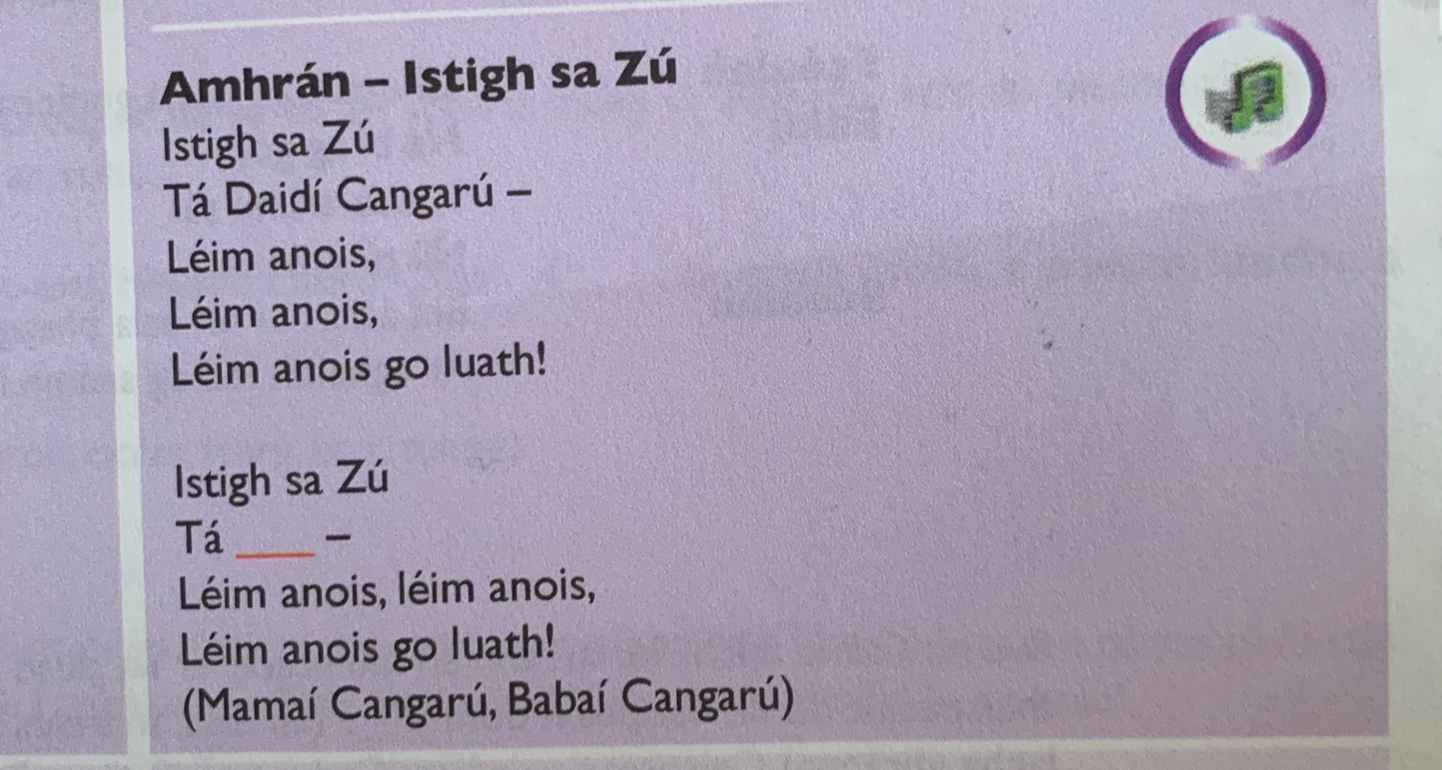
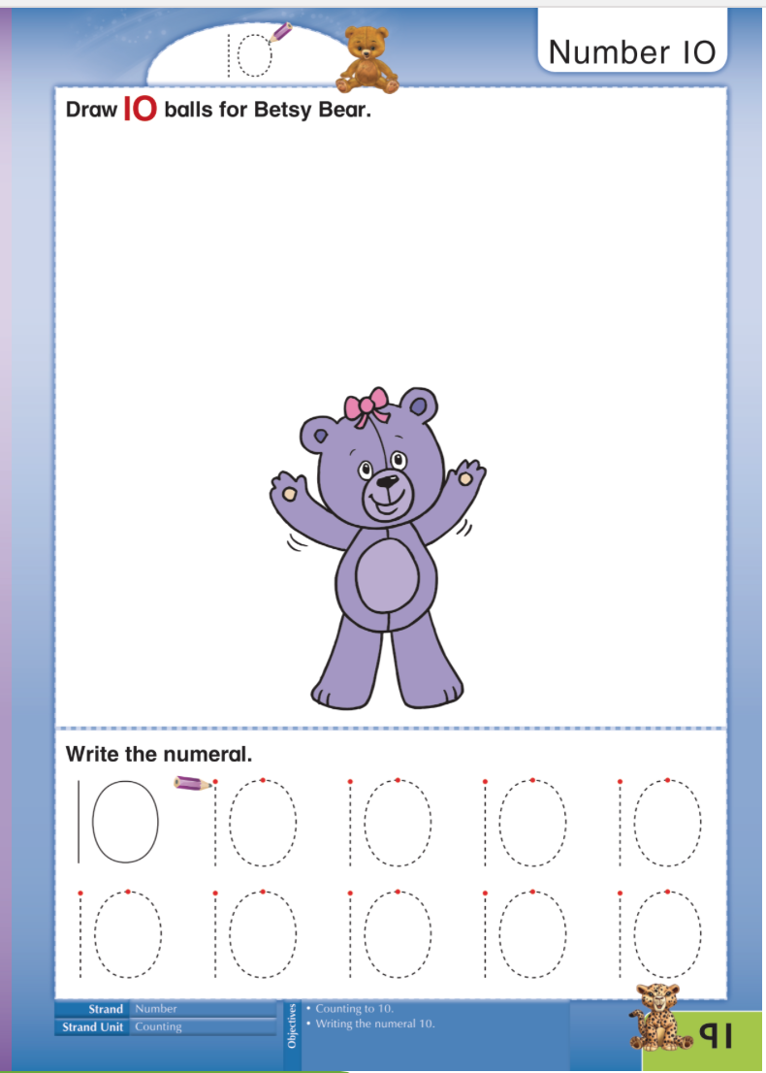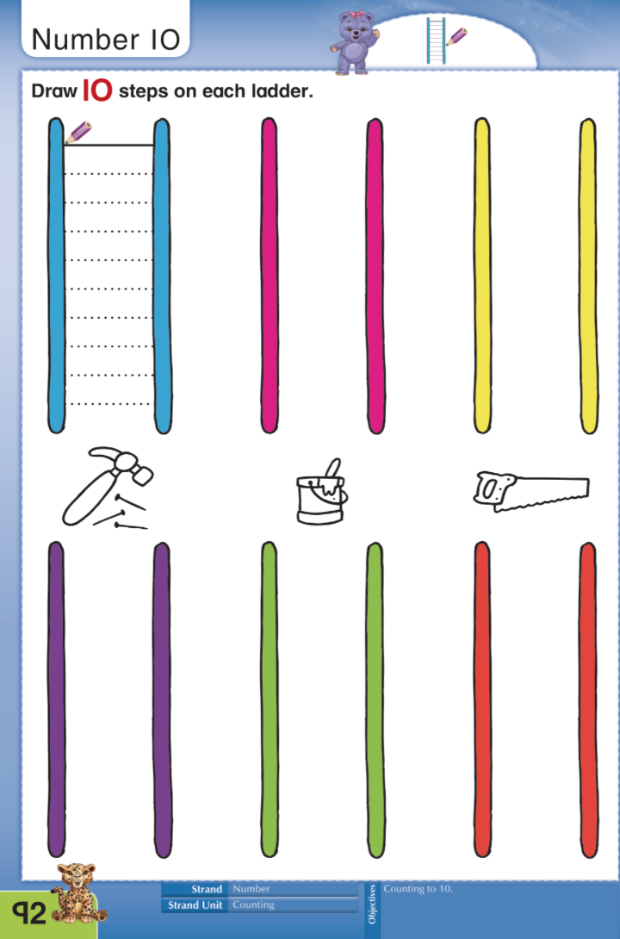
Tuesday 21st
Please remember that these activities are not mandatory. You can pick and choose different activities you wish to do each day. You don’t have to do every activity every day! We just want to give you lots of different activities and ideas. You choose what will suit you best. Feel free to send back any pictures or work that your child has done if you would like to but again, you don’t have to! If you have any questions about anything just send us an email!

Ms Denieffe and Ms O’Neill
Subject | Activity
English | - Sing “ck” song using https://www.youtube.com/watch?v=C8G3EzjG-t0  - Brainstorm all the “ck” words you can think of  - Play “Roll the Dice” game (located on page 3 of this document ) and see if you can sound out all the words to make it to the end  - Practice reading the words and matching them to the pictures from your child’s Sounds book pg 64 (located below on page 3 of this document)
Maths | - Story of 10 – practice adding numbers together that make 10  - Create two circles e.g. two pieces of paper, two hula hoops, two boxes and 10 pencils  - Put 10 pencils into one circle – this makes your first sum 10+0=10  - If you want your child could write down and record the sums as you do them  - Move one pencil over into the other circle – what is your new sum? 9+1=10  - Repeat until your last sum 0+10=10  - There is a game on the FolensOnline website in Senior Infant Planet Maths that can help you with this - https://content.folensonline.ie/programmes/PlanetMaths/PMSI/resources/activities/pm_si_096/index.html
Gaeilge | - Log in to Bua na Cainte and choose ‘ceacht 2” in siopadóireacht  - Again there are a number of interactive games you can play for this lesson  - You can revise the song “Istigh sa Zú” from yesterday also.
SESE | Jobs/Workplaces  - Discuss what jobs the different members of your family might have  - Brainstorm all the different jobs you can think of – how many can you get?  - Discuss what all these different workers do – Use the “Who can help me?” worksheet to assess if your child knows what all the different jobs entails (located on page 4 of this document)  - What would you like to be when you grow up and why?  - You can use the two pages from your child’s Small World book to help you (located on page 5 of this document)
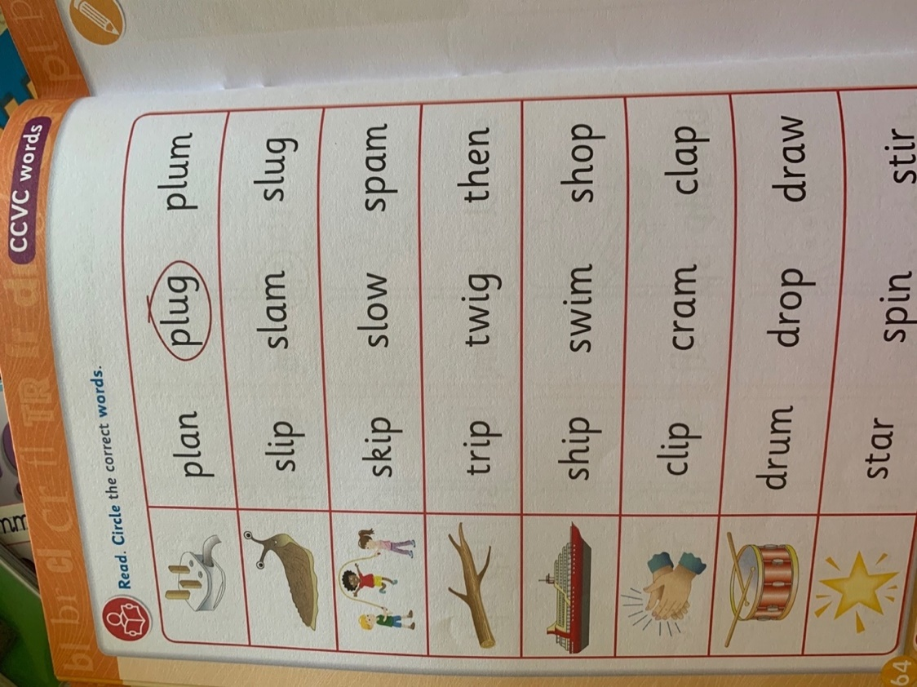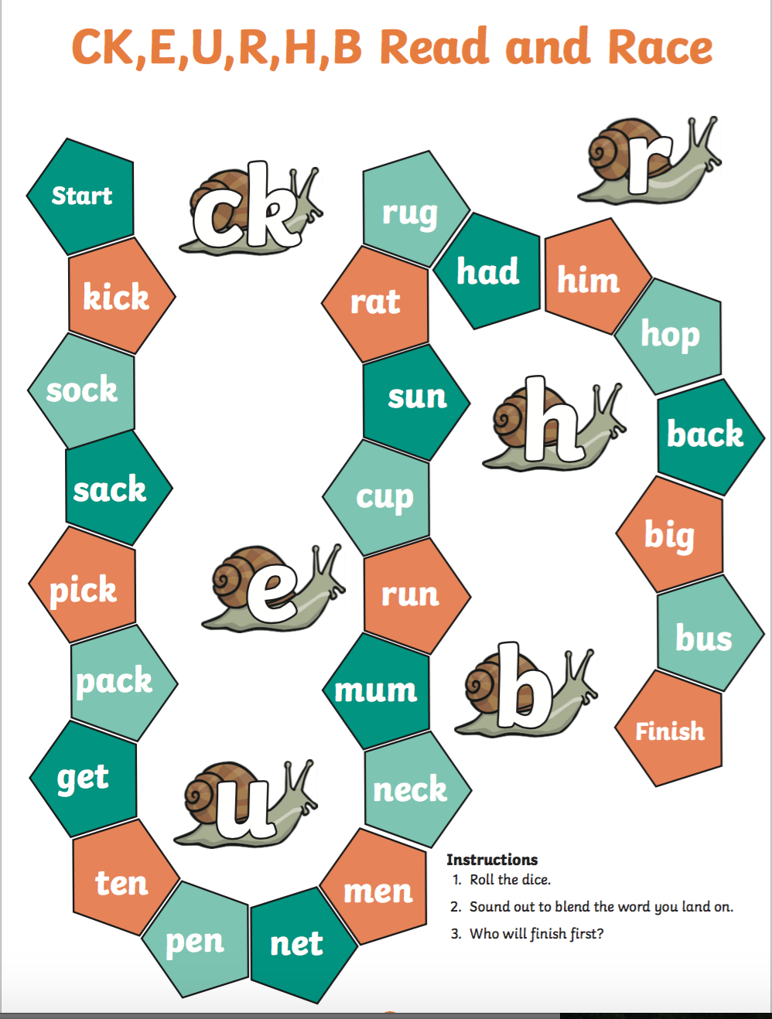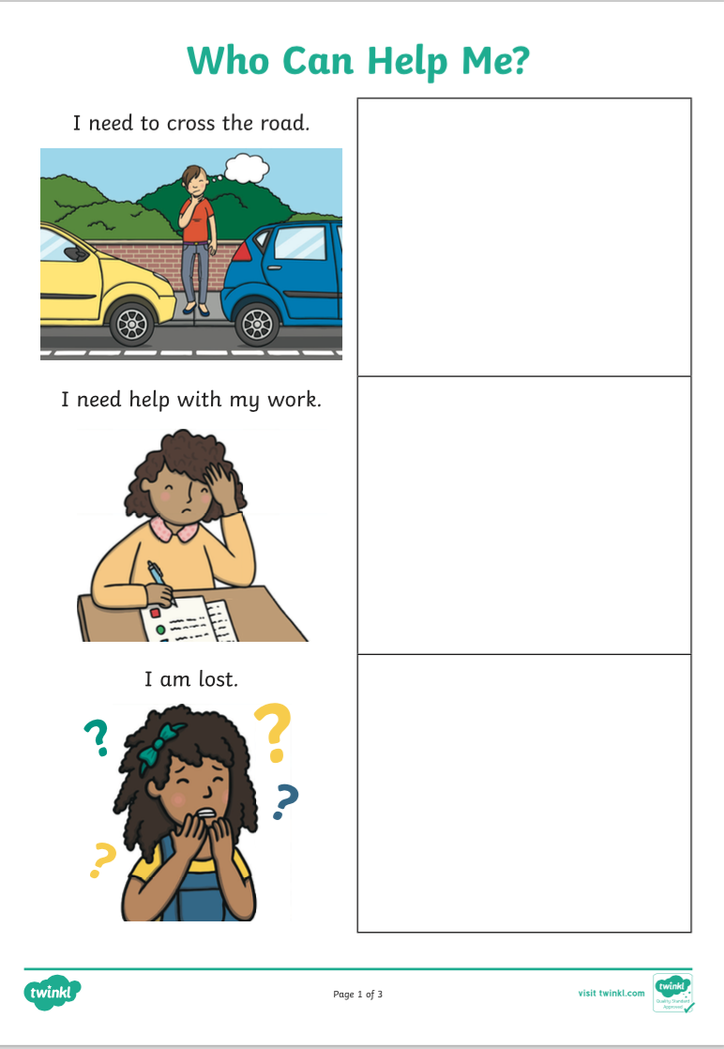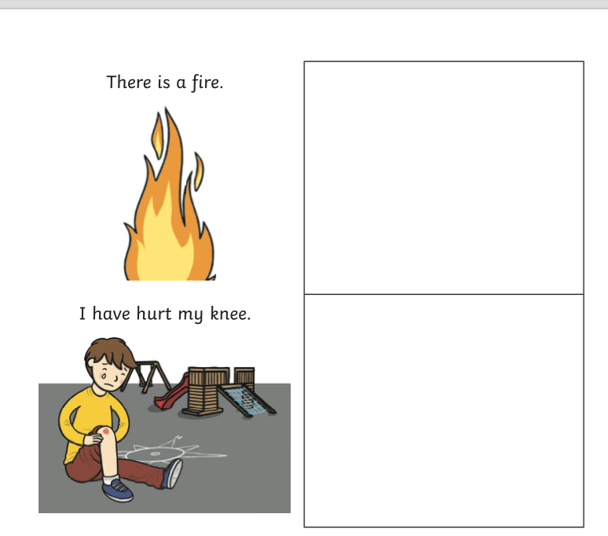
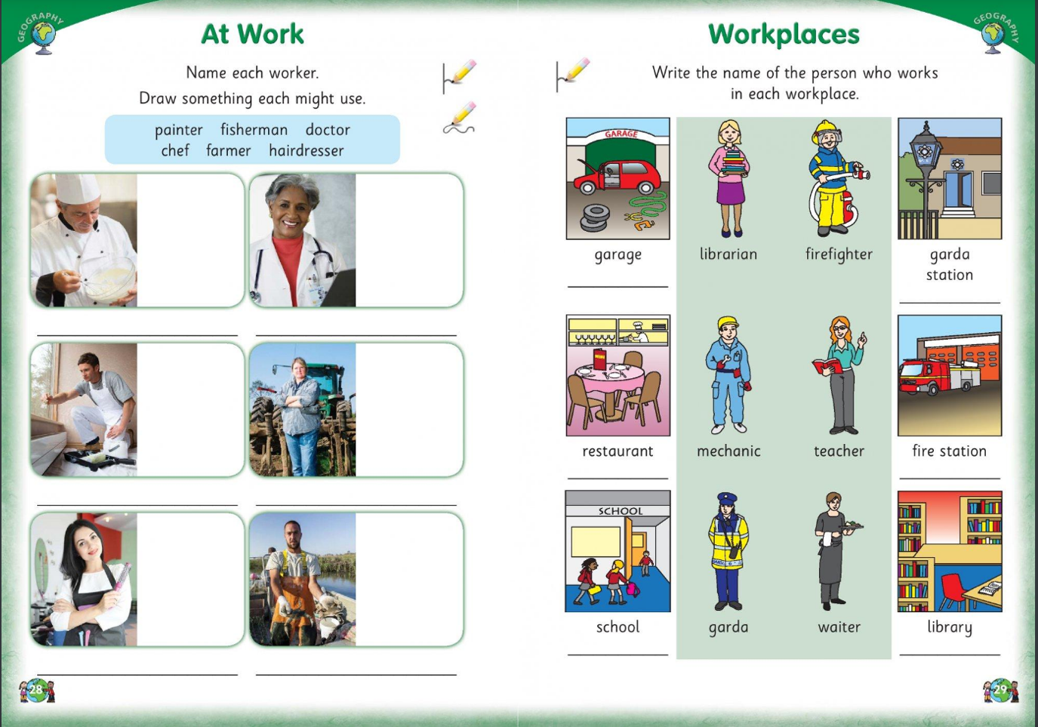
Wednesday 22nd
Please remember that these activities are not mandatory. You can pick and choose different activities you wish to do each day. You don’t have to do every activity every day! We just want to give you lots of different activities and ideas. You choose what will suit you best. Feel free to send back any pictures or work that your child has done if you would like to but again, you don’t have to! If you have any questions about anything just send us an email!

Ms Denieffe and Ms O’Neill
Subject | Activity
English | - Discuss rhyming words – what does it mean if two words rhyme? (the words sound the same at the end e.g hat, mat, bat)  - Using the rhyming cards (located on page 2 of this documet) decide which words rhyme and which is the odd word out  - Explain why the word you chose doesn’t rhyme? (it doesn’t sound the same ending sound)  - Can you brainstorm any other words that rhyme?  - Test your parent/sibling by thinking of three words (two rhyme, one doesn’t) – can they figure out which word doesn’t rhyme?  - Discuss the rhyming words in your child’s Sound’s book pg 59 (located below on page 3 of this document)  - Ask your child to read a word and then find and point at the matching rhyming word
Maths | - Revise and practice the story of 10  - Use the circles and objects to practice the story of 10, similar to yesterday  - Practice addition using fingers/pencils e.g. show me 8 fingers, how many more fingers must be added to make 10?  - You can practice addition using this interactive online game https://www.starfall.com/h/addsub/add-machine-1/?sn=math1--math0  - You can use pages 93+94 from your child’s Planet Maths book to help (located on pages 3+4 of this document)
Gaeilge | - You can look at ceacht 3 in the theme siopadóireacht for Bua na Cainte  - There are interactive games you can play for this lesson too
SESE | Floating and Sinking  - You can listen to “Who Sank the Boat” as an introduction into the topic if you wish https://www.youtube.com/watch?v=VhE2gcy6Z3A  - Discuss what the words floating/sinking mean  - Brainstorm different objects that might float/sink  - This video might help you https://www.youtube.com/watch?v=eQuW8G2QV_Q  - Collect different objects to experiment with  - Predict if you think they will float or sink before you try!  - You can use page 50 from your child’s Small World book to help you choose suitable objects if you wish (located on page 4 in this document)
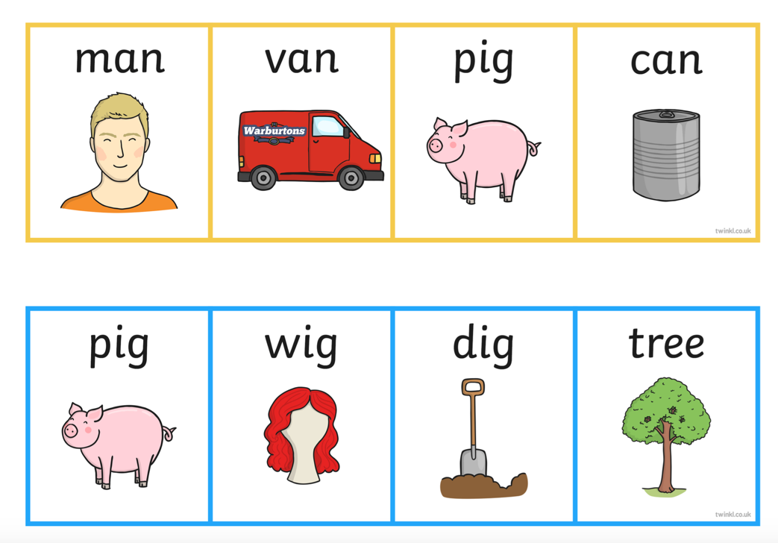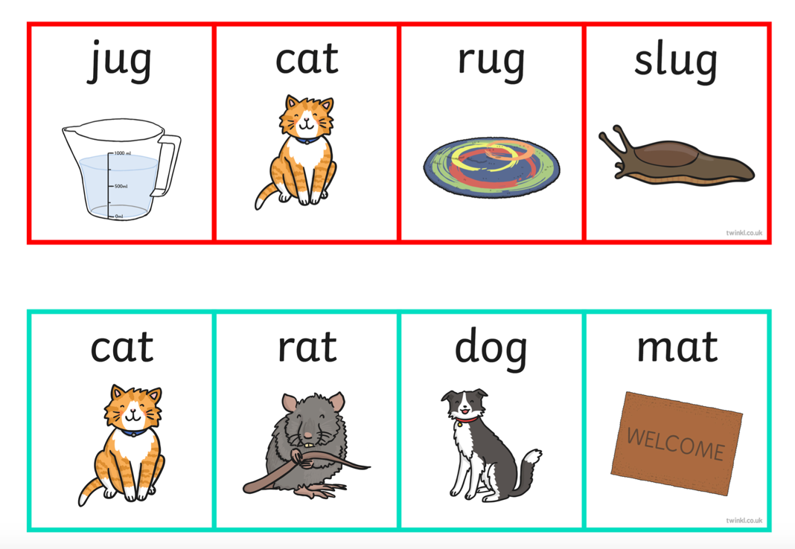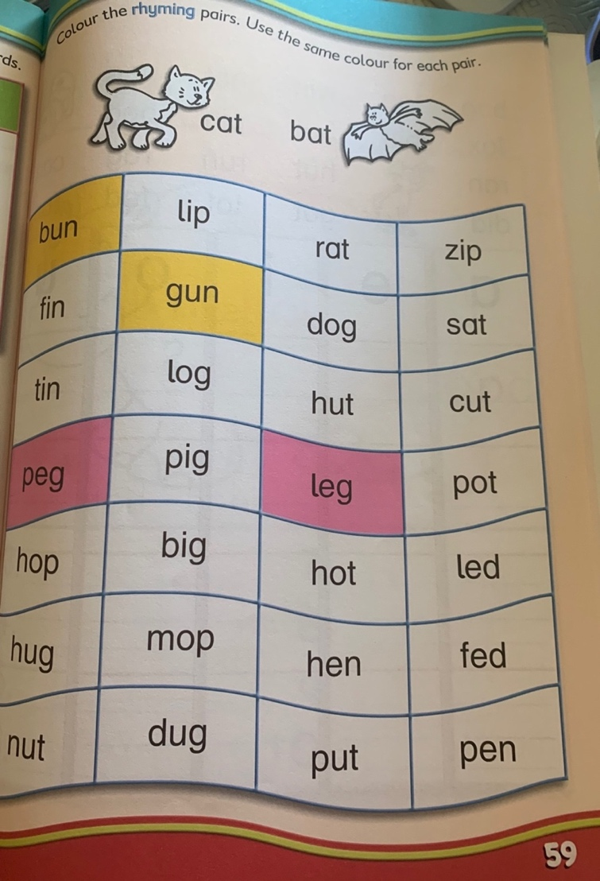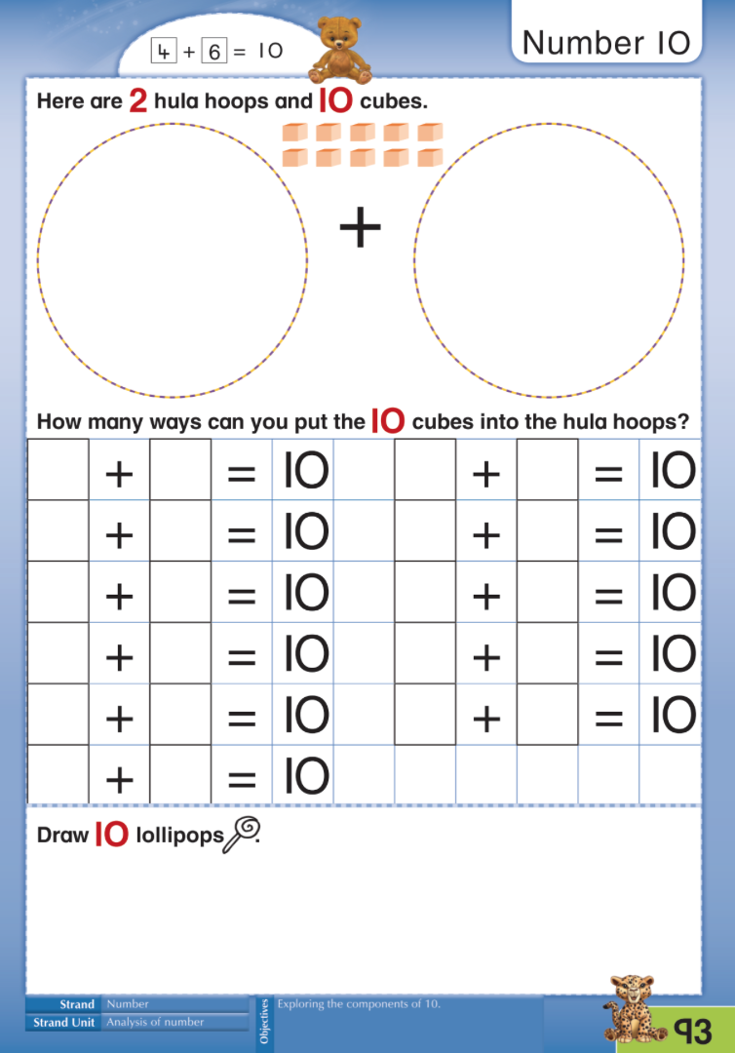
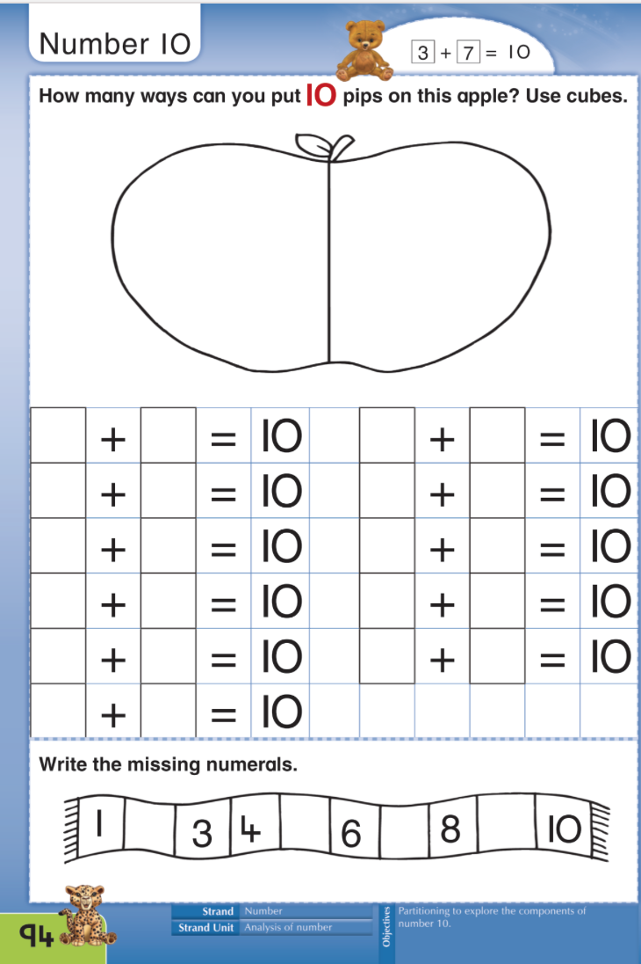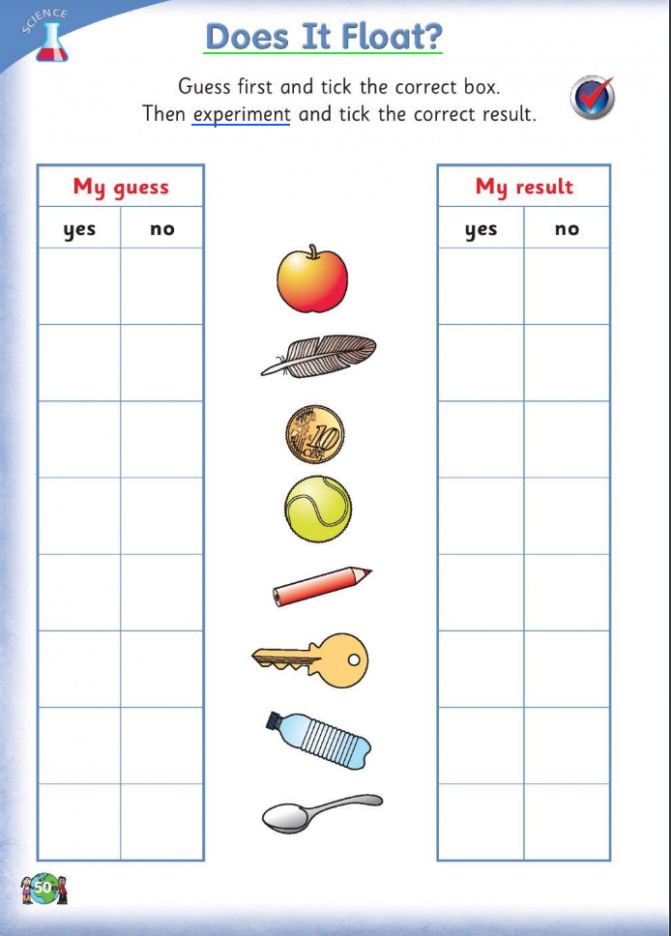
Thursday 23rd
Please remember that these activities are not mandatory. You can pick and choose different activities you wish to do each day. You don’t have to do every activity every day! We just want to give you lots of different activities and ideas. You choose what will suit you best. Feel free to send back any pictures or work that your child has done if you would like to but again, you don’t have to! If you have any questions about anything just send us an email!

Ms Denieffe and Ms O’Neill
Subject | Activity
English | Dictation  - Ask your child to listen carefully as you will only say the sentence twice.  - Call out the sentence and give your child a chance to write it down  - Look at the sentence together - What words were tricky? How did you figure out how to spell this word? Where did you go wrong?  Sentences  - The big man ran to the shop.  - My pen is in the red bag.  - The cat got hot in the sun.  Challenge – Ask your child to write their own sentence!
Maths | Capacity  - Useful vocabulary – full, empty, nearly full, holds more, holds less, as much as, holds the least, holds the most, empty, fill, level, enough, the same amount,  - Free playing using water and a selection of different sized containers e.g. saucepans, milk cartons, basins, buckets, bottles, eggcups  - Discuss which container holds the most/the least/is empty/is full  - Compare two containers – which one holds more/less?  - Use cups to fill different containers but predict how many cups you think it will take to fill a container e.g. I predict it will take 4 cups to fill this bottle  - You can use page 122 in the Planet Maths book to help you (located on page 3 in this document)
Gaeilge | - Ceacht 4 for the theme siopadóireacht using the Bua na Cainte programme
Music + Drama | Song: Please Mr Noah  - See what your child knows about Noah and the ark e.g. Who is Noah? What is an ark? Who did Noah bring onto the ark?  - Listen to the song “Please Mr Noah” being performed by a class at assembly https://vimeo.com/46942559  - Lyrics to the song are located below on page 2+3 of this document  - See if you can think of any other actions or sounds to perform for the different animals!  - Act out what you think it would be like on the Ark  - You’ve been out in the water for ages, what plan can you come up with to help you find land?  - Imagine a conversation between two of the animals on the Ark – what do you think they might be chatting about?
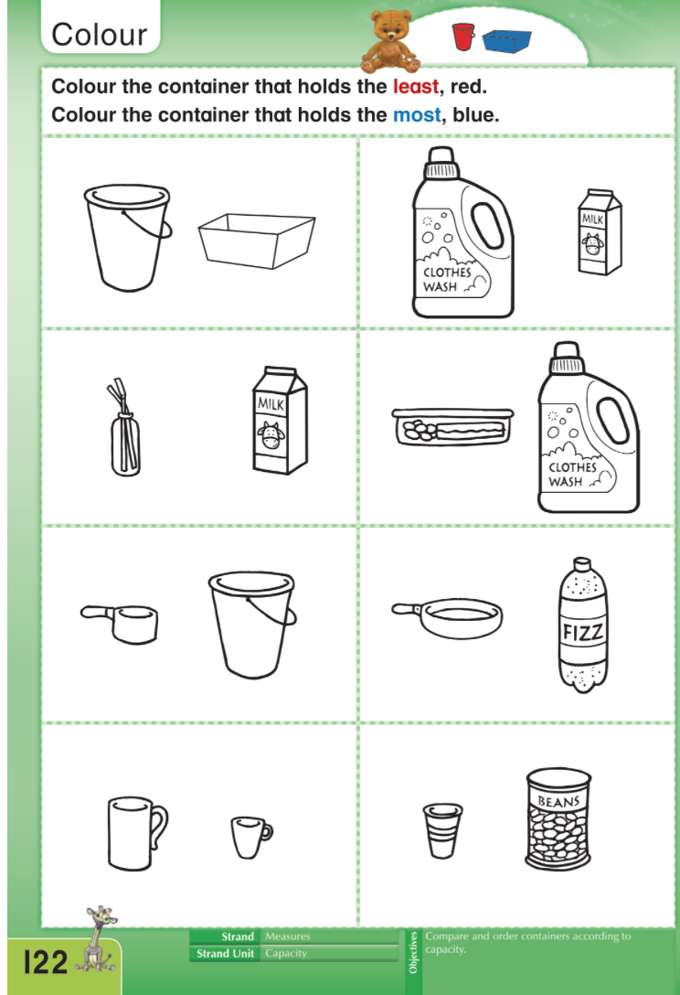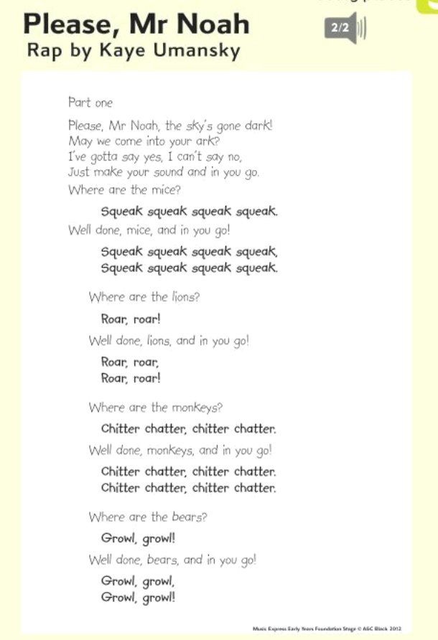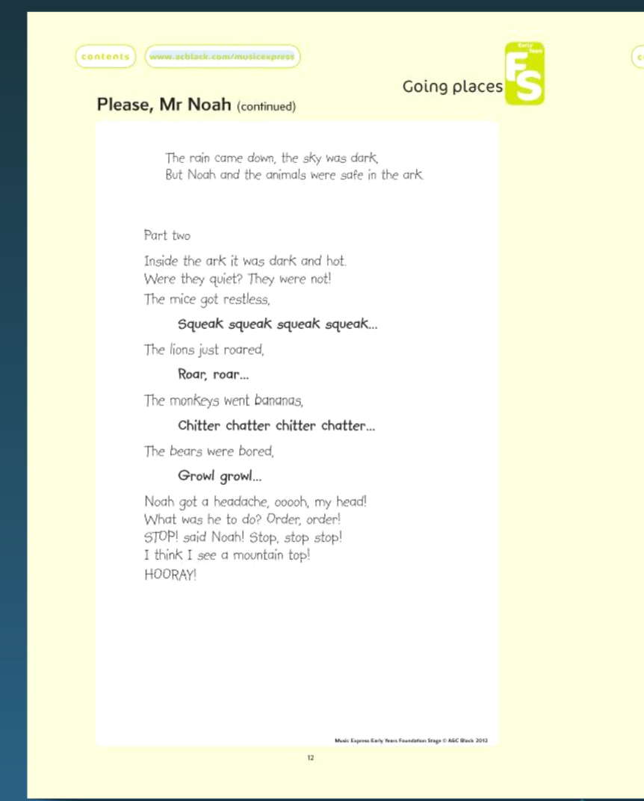
Friday 24th
Please remember that these activities are not mandatory. You can pick and choose different activities you wish to do each day. You don’t have to do every activity every day! We just want to give you lots of different activities and ideas. You choose what will suit you best. Feel free to send back any pictures or work that your child has done if you would like to but again, you don’t have to! If you have any questions about anything just send us an email!

Ms Denieffe and Ms O’Neill

Subject | Activity
English | - If you would like to you can do a spelling test and word test with your child today.  - Choose a book from home/ Youtube/ StorylineOnline to read with your child  - https://www.storylineonline.net  - Read the title of the book and use this to make a prediction – what do you think will happen in this book and why?  - Who are the author and illustrator of this book? What does an author/illustrator do?  - Read the book, stop as the book progresses and see if you need to change your prediction  - Discuss the different things you can see in illustrations  - After reading discuss your favourite character/favourite part of the story  - If you were the author, what would you change in this book? Could the ending of the story be different?  - Be an illustrator and create your own illustration for the book
Maths | - You can play this online interactive game to recall what your child learned yesterday https://www.splashlearn.com/measurement-games  - Choose two containers that have a similar capacity but are different shapes e.g. 1 litre ice cream carton and 1 litre milk carton  - Look at the two containers and ask your child to predict which will hold the most/least amount of water  - Fill one container until it is full then use the water in this container to fill the other container – what did you notice? Did they hold the same amount of water?  - You can use page 123 in Planet Maths to help you (located in page 3 of this document)
Gaeilge | - You can listen to the ‘scéal” for this theme today  - The story is “Sicín Licín”  - You can look back over any of the lessons or interactive games you might have enjoyed from earlier in the week if you’d like!
SESE | Old and New toys  - Discuss some of your child’s favourite toys – why is that your favourite toy? Did you have different toys when you were a baby? Does your older sibling have different toys?  - Tell your child about your favourite toy when you were young  - Do you have any really old toys in your house? What do you think an old toy would look like?  - You might want to ring a grandparent and ask them about their favourite toy when they were young
