Tuesday 23rd June 2020
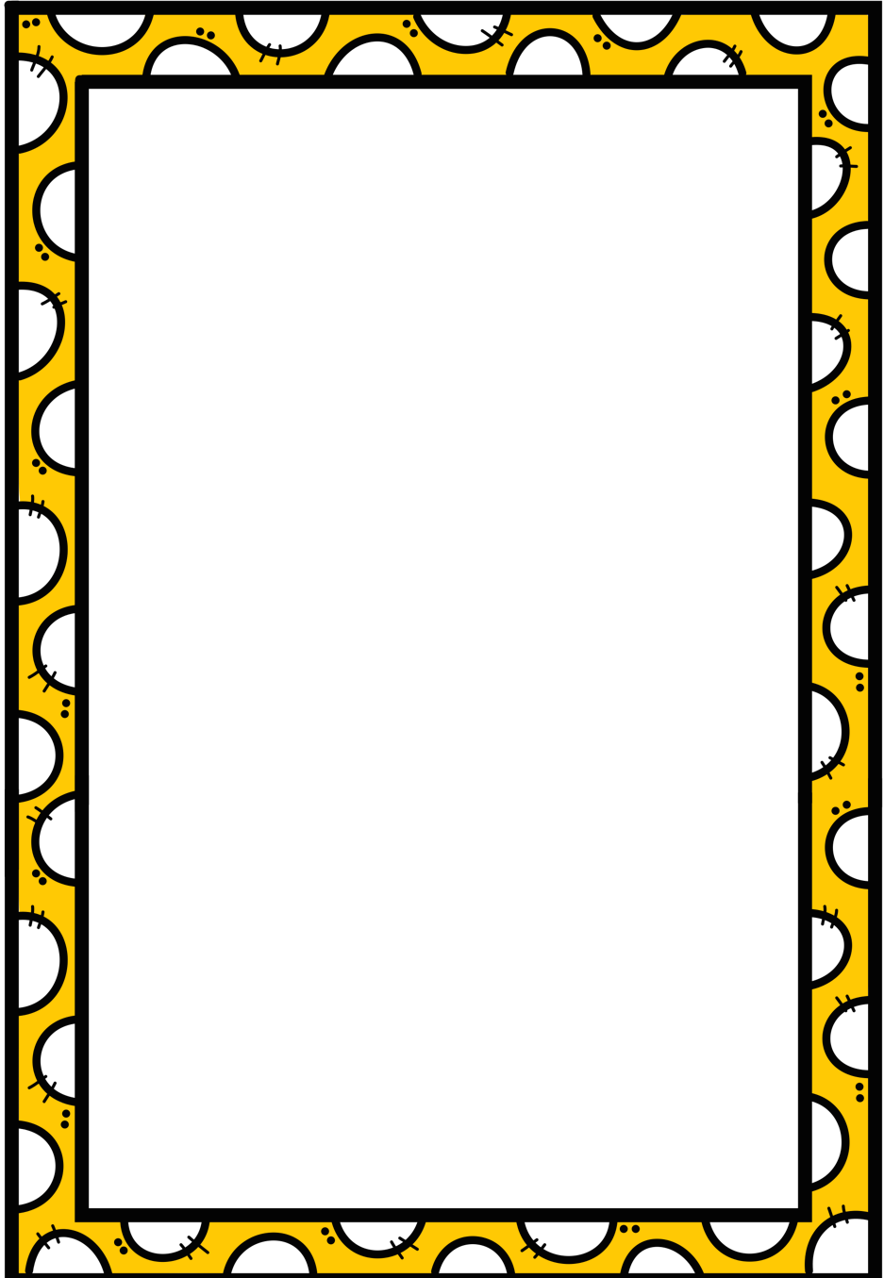
Writing Choice Board – Complete at least two activities
Make a list of 10 questions you would ask the president. | Write a schedule (or timetable) for the best day ever! | Make up a sentence with words that only start with the same letter. This is called alliteration
Pick a country on the map and find out more about it online or in a book. Write a mini-report about it. | Write the recipe to your favourite meal or dessert. Remember to include the ingredients! | Write a poem using your senses (hear, smell, see, touch, taste). Try to make some of the words rhyme.
Finish the story starter, “I grabbed my runners and….”. | Write a letter to someone you miss. Remember to include the features of a letter- date, name, address, and your name too. | Write a definition for 5 nouns and draw a picture of each.
Start a journal about your day. Write a small bit in it every day. | Find something in your house that starts with each letter of the alphabet. Write a story using 12 of these words.. | Write about the last holiday you went on.
Draw a picture of someone you know very well and fill the page around them with words to describe them. | Interview someone in your house. Write the questions before the interview, and fill in their answers after wards. | Tell me how to eat a ham, cheese, toasted sandwich without making a mess.

Wednesday 24th June 2020
Geography Choice Board – Complete at least two activities
Geography choice board
First, choose a country. You can pick from a map or a globe. Then, choose three activities to do to make three in a row! You can use websites like BBC bitesize, Dkfindout and National Geographic Kids or books at home to help you.
Make a mind map about everything you know about this country. You can break it in food, people, playtime etc. | Make PowerPoint on a computer or an infographic about the most famous places in this country. | Find out what language they speak in this country and learn the sentence: Hello, my name is ____.
Write a sensory poem (using all your senses) about a picture of this country. It could be the city, the countryside or a famous landmark. | Make a list of things that are the same and things that are different between Ireland and this country. | Find out about a famous person from this county and write a report / biography about them.
Find and write a recipe for a traditional food from this county. include pictures if you can. | Write a diary entry for a person your age living in this county. Include food, games, sports and school. | Draw a picture of a myth or story you found out about this country.

Thursday 25th June 2020
Maths Choice Board
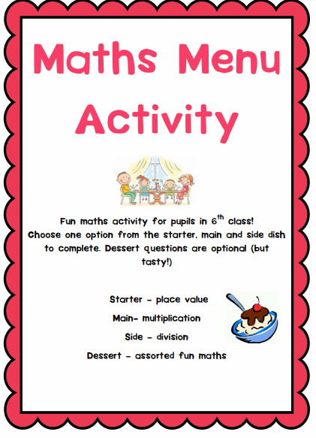
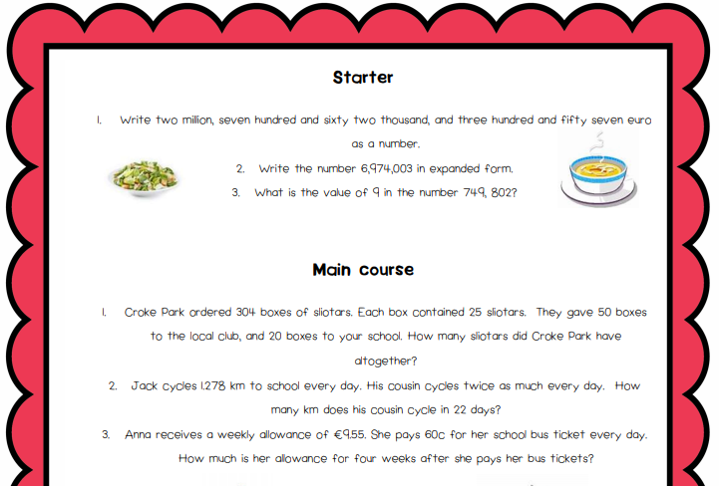
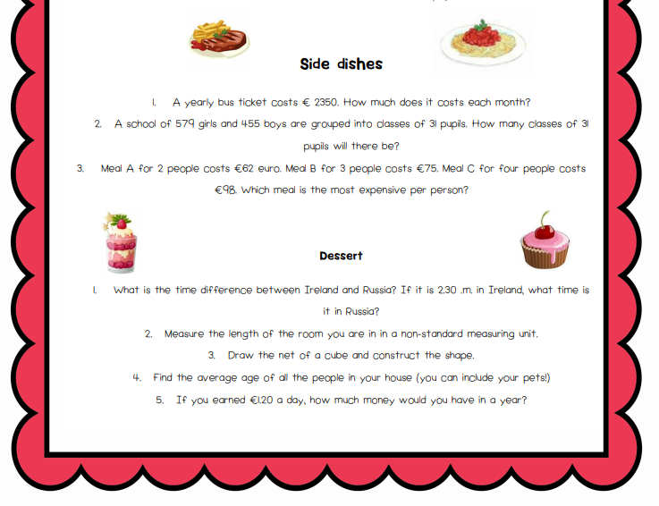
Credits: Font used: BAB from https://www.teacherspayteachers.com/Store/Bugs-And-Beaches Frame used: Rainbow Sprinkle from https://www.teacherspayteachers.com/Product/RainbowScalloped-Borders-and-Frames-FREEBIE-borders-clipart-3971224
Friday 26th June 2020
Last Day of School Year 2019 / 2020

10 Ideas on the theme of Summer

1 | Make your own ice lollies with different fruit juices. Which combination do you like best. Share your recipe
2 | Find out about celebrations from different countries that take place during the summer. Create a fact file, PowerPoint presentation, or record yourself telling us all about it.
3 | Record how your shadow changes throughout the day by drawing around it or taking pictures. Write a conclusion about what you find.
4 | Make some Rainbow fruit skewers using strawberries, watermelon,  orange, pineapple, grapes and blueberries!
5 | Make a Summer Bucket List for 2020. Include at least ten activities. Write your ideas in a summer themed picture. ex. inside a bucket and spade, inside a sandcastle, use your imagination. See how many you can cross off by the end of this summer.
6 | Make your own summer den, either from sheets and chairs or for something more adventurous, build a shelter in the wood. Share a picture with us.
7 | The next time you go to a beach concentrate on the sand between your toes. Did you know that sand is used to make glass? Do some research on how glass is made, and present your findings in whatever way you wish.
8 | Create a summer themed word search. Make sure to include at least 12 words. Share with you classmates.
9 | Finish this summer themed story. Here are the first lines “It was a beautiful sunny day, I was running along the beach, and then I saw it. Just there, right in front of me” Don’t forget your start, middle and end.
10 | Make a Frisbee using paper plates. (Get 2 paper plates and cut out the centres. Decorate the bottom of both plates and then place them together to make a ‘UFO’ shape. Staple/Stick around the edges and get playing!) Write a set of instructions for your classmates

